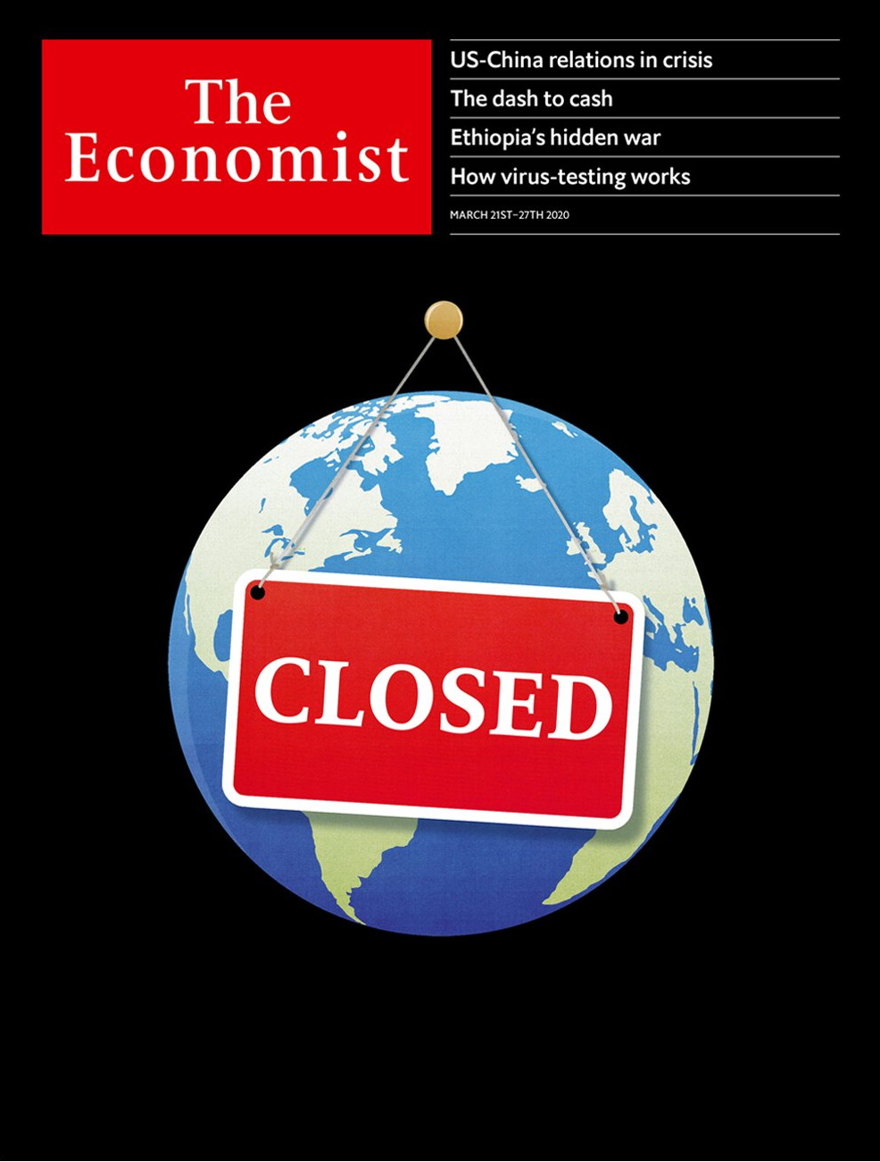

# Table of Contents

The world this week

Politics this week

Business this week

KAL’s cartoon

Leaders

The Pandemic: Closed

The world economy: Fighting the slump

Free speech: Stop deporting reporters

Guyana: Petro power struggle

Professional sports: The game’s the thing

Letters

Letters to the editor: On coronavirus and business, central banks, Hong Kong, data

Briefing

The pandemic: The lockdown and the long haul

The economic emergency: Experimental treatment

United States

Responding to covid-19: In sickness, not in health

The 2020 population count: Census and sensibility

The Democratic primary: Electoral distancing

Families: Little gay house on the prairie

The Bible museum: A load of old cobblers

Lexington: Pandemic polarisation

The Americas

Eradicating coca: Burning leaves, spurning leavers

Bello: Venezuela’s political quarantine

Canada: A little lichen relief

Asia

Covid-19 in India: The billion-person question

Banyan: No island is an island

Australia’s economy: Up, up, up and down

The Maldives: The other contagion

Making wagyu Japanese again: Sperm wail

China

China and America: The blame game

Imported infections: A frosty welcome

Chaguan: This virus also kills dreams

Middle East and Africa

Separatism in Ethiopia: Abiy’s war

HIV and the disabled: Double trouble

The Democratic Republic of Congo: A crocodile-hunter’s tears

Coping with covid-19: Prayer in a pandemic

Israeli politics: Bibi and the virus

Europe

Italy and covid-19: The race against time

Spain: Sánchez’s big test

Europe’s borders: Frontier theatre

France: The virus and the vote

North Macedonia: Deplinthing Alexander

Russia: The new Soviet Union

Charlemagne: Europe, more or less

Britain

Government: Leviathan rising

Theatreland: Curtains

Trains: Bailing out the railways

Panic buying: Supermarket sweep

Old people: Leave granny alone

Life under lockdown: Dispatches from the front room

Brexit and covid-19: Crises collide

Digital infrastructure: Stayin’ online

Bagehot: The spirit of the Blitz

International

School closures: Mid-term break

Business

Business and the pandemic: Covid carnage

Air transport: Flight risk

Manufacturing: My iron lung

Very golden oldies: Berkshire Hathaway has America Inc’s oldest board

Bartleby: Embracing the suck

Schumpeter: Processing power

Finance and economics

The cash crisis: Down the drain

Buttonwood: Capitulation

The surging dollar: Multi-coloured swap shop

Two versions of reality: Exchange-traded fundamentals

Closing stock exchanges: The pits

Free exchange: From V to victory

Science and technology

The coronavirus pandemic: Test acts

Scientific methods: Sentimental journey

Palaeontology: Fowl play

Books and arts

Music and politics: Ghetto blasters

Muhammad bin Salman: The prince

The play’s the thing: Brave new world

Arresting new fiction: He said, she says

Johnson: Talking to the world

Economic and financial indicators

Economic and financial indicators

Graphic detail

Obituary

Falafel: The throw of the dice



### Friday, March 20, 2020

|  |  |
| --- | --- |
| The world this week | 3 |
| Leaders | 5 |
| Letters | 1 |
| Briefing | 2 |
| United States | 6 |
| The Americas | 3 |
| Asia | 5 |
| China | 3 |
| Middle East and Africa | 5 |
| Europe | 7 |
| Britain | 9 |
| International | 1 |
| Business | 6 |
| Finance and economics | 6 |
| Science and technology | 3 |
| Books and arts | 5 |
| Economic and financial indicators | 1 |
| Graphic detail | 1 |
| Obituary | 1 |

|  |  |  |
| --- | --- | --- |
|  | Sections | Leaders |

The world this week

Politics this week

.

Business this week

.

KAL’s cartoon

.

|  |  |  |
| --- | --- | --- |
|  | Sections | Leaders |

|  |  |  |  |
| --- | --- | --- | --- |
|  | Articles | Sections | Next |

# Politics this week

Mar 21st 2020 |

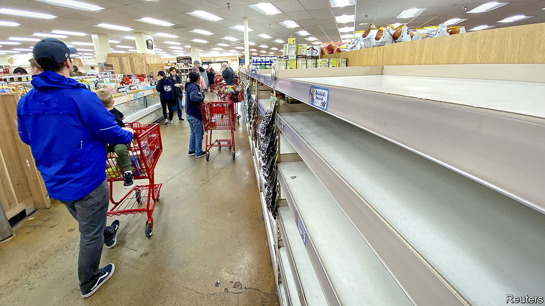

Governments around the world took extraordinary measures to curb the novel coronavirus and alleviate its economic consequences. In America the Trump administration proposed giving direct cash transfers to every American as part of an emergency- spending package. Some Republicans balked at the idea, but Mitch McConnell, the leader of the Senate, said that now was the time for “urgent bipartisan action”. See article.

Joe Biden swept the board in the latest Democratic primaries. In Florida, the biggest prize on offer, he won 62% of the vote to 23% for Bernie Sanders. The pair also debated in their first one-on-one clash. Ohio postponed its primary because of the pandemic, as have Georgia and Louisiana. See article.

The Justice Department dropped charges against two Russian entities indicted by the Mueller inquiry because it believes a trial would give Russia access to sensitive documents it would have to share with the defence.

## It’s war

The president of France, Emmanuel Macron, declared that the country is “at war” with the coronavirus. He announced the suspension of local elections, a day after France had voted in the first round. See [article](https://www.economist.com/europe/2020/03/21/france-suspends-local-elections-because-of-covid-19).

The Constitutional Court in Russia approved amendments to the country’s constitution that will reset to zero the number of terms already served by Vladimir Putin. He would otherwise have been ineligible to run again when his current term expires in 2024. See [article](https://www.economist.com/europe/2020/03/21/some-russians-are-resisting-putins-power-grab).

The brother of the suicide-bomber who killed 22 people at an Ariana Grande concert in Manchester in 2017 was found guilty of the murder of each victim. He was convicted for obtaining the materials for the bomb and of helping in the plot. In addition to those murdered a further 800 were hurt, more than 90 with life-changing injuries.

## Another chance for Gantz

Benny Gantz, the leader of the opposition in Israel, was given the first shot at forming a government after a tight election earlier this month. But his coalition is divided. Binyamin Netanyahu, the prime minister, has tried to push Mr Gantz into forming a unity government, under Mr Netanyahu, to deal with covid-19. See article.

The president or Iraq named Adnan al-Zurfi as prime minister-designate in a bid to end a months-long political deadlock. The previous prime minister resigned in November amid large anti-government protests. Powerful Shia parties have already lined up against Mr Zurfi’s nomination.

Sweden promised to send 150 commandos and helicopters to Mali to join a French-led mission fighting jihadists in the Sahel. Security in the country has continued to deteriorate.

Peter Mutharika, president of Malawi, sacked the head of the army, dissolved his cabinet and refused to sign new laws allowing for fresh elections in May. Malawi’s top court had annulled his re-election victory, citing vote-rigging. He plans to stick around anyway.

## Risky behaviour

Brazil’s president, Jair Bolsonaro, joined supporters who were holding demonstrations in favour of him. He fist-bumped his fans and took selfies with them even though at least 17 people who accompanied him on a recent visit to Mar-a-Lago, Donald Trump’s getaway in Florida, tested positive for covid-19. Mr Bolsonaro describes the reaction to the virus as “hysteria”.

A court in Guyana temporarily blocked a recount of votes cast in the general election on March 2nd. A candidate from the president’s coalition brought the suit seeking the injunction. International observers had said there was credible evidence of fraud in an initial tally, which gave victory to the president.

## Repressing the press

China ordered American citizens working for the New York Times, the Wall Street Journal and the Washington Post to leave the country. It was the biggest mass expulsion of western correspondents from China since the Communist takeover in 1949. The government said it was a response to America’s decision to limit the number of people working for China’s main state-owned news organisations stationed in America to 100. See [article](https://www.economist.com/leaders/2020/03/21/expelling-journalists-is-no-way-to-fight-a-pandemic).

Amid cries of “shame”, opposition MPs staged a walkout from the Rajya Sabha, India’s upper house, when Ranjan Gogoi took oath as a new member. Mr Gogoi recently retired as chief justice; critics of the ruling Bharatiya Janata Party claim his seat is a pay-off for rulings that favoured the government.

East Timor entered its third week of political flux after the prime minister resigned. The president is mulling whether to call a snap election or appoint as prime minister Xanana Gusmão, a former president who says he has the support of a majority of MPs.

America urged the government of Afghanistan and the Taliban to proceed with a proposed exchange of prisoners, as promised in the agreement the Taliban signed with America in February. The Afghan government wants the exchange to proceed alongside peace talks, but the Taliban say talks cannot begin until the prisoners are released.

## Coronavirus briefs

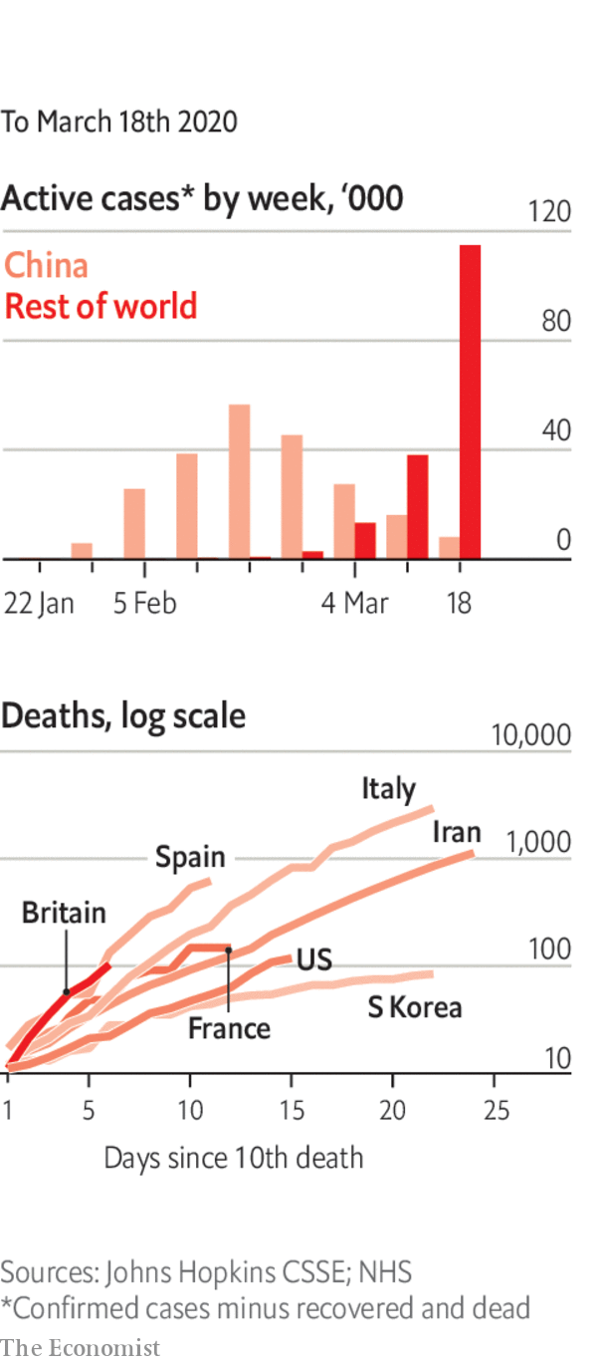

Countries imposed strict restrictions on border crossings, including between America and Canada. See article.

Stringent curbs on the movement of people were enforced in France, Spain, the San Francisco Bay Area and other places.

The number of deaths surged in Italy. For the first time China reported no new daily local infections. See article.

The Philippines declared a “state of calamity”.

Researchers were concerned about a second wave of infections in Hong Kong, Singapore and Taiwan.

Supermarketstook steps to ration the sale of products and to set aside shopping hours for the vulnerable.

In what some saw as a blow, the Eurovision Song Contest was cancelled.

For our latest coverage of the virus and its consequences please visit [economist.com/coronavirus](http://economist.com/coronavirus) or download the Economist app.

This article was downloaded by calibre from <https://www.economist.com/the-world-this-week/2020/03/21/politics-this-week>

|  |  |  |  |
| --- | --- | --- | --- |
|  | Articles | Sections | Next |

|  |  |  |  |
| --- | --- | --- | --- |
| Previous | Articles | Sections | Next |

# Business this week

Mar 21st 2020 |

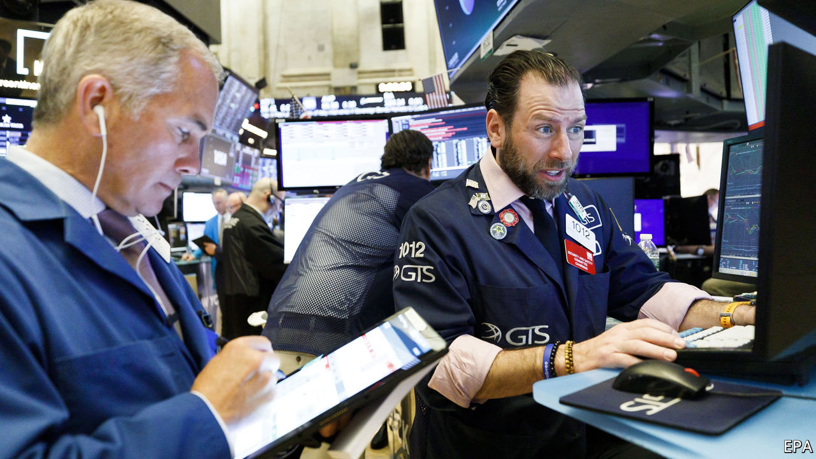

The Federal Reserve took more emergency measures to bolster short-term liquidity in markets by providing new funding lifelines to banks. It also cut its benchmark interest rate close to zero and began a new programme to buy commercial paper. Stockmarkets were in free fall; trading was halted again on the New York Stock Exchange after steep plunges triggered an automatic “circuit breaker”. The S&P 500 had its worst day since 1987, falling by 12%. It has now shed all the gains it made last year. See [article](https://www.economist.com/finance-and-economics/2020/03/21/why-americas-financial-plumbing-has-seized-up).

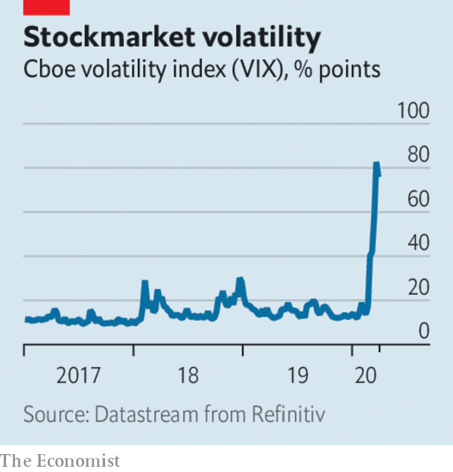

## Sinking sterling

As investors turned to the dollar for safety, the pound fell to levels last seen during the 1980s, dropping below $1.15 in trading. Uncertainty about Brexit was an extra factor weighing on panicky markets. See [article](https://www.economist.com/britain/2020/03/21/covid-19-is-delaying-brexit-negotiations).

The European Central Bank launched a €750bn bond-buying programme that covers government and corporate debt. Banks in the euro zone tapped €109bn in ultra-cheap loans under a new facility. China’s central bank lowered the amount of cash holdings that banks are required to keep in reserve, a measure intended to free up loans to businesses. Industrial output in China shrank by 13.5% in January and February compared with the same two months in 2019, the biggest drop on record. In Britain the government unveiled a £330bn ($380bn) loan package for firms. See article.

Andrew Bailey took over as governor of the Bank of England, a baptism of fire as the central bank reacts to the covid-19 crisis and continues its preparations for Britain’s withdrawal from the EU’s financial provisions by the end of the year. Mr Bailey said the bank would seek to limit the fallout from the crisis so that it would be “disruptive” instead of “destructive”. He added that the bank was willing to pump unlimited amounts of money into the economy through the government’s new covid financing facility.

At an emergency meeting Turkey’s central bank cut its benchmark interest rate by one percentage point, to 9.75%, causing the lira to slide. The bank thinks a global slowdown will cool inflation, which is on the rise again in Turkey.

Commodity prices continued to tumble amid gloomy forecasts for industrial demand. Facing a double whammy of reduced demand and a price war started by Saudi Arabia, oil prices plunged, with Brent crude at a 17-year low of around $25 a barrel. Gold prices, usually a haven in stressed markets, dropped as investors cashed in their holdings. Silver, which is widely used in industrial processes, was at its lowest price since 2009.

The International Air Transport Association warned that the forecast it provided only recently about the hit to airline revenues during the crisis is now out of date. The association is calling for governments around the world to provide carriers with direct financial support, favourable loans and tax relief, which it now reckons could cost between $150bn and $200bn. The situation is “totally beyond the control of the airlines”, it said. See [article](https://www.economist.com/business/2020/03/21/airlines-are-running-out-of-cash).

Boeing also asked for help, requesting $60bn “in access to public and private liquidity”, including loan guarantees, for the aerospace industry. Already battered by drawbacks in getting the 787 MAX to fly again, its share price has slumped since mid-February, and fell sharply again this week when Standard & Poor’s cut its credit rating by two notches.

Amazon decided to employ an extra 100,000 warehouse and logistic workers in America to help it cope with a surge in online shopping. It is also restricting space in its warehouses to household essentials and medical supplies, leaving little room for third-party sellers. Although Amazon is hiring, Steven Mnuchin, the treasury secretary, reportedly thinks America’s unemployment rate could hit 20% if drastic action isn’t taken.

The crisis is taking a heavy toll on other retailers. Zara, a fashion chain, temporarily shut half its stores worldwide. Laura Ashley, a purveyor of textiles and other goods themed in the English- romantic style, was close to collapse. It opened its first shop in the 1960s.

France slapped a €1.1bn ($1.2bn) fine on Apple for conniving with wholesalers to suppress competition. Apple said the decision, the biggest antitrust penalty imposed on a single company in France, ignored 30 years of legal precedent. The firm plans to appeal.

## The mighty Quinn

HSBC appointed Noel Quinn as its chief executive. Mr Quinn was given the job on an interim basis when John Flint was defenestrated last August and is ploughing ahead with a huge restructuring at the bank.

Stepping up to the coronavirus crisis in France, LVMH, the world’s biggest maker of luxury goods, switched its perfume and cosmetic production lines to make hand sanitiser, which it is giving away to hospitals. Sites that made Dior and Givenchy scents are now churning out hydroalcoholic gel.

This article was downloaded by calibre from <https://www.economist.com/the-world-this-week/2020/03/21/business-this-week>

|  |  |  |  |
| --- | --- | --- | --- |
| Previous | Articles | Sections | Next |

|  |  |  |  |
| --- | --- | --- | --- |
| Previous | Articles | Sections | Next |

# KAL’s cartoon

Mar 21st 2020 |

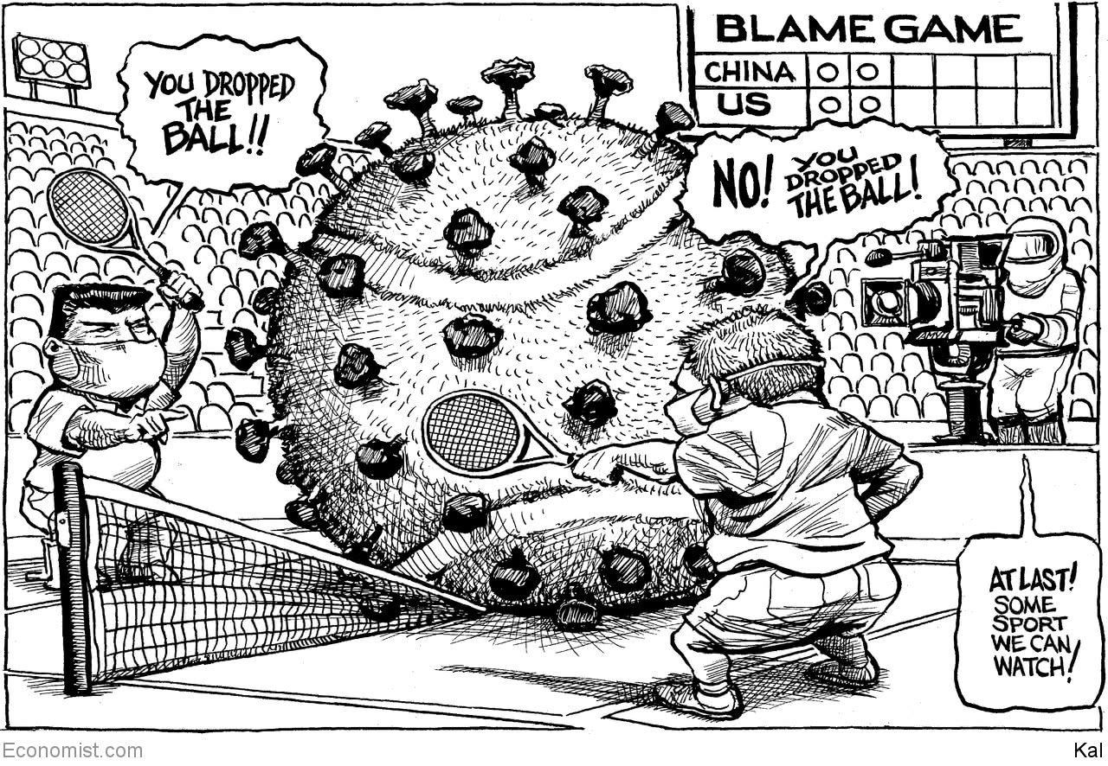

This article was downloaded by calibre from <https://www.economist.com/the-world-this-week/2020/03/21/kals-cartoon>

|  |  |  |  |
| --- | --- | --- | --- |
| Previous | Articles | Sections | Next |

|  |  |  |
| --- | --- | --- |
| The world this week | Sections | Letters |

Leaders

The Pandemic: Closed

.

The world economy: Fighting the slump

.

Free speech: Stop deporting reporters

.

Guyana: Petro power struggle

.

Professional sports: The game’s the thing

.

|  |  |  |
| --- | --- | --- |
| The world this week | Sections | Letters |

|  |  |  |  |
| --- | --- | --- | --- |
|  | Articles | Sections | Next |

#### Closed by covid-19

# Paying to stop the pandemic

The struggle to save lives and the economy is likely to present agonising choices

Mar 19th 2020 |

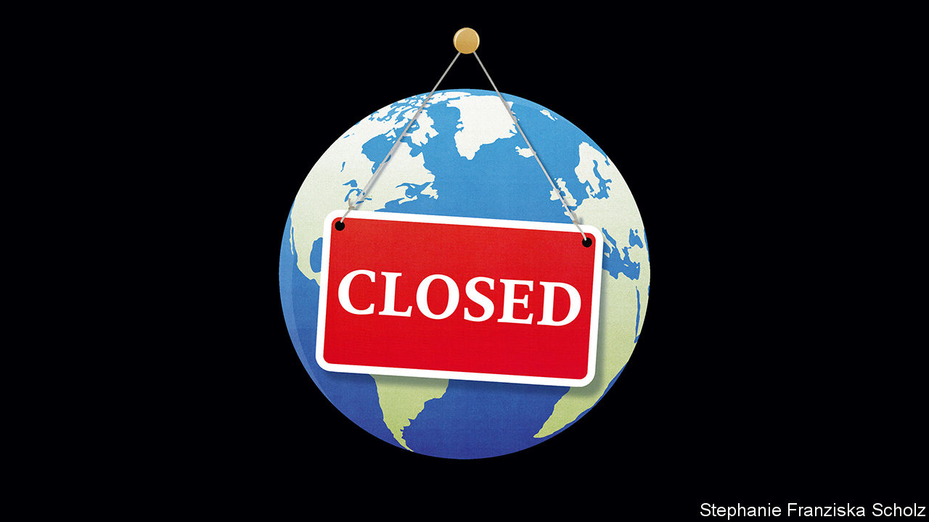

PLANET EARTH is shutting down. In the struggle to get a grip on covid-19, one country after another is demanding that its citizens shun society. As that sends economies reeling, desperate governments are trying to tide over companies and consumers by handing out trillions of dollars in aid and loan guarantees. Nobody can be sure how well these rescues will work.

But there is worse. Troubling new findings suggest that stopping the pandemic might require repeated shutdowns. And yet it is also now clear that such a strategy would condemn the world economy to grave—perhaps intolerable—harm. Some very hard choices lie ahead.

Barely 12 weeks after the first reports of people mysteriously falling ill in Wuhan, in central China, the world is beginning to grasp the pandemic’s true human and economic toll. As of March 18th SARS-CoV-2, the virus behind covid-19, had registered 134,000 infections outside China in 155 countries and territories. In just seven days that is an increase of almost 90,000 cases and 43 countries and territories. The real number of cases is thought to be at least an order of magnitude greater.

Spooked, governments are rushing to impose controls that would have been unimaginable only a few weeks ago. Scores of countries, including many in Africa and Latin America, have barred travellers from places where the virus is rife. Times Square is deserted, the City of London is dark and in France, Italy and Spain cafés, bars and restaurants have bolted their doors. Everywhere empty stadiums echo to absent crowds.

It has become clear that the economy is taking a much worse battering than analysts had expected (see Briefing). Data for January and February show that industrial output in China, which had been forecast to fall by 3% compared with a year earlier, was down by 13.5%. Retail sales were not 4% lower, but 20.5%. Fixed-asset investment, which measures the spending on such things as machinery and infrastructure, declined by 24%, six times more than predicted. That has sent economic forecasters the world over scurrying to revise down their predictions. Faced with the most brutal recession in living memory, governments are setting out rescue packages on a scale that exceeds even the financial crisis of 2007-09 (see leader).

This is the backdrop for fundamental choices about how to manage the disease. Using an epidemiological model, a group from Imperial College in London this week set out a framework to help policymakers think about what lies ahead. It is bleak.

One approach is mitigation, “flattening the curve” to make the pandemic less intense by, say, isolating cases and quarantining infected households. The other is to suppress it with a broader range of measures, including shutting in everybody, other than those who cannot work from home, and closing schools and universities. Mitigation curbs the pandemic, suppression aims to stop it in its tracks.

The modellers found that, were the virus left to spread, it would cause around 2.2m deaths in America and 500,000 in Britain by the end of summer. In advanced economies, they concluded, three months of curve-flattening, including two-week quarantines of infected households, would at best prevent only about half of these. Moreover, peak demand for intensive care would still be eight times the surge capacity of Britain’s National Health Service, leading to many more deaths that the model did not attempt to compute. If that pattern holds in other parts of Europe, even its best-resourced health systems, including Germany’s, would be overwhelmed.

No wonder governments are opting for the more stringent controls needed to suppress the pandemic. Suppression has the advantage that it has worked in China. On March 18th Italy added 4,207 new cases whereas Wuhan counted none at all. China has recorded a total of just over 80,000 cases in a population of 1.4bn people. For comparison, the Imperial group estimated that the virus left to itself would infect more than 80% of the population in Britain and America.

But that is why suppression has a sting in its tail. By keeping infection rates relatively low, it leaves many people susceptible to the virus. And since covid-19 is now so widespread, within countries and around the world, the Imperial model suggests that epidemics would return within a few weeks of the restrictions being lifted. To avoid this, countries must suppress the disease each time it resurfaces, spending at least half their time in lockdown. This on-off cycle must be repeated until either the disease has worked through the population or there is a vaccine which could be months away, if one works at all.

This is just a model, and models are just educated guesses based on the best evidence. Hence the importance of watching China to see if life there can return to normal without the disease breaking out again. The hope is that teams of epidemiologists can test on a massive scale so as to catch new cases early, trace their contacts and quarantine them without turning society upside down. Perhaps they will be helped by new drugs, such as a Japanese antiviral compound which China this week said was promising.

But this is just a hope, and hope is not a policy. The bitter truth is that mitigation costs too many lives and suppression may be economically unsustainable. After a few iterations governments might not have the capacity to carry businesses and consumers. Ordinary people might not tolerate the upheaval. The cost of repeated isolation, measured by mental well-being and the long-term health of the rest of the population, might not justify it.

In the real world there are trade-offs between the two strategies, though governments can make both more efficient. South Korea, China and Italy have shown that this starts with mass-testing. The more clearly you can identify who has the disease, the less you must depend upon indiscriminate restrictions. Tests for antibodies to the virus, picking up who has been infected and recovered, are needed to supplement today’s which are only valid just before and during the illness (see article). That will let immune people go about their business in the knowledge that they cannot be a source of further infections.

A second line of attack is to use technology to administer quarantines and social distancing. China is using apps to certify who is clear of the disease and who is not. Both it and South Korea are using big data and social media to trace infections, alert people to hotspots and round up contacts. South Korea changed the law to allow the state to gain access to medical records and share them without a warrant. In normal times many democracies might find that too intrusive. Times are not normal.

Last, governments should invest in health care, even if their efforts take months to bear fruit and may never be needed. They should increase the surge capacity of intensive care. Countries like Britain and America are desperately short of beds, specialists and ventilators. They should define the best treatment protocols, develop vaccines and test new therapeutic drugs. All this would make mitigation less lethal and suppression cheaper.

Be under no illusions. Such measures might still not prevent the pandemic from extracting a heavy toll. Today governments seem to be committed to suppression, whatever the cost. But if the disease is not conquered quickly, they will edge towards mitigation, even if that will result in many more deaths. Understandably, just now that is not a trade-off any government is willing to contemplate. They may soon have no choice. ■

This article was downloaded by calibre from <https://www.economist.com/leaders/2020/03/19/paying-to-stop-the-pandemic>

|  |  |  |  |
| --- | --- | --- | --- |
|  | Articles | Sections | Next |

|  |  |  |  |
| --- | --- | --- | --- |
| Previous | Articles | Sections | Next |

#### The world economy

# How to prevent a covid-19 slump, and protect the recovery

Governments need to be able to dial financial support up and down for people and firms

Mar 19th 2020 |

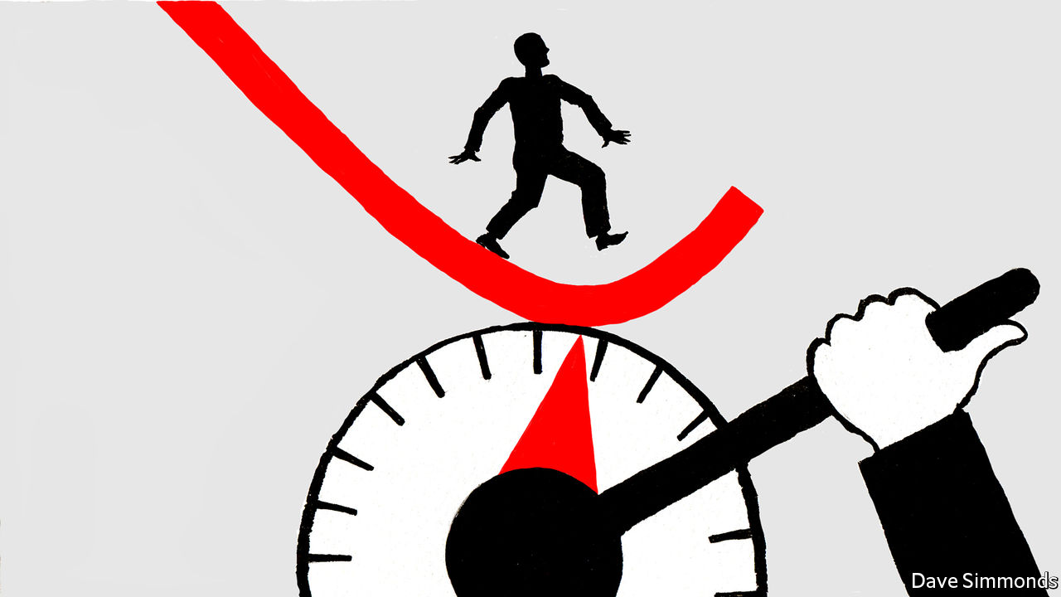

IN JUST TWO months the world economy has been turned upside down. Stockmarkets have collapsed by a third and in many countries factories, airports, offices, schools and shops have been closed to try to contain the virus. Workers are worried about their jobs and investors fear companies will default on their debts. All this points to one of the sharpest economic contractions in modern times. China’s GDP probably shrank by 10-20% in January and February compared with a year earlier. For as long as the virus rages, similar drops are likely in America and Europe, which could trigger a further downward lurch in Asia. Massive government intervention is required to ensure that this shock does not spiral into a depression. But scale alone is not good enough—new financial tools need to be deployed, and fast.

Western authorities have already promised huge sums. A crude estimate for America, Germany, Britain, France and Italy, including spending pledges, tax cuts, central-bank cash injections and loan guarantees, amounts to $7.4trn, or 23% of their GDP (see Briefing). Yet central banks are responsible for over four-fifths of that and many governments are doing too little. A huge array of policies is on offer, from holidays on mortgage-payments to bail-outs of Paris cafés. Meanwhile, orthodox stimulus tools may not work well. Interest rates in the rich world are near zero, depriving central banks of their main lever. Governments typically try to stimulate demand in a downturn but people trapped at home cannot spend freely. History is not much of a guide. The global pandemic of 1918 took place when the economy was wrecked by war. China has endured a lockdown but its social model is different from the West’s.

What to do? An economic plan needs to target two groups: households and companies. And it needs to be fast, efficient and flexible so that if the virus retreats only to resurge, workers and firms can be confident that governments will dial assistance down and up again as needed. Start with households, where large government spending is needed. One aim is to protect vulnerable people, by subsidising sick pay and ensuring those without insurance have health care. But spending is also needed to discourage lay-offs at firms running far below capacity, by subsidising workers’ wages—an area where Germany has led the way.

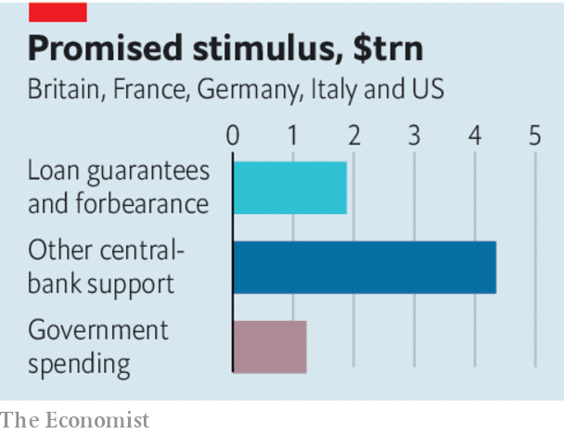

Governments also need to jerry-rig digital systems so they are able to distribute cash to households directly, as Hong Kong hopes to. The aim should be to have the capability to ramp further support up and down quickly. Many places, including America, rely on sluggish postal services and tax agencies to distribute cash. If funds can be sent instantly through mobile phones or online bank accounts, people will feel more confident and avoid hoarding cash and slowing the recovery when the virus recedes.

All this spending will cost governments dear, but the fiscal stimulus of about 1% of GDP so far across Europe is clearly too low. America’s plan to spend 5% is closer to the mark given the risk of a double-digit GDP drop. As fiscal deficits balloon, governments will have to issue piles of bonds. Central banks should step in to buy those bonds in order to keep yields low and markets orderly. Inflation is a second-order concern and there is little danger of it taking off. To prevent a euro-zone crisis, the European Central Bank plans to buy €750bn of assets. But it and European governments should also give a clear guarantee of sovereign support for Italy and other peripheral economies.

The second priority is to get cash to millions of companies, whose failure would damage the economy’s potential. They face a cash drought even as bills fall due. Bond markets are closed to many of them. Mass defaults would fuel unemployment and bad debts at banks, and make it harder for commercial activity to rebound. Most governments have intervened, but in flawed ways. France says nationalisation is an option—which firms will resist. America is propping up the commercial-paper market, but this funds only a fraction of all corporate debt and is used by big firms—not small ones, which employ most people. Germany and Britain have offered loan-guarantee schemes but it is unclear who will process millions of loan applications. The best approach is to use the banking system—almost all firms have accounts, and banks know how to issue loans. Governments should offer banks cheap funding to lend to their clients while guaranteeing that it will bear most of the losses. Borrowers could be offered bonuses for repaying loans early.

There are huge drawbacks to all of this. Public and corporate debt will soar. Handouts will be given to rich people and loans extended to firms that are badly run. But even with this fearful list of side-effects, the advantages are overwhelming. Cash will be distributed fast. Vulnerable people will be able to get by. Households will be confident enough to spend when conditions improve. And firms will keep their workforces and plants intact, ready to get back to action when this dark episode has passed.■

This article was downloaded by calibre from <https://www.economist.com/leaders/2020/03/19/how-to-prevent-a-covid-19-slump-and-protect-the-recovery>

|  |  |  |  |
| --- | --- | --- | --- |
| Previous | Articles | Sections | Next |

|  |  |  |  |
| --- | --- | --- | --- |
| Previous | Articles | Sections | Next |

#### China v America

# Expelling journalists is no way to fight a pandemic

In a crisis, reporting is more valuable than ever

Mar 19th 2020 |



THE FLOW of information is essential to curbing a pandemic. Yet on March 17th China took a dramatic step towards throttling it. Xi Jinping’s government ordered American journalists for the New York Times, the Washington Post and the Wall Street Journal to leave the country, in the biggest expulsion of Western correspondents from China since the Communist takeover in 1949. The world sorely needs objective reporting on the place with the longest experience of fighting covid-19. China, too, lacks objective reporting about the virus or any other sensitive topic. At times like this people need masks, not muzzles.

The expulsion is part of an ongoing feud between America and China. For a moment in January it seemed as if tempers were cooling, when both sides wisely agreed to suspend their trade war. In recent weeks the temperature has reached boiling-point. In a stunning failure of diplomacy, American and Chinese officials have been trading insinuations, all but blaming each other for covid-19. A few Chinese diplomats and American lawmakers have shared preposterous conspiracy theories about the virus having been cooked up in biowarfare labs. Enough, already.

The two powers are behaving more and more like cold-war rivals, tussling in every domain (see [article](https://www.economist.com/china/2020/03/21/amid-the-pandemic-sino-american-relations-are-worsening)). President Donald Trump’s administration made CGTN America, a state-owned broadcaster, register last year as a “foreign agent” and in February designated it and four other state-media outlets as foreign missions, a declaration that their staff are propagandists, not journalists. This is a foolish battleground for a democracy to pick. It cannot out-censor an authoritarian regime. Inevitably, a tit-for-tat cycle has ensued. Last month China expelled three correspondents of the Wall Street Journal, citing a single offensive headline. Mr Trump then booted out 60 staff from Chinese state-owned media. Now China has shut out many of the finest reporters on its territory.

One alarming implication concerns Hong Kong. The expelled Americans have been told they cannot work there either. This upends a convention that has largely prevailed under Chinese rule that foreign correspondents are free to work in the territory even if barred from the mainland. China has, in effect, scrapped an important feature of its “one country, two systems” policy.

But the most alarming consequences are global. There was a time, more than a decade ago, when some Americans talked optimistically about a possible “G2” partnership. They believed that America and China, for all their differences, could tackle the world’s challenges together. That now seems laughable.

Americans have cause to be irked by China’s behaviour. Western media there are suffering ever tighter restrictions. Chinese officials have become blunter in their warnings: carry on reporting like that on Xinjiang’s gulag for Muslims, or on the finances of powerful families, and your visa may not be renewed. But when America expels Chinese media workers, it does not make things better. On the contrary, it gives China a pretext to treat American reporters as if they represent America—which they do not.

Mr Trump may shrug. He never cared much for press freedom. Like many Chinese officials, he dismisses unwelcome reporting as “fake news”. To him, journalists are collateral damage in a struggle with China that is about something bigger: ensuring that America retains its pre-eminence. This zero-sum approach further poisons a sour relationship. It also makes it harder to grapple with global problems.

During the financial crisis of 2007-09, China and America did manage to talk to each other about how to save the world from economic ruin. Their ability to co-ordinate was a huge help. Today’s disaster requires their co-operation all the more. Instead, both countries are treating covid-19 as a trial of strength between competing political systems. That augurs badly for global efforts to fight the pandemic—and for the world that will emerge when the virus has eventually been tamed. ■

This article was downloaded by calibre from <https://www.economist.com/leaders/2020/03/19/expelling-journalists-is-no-way-to-fight-a-pandemic>

|  |  |  |  |
| --- | --- | --- | --- |
| Previous | Articles | Sections | Next |

|  |  |  |  |
| --- | --- | --- | --- |
| Previous | Articles | Sections | Next |

#### Petro power struggle

# Guyana’s dodgy poll is all about oil

If the election is stolen, the windfall will surely be squandered

Mar 19th 2020 |

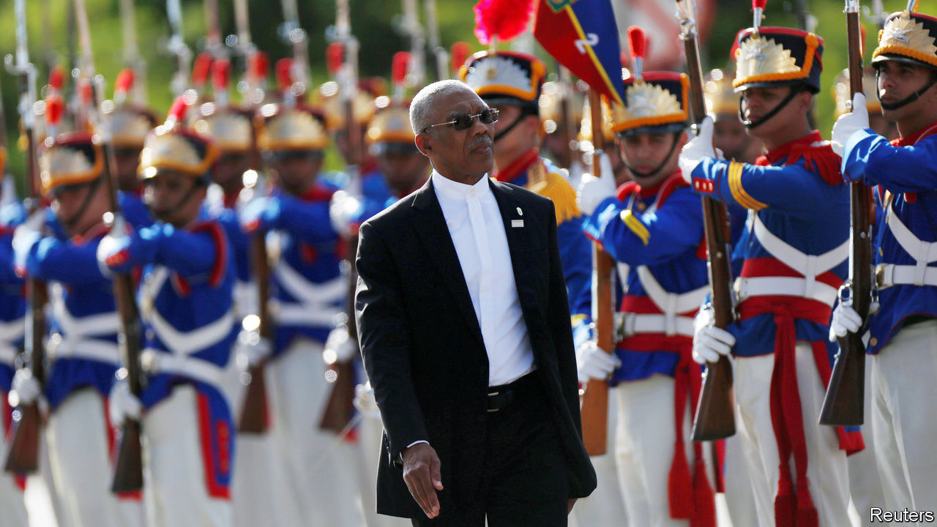

GUYANA IS MINUSCULE. Its population of 780,000 is roughly that of Seattle. But it has recently struck oil. ExxonMobil, which holds the biggest share of the licence to the first productive offshore block, reckons that 8bn barrels can be pumped out of it. That puts Guyana’s reserves among the world’s top 20. Petrodollars could soon transform Guyana from South America’s third-poorest country into one of the richest.

The power to begin spending that bonanza was at stake in the general election held on March 2nd, the first since oil started flowing. The weeks since have been chaotic. No overall result has been declared. The opposition and outside observers suspect that the president, David Granger, lost his bid for re-election. He may be plotting to have himself sworn in for a second term regardless. The danger to democracy is obvious. A government that lacks legitimacy would be more likely to squander Guyana’s newfound oil wealth.

Its politics is set up to fail its citizens. Party divisions follow ethnic ones. Mr Granger’s A Partnership for National Unity represents mainly Afro-Guyanese, who are 30% of the population. The opposition People’s Progressive Party (PPP) defends principally the interests of the Indo-Guyanese, 40% of the total. The rift is made worse by an electoral system that makes members of parliament directly accountable to party leaders rather than to constituents. This poisons political debate, thwarts compromise and undermines any sense of unified national purpose.

The election this month was a delayed response to a vote of no confidence in Mr Granger’s government in December 2018. He put it off as long as possible, compounding the opposition’s mistrust. As the votes were being counted suspicion flared up. The government’s vote share in its stronghold, the region including the capital, Georgetown, appeared to offset its losses elsewhere. Western diplomats warned of fraud. Mr Granger agreed to a recount, to be supervised by observers from the Caribbean Community. But a court has issued an interim injunction blocking it. A further ruling is expected on March 20th. America’s secretary of state, Mike Pompeo, has warned of “serious consequences” if the votes are not counted fairly.

There are no innocents in this story. The PPP governed for 23 years until Mr Granger took office in 2015. Many Guyanese remember that period as one of large-scale corruption and Indo-Guyanese chauvinism. Mr Granger’s government, though not free of graft or racial animus, has held itself to a higher standard. The president is thought to be personally honest. He governs in partnership with the Alliance for Change, a multiracial party.

Although institutions are weak, in part because of very high emigration, the government has tried to deal with the risks that come with sudden oil wealth, such as corruption and an overvalued currency. All the money will flow into a sovereign-wealth fund. The rules for drawing it down are strict. The government has not indulged in a debt-fuelled spending spree in anticipation of the oil windfall, one reason it may have lost the election.

There is no reason to think that the PPP would govern better. It wants to scrap the law that created the sovereign-wealth fund, supposedly because it gives politicians too much control. A new law could create more opportunity for patronage and misspending. But pessimism about a PPP administration does not justify electoral theft. The votes must be counted honestly. Just as important, Guyana must find a way out of the dead end into which ethnic animosity has driven it. That will require a change of political culture and constitutional reforms. Petrodollars may help. But only if the government that controls them is honest, competent and legitimately elected. ■

This article was downloaded by calibre from <https://www.economist.com/leaders/2020/03/19/guyanas-dodgy-poll-is-all-about-oil>

|  |  |  |  |
| --- | --- | --- | --- |
| Previous | Articles | Sections | Next |

|  |  |  |  |
| --- | --- | --- | --- |
| Previous | Articles | Sections | Next |

#### The game’s the thing

# As covid-19 causes sports cancellations, what can be done?

Exhibition matches? All-star games? A solution may be needed to maintain morale

Mar 19th 2020 |

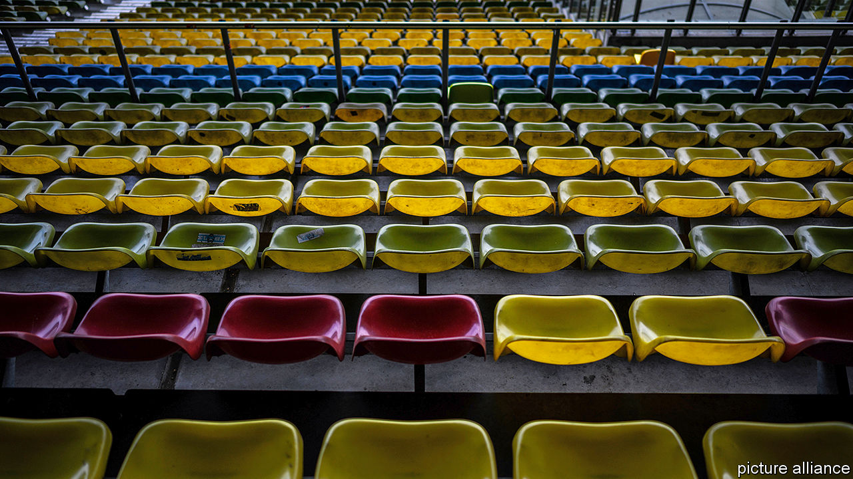

MOST FANS of professional sports have some kind of ritual associated with watching a game. Perhaps they wear their team’s shirt, scarf or hat to show their allegiance and bring their team luck. They may organise a “tailgate” party in the stadium car park, or head to a nearby bar to be with friends. For many, the match is the highlight of the week. And their emotions will rise and fall with the fortunes of their team. So the sudden cancellation of sporting events because of the coronavirus outbreak has come as a great disappointment.

Almost all the most prestigious events have been postponed: top-flight football matches, professional basketball and its “March madness” college equivalent, Major League Baseball, professional ice hockey, the Masters golf, the French Open tennis and Formula 1 car-racing. The Euro 2020 football championship has been put off until 2021. The prospects for the Tokyo Olympics in July and August are doubtful.

The economic implications will be significant. Sport is a big business. As well as attending games, American fans buy around $15bn of sports merchandise annually. Globally, many fans pay to subscribe to a sports channel to watch games; the global audience for English Premier League football was 3.2bn people last season in 188 countries. The TV rights for Premier League matches are worth £3.1bn ($3.6bn) a season. Loyal viewers mean companies like to associate themselves with teams; global sports sponsorship was estimated to be worth $55bn in 2018. Up to $150bn is wagered illegally on sports every year in the United States and more than 50% of Americans have placed a sports bet at some point.

But the effect on consumer sentiment of the hiatus may be even greater. Surveys suggest that 59% of Americans are sports fans. For many, the loss of their favourite sports events will compound the effect of being stuck at home. An important source of enjoyment will disappear. And alternative sources of entertainment are hard to find. Big movie releases, such as the latest James Bond film and Disney’s “Mulan”, have been postponed. Broadway has been closed down. Many rock concerts have been cancelled or postponed. Classical recitals (traditionally a magnet for a nation’s worst coughers) have gone the same way.

The cancellations are understandable. Allowing people to congregate in huge numbers during a pandemic seems like a big risk. Mass events also require a large presence of police and emergency services who may be needed elsewhere.

John Maynard Keynes talked a lot about the importance of “animal spirits” to economic growth. How will consumers feel when all forms of collective enjoyment are denied them? There are only so many Netflix shows one can binge-watch without going stir crazy. The Romans understood the importance of “bread and circuses”—keeping the public not just fed, but entertained, too. Hence the provision of gladiatorial games and chariot races in ancient times.

In the second world war many sports were cancelled as players were conscripted into the armed services. But exhibition games were played where possible. A British services eleven played football in newly liberated Paris and Brussels in September 1944. In America a women’s baseball league was organised. Tyler Cowen, an economist, has proposed that a small number of elite athletes could be tested for the virus and then cocooned. After a quarantine period, they could play all-star games to keep citizens entertained, with audiences watching via the internet or TV. It seems an idea worth exploring. If all work and no play makes Jack a dull boy, then no work and no play risks making Jack (and Jill) depressed and discontented. ■

This article was downloaded by calibre from <https://www.economist.com/leaders/2020/03/19/as-covid-19-causes-sports-cancellations-what-can-be-done>

|  |  |  |  |
| --- | --- | --- | --- |
| Previous | Articles | Sections | Next |

|  |  |  |
| --- | --- | --- |
| Leaders | Sections | Briefing |

Letters

Letters to the editor: On coronavirus and business, central banks, Hong Kong, data

.

|  |  |  |
| --- | --- | --- |
| Leaders | Sections | Briefing |

|  |  |  |  |
| --- | --- | --- | --- |
|  | Articles | Sections | Next |

#### On coronavirus and business, central banks, Hong Kong, data

# Letters to the editor

A selection of correspondence

Mar 19th 2020 |

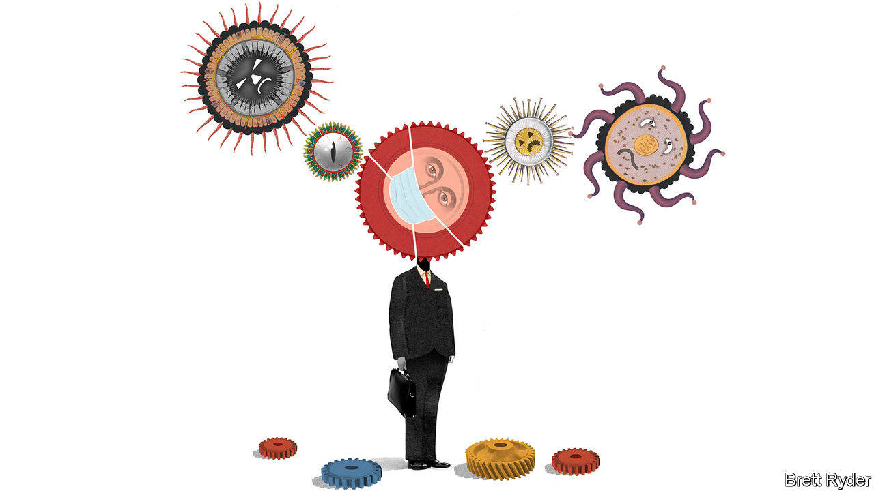

## A world turned upside down

[Schumpeter](https://www.economist.com/business/2020/03/05/covid-19-is-foisting-changes-on-business-that-could-be-beneficial) (March 7th) connected the coronavirus crisis to the lesson of “resilience and adaptation” offered by the strike on the London Underground in February 2014. Shaun Larcom, Ferdinand Rauch and I analysed the strike and found that the partial closure of the network forced many commuters to experiment with new routes. For many this resulted in shorter travel times; they continued to use the new routes after the strike, thus generating a lasting benefit.

The current global experiment with alternative work arrangements (less business travel, increased teleworking) might also bring long-term gains to businesses. There is another benefit. The covid-19 crisis has brought about mass-education on hygiene. Schoolchildren are being taught how to sneeze responsibly, touching one’s face is becoming frowned upon, and proper handwashing techniques are enjoying their 15 minutes of fame. Although covid-19 might unfortunately be here to stay, it may also change social norms (elbow bumps instead of handshakes) and improve hygiene habits. If those changes stick, we may see fewer cases of flu and other infectious diseases. Going forward, this could improve health outcomes and lower associated costs.

Joseph Schumpeter taught us to embrace disruption. Although the covid-19 crisis is making this very challenging, at the moment it is preferable to embracing people.

TIM WILLEMS  
Washington, DC

Another lasting effect may be the reinvention of the office. Schumpeter noted that firms may now find it is better to encourage remote working, given how inefficiently office space is used. Big British and American companies pay on average $5,000 per employee in annual rental costs, though just half the desks are used during working hours. The potential benefit to companies is clear. Yet it is less clear whether employees would share equally in those benefits.

It may be prudent, from the point of view of employees’ wellbeing, to reflect before implementing long-term remote-working policies. Feeling part of a shared institutional culture can be meaningful and motivating. Flexible working may cut commuting times and improve the work-life balance, but working remotely reduces the valuable face-to-face connection between employee, colleagues and company. It would be a shame if flexible working were weaponised against employees for the sake of saving on office costs.

PATRICK KELLY  
Chief executive  
Mizen Group  
New York

Working from home could result in staff forking out thousands in extra costs. An office employee who works a 40-hour-week for, say, 46 weeks a year will spend an extra 1,840 hours at home. Think of the additional cost for heating and lighting a house that is otherwise vacant during the day, not to mention powering a computer during that time and running a printer (ink, paper). Firms also provide extensive IT support. What happens if your personal computer breaks down? Is that a company cost or individual cost? Then there are the small items such as stationery, coffee and, dare I say it, toilet paper that are provided at the office.

MARGARET O’BRIAN  
London

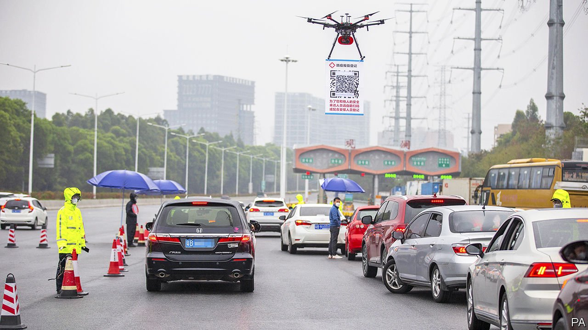

The problem with China’s success in using surveillance methods such as facial recognition and colour codes to tame covid-19 is that this could legitimise the extensive use of profiling tools (“[Code red](https://www.economist.com/china/2020/02/29/to-curb-covid-19-china-is-using-its-high-tech-surveillance-tools)”, February 29th). One can easily imagine how massive surveillance and limitations to fundamental rights like privacy could become the new norm. Desperate times call for desperate measures, but democracies face the dilemma of solving serious problems and at the same time protecting privacy, covid-19 or not.

ASBJORN AMMITZBOLL FLUGGE  
phd fellow  
Department of Computer Science  
University of Copenhagen

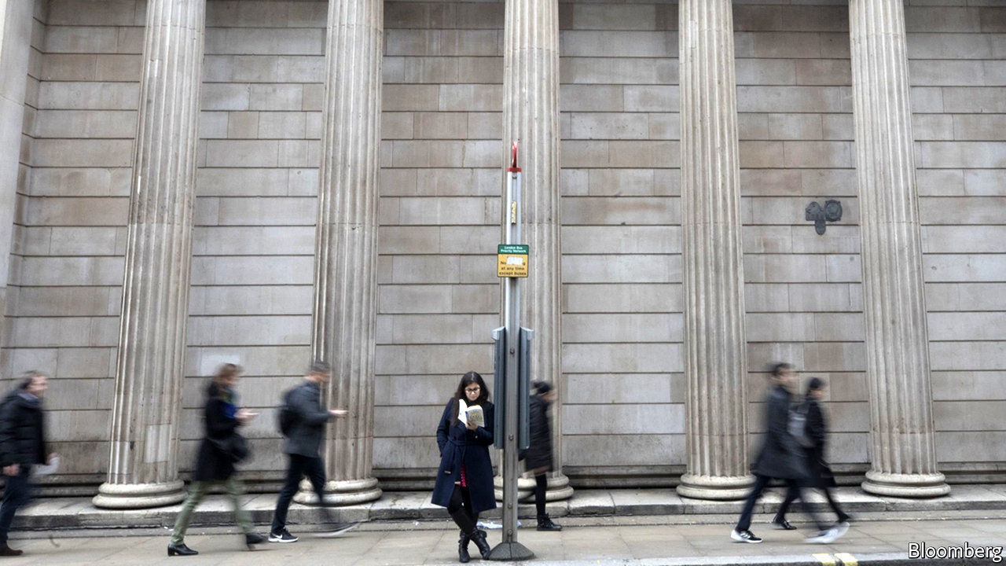

## Central-bank staff

I read your short piece noting the high staffing numbers at European central banks (“[Labour hoarding](https://www.economist.com/finance-and-economics/2020/02/22/are-there-too-many-central-bankers)”, February 22nd). Please consider that apart from the core functions related to monetary policy, banknotes and currency management, the size of central banks varies depending whether a single institution also handles coinage, printing, payment-system supervision, public-debt management, economic surveys, statistical collection, banking resolution, and the supervision of banking, insurance and markets. Then there is financial consumer protection and the duties related to new challenges, like fintech.

For instance, when comparing staffing levels at most European central banks with the Federal Reserve, you should add staff at the FDIC, OCC, SEC, NCUA, NAIC, and others, and of the regulatory authorities in each state. All in all, this raises the central-bank staff per inhabitant in the EU and America to the same level.

THIERRY DESANOIS  
President  
Standing Committee of European Central Banks Unions  
Paris

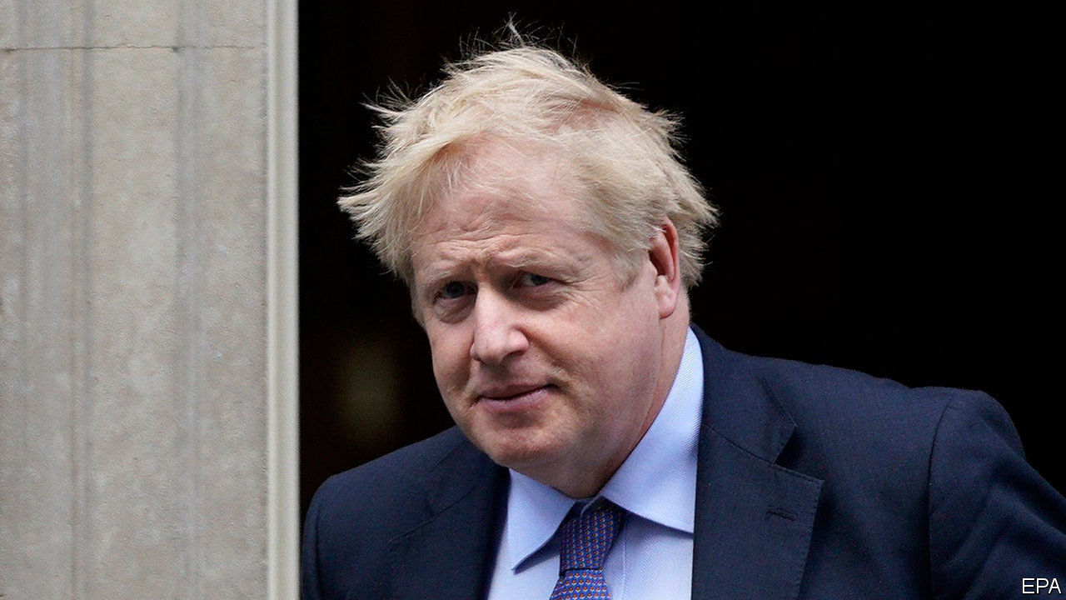

## Judges in Hong Kong

The consequences of Boris Johnson restricting the power and independence of the judiciary in Britain may be more far-reaching than the erosion of a safeguard against unchecked executive power (“[Boris v the judges](https://www.economist.com/leaders/2020/02/20/boris-johnson-takes-on-the-judges)”, February 22nd). The principle of judicial independence in Britain underpins the legal systems of some former British colonies, in which authoritarianism is more appropriately described as a feature rather than a tendency. The weakening of judicial independence in Britain may thus have a knock-on effect of undermining judicial independence in other places.

For Hong Kong, the recent appointment of the heavy-handed Xia Baolong as director of the Hong Kong-affairs office signals Beijing’s tightening grip on the city’s administration. A decline in Britain’s judicial independence may stoke concerns of opportunistic attempts by Beijing to diminish the power of Hong Kong’s judiciary. Even though judicial independence requires judges to be partial only to the law, Beijing expressed in a white paper published in 2014 that it is a basic political requirement that judges in Hong Kong be patriotic. When Baroness Hale was appointed to the city’s Court of Final Appeal in 2018, it came as no surprise that pro-Beijing lawmakers voiced concern about her handling cases in which national interests may be at stake. If Mr Johnson has his way, it may spell an unprecedented challenge to Hong Kong’s independent judiciary.

JUSTIN BONG-KWAN  
Barrister-at-law  
Hong Kong

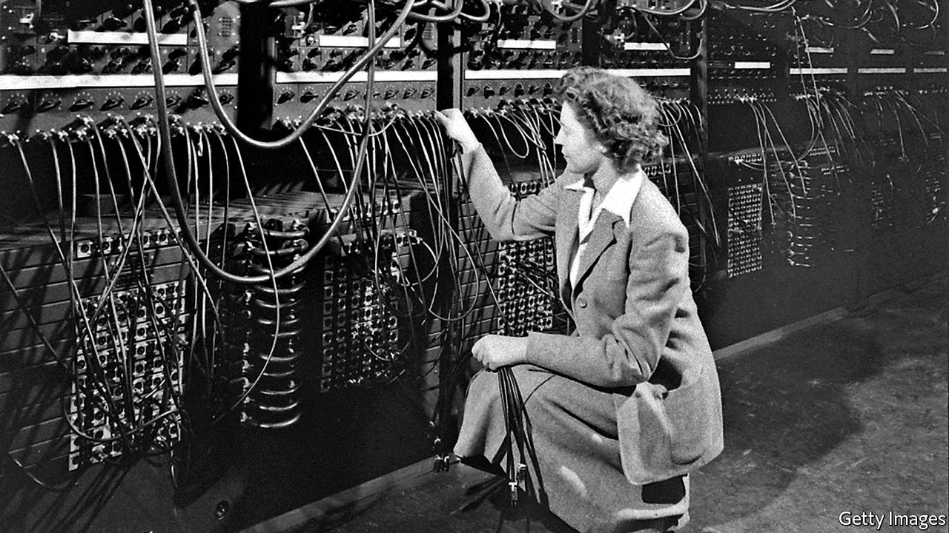

## Digital plurality

Kudos to The Economist for sticking to using data as a plural (“[Data, data everywhere](https://www.economist.com/finance-and-economics/2020/02/27/rethinking-how-we-value-data)”, February 29th). Although I don’t understand why there is a grammatical quarrel over this, I have found myself for years having to correct the young scientists I’ve mentored. While we’re on the topic, bacteria and sera are also plurals, the singular forms being bacterium and serum (also media/medium, in contexts other than the media world The Economist inhabits).

GEORGE CROSS  
New York

This article was downloaded by calibre from <https://www.economist.com/letters/2020/03/19/letters-to-the-editor>

|  |  |  |  |
| --- | --- | --- | --- |
|  | Articles | Sections | Next |

|  |  |  |
| --- | --- | --- |
| Letters | Sections | United States |

Briefing

The pandemic: The lockdown and the long haul

.

The economic emergency: Experimental treatment

.

|  |  |  |
| --- | --- | --- |
| Letters | Sections | United States |

|  |  |  |  |
| --- | --- | --- | --- |
|  | Articles | Sections | Next |

#### The lockdown and the long haul

# In Europe, and around the world, governments are getting tougher

But what happens when restrictions slip?

Mar 19th 2020 | BEIJING, BERLIN, MADRID, PARIS AND SEOUL



SOMETIMES PEOPLE can be a bit of a disappointment to their politicians. On March 12th Emmanuel Macron, addressing the French nation on the fight against covid-19, appealed to their sense of “national solidarity”. In asking them to follow basic health advice and stay at home as much as possible, the president said, he was counting on their “individual and collective discipline”. Individually and collectively, much of the country went on to spend a rather sunny early spring weekend wandering around parks with friends and shopping in crowded street markets. Mr Macron returned to their television screens on March 16th singularly unimpressed. “Not only are you not protecting yourselves,” he admonished the nation: “You are not protecting others.”

And so the state stepped in. From midday on March 17th onwards, everyone leaving home required a signed attestation—hand-written, or printed out from the interior ministry’s website—that they were on essential business: shopping for food or basic necessities, attending medical appointments, or going to a job that cannot be done from home. Cafés, restaurants, cinemas, nightclubs, museums and sports centres are all closed. Only food shops, pharmacies, banks, newsagents, petrol stations and—the irony—tobacco shops remain open. There are 100,000 police officers and gendarmes on the streets keeping an eye on things; on March 18th they issued 4,095 fines. Mr Macron has also mobilised the army. It is not a lockdown on the scale of Italy’s (see [article](https://www.economist.com/europe/2020/03/19/italys-death-toll-could-soon-surpass-chinas)); but it was a step change in the country’s response.

A couple of hours before Mr Macron spoke, Boris Johnson, the British prime minister, took a newly tough line, too, though from a more lax starting point. No self-printed papers, or for that matter, enforced closures—but a directive to stay away from both the office and the pub, and a clear steer that further restrictions could be coming in pretty short order. On the same day Angela Merkel, the German chancellor, issued a series of “guidelines” that aimed to level up the various limits on physical interaction that had been imposed by the country’s different states. Spain had moved more quickly. At a seven-hour cabinet meeting on March 14th, its coalition government approved a decree putting the whole country into a 15-day state of emergency.

It seemed that over the weekend—the Ides of March, as fate would have it—Europe had woken up to the sheer scale of the crisis which it faced: so, to some extent, did President Donald Trump’s administration (see article). In part, this was another example of a cognitive phenomenon that SARS-COV-2, the virus which causes covid-19, has been provoking around the world: exponential whiplash. Knowing in principle that something may take only a few days to double in size does little to prepare you for the experience of being continually behind the ever-steepening curve such doubling creates.

On the day of Mr Macron’s first speech, France had seen 2,281 covid cases and suffered 48 deaths. Six days later, on March 18th, those numbers had more than tripled, to 9,043 and 148 respectively. In Spain they were 13,910 and 623, in Italy 35,713 and 2,978. Over the week to the 18th the EU and Britain acknowledged around 62,000 new cases of covid-19, 2.6 times the number seen in the rest of the world. Europe’s cumulative caseload now exceeds China’s. In terms of its rapidly evolving responses, too, Europe seems now to lead the world. And it is leading it into lockdown.

But if general exponential whiplash was the bulk of the explanation, in Britain a model of the epidemic produced by epidemiologists at Imperial College in London played a particular role. Earlier versions had been circulating in the corridors of power for a while (as covid-19 may have been doing, too; on March 18th the study’s lead author, Neil Ferguson, isolated himself with a cough and a fever). Published on March 16th, it is now proving influential elsewhere, too.

The Imperial modellers adapted a model originally developed for influenza outbreaks. They assumed that the time from infection to symptoms, among those who showed symptoms, would be about five days; that people without symptoms would be somewhat infectious, but less so than people with symptoms; that people would vary in how infectious they get. They assigned covid-19 a “basic reproduction number” of 2.4. This means that in a population not taking any precautions, and where no one is immune, each case leads, on average, to 2.4 secondary cases.

Under those conditions the model showed the disease infecting 80% of the British population in three to four months. If 4.4% of the people infected became ill enough to be hospitalised and 30% of those deteriorated to the point of needing intensive care, then by mid-April demand for beds in intensive-care units (ICUs) would outstrip the health service’s “surge” capacity. In May the number of critical patients would be more than 30 times the number of ICU beds available. Estimates of the fatality rate in China range from 0.5% to 1.5% of infections. Using a conservative 0.9% for Britain, the model put the death toll by the end of the summer at over half a million.

The 4.4% hospitalisation rate was generated by breaking figures from China down by age cohorts and applying those age-specific rates to Britain’s population structure. This makes the numbers bigger. In China only 12% of the population is over 65; in Britain the proportion is 19% (in America, which the team also looked at, it is 17%). In continental countries you would expect the number to be bigger still; 23% of Italians are over 65, as are 22% of Germans.

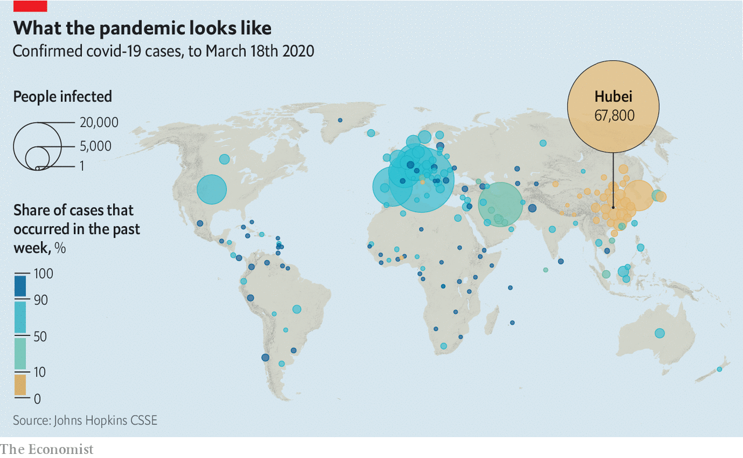

The model’s most striking message, though, was not this worst-case scenario: it was how small the effects of less-than-wholehearted interventions appeared to be. Imposing isolation on people with symptoms of the disease, quarantine on their households and protecting the elderly through social distancing—broadly speaking, the sum of British government advice as of last week—cut the height of the epidemic’s peak by two-thirds and pushed it from May to June. But the demand for beds still outstripped the supply by a factor of eight, and the death toll still reached the hundreds of thousands.

Extending social distancing from the over-70s to the whole population, though—a lockdown along the lines of Mr Macron’s, or of what is being seen in Italy—made a big difference. The peak of the disease outstripped the NHS’s surge capacity by just a factor of two. And it was delayed until July or August. That is a time-frame over which increasing that capacity is clearly plausible. It might also allow the change of the seasons to nibble away at the disease’s reproductive number.

## ¡No pasarán!

Because cases of covid-19 have already appeared in hot places such as Saudi Arabia and Singapore—not to mention Australia, where it is currently the end of summer—some experts have dismissed the idea that it may be at its worst in winter. But there remains hope that the change in the seasons may slow its spread. In early March Chinese scientists circulated a preprint looking at how air-temperature and humidity influenced transmission in 100 Chinese cities, and controlling for population density and wealth, they concluded that transmission became a little less likely when the weather was hotter and more humid. Summer and rainy seasons may not help a lot—but they could help a bit.

The Imperial results shaped the British government’s new plans: everyone to work from home if they can, no travel for fun, no “unnecessary” visits to care homes, avoid pubs, restaurants, theatres and the like, quarantines of 14 days for households where someone develops symptoms.

This still did not put Britain quite on a par with its neighbours (see chart 1). In Spain the state of emergency has closed all schools and universities, and almost all non-food shops except dry-cleaners, pharmacies and, again, tobacconists. The number of travellers on the Madrid metro on March 18th was 15% of what it usually is, and parks and promenades in the capital are sealed off. Thousands of madrileños who, given lovely weather and clear indications of restrictions on the way, had headed for their beach houses at the weekend promptly found themselves confined by the regional government of Murcia. The state of emergency—which will need parliamentary approval to continue for more than 15 days—allows the government to requisition the facilities of private hospitals and to take over hotels, too. It has already taken over two in Madrid.

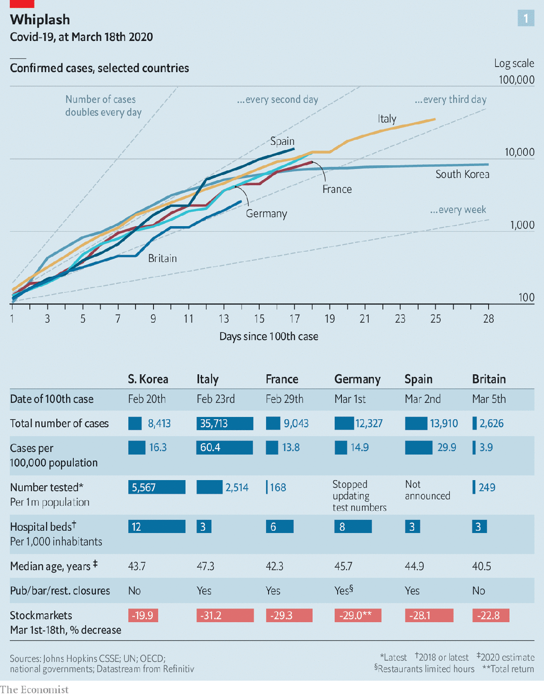

Mrs Merkel’s guidelines of March 16th called for most retail outlets to close and for the shops staying open to do so on Sunday, when trading restrictions normally keep almost everything shut. Bars and clubs are closed. In Berlin police went door-to-door in Neukölln and Kreuzberg ordering patrons to drink up. Theatres, concert halls, museums, cinemas, exhibition halls, gymnasiums, swimming pools and casinos have all been closed, as have Germany’s many legal brothels. Hairdressers, though, remain open.

The hairdressers of Spain were initially granted the same privilege, but it was revoked. That said, the Spanish can still go to church services, though with precautions, whereas Germany’s churches and mosques are closed. The Church of England has voluntarily brought an end to public worship, too. As for secular religions, all Europe’s major football leagues have put games on hold until April, and the hiatus is likely to be a lot longer. This summer’s international Euro 2020 tournament has been put off until 2021 (as has the Copa América, which was to take place in Colombia and Argentina). The Glastonbury festival has been cancelled; so will much of the summer be.

Not all the steps being imposed are well supported by evidence. Size limits on smaller gatherings—Austria, which is imposing some of the strongest rules, wants no more than five people together at a time—are open to question. Anastasia Pharris of the European Centre for Disease Prevention and Control, the EU’s public-health agency, says she knows of no data supporting specific cut-offs for gathering-size with regards to covid-19 transmission.

Politicians also seem much keener on banning international travel than epidemiologists are. The World Health Organisation does not recommend broad international travel restrictions, or the closure of borders. But on March 17th the EU banned non-essential travel into the bloc for 30 days (see article)—at the same time that other countries, from India to America, have banned non-citizens arriving from the EU. Experts agree cordons sanitaires around whole regions will make no difference to the epidemics in individual countries at this point.

Perhaps the most interesting area of divergence has been school closures. For continental countries, they were among the first controls to be put in place, as they have been worldwide (see article). It was not until March 18th that first Wales, then Scotland and finally England said they would close theirs, too.

## Be careful of Grandma

How useful this will be will vary from place to place. School closures make most sense in societies where old people spend a lot of time with children and young people and disrupting those ties is hard. Italy, where about two-thirds of adults aged 18-35 live with their parents, and many houses contain three generations, is a case in point. At the same time, closing schools means parents have to find someone else to look after their children or do it themselves. In 2009 researchers at the Brookings Institution, an American think-tank, estimated that closing schools and nurseries for a month would cost America somewhere between 0.1% and 0.3% of GDP. And if the parent works in health care, the losses will be more than financial. The Brookings paper estimated that between 6% and 19% of health-care workers would have to stay at home during a school closure; the English closures allow for the children of health-care workers to continue to go to school.

There is also the question of when to introduce such closures. In the Imperial modelling the closure of schools and universities has a prompt, if not overwhelming, effect. But they also have a delayed cost. This is because of the effect they have on the second wave of the disease.

Interventions which suppress the reproduction number save a lot of lives. But they do not make the population immune to the disease. So if you relax the interventions, thus letting the disease’s reproduction number rise back up, it will promptly set about infecting the large pool of people it missed the first time round.

The model from Imperial showed this well-known effect in action. After its five months of restrictions were brought to a close, a second wave started to build in late autumn. When the model was run with schools and universities closed down at the beginning of the first outbreak, this second wave was considerably worse, because immunity built up through infection-in-the-course-of-education was absent (see chart 2).

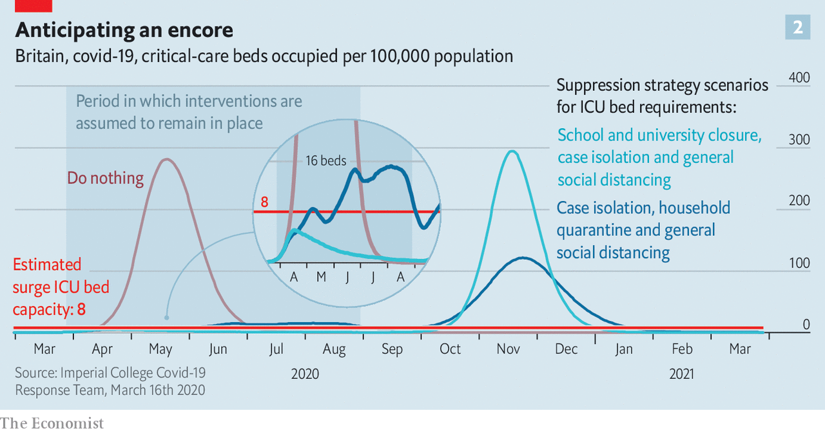

Concerns about a second wave are one of the reasons that governments cannot reassure citizens over just how long the disruption to normal life will continue, instead bandying about “the time beings” and “coming weeks and months”. Few are as open as the Robert Koch Institute, a German government health agency, in saying that, in extremis, tough restrictions may need to remain in place until a vaccine can be made, tested and put into use—a period it sees as lasting up to two years.

Even if governments were forthright about how long they expected their impositions to last, it is not clear that the decision will be theirs to make. In free societies the duration will, in practice, depend on how compliant people are, and for how long. The team at Imperial reckons that, if their measures are to show the desired results, compliance with each of those measures must be at least 50-75%. In the early days that may be possible: the chastened and fined French will not be out in the same numbers over the coming weekend as they were over the previous one. And as hospitals start to fill and then overflow, fear may increasingly add its weight to government say-so and social stigma. Still, good behaviour does tend to wear off.

South Korea started to take social distancing seriously long before Europe did, telling the citizens of Daegu and Gyeongbuk, two early hotspots, to stay at home in the middle of February and those of metropolitan Seoul to do so in early March. Public spaces emptied out. This was not the only factor in the country’s apparent success in containing the disease. A huge amount of testing and contact tracing, as is now being implemented in Italy, has been crucial. But it helped. However there is some evidence that people may be becoming more restive. Use of the Seoul metro has ticked up a bit.

No government other than the most repressive will believe it can keep its country on lockdown for months on end—and even if it could, the economic effects would be intolerable. China, having instituted a draconian lockdown, has, now that new cases are rare, begun to ease some restrictions where it can. A couple of provinces that were not badly affected are starting to re-open schools. In Beijing, by contrast, the rules have tightened since orders went out to protect the capital from imported infections. Office buildings are open, but tenants must show that their workplaces are not too crowded; some are allowing only a half or a third of their staff in at any one time. Guards with loud hailers count shoppers in and out of markets and chide those who stand less than a metre apart.

## And next time?

Citizens must wear masks to go outside; after weeks of shortages these can now be found, but at a price. In Hong Kong, where there were admittedly very few cases, the ubiquitous masks are the only indication that the city is not quite back to normal—whether you are on the as-crowded-as-usual metro or at a rave, there is not an unshielded nostril to be seen.

Epidemiologically, these places have, in a way, returned to the tail end of 2019. Just as the world did then, they face a new pathogen to which the population has no immunity. But now they are forewarned. They know about SARS-CoV-2, and no longer see a need to try to deny its existence; they know how to react should it rear its head, and are ready to do so. The emphasis is thus not on suppression, but on hygiene and surveillance.

China is using a variety of smartphone apps to facilitate this. In Shanghai QR codes are used to determine whether a person can be admitted to a building, or even the city—and to provide a detailed contact history should that person later be found to have become infected. Each subway car has its own QR code to be scanned when you get on. If one of the passengers gets sick, only that car, rather than the whole train, needs to be contacted.



Citizens of other countries might be willing to tolerate such surveillance if they really believed it was temporary. One thing that might make it so would be better treatment. Drugs do not make people immune to disease; but if severe cases could be treated more effectively, there would be much less to fear about letting people circulate quite freely. On March 17th Chinese doctors reported that Avigan (favipiravir), a drug used against influenza in Japan, led to clinical improvements in patients. The day before a drug called hydroxychloroquine jumped to prominence after a small, unrandomised trial. Results from large trials of remdesivir, an antiviral developed to tackle Ebola, are weeks away but eagerly anticipated.

Then there is the possibility of giving people immunity without requiring them to get the disease: that is, vaccination. The first genome sequence for SARS-CoV-2 was published on January 10th. The next morning Sarah Gilbert, a virologist at Oxford University, headed straight for her laboratory to see what she could do to turn that sequence into a vaccine—as did hundreds of others at dozens of institutions and companies.

Adrian Hill, a professor at Oxford, says that in general terms “six months from sequence to vaccination is very doable if the right vaccine technology is used”. That means vaccines could be in efficacy tests by summer. There is a risk that they will not work; some microbes, such as HIV and malaria, have proved resistant to being impersonated by vaccines for decades. But other cases—such as that of Ebola—have been comparatively easily cracked.

Suppression strategies may work for a while. But there needs to be an exit strategy—be it surveillance, improved treatment, vaccination or whatever. If governments impose huge social and economic costs and the virus cuts a swathe through the population a little later, they will discover that when politicians disappoint the people over something this serious there is hell to pay. ■

This article was downloaded by calibre from <https://www.economist.com/briefing/2020/03/19/in-europe-and-around-the-world-governments-are-getting-tougher>

|  |  |  |  |
| --- | --- | --- | --- |
|  | Articles | Sections | Next |

|  |  |  |  |
| --- | --- | --- | --- |
| Previous | Articles | Sections | Next |

#### Experimental treatment

# Governments are spending big to keep the world economy from getting dangerously sick

The help is targeted at companies and individuals. More will be needed

Mar 19th 2020 | BERLIN, SHANGHAI AND WASHINGTON, DC

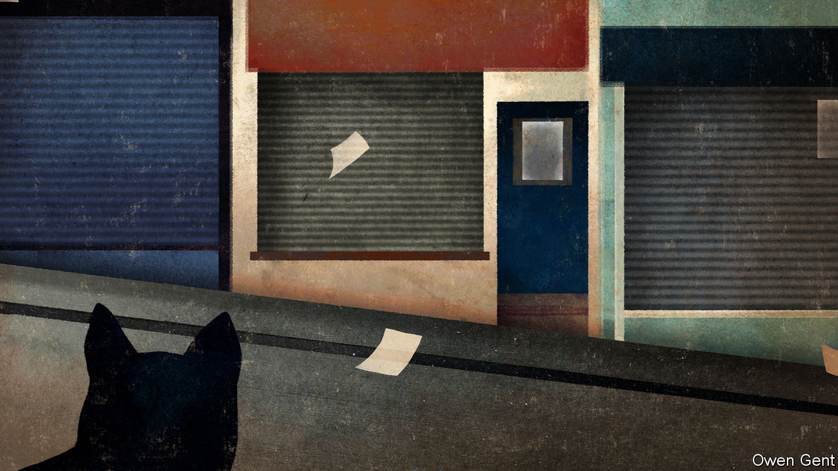

A CHARACTER IN a novel by Ernest Hemingway once described bankruptcy as an experience that occurs “two ways: gradually, then suddenly”. The economic response to the covid-19 pandemic has followed this pattern. For weeks policymakers dithered, even as forecasts for the likely economic damage worsened. But in the space of just a few days the rich world has shifted decisively. Many governments are now on a war footing, promising massive state intervention and control over economic activity.

The new phrase on politicians’ lips is “whatever it takes”—a line borrowed from Mario Draghi, president of the European Central Bank (ECB) in 2011-19. He used it in 2012 to convince investors he was serious about solving the euro-zone crisis, and prompted an economic recovery. Mr Draghi’s promise was radical enough. Politicians are now proposing something of a different magnitude: sweeping, structural changes to how their economies work.

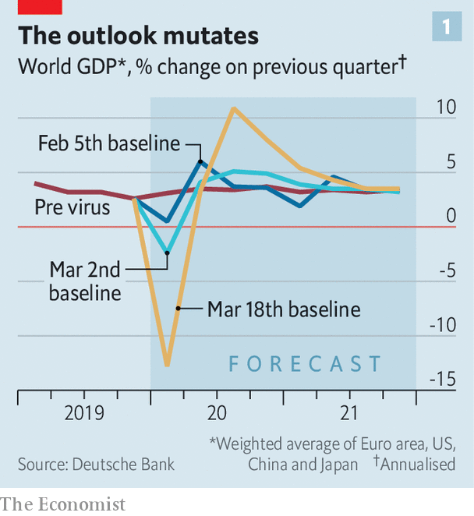

There are unprecedented promises. On March 16th President Emmanuel Macron of France declared that “no company, whatever its size, will face the risk of bankruptcy” because of the virus. Germany pledged unlimited cash to businesses hit by it. Japan passed a hastily compiled spending package in February, but on March 10th supplemented it with another one that included over ¥430bn ($4bn) in spending and almost four times as much in cheap lending. Britain has said it will lend over £300bn (15% of GDP) to firms. America may enact a fiscal package worth well over $1trn (5% of GDP). The most conservative estimates of the total extra fiscal stimulus announced thus far put it at 2% of global GDP, more than was shovelled out in response to the global financial crisis of 2007-09.

## That sinking feeling

In part this radical action is motivated by the realisation that the coronavirus, first and foremost a public-health emergency, is also an economic one. The jaw-droppingly bad economic data coming out of China hint at what could be in store for the rest of the world. In the first two months of 2020 all major indicators were deeply negative: industrial production fell by 13.5% year-on-year, retail sales by 20.5% and fixed-asset investment by 24.5%. GDP may have declined by as much as 10% year-on-year in the first quarter of 2020. The last time China reported an economic contraction was more than four decades ago, at the end of the Cultural Revolution.

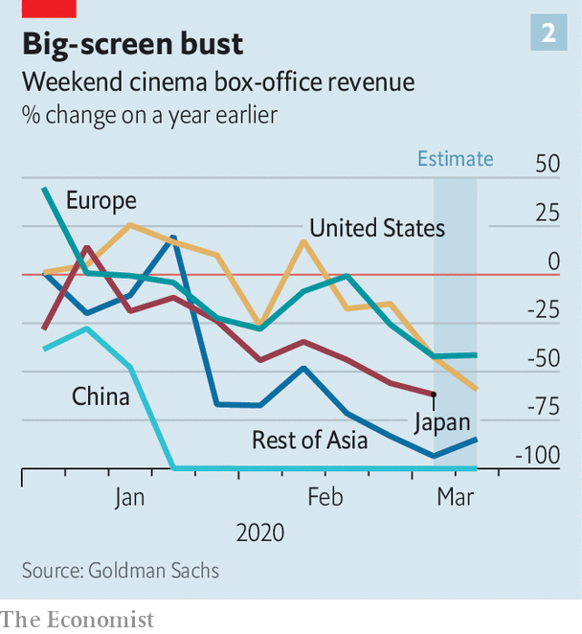

Grim numbers are starting to pile up elsewhere, not so much in the official statistics, which take time to be published, as in “real-time” economic data produced by the private sector. Across the world, attendance at restaurants has fallen by half, according to OpenTable, a booking platform. International-passenger arrivals at the five biggest American airports are down by at least 30%. Box-office receipts have crumpled (see chart 2).

The disruption to international travel will hurt trade, since over half of global air freight is carried in the bellies of passenger planes. The combination of disrupted supply chains and depressed demand from shoppers should hit trade far harder than overall GDP, if the experience of the last financial crisis is anything to go by. Already, the American Association of Port Authorities, an alliance of the ports of Canada, the Caribbean, Latin America and the United States, has warned that cargo volumes during the first quarter of 2020 could be down by 20% or more from a year earlier.

Official data are now starting to drip out. The Empire manufacturing index, a monthly survey covering New York state, in March saw its steepest drop on record, and the lowest level since 2009. In February Norway’s jobless rate was 2.3%; by March 17th it was 5.3%. State-level numbers from America suggest that unemployment there has been surging in recent days.

All this is fuelling grim forecasts. In a report on March 17th Morgan Stanley, a bank, estimated that GDP in the euro area will fall by an astonishing 12% year-on-year in the second quarter of the year. The Japanese economy is forecast to contract by 2% this quarter and 2% next. Most analysts see global GDP shrinking in the first half of the year, with barely any growth over 2020 as a whole—the worst performance since the financial crisis of 2007-09.

Even that is likely to prove optimistic. On March 17th analysts at Goldman Sachs noted that they had “not yet built a full lockdown scenario” into their forecasts for advanced economies outside Europe. Forecasts for America, which is at an earlier stage than Europe and Asia when it comes to the outbreak, remain Panglossian; very slow growth in China and a big recession in Europe could by itself be enough to send the world’s largest economy the same way. Steven Mnuchin, America’s treasury secretary, warned this week that the country’s unemployment rate could reach 20% unless Congress passes a stimulus package. A negotiating ploy? With shopping malls emptying, factories grinding to a halt and financial markets buckling, lawmakers may be loth to challenge the claim.

Despite stomach-churning declines in GDP in the first half of this year, and especially the second quarter, most forecasters assume that the situation will return to normal in the second half of the year, with growth accelerating in 2021 as people make up for lost time. That judgment is in part informed by China’s experience. More than 90% of its big industrial firms are officially back in business. Its stockmarket had been one of the world’s worst performers in early February but is now the best (or rather, least bad). There remains, however, a risk that global containment and suppression of the virus will need to continue for a year or longer. If so, global economic output could be dragged down for much longer than most people expect.

Perhaps the greatest lesson of the global financial crisis was that it paid to act decisively and to act big, convincing markets and households that policymakers were serious about countering the slump. If done right, central banks and governments can end up doing a lot less than they actually promised. A pledge to bail out banks makes it less likely savers will withdraw deposits and make a rescue necessary.

This time around, central banks sprang into action. Since February the Federal Reserve has cut interest rates by 1.5 percentage points. Other central banks have followed suit. Further deep rate cuts are not possible, though; interest rates were very low long before the virus began to spread.

## Let’s get fiscal

Not all central banks are acting as boldly as they can. China has room to cut interest rates—its benchmark rate is 1.5%—but has held back in part because inflation is quite high (largely as a result of African swine fever, which hit pig stocks, raising prices). Central banks could try more creative policies. On March 19th the ECB’s governing council agreed to launch a €750bn bond-buying programme, covering both sovereign and corporate debt. But the real action is now taking place on the fiscal front.

Governments are falling over each other to offer bigger and better stimulus packages. All countries are spending more on health care, both in an effort to find vaccines and cures and to increase hospital capacity. However, the bulk of the extra spending is on companies and people.

Take companies first. China, where the outbreak has slowed, is now trying to get people out and buying things. Foshan, a city in Guangdong province, has launched a subsidy programme for people buying cars. Some cities have started giving out coupons that can be spent in local shops and restaurants. Nanjing this month gave out e-vouchers worth 318m yuan ($45m).

Most countries, however, are in or about to enter the worst part of the outbreak. As customers dry up, many firms will go bust without government help. Calculations by The Economist suggest that 40% of consumer spending in advanced economies is vulnerable to people shunning social situations. Firms in leisure and hospitality are especially rattled. The Moor of Rannoch hotel, in about as rural a part of Scotland as it is possible to find, says its insurer will not be paying out a penny for lost custom, since covid-19 is a new disease and thus not covered under its policy.

One approach is to reduce firms’ fixed costs, largely rent and labour. China’s finance ministry will exempt companies from making social-security contributions for up to five months. The government has also temporarily cut the electricity price for most companies by 5% and enacted short-term value-added-tax cuts. The British government has extended a one-year business-rates holiday to all companies operating in the retail, hospitality and leisure sectors. Yet for many firms, no matter how much the government helps them reduce costs, revenues are likely to fall further.

So measures may be needed to allow firms to maintain cashflow. Many banks are offering hefty overdrafts to tide corporate clients over. To encourage banks to keep lending, Britain has promised them cheap funding and state guarantees against losses. For very small firms, many of which do not borrow at all, it is offering non-repayable cash grants of up to £25,000.

Other countries are enacting similar plans. The Japanese government is helping small firms by mobilising its state-owned lenders to provide up to ¥1.6trn of emergency loans, much of it free of interest and collateral requirements. Small firms qualify for help if their monthly sales fall at least 15% below a normal month’s takings. Bavaria, a rich state in Germany, announced on March 16th that small and medium-sized companies with up to 250 employees could receive an immediate cash injection of between €5,000 and €30,000. The European Commission has already relaxed state-aid rules so that governments can channel help to ailing companies.

The second part of the fiscal response is about helping people, and in particular protecting them from being made unemployed or suffering a drastic drop in income if that does happen. Ugo Gentilini of the World Bank counts more than 25 countries that are using cash transfers as part of their economic response to the virus. Brazil will give informal workers, who make up roughly 40% of the labour force, 200 reais ($38) each. Small businesses will be allowed to delay tax payments and pensioners will get year-end benefits early. Australia is instituting a one-time cash payment of A$750 ($434) to pensioners, veterans and people on low incomes.

Northern Europe has led the way on implementing policies that make it less likely firms lay off workers. Germany has relaxed the criteria for Kurzarbeit (“short-time work”), under which the state pays 60-67% of the forgone wages of employees whose hours are reduced by struggling firms. Applications are going “through the roof”, according to the federal labour agency. The use of Kurzarbeit probably halved the rise in unemployment during the recession of 2008-09. More firms are now eligible to use it, temporary workers are covered, and the government will also reimburse the social-security contributions companies make on behalf of affected workers.

## Bringing home the Danish bacon

In Denmark firms that risk losing 30% or more of their workforce will see the government pay 75% of the wages of employees who would otherwise be laid off, until June. Norway’s government has beefed up unemployment benefits, guaranteeing laid-off workers the equivalent of their full salary for the first 20 days. Freelancers whose work vanishes for more than a fortnight will get payments equivalent to 80% of their previous average income. In Sweden the state will cover half of the income of workers who have been let go, with employers asked to cover most of the rest.

So far America has passed more modest legislation. Federal funding for Medicaid, which provides health care for the poor, is likely to boost spending by about $30bn, assuming it remains in place until the end of December, reckons Oxford Economics, a consultancy. America also has a new paid-sick-leave policy for some 30m workers, including 10m who are self-employed, worth just over $100bn. But in that regard America is merely catching up with other rich countries, which have far more generous sick-leave policies. America also has fewer automatic economic stabilisers, such as generous unemployment insurance, than most other rich countries. As a result, its discretionary fiscal boost needs to be especially large to make a difference.

It might be. The Trump administration’s plan to funnel money directly to households, if approved by Congress, is the most significant policy. It bears some resemblance to a scheme that was introduced in February in Hong Kong, in which the government offered HK$10,000 ($1,290) directly to every permanent resident. Mr Mnuchin is thought to favour a cheque of $1,000 per American—roughly equal to one week’s average wages for a private-sector worker—with the possibility of a second cheque later. Some $500bn-worth of direct payments could soon be in the post.

Some economists are leery about such a policy. For one thing, it would do little to prevent employers from letting people go, unlike the plans in northern Europe. Another potential problem, judging by Hong Kong’s experience, is administration of the plan: the territory’s finance secretary hopes to make the first payments in “late summer”, far too far away for people who lost work last week. Mr Mnuchin promises that payments will happen much sooner.

## Chequered past

America has done something similar before, with results that were not entirely encouraging. The government sent out cheques in both 2001 and 2008 to head off a slowdown. The evidence suggests that people saved a large chunk of it. The psychological reassurance of a bit of extra cash could be significant for many Americans, but the sums involved are not especially impressive. Bernie Sanders, a Democratic presidential contender, is not known for his smart economic policymaking, but his suggestion of $2,000 per household per month until the crisis is over is probably closer to what is required.



Indeed, more fiscal stimulus will be needed across the world, especially if measures to contain the spread of the virus fall short. After the Japanese government passes the budget for next fiscal year at the end of this month, it can begin work on a supplementary budget that takes the virus into full account. Britain’s Parliament has given Rishi Sunak, the chancellor of the exchequer, carte blanche to offer whatever support he deems necessary, without limit.

How much further can fiscal policy realistically go? Last year the 35-odd rich countries tracked by the IMF ran combined fiscal deficits of $1.5trn (2.9% of GDP). On the not-unrealistic assumption that the average deficit rose by five percentage points of GDP, total rich-country borrowing would rise to over $4trn this year. Investors have to be willing to finance that splurge. The yield on ten-year Treasury bonds, which had fallen as low as 0.5% as fears of the virus took hold and traders sought havens, has recently risen above 1%. This is probably due to firms and investors selling even their safest assets to raise cash, but might reflect some anxiety over the scale of planned government borrowing.

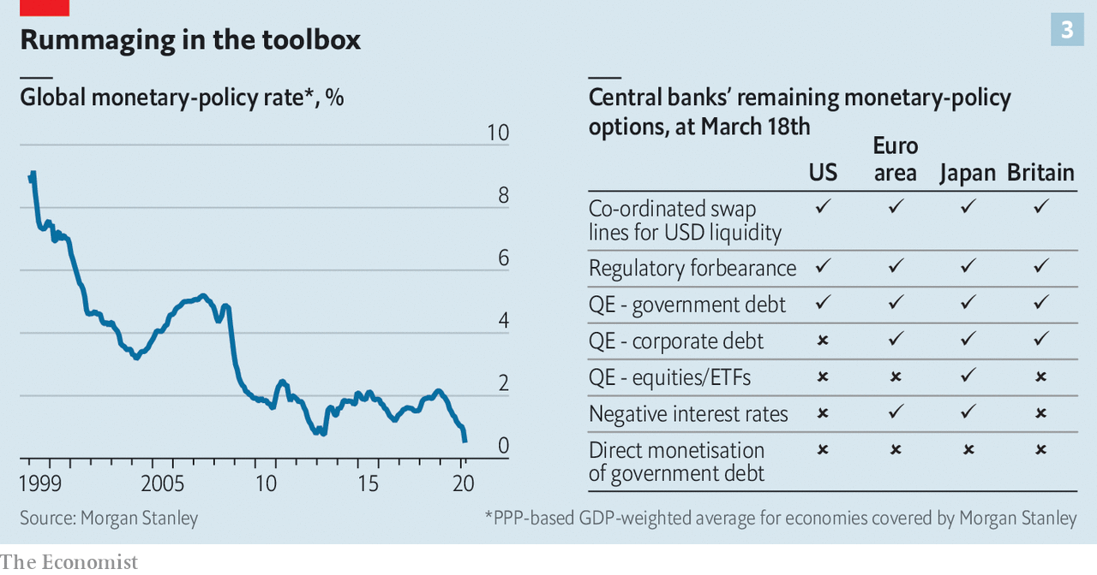

Still, 1% is still extremely low by historical standards. For a variety of reasons, including population ageing, there is—in normal times, at least—unprecedented demand for low-risk government securities. The Bank of Japan has promised to buy as many bonds as necessary to hold the yield on its government’s ten-year bonds close to zero. Investors remain queasy over some rich countries’ bonds, especially slow-growing European states. The ECB’s latest intervention should allow heavily indebted economies viewed with suspicion by markets, such as Italy, to borrow more cheaply—though it does not fully dispel doubts around the euro zone’s willingness to act to avert crisis.

The question of financing the spending splurge may be more one of practicalities than of feasibility. America’s Treasury cannot issue trillions of dollars of new bonds overnight. It can, however, issue notes and bonds to the Federal Reserve, which could then credit the Treasury’s account, allowing vast sums to be spent immediately, points out Ian Shepherdson of Pantheon Macroeconomics, a consultancy. The bonds could then be sold to investors at a later date. This approach amounts to money-printing, but with little risk of runaway inflation in these straitened times.

The economic hit from covid-19 will be bad enough for rich countries, in both human and economic terms. But they are in a relatively fortunate position, with strong health-care systems, and investors who, for now, remain willing to lend to them on cheap terms. Poorer countries, where the threat posed by the virus is also growing rapidly, have less room to borrow and job markets with a higher share of informal workers who are ineligible for many protections. The rich world faces tough times, but will get through the crisis. The prospects of poorer places are far less certain. ■

This article was downloaded by calibre from <https://www.economist.com/briefing/2020/03/19/governments-are-spending-big-to-keep-the-world-economy-from-getting-dangerously-sick>

|  |  |  |  |
| --- | --- | --- | --- |
| Previous | Articles | Sections | Next |

|  |  |  |
| --- | --- | --- |
| Briefing | Sections | The Americas |

United States

Responding to covid-19: In sickness, not in health

.

The 2020 population count: Census and sensibility

.

The Democratic primary: Electoral distancing

.

Families: Little gay house on the prairie

.

The Bible museum: A load of old cobblers

.

Lexington: Pandemic polarisation

.

|  |  |  |
| --- | --- | --- |
| Briefing | Sections | The Americas |

|  |  |  |  |
| --- | --- | --- | --- |
|  | Articles | Sections | Next |

#### Responding to covid-19

# American life has been transformed in a few short weeks

The next few will be even tougher

Mar 19th 2020 | WASHINGTON, DC

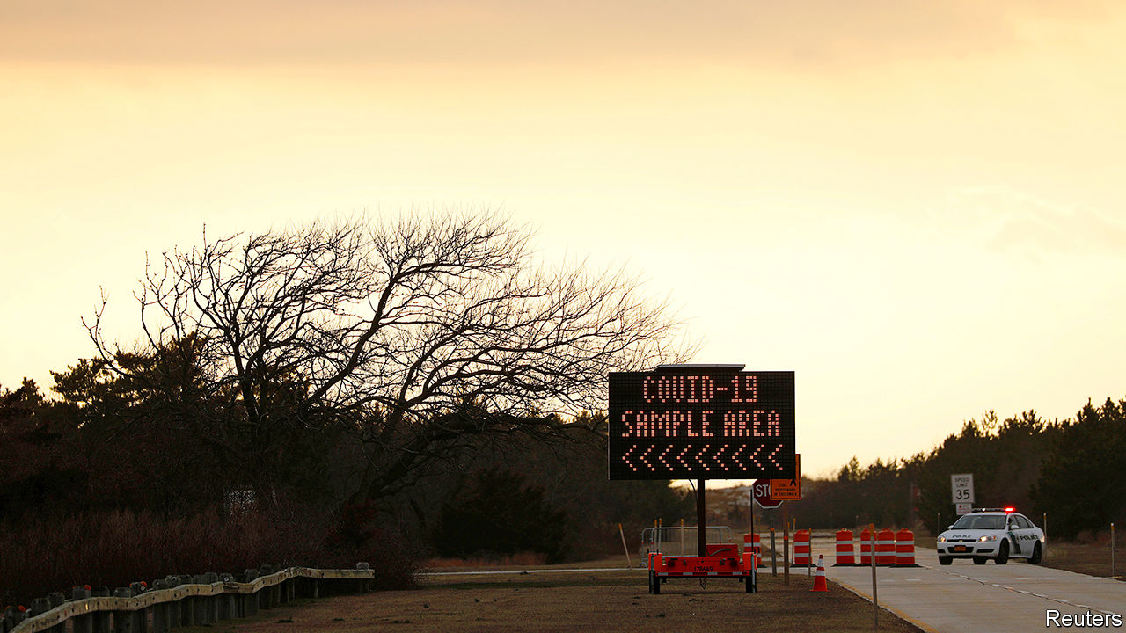

THE TITULAR conceit of “28 Days Later”, as with many contagion-style horror films, is of a man waking up after a month-long coma only to find society upended by a rampaging virus. Many Americans are experiencing something similar. On March 3rd there were just 122 confirmed cases of covid-19—the disease currently sweeping the world—and only seven deaths. By March 17th there were 7,786 confirmed cases (even these were a sure underestimate given the dearth of testing) and 118 deaths. Twenty-eight days later, on March 31st, what might America look like?

“We don’t know whether we’re going to look like Italy or the provinces outside Hubei” in China where the spread of covid-19 was fairly effectively contained, says David Blumenthal, president of the Commonwealth Fund, a health-policy think-tank. “But the likelihood is—given the slowness with which we responded to the epidemic—that we look more like Italy,” he adds. Jerome Adams, the surgeon-general, has warned of the same.

Can America’s health system cope? The structural problems that make pandemic response more difficult—lack of paid sick pay, a large uninsured population and a significant number of insured people nonetheless worried about out-of-pocket medical bills—cannot be mended overnight. Instead, public-health experts and doctors are increasingly worried about sheer capacity constraints. In China, 5% of those diagnosed needed intensive care. There are roughly 97,000 beds in intensive care units (ICUs), of which one-third are empty. Though America has relatively few total hospital beds per person compared with other countries, it ranks among the highest for ICU beds per person, with nearly three times as many as Italy.

“The real limiting factors are likely to be the ventilators or the staff,” says Greg Martin, a professor of medicine at Emory University and president-elect of the Society of Critical Care Medicine. There are roughly 50,000 physicians trained in critical care and 34,000 similarly specialised nurses and assistants. This could be insufficient in the face of hundreds of thousands of cases at peak rates of infection.

Then there is the problem of kit. In China, half of those in critical care required the use of ventilators, machines that help people breathe. There are thought to be 62,000 full-featured mechanical ventilators in the country, many of which are already in use (see article). Older stocks of perhaps 100,000 devices—including CPAP machines used for those with sleep apnea—could be called upon if needed, but would provide only basic functions. Ramp-ups in ventilator production are being pondered, including through emergency powers given to the president under the Defence Production Act of 1950, but there has been little actual action yet. On a phone call with state governors, President Donald Trump urged “respirators, ventilators, all of the equipment—try getting it yourselves”, which could spark an unhelpful competition between states for scarce resources.

“Under almost any basic scenario, things look tough. Hospital beds will be completely full many times over if we don’t substantially spread the load,” warns Ashish Jha, director of the Global Health Institute at Harvard. To head that off, Mr Jha has called for an Italy-style national quarantine, lasting for at least two weeks, in which all non-essential businesses are closed and gatherings of more than five people are barred to give time for testing to become widespread. After a dismally slow start to testing, the numbers are finally heading up—although the best estimates come not from public-health agencies, but volunteer trackers using a Google sheet—to an estimated 12,535 tests conducted on March 17th. Given the expected scope of the disease, and the reported obstacles to people with symptoms actually getting tested, much more will be needed.

Most hospitals are making contingency plans. There are plans to add physical beds by cancelling elective surgeries that can be postponed, converting recovery rooms into added beds and building tents to house some patients. The Cleveland Clinic, a prominent hospital, says it has plans in place to add 1,000 beds of capacity within 72 hours if needed. Teams of doctors and nurses with other specialities could be conscripted into critical-care work, supervised by critical-care doctors who handle the trickiest cases—like respiratory distress coupled with organ failure in the kidneys or heart. If this is insufficient, recently retired doctors could be drafted into service. Some teaching hospitals are using simulation centres to prepare medical staff for the inevitable surge in cases.

## Testing? Testing?

Whether it will come to all this is still unclear. Testing capacity remains constrained, limiting the information epidemiologists have to feed both their models and their willingness to speculate. Their policy recommendations—social distancing, closure of schools and large gatherings—are nevertheless clear. One team of researchers has concluded that an epidemic resembling that of Wuhan, where the novel coronavirus first broke out, would overwhelm hospitals many times over, while one resembling Guangzhou, a city that locked down in the early days of the virus, could be dealt with.

On March 16th, however, a team of scientists based at Imperial College London, who have been advising the British government, also published forecasts of the epidemic’s trajectory in America. As with Britain, the figures look grim. Without any mitigation, America would experience 2.2m deaths, they predict (see Briefing). Even in the case of some mitigation—isolation of the sick, social distancing for the elderly, but an otherwise normal society—American hospital and ICU capacity would be exceeded eight times over, and the country would be on track for at least 1.1m deaths. Averting this through “suppression”—isolation of sick, closing of schools and universities, social distancing for everyone—would require months until therapeutics or vaccines can be developed.

America is therefore turning towards suppression of the virus. Millions of pupils and university students have been sent home and left to take classes online. Mr Trump has advised that people not congregate in gatherings of more than ten people. San Francisco and surrounding counties have issued a “shelter-in-place” order that requires 7m to remain in their homes unless necessary. New York City is expected to do the same for its 8m residents. In 22 states, bars and restaurants have been ordered to close their seating and only serve takeaway. The state of New York is setting up drive-through testing centres, starting in New Rochelle, a commuter town in Westchester County that was one of the early sites of a covid-19 cluster, and is urging federal troops to build emergency, temporary hospital facilities. New Rochelle’s mayor says he is surviving the lockdown there on “adrenalin, coffee and M&Ms”.

The goal is to increase general hospital capacity by a factor of two and ICU capacity by a factor of ten within two months. Elections have been postponed in a few states for the Democratic primary, which now seems a dull, distant affair. America’s devolved system means that the shuttering will happen at different rates in different places, but the trajectory is clear. “You want a single national response. But when the federal government completely fails, as it has so far, then you can get states and cities to step up,” says Mr Jha.

The question is how long this can go on for. Unmitigated, the epidemic would not peak for at least another three months. Suppression can reduce the spread of the disease, as China’s experiment with locking down most of its population showed, but relaxing these measures will inevitably bring another surge in cases. Mr Trump, who a few weeks ago was suggesting the virus was the latest hoax invented to damage him, is now warning that this could be the start of a months-long reorientation in American life. And while these extraordinary actions should smother the disease, they will also smother the economy.

The dismal economic forecasts will require further action from Congress. It spent the last week haggling over a bill that would make testing for the disease free, increase the flow of safety-net benefits and grant paid sick leave to more workers (though this provision appears to be hollowing out with every iteration). Even before that bill was finalised, Washington’s attention had already turned to the even bigger economic stimulus package that must come next. Senators, both Democrats and Republicans, are tripping over themselves issuing plans to send cash directly to American families.

The total package, which could be worth $1trn or more, dwarfs the $100bn-or-so bill recently signed into law and every other stimulus package in history. The Trump administration has proposed sending $500bn in direct cash to taxpayers, $300bn to keep firms afloat, and $200bn to bail out critical industries like airlines. The typical partisan bickering from Congress and even from Mr Trump has been muted. Every politician seems to now realise that the country faces an unprecedented crisis, first of public health and then of the economy, that will last for months. Whether this action will look sufficient 28 days later is, as with seemingly every aspect of the covid-19 pandemic, deeply uncertain.■

This article was downloaded by calibre from <https://www.economist.com/united-states/2020/03/19/american-life-has-been-transformed-in-a-few-short-weeks>

|  |  |  |  |
| --- | --- | --- | --- |
|  | Articles | Sections | Next |

|  |  |  |  |
| --- | --- | --- | --- |
| Previous | Articles | Sections | Next |

#### Census and sensibility

# Coronavirus disruption risks damaging the 2020 United States census

The data gathered will be used for a decade to distribute trillions

Mar 19th 2020 |

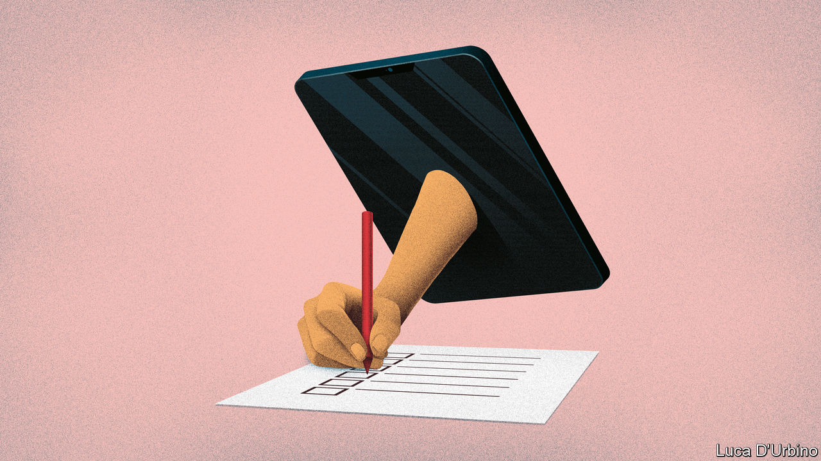

WHEN THE 2020 United States census, scheduled for April 1st, was planned, the areas of most concern were mapped. They include places like Deep East Texas, an area of 10,000 square miles north-east of Houston with a population of roughly 385,000 people. “We are a totally rural region,” says Lonnie Hunt, the director of the Deep East Texas Council of Governments (DETCOG), an intergovernmental agency. “We have economically distressed people, rural people, senior citizens, minorities—we check box after box after box.” In large parts of the region most people do not have internet access. Many live in places only accessible with four-wheel drives.

Counting everybody in Deep East Texas was never going to be easy. Now it looks like it may be near impossible. “The coronavirus has certainly complicated matters,” says Mr Hunt. To help ensure an accurate count, DETCOG had hired a dozen census co-ordinators to go out to community events—sports matches, church services, school sports days—with information to persuade people to send their returns in, and internet hotspots and iPads with which to do it on the spot. Most of those events are now being cancelled. With people staying indoors, they probably will not encounter any of the workers meant to explain to them the importance of the census and get them to fill it in.

The virus may represent the biggest threat to the United States census in its 230-year history. Mandated by the constitution, it is the world’s most expensive and among the world’s oldest consistent data-gathering operations. The results determine how many congressional seats and electoral-college votes are allocated to each state, and where those districts are. Roughly $1.5trn of federal money each year is spent according to data derived at least in part from census returns. It is not just the government that uses it. Firms use it to decide where to build supermarkets, target advertising or open factories. “Every nook and cranny of the private economy relies on census data,” says Andrew Reamer of George Washington University.

It is also a huge operation involving hundreds of thousands of workers travelling across the country knocking on doors. In 2010 a quarter of Americans were counted by workers in person. It is not only the door-knocking, which begins on May 13th, that may be threatened by the need for people to self-isolate. The televised sports events that advertising would have targeted, such as the March Madness college basketball games, are all being cancelled.

Even before the outbreak of the virus this year’s census was raising concerns. The census is meant to record every single person in America on the day it is held. But this year President Donald Trump’s government wanted to add a question to the census about citizenship. The question was struck down by the Supreme Court. But Nestor Lopez, an official from Hidalgo County along the Texas-Mexico border, says he worries many people, especially undocumented immigrants, still fear information gathered could be used against them. People “do not want to be answering anything from the federal government,” he says. In fact, personally identifiable data from the census cannot be revealed for 72 years, even to other government agencies. But most people do not know that. And now they may never hear otherwise.

So far the Census Bureau has only made modest changes. On March 18th the agency announced that all field operations are to be suspended until April 1st. On other surveys officials will make phone calls instead of visits. It has asked administrators of “group quarters”—institutions like nursing homes, prisons and college dormitories—to “choose a way to count their residents that requires less in-person contact”. But more radical adjustments may be needed. Terri Ann Lowenthal, a former director of the House committee that oversees the census, notes that the count takes ten years to plan, and “yet now the Census Bureau is being forced to make shifts basically on the fly”. On March 17th Brazil announced it would delay its census by a year. American officials might have to consider that, too.■

This article was downloaded by calibre from <https://www.economist.com/united-states/2020/03/19/coronavirus-disruption-risks-damaging-the-2020-united-states-census>

|  |  |  |  |
| --- | --- | --- | --- |
| Previous | Articles | Sections | Next |

|  |  |  |  |
| --- | --- | --- | --- |
| Previous | Articles | Sections | Next |

#### Electoral distancing

# Joe Biden builds an insurmountable lead

The former vice-president is way out in front in what looks like being a very odd campaign

Mar 19th 2020 | NEW YORK

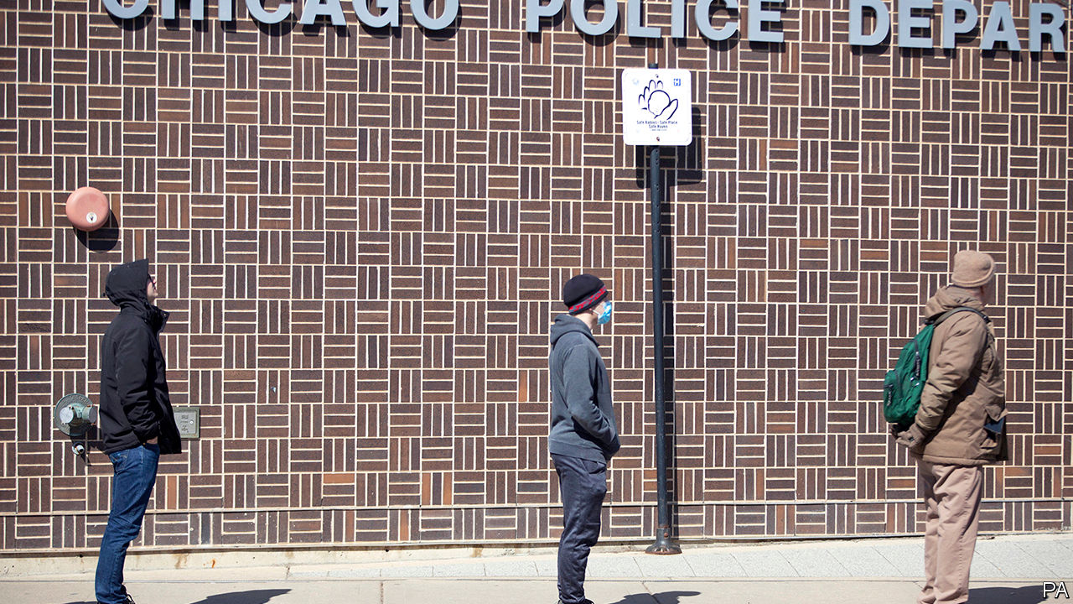

MAGNANIMITY IS A winner’s privilege, and the speech that Joe Biden delivered on March 17th was amply magnanimous. He told supporters of Bernie Sanders, whom he defeated in all three states voting that night, that he and his rival “may disagree on tactics, but we share a common vision”. Standing alone in his Delaware home behind a podium (a necessary piece of furniture for a candidate working from home), he praised first responders and poll-workers, consoled the bereaved and sounded more like a wartime president than a candidate. His victory in the primary is now all but assured. But what campaigning and voting will look like during the pandemic is anything but.

The most striking aspect of Mr Biden’s victory was its breadth. Arizona, Florida and Illinois collectively have 184 counties. Bernie Sanders won three of them, none by more than five points. He hoped that Latinos would buoy him in Florida, but lost the state by nearly 40 points. This may partly have been because of the weight of Cuban-Americans: Mr Sanders—in an act either of admirable principle or political lunacy—has repeatedly praised the accomplishments of the Castro regime. The picture was different in Arizona, which Mr Sanders lost by just 12 points. A greater proportion of Latinos there are Mexican, and many are recent arrivals; these groups tend to be more left-wing than Hispanics in Florida. And Arizona has a bigger Hispanic population than Florida: 30% of its residents are Latinos versus 23% in Florida.

Mr Sanders’s supporters, who have visions of turning Texas and Arizona Democratic, point to his strength with Latinos as a reason he should lead the party. The results on March 17th show that such thinking is flawed. There are more competitive electoral-college votes at stake in Florida, where Mr Sanders is much less popular. Such assertions also ignore general-election polls, which show Mr Biden beating Mr Trump in Arizona, but Mr Sanders losing. Besides, Mr Biden’s delegate lead now appears insurmountable. To win the nomination, Mr Sanders would need to win 64% of the remaining delegates. He is polling nationally at just 36%.

The Illinois primary, which Mr Biden won by 23 points, was marked by low turnout. Chicago election officials said at least 10% of 8,500 election judges—volunteers who oversee polling booths—had dropped out, fearful of viral contagion. Polling stations in Chicago had more bottles of hand sanitiser than walk-in voters. An official at one north-side site likened the dour public mood to the “start of world war two”.

Ohio, which Mr Sanders probably would have lost badly, was due to vote on March 17th, but the night before postponed its primary until June. Mike DeWine, the state’s Republican governor, said that people “mustn’t be forced to choose between their health and exercising their constitutional rights.” The state’s Supreme Court backed him in a pre-dawn ruling on polling day, leaving some voters rattling locked doors at polling stations as the sun rose.

Georgia and Louisiana, also Biden-friendly states due to vote in the coming weeks, pushed back their primaries too. Puerto Rico, due to vote on March 29th, looks likely to do the same (Maryland and Kentucky also delayed theirs). That would leave Alaska, Hawaii and Wyoming—all of which Mr Sanders could plausibly win—as the next states to vote, allowing the senator to spin a tale of comeback against the odds. Given how strong Mr Biden’s position is, though, few would believe it.

For some, the decisions to postpone voting, whatever their public-health merits, raised the spectre of Donald Trump doing something similar in November. He cannot cancel an election—that takes an act of Congress—or change the inauguration date, which is in the constitution. But a president could, conceivably, order polling places closed for public-health reasons, or take similar measures to depress turnout or discourage voting.

Tom Perez, who heads the Democratic National Committee, has urged states against peremptorily rescheduling primaries, and has instead asked them to adopt measures such as expanded absentee and postal voting, as well as longer voting hours, which would lessen the need to gather in crowds. Congress has also begun mulling how to conduct elections during a pandemic: Ron Wyden and Amy Klobuchar, two Democratic senators, introduced legislation on March 16th to make early in-person voting and voting by mail available everywhere (currently just 34 states let all voters have absentee or mail-in ballots).

However people ultimately vote, the campaign will be a much quieter affair for the next few months: no big rallies, debates before live audiences or working rope lines. That will no doubt annoy Mr Sanders, who is at his best exhorting large crowds. So is Mr Trump. If America remains locked down into autumn, he faces the prospect of either running for president without his trademark rallies, or asking his supporters to ignore the risks and gather anyway. ■

Dig deeper:

* Sign up and listen to Checks and Balance, our new [newsletter](https://www.economist.com/checksandbalance/) and [podcast](https://www.economist.com/podcasts/2020/02/21/checks-and-balance-our-new-weekly-podcast-on-american-politics) on American politics
* [Explore our guide](https://www.economist.com/united-states/2020/02/26/the-economists-guide-to-the-us-2020-elections) to the US 2020 elections
* For more coverage of covid-19 see our [coronavirus hub](https://www.economist.com/news/2020/03/11/the-economists-coverage-of-the-coronavirus)

This article was downloaded by calibre from <https://www.economist.com/united-states/2020/03/19/joe-biden-builds-an-insurmountable-lead>

|  |  |  |  |
| --- | --- | --- | --- |
| Previous | Articles | Sections | Next |

|  |  |  |  |
| --- | --- | --- | --- |
| Previous | Articles | Sections | Next |

#### Little gay house on the prairie

# Rural, gay Americans have more children

Why same-sex couples are more likely to be parents in Middle America than in big cities

Mar 19th 2020 | CHEYENNE



FOR MORE than a decade, America’s most prominent gay family have lived on ABC. Gay and lesbian television characters were once such a rare sight that GLAAD, an advocacy group, began an annual count, as if it were tracking an endangered species. Now millions tune in to “Modern Family” to see how Cam and Mitch are getting on raising their adopted daughter. Their portrayal of gay domesticity has been credited with helping to change attitudes and with boosting support for same-sex marriage. One poll found it was the third most popular show among Republican voters.

Yet such families are not only the preserve of Los Angeles, where the show is set. Indeed, though data are imperfect, academic studies suggest that a greater proportion of same-sex couples have children in southern states and in the Mountain West than on the coasts. Overall, more such families live in cities like Los Angeles and New York, since these have far higher gay populations. But same-sex couples who live inland seem most likely to plump for family life. Academics expect the results from the latest census, forms for which are due to land in mailboxes by March 20th, to fit the same pattern.

Take Wyoming. It has the fourth-lowest share of homosexual couples of all American states. Yet a quarter of them are raising children, compared with 9% in Washington, DC and 16% in California, according to an analysis of Census Bureau and polling data by the Williams Institute at the University of California at Los Angeles. In Laramie County, the most populous corner of the state, that rate rises to 43%.

In Cheyenne, the county seat and state capital, Dan Zwonitzer, a Republican legislator, is raising two adopted children with his husband, Justin. Another gay father boasts that he can name every character in “Paw Patrol”, an animated children’s show. One gay couple, enthusiastic supporters of Donald Trump, pose on social media in matching stars-and-stripes Speedos.

Mr Zwonitzer, whose family has lived in Cheyenne for five generations, did not come out of the closet until his mid-20s. When he did so, he gave up on his long-cherished ambition to raise a family. “I didn’t think it was going to happen in Wyoming,” he says. Yet, in common with other local couples, he claims to have encountered no hostility when he became a parent. A lesbian couple was inundated with home-cooked food when their daughter was born; a gay couple turned down several offers to babysit on Valentine’s Day, a few weeks after their daughter’s birth.

Two factors help explain the trend. The first is a legacy of conservative attitudes to gay and lesbian people that only began to shift relatively recently. An analysis of population survey data by Gary Gates, a demographer, suggests that most children living in same-sex households were born in heterosexual relationships, before one partner moved out to live with someone of the same sex. At least in the past, gays and lesbians were likely to feel less comfortable coming out early in life in socially conservative states, like Wyoming. Some began heterosexual relationships instead, producing children. “It is largely giving you information about social acceptance,” says Mr Gates.

Brian Hardy is a good example. The doctor, who was raised in Cheyenne, had four children during his 14-year marriage to a woman. “I grew up in a very religious home,” he says. “I was definitely trying to fit into a mould of what I’d always been taught was the right thing to do.” His children now spend every other week with him and his fiancé, Jason Caswell, whom he met at work two years ago.

The second factor is cultural. In general, fertility rates are higher in the interior than on the coasts. Factors that explain this gulf, such as differential rates of social conservatism and the varying cost of raising a family, might apply equally to same-sex couples. “If you’re gay in the big city, you’re always bar-hopping,” says Mr Zwonitzer. “In rural areas, you get married and settle down and have kids early.” He and his husband became foster carers for two teenagers, whom they have since adopted.

In family-oriented communities like Cheyenne, folks sometimes expect the maternity ward to follow quickly after the church aisle. “It’s like you get to a certain age round here and you should be having children,” says Kevin Ogle. Locals never asked him and his boyfriend, Shawndae, whether they wanted to have children until they got married, in 2011. “Then they were like ‘well, are you guys going to start a family?’ That’s the next step.” They met their surrogate, in Georgia, through a Facebook page. Their daughter, Charlotte, is now five.

Mr Caswell reckons he and Mr Hardy have more in common with straight parents than with other gay people who are not raising children. “We’ve never been to Mykonos,” he says, referring to a Greek island popular with gay tourists. “We teach our children that taxation is theft and that a big government is a bad government.”■

This article was downloaded by calibre from <https://www.economist.com/united-states/2020/03/19/rural-gay-americans-have-more-children>

|  |  |  |  |
| --- | --- | --- | --- |
| Previous | Articles | Sections | Next |

|  |  |  |  |
| --- | --- | --- | --- |
| Previous | Articles | Sections | Next |

#### A load of old cobblers

# The Bible museum’s fake scrolls

The museum bought an expensive fake, but has been transparent about it

Mar 19th 2020 | WASHINGTON, DC

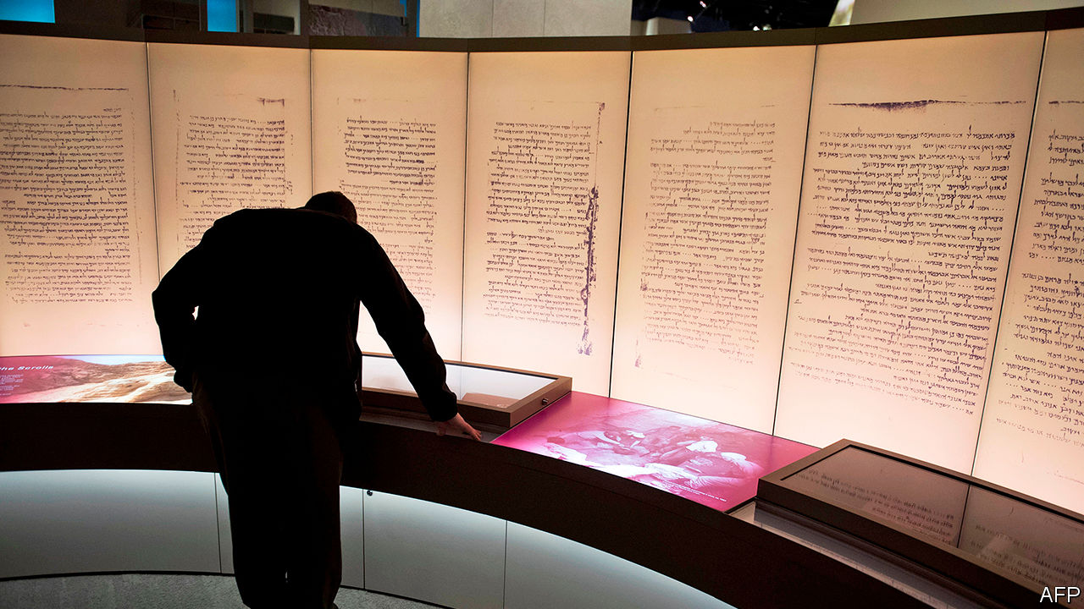

WHEN THE Museum of the Bible opened in Washington, DC in 2017, it boasted an exhibit to make archaeologists salivate: fragments of the Dead Sea scrolls. These 2,000-year-old scraps of parchment include the oldest known transcripts of the Old Testament—and the museum had 16 of them. Except that it didn’t. In 2018 five of its fragments were revealed to be fakes. Last week, the museum announced that all 16 were forgeries, probably created in the 20th century out of ancient leather, perhaps from old shoes.

The revelation is an embarrassment for the museum, which has sought to present itself as an academically rigorous institution worthy of its location just off the National Mall, where the Smithsonian’s fine museums are located. The museum was founded by Steve Green, a prominent evangelical Christian and president of Hobby Lobby, a chain of craft shops which in 2014 persuaded the Supreme Court that it deserved a religious exemption from a federal requirement under which employers provide their workers with certain contraceptives. It has rebuffed criticisms that it is an expensive advertisement for fundamentalist Christianity. The museum has several respected biblical-scholar consultants and a breathtaking collection of biblical texts and artefacts. They include a Gilgamesh tablet from the second millennium BC and sections of the Gutenberg bible.

The museum’s Dead Sea fragments are a less impressive acquisition, apparently bought without looking too closely into their origins. The real things, most of which are in the Israel Museum in Jerusalem, were discovered in caves in what is now the West Bank in the 1940s. The “scrolls” Mr Green snapped up, part of a group of 70 or so, came to market after 2000. The researchers who studied them say the clues to their forgery include indications that they were written on a bumpy surface: parchment resembles leather after 2,000 years but it would originally have been smooth. They are also coated in animal glue to mimic the waxy sheen that develops when collagen in parchment breaks down over time to form gelatine.

This is not the first time the Bible museum has been embarrassed over its acquisitions. Last year it emerged that Hobby Lobby had bought 13 fragments of ancient papyrus texts, which had been sold by an Oxford professor who has been accused of stealing them from the collection he oversaw. The museum said the acquisitions were made “in good faith” and promptly handed them back.

It appears to have been similarly upright and transparent about its Dead Sea mis-purchases. Last February, it commissioned an independent team of researchers, who spent six months studying the fragments. Their 200-page report is displayed prominently on the museum’s website. Jeff Kloha, the museum’s chief curatorial officer, says he hopes the techniques used by the researchers will be helpful to other buyers of other such scrolls. Though Mr Green has not disclosed how much he paid for his, the group from which they came are estimated to have sold for upwards of $35m.

Yet purchasing and then displaying such artefacts without first establishing their provenance is no way to run an institution that presents itself as an authority on the Bible. The error is indicative of a wider lack of academic rigour at the museum. Though its display of biblical artefacts is impressive, with fact-based descriptions of how the Old and New Testaments were gathered and translated, elsewhere, including in a walk through the stories of the Old Testament, the museum tends to elide biblical stories with historical fact in a way that makes many biblical scholars uncomfortable. Given that America’s division of church and state means few people have the opportunity to learn about the history of the Bible, this seems unfortunate.

Yet the museum may be evangelising to fewer people than it had hoped, even before the novel coronavirus led to its temporary closure this week. In its first year, when entry was free, it received a million visitors. Since late 2018, it has charged an entrance fee. Though it will not say how many visitors it has welcomed since, it seems likely that fewer tourists, visiting the free museums on the Mall, have been swinging by to see its treasures. ■

This article was downloaded by calibre from <https://www.economist.com/united-states/2020/03/19/the-bible-museums-fake-scrolls>

|  |  |  |  |
| --- | --- | --- | --- |
| Previous | Articles | Sections | Next |

|  |  |  |  |
| --- | --- | --- | --- |
| Previous | Articles | Sections | Next |

#### Lexington

# Covid-19 is exposing America’s resilience—and vulnerability

Governors, mayors and sheriffs will not let a hopeless president stop them from doing what they need to do

Mar 19th 2020 |

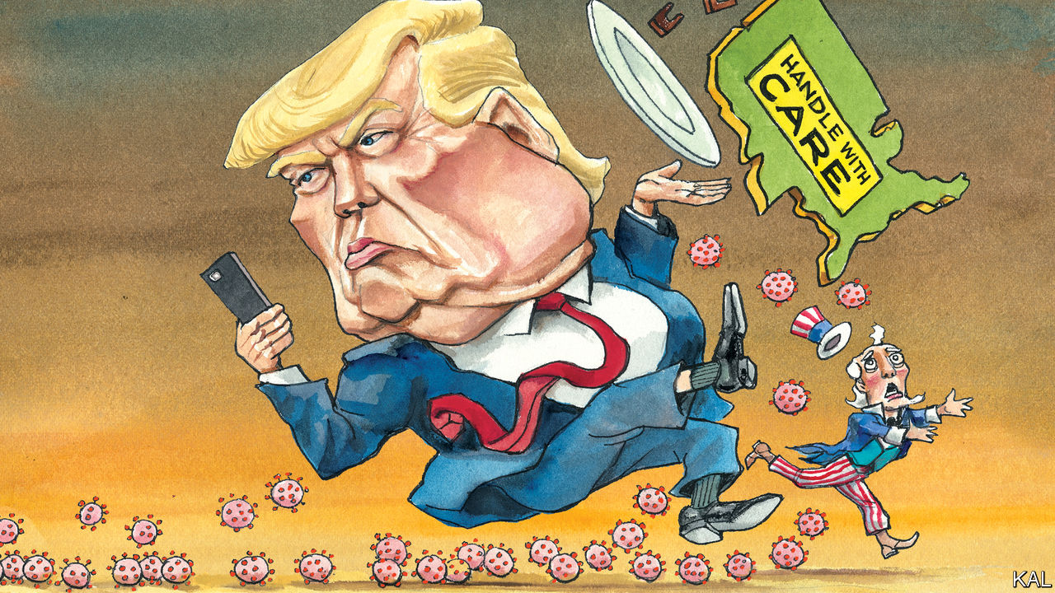

IT IS HARD to pick the best illustration of the administration’s failings on covid-19. There have been so many.

Having been in the crowd to hear Donald Trump dismiss the virus as the Democrats’ “new hoax” three weeks ago, Lexington is still grappling with the president’s denialism. The predictable result, surveys this week suggest, is that Republican voters are much less likely than Democrats to consider the virus dangerous or to take any measure to avoid contracting it. Given that they also tend to be older, this threatens to bring a dramatic new meaning to the hoary trope about Republicans voting against their own interests.

Yet the problems extend beyond the president’s rhetoric. John Bolton’s decision to scrap the NSC’s dedicated pandemic unit is another contender. So is the Centres for Disease Control sticking with a faulty viral test when the WHO could have provided a working alternative; also the turf wars among the White House’s cast of suck-ups and cronies; and Mr Trump’s latest xenophobic attack on China. It is a stunning catalogue of failure.

And its effects could be profound. The Iraq war and financial crisis fuelled a wave of mistrust in government that helped elect Mr Trump. The viral plague may end up deadlier than the war and costlier than them both. Even cool heads are sounding the alarm. In the Atlantic Anne Appelbaum foresees a devastating national epiphany—a moment when the country “long accustomed to thinking of itself as the best, most efficient, and most technically advanced society in the world, is about to be proved an unclothed emperor.” In the Financial Times another veteran of this newspaper, Gideon Rachman, suggests America’s failure on covid-19 and China’s perceived success could do dreadful damage to democracy.

These are plausible scenarios. The virus is descending on a country already gripped by pessimism. In “A Time To Build”, the conservative thinker Yuval Levin discerns a “twilight age” of national frustration and joylessness, which he ascribes to a part-justified, morally sapping loss of trust in institutions. In another new book, “Why We’re Polarised”, Ezra Klein describes the corrosive role that racially infused partisanship plays in that. He also holds out little hope of it or the political dysfunction it causes receding, because of the electoral advantages the Republicans’ lily-white minority will continue to enjoy, even as it shrinks. By 2045 whites are expected to be a minority but, thanks to West Virginia, Wyoming and the other small, mostly white states, the withered hand of Mitch McConnell could in theory still control the Senate.

Such imposing problems will probably ensure that America’s adjustment to greater diversity at home and multipolarity abroad will continue to be rocky. But they need not lead to the head-on collision pessimists fear. America’s fortunes have hardly ever been smooth (notwithstanding, as Mr Levin has previously described, rival forms of liberal and conservative nostalgia for an imagined mid-20th-century golden age). And the country’s traditional sources of resilience are still apparent—even in the current crisis.

One strength is the flipside of the bureaucratic havoc and buck-passing that the pandemic has triggered. It is a decentralised and fragmented democratic system that responds much better to local than national trials. The federal government defers to the states as a matter of course on public health, policing and emergency response. In the event of a major crisis, this is a recipe for chaos, which is why the quality of the president matters so much, as George W. Bush showed in the bungled aftermath of Hurricane Katrina and Mr Trump is showing more grievously. Only he has the bully pulpit and powers required to cut through the institutional rivalries, bottlenecks and excessive legalisms that Americans have intentionally put in the way of central authority.

Yet each cascading layer of American governance offers a partial fix, from governors—many of whom are now battling to fill the void, led by Mike DeWine of Ohio and Andrew Cuomo of New York —to hospital boards and sheriffs. And though the main strengths of this diffuse system—local sensitivity and experimentation—may now be of secondary importance, their time will soon come.

Meanwhile, the crisis is underlining how asymmetric Americans’ pessimism and mistrust of the mainstream is. While Jerry Falwell junior was informing Fox News viewers last week that covid-19 was designed by North Korea to hurt Mr Trump, mainstream media organs, universities, other centre-left entities and both the main Democratic presidential contenders were preaching social distancing. In 2009 Mr Obama’s $830bn stimulus limped out of the House of Representatives without one Republican backer; the House Democratic majority is about to grant Mr Trump’s wish for even bigger measures. Democrats, unlike many Republicans, still believe in expertise, objective truth and good government. And the fact that many blame this disaster on Mr Trump, who represents none of those things, suggests it will not shake their trust in them. Indeed they are about to nominate for president one of America’s most upbeat, undogmatic politicians. Even before considering the merits of Joe Biden’s policies, this is a basis for optimism.

## Health tips from Hannity

Ever since Mr Trump’s election, many have asked whether he could rally the country against a major threat. The worst of their fears seem to be justified. Yet, for another tentative solace, there is still some rallying afoot. Fox has abruptly switched from offering conspiracy theories to public-health advice. It knows things have got serious. The pragmatism of many Republican lawmakers—including Mitt Romney, an early advocate of individual cash transfers—is also encouraging. Congress is about to raise its game dramatically.

The functional moment will pass, whenever the crisis recedes, leaving who knows what devastation in its wake. But amid that uncertainty, here is another silver lining. It seems increasingly possible that, in eight months’ time, voters will appraise Mr Trump on a substantial new issue: his competence to be president.■

This article was downloaded by calibre from <https://www.economist.com/united-states/2020/03/19/covid-19-is-exposing-americas-resilience-and-vulnerability>

|  |  |  |  |
| --- | --- | --- | --- |
| Previous | Articles | Sections | Next |

|  |  |  |
| --- | --- | --- |
| United States | Sections | Asia |

The Americas

Eradicating coca: Burning leaves, spurning leavers

.

Bello: Venezuela’s political quarantine

.

Canada: A little lichen relief

.

|  |  |  |
| --- | --- | --- |
| United States | Sections | Asia |

|  |  |  |  |
| --- | --- | --- | --- |
|  | Articles | Sections | Next |

#### Burning leaves, spurning leavers

# A tale of two crises in Colombia

America pays for a pointless drug war, but is less keen to help with a huge refugee crisis

Mar 19th 2020 | TUMACO AND VILLA DEL ROSARIO

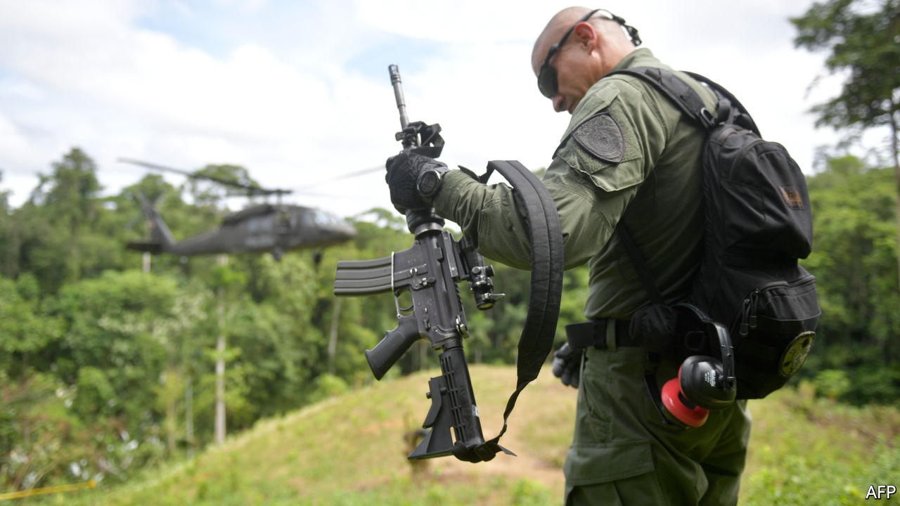

A PLUME OF pink smoke wafts above the treetops, signalling where the Black Hawk helicopters should land. They circle down and, one at a time, rest their front wheels on the hillside. It is too steep to land properly, so they keep their rotors whirring while the passengers alight and then immediately lift off again.

The Colombian government is pulling up coca bushes, the leaves of which are used to make cocaine. It is a costly task, both in blood and treasure. Ten Colombians were killed during coca-eradication operations in 2019, and 50 were wounded.

Gun-toting police stand guard on the hillside, near Tumaco in south-western Colombia, to scare off gangsters. Riot police with shields, batons and tear-gas grenades stand ready, too. Their job is to deal with angry coca farmers, who object to having their crops destroyed. They wear anti-slash gloves in case a farmer expresses his feelings with a machete.

Dogs sniff the field for landmines, which gangsters sometimes plant to make eradication more hazardous. Happily, they find none. Finally, men working in pairs uproot the coca bushes with a shovel and a two-handed tug. They are farmers, flown in from other parts of Colombia so they cannot be identified by the gangs. They are paid well, to compensate for the risk and long absences from home.

President Iván Duque’s administration is trying to wipe out coca, as the United States insists it must. Last year it destroyed 100,000 hectares of it—twice as much as the previous administration managed in 2017. However, cocaleros replanted slightly more. Coca was grown on 212,000 hectares of Colombia in 2019, 2% more than the previous year, according to estimates released by the White House on March 5th. And the new bushes were higher-yielding than the ones they replaced. Potential pure cocaine production rose by 8%, to 951 tonnes.

Both the White House and the Duque administration try to put a positive spin on these dismal numbers. The number of coca fields has stabilised, they argue, after rising sharply over the previous decade.

But so long as people want to snort cocaine, it will be hard to stop people from growing coca. Demand is brisk: some 2m Americans took the drug in 2018, up from 1.4m in 2011, according to the National Survey on Drug Use and Health. Colombia produces perhaps 70% of the world’s cocaine. If, somehow, eradication reduced the supply significantly, the price would rise, raising the incentive for farmers to plant more coca. And as a helicopter ride over south-western Colombia illustrates, there is plenty of space on which to grow it. The forest stretches to the horizon in every direction, punctuated only by smouldering gaps where it has been slashed and burned to make way for coca bushes.

Colombia is twice the size of France. Gangs encourage coca farmers to encroach on national parks, which are 11% of Colombian territory. Many indigenous reserves (which are 32% of Colombian territory) are full of coca. Police can only enter in consultation with their leaders. In areas with no good roads, farmers struggle to get alternative crops such as papayas to market. Coca leaves, by contrast, are light; and the buyers come knocking on your door. Since farmers seldom own the land they sow, they are not deterred by threats to confiscate it. Small wonder that Mr Duque’s predecessor, Juan Manuel Santos, likened the war on drugs to pedalling “a stationary bicycle”.

Yet President Donald Trump urges Colombia to pedal harder. He demands that it resume aerial spraying of herbicide on coca fields. This stopped in 2015 after the World Health Organisation said it might cause cancer. Spraying by hand continues—men in hazmat suits carefully target individual plants. Mr Trump wants to dump clouds of glyphosate over wide areas again. “You’re gonna have to spray,” he told Mr Duque on March 3rd. “If you don’t spray, you’re not gonna get rid of [the coca fields].”

Colombia may have to comply. The Trump administration has previously threatened to decertify it as an ally in the war on drugs, which could trigger sanctions and the withdrawal of most American aid. “Aggressive forced eradication [is] a way of appeasing the US government,” writes Vanda Felbab-Brown of the Brookings Institution, a think-tank.

Since 2000 the United States has given Colombia more than $11bn to fight drugs and deal with insurgencies. For 2019-20 Congress has approved $418m in aid to continue that war, and also to promote peace with ex-rebels and rural development. In 2016 the FARC, the largest insurgent group, signed a peace deal and has laid down its arms. That created a vacuum in other parts of the country that has been filled by other drug-dealing groups.

In remote areas where the state is more or less absent, dozens of local leaders are being murdered. Intensive forced eradication of coca makes matters worse. It alienates rural Colombians from the state, argues Ms Felbab-Brown, and so makes it harder to pacify the coca-growing areas. Often, the state destroys a farmer’s livelihood today and offers an alternative, such as a road to get papayas to market, some time in the future. For peasants who live hand-to-mouth, this is unappealing.

Meanwhile, on the other side of Colombia is an emergency that outsiders are neglecting. Thousands of Venezuelan refugees arrive every day. On March 13th Mr Duque announced that border crossings would be closed temporarily because of covid-19. This is unlikely to stop the influx entirely—the border is more than 2,000km (1,200 miles) long and impossible to police.

The refugees who have recently crossed are in a wretched state. “One group came and picked up some dirty saucepans. I thought they were going to clean them, but they started licking them. That’s when I realised how hungry they were,” says Father Jose David Caña Pérez, who runs a Catholic feeding centre in the border town of Villa del Rosario.

Venezuela’s economy shrank by two-thirds between 2013 and 2019, mainly because of the ineptitude of Nicolás Maduro’s dictatorship. The proportion of Venezuelans who are extremely poor has risen from 10% in 2014 to an incredible 85% in 2018. “I had a choice between buying shoes for my kids or food,” says Anais Parra, who used to work in a bakery in Venezuela. Now she sits in Father Caña’s feeding centre, watching her children tuck into pork, beans and plantains. By selling snacks in the street, she earns as much in a day in Colombia as she did in a month in Venezuela.

Of the 4.5m Venezuelans who have left their country, Colombia has absorbed 1.8m. Its foreign-born population has risen 14-fold since 2013. It has welcomed the newcomers, treating their illnesses, educating their children and letting them work. Until this week, thousands of children who lived in Venezuela near the border commuted to classrooms in Colombia each day. On the Colombian side, the state laid on buses for them. On the Venezuelan side, their own government made them walk.

The pressure on the border is likely to intensify. The price of oil, Venezuela’s only big export besides people, has crashed. Peru and Ecuador, two of Colombia’s neighbours which had previously accepted lots of refugees, tightened visa rules last year. Colombia stoutly kept its border open for a long time; whether it will formally re-open it when the threat of the novel coronavirus eventually lifts remains to be seen.

The rest of the world is helping, but not much. It would cost about $1.5bn a year—or 0.5% of GDP—for Colombia to cope with the influx humanely, the International Monetary Fund estimates. Donors are supplying an eighth of this. Colombia is doing what it can, but it is struggling. Many refugees sleep on bits of cardboard under trees. Schools are groaning with extra pupils.

Clinics are finding it even harder. It was the fear of Colombia’s health service being overwhelmed that prompted the border closure. Venezuelans cannot get treatment for covid-19 in their own country, so they are likely to seek it in Colombia. Indeed, many cannot even get soap in Venezuela.

Colombians feel a historic obligation: many of them went to work in Venezuela back in the days when Venezuela was prosperous and Colombia was not. Venezuelans are culturally similar and speak the same language, so they assimilate relatively easily. Because the refugees work, they will ultimately contribute to the Colombian economy, argues the finance minister, Alberto Carrasquilla. “Immigration is a net plus, over the medium term,” he says.

But in the short term, the welcome mat has worn thin. A year ago most Colombians approved of the government’s policy of offering a haven to Venezuelans, according to Gallup. Now most do not. Many people near the border “feel threatened. They feel there is no control over who is coming in,” said Estefania Colmenares, a journalist, shortly before the border closed.

Colombia did not create either of these crises. The drug trade is driven by global demand. The Venezuelan exodus is driven by a corrupt, brutal and incompetent dictatorship in Venezuela. Yet Colombia is left to deal with the consequences: swathes of ungovernable territory in one part of the country, overstretched public services in another. It needs the right kind of help: less bullying to wage an unwinnable war on drugs, and more cash to cope with a refugee crisis in the middle of a pandemic. ■

This article was downloaded by calibre from <https://www.economist.com/the-americas/2020/03/19/a-tale-of-two-crises-in-colombia>

|  |  |  |  |
| --- | --- | --- | --- |
|  | Articles | Sections | Next |

|  |  |  |  |
| --- | --- | --- | --- |
| Previous | Articles | Sections | Next |

#### Bello

# Venezuela’s political quarantine

The virus may favour an unlikely deal between the regime and the opposition

Mar 19th 2020 |

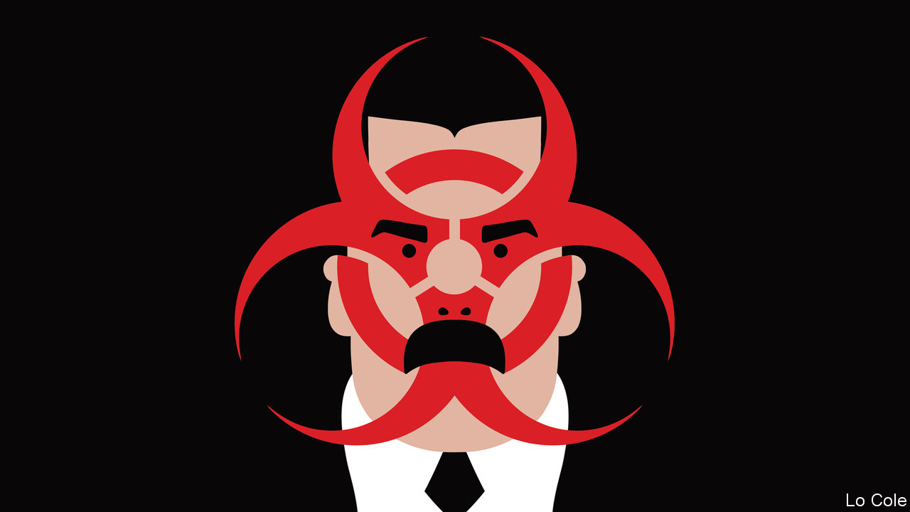

AS IF IT were needed, coronavirus is a cruel reminder that the man who holds all the power in Venezuela is not Juan Guaidó, whom some 60 countries recognise as its president, but Nicolás Maduro, the dictator who kept the office by electoral theft. Blaming foreigners for 36 detected cases of covid-19, on March 16th Mr Maduro ordered a lockdown of the country similar to those in Spain and Italy, placing the armed forces in charge of enforcing it. That may be medically sensible. It is also politically convenient.

Mr Guaidó, who is the speaker of the National Assembly, last month began a new round of street demonstrations against Mr Maduro’s regime, which will now presumably stop. They are a shadow of the massive protests that followed his proclamation as “interim president” 14 months ago, when Mr Maduro began a second term after a fraudulent election. In theory the opposition remains committed to ousting Mr Maduro and calling a democratic presidential ballot. But sweeping American sanctions on Venezuela’s oil industry have so far failed to break the regime. Talks between government and opposition broke down in September. That leaves the opposition with a dilemma.

Under the constitution an election for the National Assembly is due towards the end of this year. In 2015, in Venezuela’s last free election, the opposition won a big majority in the assembly. Mr Maduro’s people see the chance to seize the only institution they don’t control. Radicals in the opposition insist that the vote will be a farce and pledge to boycott it. Any credible election would have to include a fresh presidential vote, they say. Pragmatists fear that a boycott will render the opposition irrelevant. They see a faint opportunity for a deal.

Earlier this month representatives of the government and the opposition agreed on a procedure to appoint new members to the electoral authority. In theory the government would accept international observation of the vote, by the UN and the European Union, says a European diplomat. But there are plenty of obstacles. Around 30 of the opposition’s legislators have been stripped of their parliamentary immunity by Mr Maduro’s puppet judiciary, and are either in exile or jail. Its main parties are banned on technicalities. Any deal would have to involve complete freedom to campaign.

But Mr Maduro has weaknesses, too. Thanks mainly to his mismanagement, Venezuela is in no condition to cope with the virus. Its hospitals were already death traps. Many of its doctors are among the 4.5m Venezuelans who have fled his rule. With Russian help, Venezuela’s production of oil, which accounts for 95% of its legal exports, has stopped falling (though it is still only 60% of its level of 2018). But this month’s plunge in the oil price leaves it below Venezuela’s average cost of production. On March 15th Mr Maduro wrote to the IMF, which he has spent years denouncing as an imperialist tool, asking for a $5bn loan to fight covid-19. The IMF turned him down because his government lacks sufficient international recognition.

There is little sign that Mr Guaidó’s backers in the administration of President Donald Trump are prepared to contemplate any deal in Venezuela. This week Mr Trump nominated Carlos Trujillo, a hardliner, to be his top diplomat on Latin America. The region continues to be polarised by Venezuela, as the battle to be secretary-general of the Organisation of American States, a 34-member club, has illustrated. Luis Almagro, the Uruguayan incumbent, is seeking a second term in a vote of foreign ministers due to take place on March 20th (virus permitting). A vocal opponent of Mr Maduro, he has been more effective at grandstanding than diplomacy, say his critics. But there is no space for nuance. Hugo de Zela, an experienced Peruvian diplomat who favoured a less confrontational approach, this week dropped out. Mr Almagro is likely to beat his remaining rival, María Fernanda Espinosa, a former Ecuadorean foreign minister widely seen as Mr Maduro’s candidate.

The hardliners have a problem. There is no evidence that sanctions alone will get rid of Mr Maduro. That means having to deal with him, one way or another. This week Colombia, which has no diplomatic relations with Venezuela, recognised that when its health minister spoke to his counterpart about the virus. None of this means caving in to dictatorship. It is merely to grasp that the virus offers a fresh opportunity for negotiations. “It’s a road,” says the European diplomat. “There is no other one.”

This article was downloaded by calibre from <https://www.economist.com/the-americas/2020/03/19/venezuelas-political-quarantine>

|  |  |  |  |
| --- | --- | --- | --- |
| Previous | Articles | Sections | Next |

|  |  |  |  |
| --- | --- | --- | --- |
| Previous | Articles | Sections | Next |

#### A little lichen relief

# Canada’s quest for a national lichen

Scientists have narrowed down the country’s 2,500 species to a shortlist of seven

Mar 19th 2020 | VANCOUVER



CANADA HAS a national tree (the maple), a national animal (the beaver) and a national horse (the Canadian horse). Conspicuously missing is a national lichen. Scientists at the Canadian Museum of Nature in Ottawa want to put that right. It is conducting an online poll to choose one. More than 9,000 people had voted by March 17th. The ballot closes on March 26th.

The case for choosing a Canadian lichen is compelling. The country has more than 2,500 species of lichen, a composite of fungi and another element, algae or cyanobacteria (free-living photosynthetic bacteria). Only Russia has a comparable number. Inconspicuous on suburban tree trunks and driveways, lichens help prevent soil erosion and fix atmospheric nitrogen in the soil. They provide winter food for caribou (reindeer). So far, California is the only jurisdiction with an official lichen (lace lichen, chosen in 2015). Iceland, Scotland and the Faroe Islands have issued stamps, so at least their citizens are licking lichen.

The tough question is not whether to designate a Canadian lichen but which one. Lichenologists have drawn up a shortlist of seven. They include the common freckle pelt lichen, which “blankets moss, soil and low shrubs in exposed moist areas”, says the museum’s website. Canada has half the world’s endowment of this sort.

The bright orange elegant sunburst lichen (pictured) grows on rocks and bones. Hunters use it to find nests and burrows. Horsehair lichen, “intricate brown tresses festooning the branches of fir, spruce and pine”, is eaten by flying squirrels. Trevor Goward, a naturalist, favours it because it contains a third element, yeast (also a type of fungus). Its three-part composition best represents “the origins of Canada: First Nations, the French and the English”, he says. Troy McMullin, a botanist who launched the vote, is rooting for the star-tipped reindeer lichen, which “grows like a cauliflower and is instantly recognisable, if you have what I call lichen eyes”.

But the road to national recognition is rocky. In a ballot four years ago, almost 50,000 Canadians voted on a national bird. They chose the loon, which appears on the one-dollar coin, but the Royal Canadian Geographic Society insisted on the grey jay. The government did not endorse it, perhaps because it had already singled out the beaver and backed a horse. Lichens may be luckless, too. The Department of Canadian Heritage is “not actively considering” adopting one as a symbol. The pro-lichen movement will have to be a grassroots one.

This article was downloaded by calibre from <https://www.economist.com/the-americas/2020/03/19/canadas-quest-for-a-national-lichen>

|  |  |  |  |
| --- | --- | --- | --- |
| Previous | Articles | Sections | Next |

|  |  |  |
| --- | --- | --- |
| The Americas | Sections | China |

Asia

Covid-19 in India: The billion-person question

.

Banyan: No island is an island

.

Australia’s economy: Up, up, up and down

.

The Maldives: The other contagion

.

Making wagyu Japanese again: Sperm wail

.

|  |  |  |
| --- | --- | --- |
| The Americas | Sections | China |

|  |  |  |  |
| --- | --- | --- | --- |
|  | Articles | Sections | Next |

#### The billion-person question

# If covid-19 takes hold in India the toll will be grim

It is poor, crowded, short of doctors and equipment and rife with exacerbating diseases

Mar 19th 2020 | DELHI

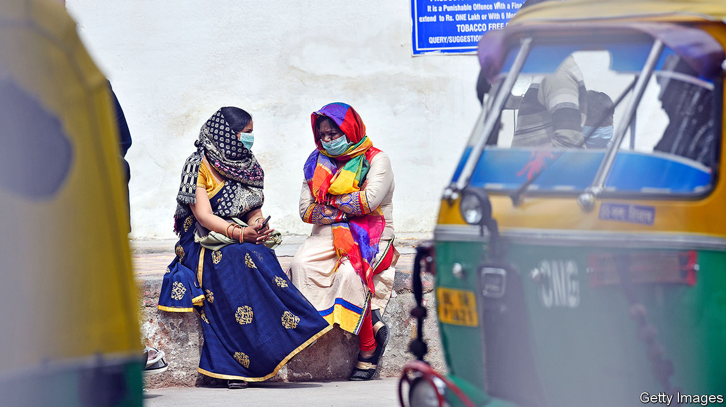

IT WAS CALLED the Spanish influenza, but given the number of Indians it killed, the flu pandemic of 1918-19 should perhaps have carried a different name. Some 18m are thought to have died, or 6% of the country’s population at the time. A century later, with covid-19 lapping at India’s now far more crowded shores, fears are rising that the world’s second-most-populous country could again bear a disproportionate share of the global agony.

Until now, India has been lucky with this coronavirus. Despite the proximity of China there is only modest human traffic between the Asian giants, a result of chronically strained relations. Nor do many travellers visit India from other early centres of the pandemic, such as Iran and Italy. Partly as a result, India has registered fewer than 200 cases so far, and only three deaths. Most of those testing positive acquired the virus outside the country.

Indian governments, both central and state, have also been strikingly forceful in their response. They were quick to restrict travel from afflicted areas and apply basic screening at airports. India has also airlifted—and closely monitored the health of—hundreds of its own citizens from stricken spots such as Wuhan, Tehran and Milan. Public information campaigns have saturated every television channel; recorded messages even interrupt calls on India’s 900m mobile phones. Across most states, schools and universities have been shut and public events cancelled. Kerala in the far south, a state with a record of excellence in public health, has gone further. Volunteers now deliver free school lunches directly to homes, while kerbside basins have been installed at even the remotest rural bus stations to encourage hand-washing. To enforce adherence to individual isolation orders, health authorities farther north in Maharashtra are stamping hands in indelible ink with the word “Home Quarantined” and an expiry date.

Health officials insist that they have managed to limit infections to people who were exposed to the virus abroad and their immediate contacts within India. In some places, they have been assiduous in finding and isolating those at risk. One case in Kerala, where success in stemming an outbreak of the far deadlier Nipah virus in 2018 has built institutional expertise, involved tracing nearly 1,000 people who had come in contact with a single family. But not all states are as efficient. Border screening varied between entry points and never amounted to more than taking the temperatures of passengers—a dragnet a covid-carrier could slip through by taking paracetamol, a doctor grumbles.

Many also note the paucity of testing data. Due to the cost and relatively small supply of testing kits, plus the limited capacity of government labs and a commendable desire to control the complex testing process so that it does not itself become a vector for the virus, India has so far only tested some 11,500 people. This compares with 270,000 in South Korea, a country with a fraction of the population. And because the testing protocol has focused so heavily on travellers, it has become what one expert calls a self-fulfilling prophecy, detecting only cases with foreign origins. “I suspect that if we did 20 times more tests we might find 20 times more cases,” says Ramanan Laxminarayan of Princeton University. “I personally think we are already in the thousands if not tens of thousands.”

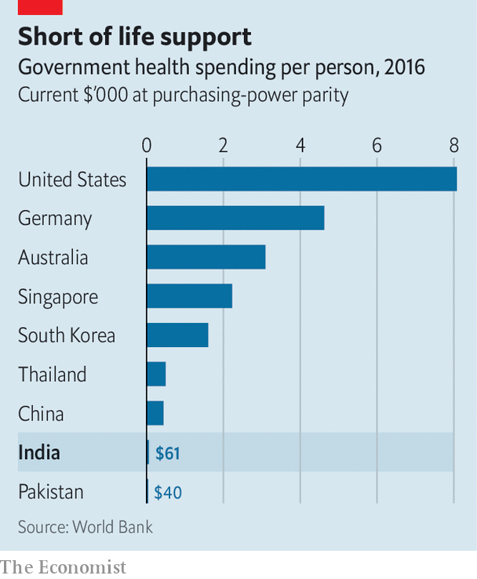

Should the virus have indeed slipped past India’s barriers, there is little reason to think it will follow a different course from elsewhere. That would put India’s epidemic about two weeks behind America’s and perhaps a month behind Italy’s. That is alarming, given how poorly prepared India is. Decades of under-investment in public health—recent budgets have averaged a meagre 1.3% of GDP—have left it with a thin and creaky system (see chart). There are not enough doctors, not enough beds and not enough equipment for the country’s 1.3bn people, even in ordinary times. Moreover, these scant resources are unevenly distributed. Excellent private hospitals and prestigious public medical schools mean that big cities such as Delhi and Mumbai may be reasonably served. But in 2017 some 63 children suffering from encephalitis died when the oxygen supply ran out at a state-run hospital in Gorakhpur, a drab provincial city near the border with Nepal. India’s 100,000-odd intensive-care beds, which cater to perhaps 5m people a year, could be faced with that many in a month.

The public is not well prepared either, particularly for a disease that primarily afflicts the lungs, and is more severe in patients with pre-existing conditions. The prevalence of both extreme air pollution and drug-resistant tuberculosis do not bode well. Indians also account for an estimated 49% of the world’s diabetics. Widespread poverty not only exacerbates such diseases, it makes it practically impossible for many Indians to leave jobs or to work at home. All too often, anyway, those homes are too tiny and crowded to allow for “social distancing”. In many cases there is not even any way to wash properly: some 160m Indians do not have access to clean water.

The potential for a dire outcome is glaring. Yet as Mr Laxminarayan notes, India has a talent for pulling together for colossal “non-routine” events, such as massive weddings and political rallies. Others hope that the novel coronavirus will take a battering from the looming and ferocious summer heat. (That is true of some other ailments, but may not be for covid-19).

On the streets, meanwhile, it is common to hear the whimsical opinion that Indians are already so toughened by hardship that this virus won’t hurt them. Then, for the truly fervent, there are magic cures. At a recent event in Delhi, members of a fringe cult celebrated the curative properties of cow urine. “It should be served to all tourists on arrival to cure them, for the protection of India,” enthuses Rajeev Kumar of the All-India Hindu Mahasabha, a Hindu nationalist group. “We are even sending a little pack to President Trump, to keep him safe from corona!” ■

This article was downloaded by calibre from <https://www.economist.com/asia/2020/03/19/if-covid-19-takes-hold-in-india-the-toll-will-be-grim>

|  |  |  |  |
| --- | --- | --- | --- |
|  | Articles | Sections | Next |

|  |  |  |  |
| --- | --- | --- | --- |
| Previous | Articles | Sections | Next |

#### Banyan

# Even tiny Pacific islands cannot escape covid-19

Contact with the outside world is risky but they can’t survive without it

Mar 19th 2020 |



REMOTE AND pristine, the tiny island nations of the Pacific are often the object of apocalypse-proofing fantasies. But if you think they are in any state to ride out covid-19, dream on.

Many Pacific jurisdictions have thrown up barriers to the new coronavirus. In late January the Federated States of Micronesia banned entry to travellers from countries with confirmed cases. The Cook Islands, Fiji, French Polynesia, New Caledonia, Papua New Guinea (PNG), Tonga and Vanuatu have banned cruise ships. Anyone coming to Samoa has had to produce a medical certificate. In early March the Marshall Islands sealed itself off, banning all inbound visitors. Even supply vessels must wait 14 days at sea before berthing.

The economic cost will be devastating. The island states import nearly everything. Moreover, tourism is the main earner for many. Fiji had a full-blown fiscal crisis even before empty hotels removed a big source of revenue. The Northern Marianas, an American territory, relies on vanished visitors from China, Japan and South Korea. Writing to President Donald Trump for help, the governor warned of the “unequivocal and complete collapse of the foundations of our private sector”.

If the measures kept the coronavirus at bay, they might be worth it. But they won’t. Already, five cases have been confirmed in Guam, five in French Polynesia (including a returning member of France’s National Assembly), two in New Caledonia and one in Fiji. One is suspected in PNG. Testing facilities barely exist in the South Pacific—samples are sent to Australia or New Zealand—although Fiji has raced to set one up.

The coronavirus has many routes to spread. PNG, the region’s most populous state, has a porous border with Australia, just across the Torres Strait, and a land border with Indonesia. It is trying to seal the sea-lanes to the nearby Solomon Islands. Tuvalu and Kiribati are among the tiniest, most isolated states in the world, yet many of their menfolk work as seafarers, with a history of carrying infectious diseases home. Half of the populations of Samoa and Tonga are abroad, many in infected countries. There are more possible vectors than isolated atolls.

It is cause for alarm. The Marshall Islands is only now recovering from a dengue outbreak infecting 3,000, followed by bursts of influenza. It left the little hospital in the capital, Majuro, looking “like a war zone”, says the health secretary, Jack Niedenthal. An outbreak of measles in Samoa in December killed 83, most of them children. Both countries are racing to respond to covid-19. But the Marshall Islands has just six ventilators. Of just 100 protective gowns, goggles and gloves, the hospital got through 22 sets investigating a single suspected case. Meanwhile, the Solomon Islands has such a dilapidated health system that many will view the main hospital in Honiara, the capital, as the last place to go with covid-19.

To cope with the pandemic, Pacific islanders will be thrown back on support networks such as family and church. People are all too used to catastrophes, from cyclones to tsunamis. Only rarely, as Jonathan Pryke of the Lowy Institute in Sydney puts it, do they feel the hand of the state. Traditional networks will prove a blessing, but also carry risks if infections are carried back to villages from capitals. It helps that Pacific populations are relatively young (covid-19 guns for the elderly and infirm). But high rates of non-communicable diseases, notably diabetes, put more people at risk. Thanks to an atrocious diet (think Spam and Kool-Aid), seven of the ten most diabetic countries are in the Pacific. The hospital in Honiara saws off three limbs a day.

Peter Kenilorea, an opposition figure in the Solomon Islands, says the government is unprepared. In its speech marking the opening of Parliament in Honiara this week, only two sentences were devoted to covid-19. A radio station in Fiji has been broadcasting public-health advice for weeks about washing hands. Yet the government will not let it link those messages to the pandemic, lest they spark panic.

Australia and New Zealand both emphasise what New Zealand’s leader, Jacinda Ardern, calls “a duty of care” to Pacific nations. Both countries have promised to send medical equipment and personnel. But Sheldon Yett of Unicef says that the region’s travel clampdown hampers the movement of aid workers and supplies. And once Australia and New Zealand face full-blown crises of their own, how much will they look out for the Pacific?

This article was downloaded by calibre from <https://www.economist.com/asia/2020/03/19/even-tiny-pacific-islands-cannot-escape-covid-19>

|  |  |  |  |
| --- | --- | --- | --- |
| Previous | Articles | Sections | Next |

|  |  |  |  |
| --- | --- | --- | --- |
| Previous | Articles | Sections | Next |

#### Up, up, up and down

# Covid-19 will end Australia’s 28 years of unbroken growth

The first recession since the 1980s looms

Mar 19th 2020 | SYDNEY

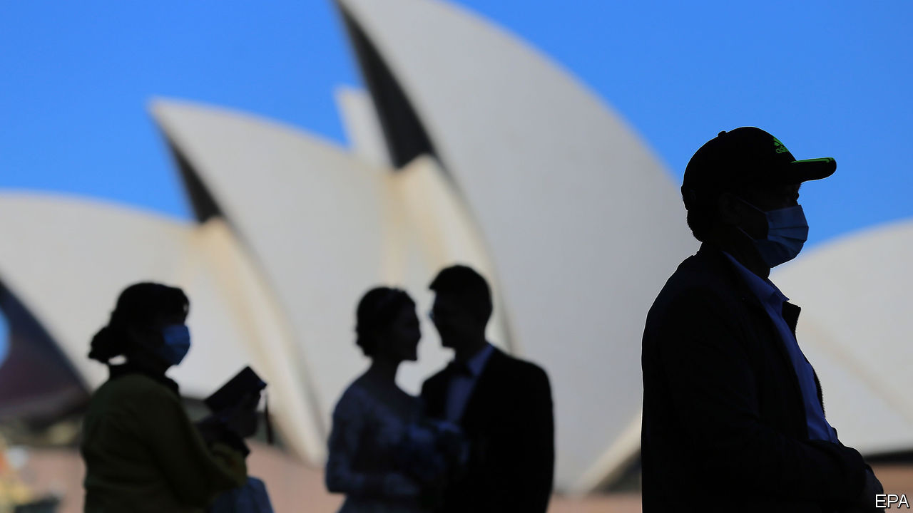

THE BUSHFIRES that raged through December and January could not stop it. Nor could a recent fall in house prices, a slump in iron-ore prices in 2014, the global financial crisis or the dotcom bust of 2001. But covid-19 seems likely to do what none of these other setbacks could: interrupt Australia’s unbeaten run of over 28 years without a recession.

It is no longer a “question of whether we have two successive quarters of negative growth,” says Warren Hogan of the University of Technology Sydney, “but how severe the contraction turns out to be.” The first half of the year is “going to be bad”, agrees Sarah Hunter of BIS Oxford Economics, a consultancy. Output could shrink by a little in the first quarter of this year and by about 3% in the second, according to her provisional forecasts, which she expects to have to revise as the outlook becomes clearer, if not necessarily brighter. In theory, the economy could rebound in the second half of the year, but only if the pandemic is quelled in the next 3-6 months.

Australia will not succumb to a recession without a fight. Its central bank, the Reserve Bank of Australia (RBA), helped it survive the global financial crisis by easing monetary policy sharply. But it entered that battle with its benchmark interest rate at 7.25%, leaving it plenty of room to cut. The RBA started this year with the rate at only 0.75%. It then cut it to a record low of 0.5% on March 3rd and lowered it again on March 19th to 0.25%—about as low as it can go. The RBA is helping banks to fund themselves, especially if they increase loans to businesses. It will also begin buying enough government bonds to keep the yield on three-year securities near 0.25%, allowing the government to spend without fear of driving up its borrowing costs.

And spend the government will. In response to the 2008 global financial crisis, Australia resorted to several rounds of fiscal stimulus worth over 4% of GDP in total, including infrastructure spending and cash bonuses of up to A$900 ($531) paid to about 8.7m taxpayers. These stimulus efforts, undertaken while the Labor Party was in power, have been derided by the conservative coalition that now leads Australia’s government. Scott Morrison, the prime minister, has described them as ill-disciplined and wasteful. He won last year’s election promising to return the budget to a surplus, undoing the “fiscal debacle” left behind by the “economic panic merchants” his party replaced in 2013.

But his government’s response to the covid-19 crisis will probably look quite similar. Last week it launched a programme worth A$17.6bn, or a little over 1% of GDP, focused on bolstering consumer spending and propping up small businesses. It plans another round of stimulus soon. “Everyone is a Keynesian in the foxhole,” as Robert Lucas, a Nobel prize-winning economist, once pointed out.

But even this admirable ideological flexibility is unlikely to prevent the economy from shrinking. The damage is already evident. Tourism, which last year contributed over 3% of output, was reeling from the bushfires even before the pandemic emerged. The dramatic rock formations of the Blue Mountains, west of Sydney, would normally be heaving with visitors at this time of year. Tour buses now drive by nearly empty. Anthea Hammon of Scenic World, which runs a cable car and railway through the area’s canyons, reckons visits have fallen by up to 70%.

On the island of Tasmania, fishermen are at a loss. They typically box up and sell 90% of their catch to China, where abalone and rock-lobster are popular, especially during Chinese new year. This year boats have been stuck with hundreds of thousands of dollars of unsold catch. Some fishermen have been forced to recast themselves as fishmongers, flogging their hauls off the side of their boats to locals at steep discounts. The catch—let alone sales—of local fisheries could fall by 12% in value in the year ending in June, according to the government’s forecasts.

During the global financial crisis, Australia’s close economic relationship with China was an asset. In this crisis, it has exposed the economy to early damage. The price of iron ore, which feeds China’s steel mills, fell by 17% from January 21st to February 3rd, although it has since rebounded. And the vulnerabilities are not limited to mining. Australia’s educational institutions host more international students, relative to the size of its population, than any other country. Almost a third of them (about 150,000) are from China. Roughly 100,000 of these hapless scholars were locked out of the country when Australia’s government banned arrivals from China on February 1st. Some of those have managed to enter after spending 14 days in a third country (the Australian press has complained about students taking “quarantine holidays” in Thailand). But the impending loss of fees is already forcing some institutions to slash spending.

Although Australia is proud of its bustless record, it should not set too much store by it. The country’s economy was free of recession over the past 28 years, but it was hardly free of trouble. Output has shrunk for a single quarter four times since 1991. And the economy has often failed fully to employ its resources of labour and capital. According to the OECD, a club mostly of rich countries, the economy has fallen short of its potential (its full-capacity output) in 18 of the past 28 years. Plenty of countries have done better by that measure, including nearby New Zealand. ■

This article was downloaded by calibre from <https://www.economist.com/asia/2020/03/19/covid-19-will-end-australias-28-years-of-unbroken-growth>

|  |  |  |  |
| --- | --- | --- | --- |
| Previous | Articles | Sections | Next |

|  |  |  |  |
| --- | --- | --- | --- |
| Previous | Articles | Sections | Next |

#### A tale of two viruses

# Jihad is as contagious as covid-19 in the Maldives

Tolerance and tourism are both under threat

Mar 19th 2020 | MALÉ

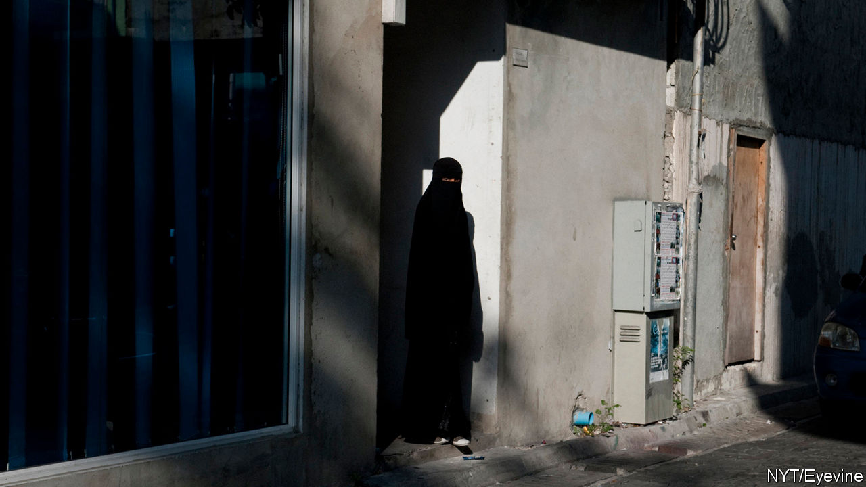

THE ARRIVAL of covid-19 in the Maldives was hardly surprising, since 1.5m tourists from all around the world visit the Indian-Ocean archipelago every year. By March 18th 13 foreigners had been declared infected, although there have not yet been any confirmed cases among locals.

But a no less dangerous contagion—Muslim extremism—is also afflicting the islands. On February 4th three foreigners were stabbed in a suburb of Malé, the capital. (They survived.) Muslim militants claimed responsibility. It was the first incident of religious violence against foreigners since 2007, when jihadists set off a bomb in a park in Malé, injuring 12 tourists. Days after the stabbing, footage of a belligerent British visitor being manhandled by the police for dressing too scantily went viral, neatly illustrating the devoutly Muslim country’s awkward reliance on bikini-clad sun-worshippers for its prosperity.

For the past dozen years, the islanders have been buffeted between authoritarian rulers peddling piety and more tolerant, democratic leaders. In 2008, after 30 years in charge, Maumoon Abdul Gayoom, a conservative, was defeated in the islands’ first truly free election and replaced by Mohamed Nasheed, a secular modernist. Four years later Mr Nasheed was ousted in a coup. Mr Gayoom’s half-brother, Abdullah Yameen subsequently took charge.

For the next six years the government turned a blind eye to growing extremism. A prominent member of parliament, Dr Afrasheem Ali, was murdered. So was a journalist, Ahmed Rilwan Abdulla, and his friend Yameen Rasheed, an influential blogger. Meanwhile the government jailed opponents and winked as an alarming number of islanders headed to Iraq and Syria to join Islamic State. In 2018, however, Ibrahim Solih, an ally of Mr Nasheed, pulled off a surprising election victory.

Under Mr Solih, investigations have been launched into unsolved political murders and into the corruption that had spread under Mr Yameen, who has been sentenced to five years in prison for money-laundering. A presidential commission has concluded that groups linked to al-Qaeda spent a decade bent on radicalisation, recruitment and murder. A police report reckons that 423 Maldivians tried to join jihadists in Syria and Iraq in the past decade or so, 173 of them successfully. It says that some 1,400 Maldivians (out of a population of 350,000) were radicalised to a point where they “would not hesitate to take the life of the person next to them”. A growing number of imams preached not only violent extremism but also the taking of child brides.

The new government has hesitated to crack down, for fear of offending the devout. Instead, in December it shut down a local human-rights NGO, the Maldivian Democracy Network, which had exposed injustices under Messrs Gayoom and Yameen. The authors of a report issued by the NGO have fled the country, after receiving death threats. Meanwhile the courts have failed to prosecute jihadist ringleaders, months after their identities were exposed. The attackers of Yameen Rasheed are the only extremists to have been taken to court so far. Witnesses have been promised anonymity, but there have been endless delays. The collapse of tourism thanks to covid-19 will hobble the economy. That will do nothing to calm the febrile mood. ■

This article was downloaded by calibre from <https://www.economist.com/asia/2020/03/19/jihad-is-as-contagious-as-covid-19-in-the-maldives>

|  |  |  |  |
| --- | --- | --- | --- |
| Previous | Articles | Sections | Next |

|  |  |  |  |
| --- | --- | --- | --- |
| Previous | Articles | Sections | Next |

#### Sperm wail

# Japan tries to stop foreigners copying its cows

A law to curb exports of bovine semen is coming

Mar 19th 2020 | OMIHACHIMAN

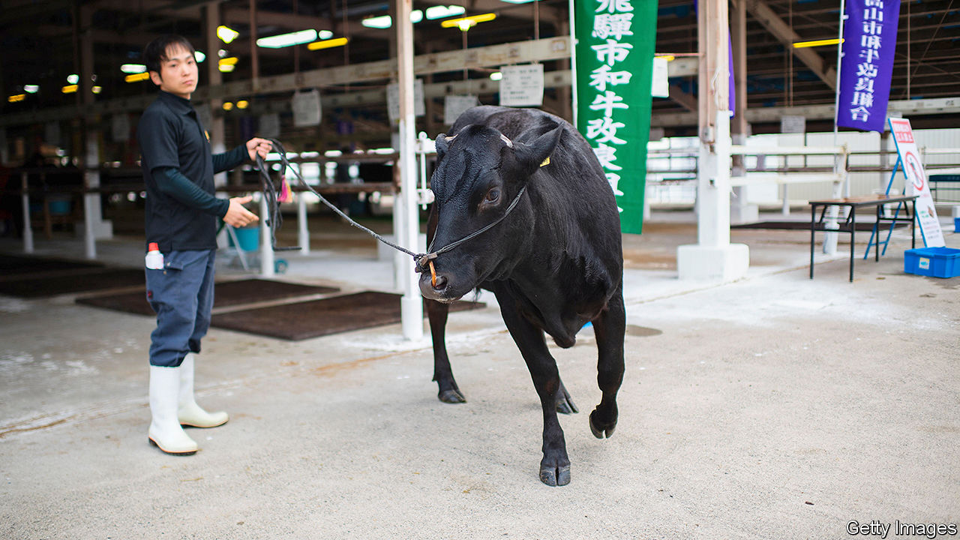

“WAGYU IS NOT just meat. It’s all things that Japan is famous for: tradition and quality and conviction.” That is how a Western chef describes Japan’s fatty marbled beef. But to the government, wagyu is a valuable asset, at risk of being pilfered by foreigners. In January the farm ministry proposed a bill to criminalise unauthorised export of wagyu eggs or sperm. Smugglers could spend as long as ten years in jail, or pay a fine of up to ¥10m ($92,000).

Raising wagyu is a booming business. Japan exported 4,339 tonnes last year, worth a total of ¥29.7bn—about three-and-a-half times the volume and value it shipped just five years prior. Demand is rising as Asia grows wealthier. The nouveau riche in Hong Kong and Taiwan, and increasingly in Thailand and Macau, are paying exorbitant prices to dine on wagyu. (The biggest importer, surprisingly, is Cambodia. Analysts reckon that imports are re-exported to China, which until recently banned Japanese beef after an outbreak of mad-cow disease in 2001.)

Moreover, foreign cattlemen are definitely trying to muscle in on the market. In 2018 two men were caught trying to smuggle more than 100 samples of wagyu DNA into China. But trying to protect the industry by banning semen exports is like slamming the barn door after the bulls have—well, never mind. Australia, whose cattle farmers began crossbreeding Japanese and local cows in the 1980s, already exports seven times more wagyu than Japan.

To purists, moreover, only purebred beef from Japan is truly worthy of the name wagyu. It is not just genetics that mark it out, but the way in which it is reared. Some Japanese cattle-farmers soak feed in beer and give their cows regular massages (relaxation, along with the marbling, is thought to keep the beef tender). Foreign versions do not “taste at all like wagyu bred in Japan”, says Thierry Voisin, a Michelin-starred chef. To Suneya Masahiko, who heads the Japan Livestock Products Export Promotion Council, foreign wagyu is “inauthentic”. He sees the legislation as a chance to introduce “proper wagyu” to the world.

This article was downloaded by calibre from <https://www.economist.com/asia/2020/03/19/japan-tries-to-stop-foreigners-copying-its-cows>

|  |  |  |  |
| --- | --- | --- | --- |
| Previous | Articles | Sections | Next |

|  |  |  |
| --- | --- | --- |
| Asia | Sections | Middle East and ... |

China

China and America: The blame game

.

Imported infections: A frosty welcome

.

Chaguan: This virus also kills dreams

.

|  |  |  |
| --- | --- | --- |
| Asia | Sections | Middle East and ... |

|  |  |  |  |
| --- | --- | --- | --- |
|  | Articles | Sections | Next |

#### The blame game

# Amid the pandemic, Sino-American relations are worsening

China’s mass expulsion of American journalists is an alarming escalation

Mar 19th 2020 |

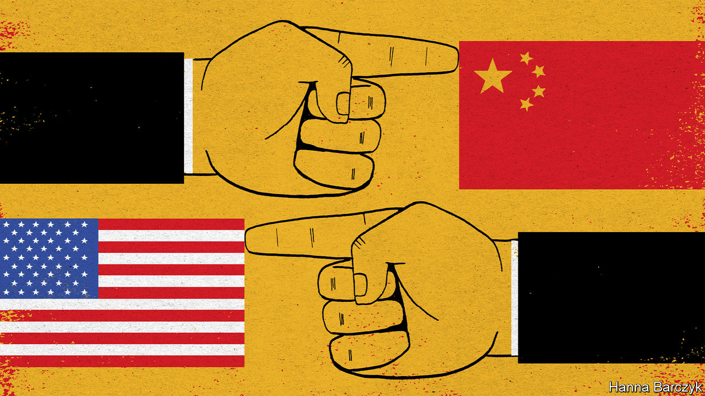

A CRIPPLING PANDEMIC would seem to be an occasion for the world’s two biggest economies to set aside differences and work together. Instead relations between America and China are nearing their darkest point since the crushing of the Tiananmen Square protests in 1989. Amid the crisis, the two countries are engaged in bitter name-calling and tit-for-tat struggles.

Some Chinese officials have been promoting a conspiracy theory that the American army brought covid-19 to China. President Donald Trump, meanwhile, has taken to calling SARS-CoV-2 the “Chinese virus”. One reason why he might wish to emphasise where the virus originated is that curbing travel from China was one of the few actions he took swiftly to fight it. More cynically still, Mr Trump is once again stoking a distracting media debate about his choice of words—whether he is being racist, as critics charge, or standing up for America by telling the truth. That is far more comfortable terrain than examining why he downplayed the virus for weeks.

On March 18th Sino-American feuding intensified. China announced the expulsions of almost all American citizens—about a dozen people—working in mainland China for the New York Times, the Washington Post and the Wall Street Journal. It was the biggest mass expulsion of Western journalists from China since Mao Zedong seized power in 1949.

The sparring has escalated quickly. Early in January China ignored requests for access to Wuhan by American disease-control experts who wanted to assess the early stages of the outbreak. It was furious when, later in January, Mr Trump barred non-American visitors from China. Now that the epidemic has waned, at least temporarily, in China, officials there are trumpeting their resolute handling of it, in contrast with America’s fumbling—a victory for one-party rule, they suggest.

The relationship between the two great powers is far worse than during the presidencies of Barack Obama and Hu Jintao less than a decade ago. At that time there was also much distrust, but the two leaders co-operated on some vital issues, such as climate change and the global financial crisis.

Under Mr Trump and China’s current leader, Xi Jinping, there has been no such detente. Mr Trump has packed his administration with China hawks, withdrawn from the Paris climate accord which Mr Obama and Mr Xi had signed, launched a trade war, hunted for Chinese spies in America and lobbied allies around the world to bar Huawei, a Chinese firm, from their 5G networks. Mr Xi in turn has pursued an increasingly aggressive foreign policy and intensified repression at home.

In January, as covid-19 began to spread beyond China’s borders, the two countries at least managed to suspend their trade war. But tensions have persisted in many other areas. The trading of blows over journalists has been straight from the cold-war playbook. On February 18th the Trump administration designated five Chinese media organisations as “foreign missions” of the Chinese government. The next day China announced the expulsions of three Wall Street Journal reporters, ostensibly as punishment for a headline in the newspaper calling China the “real sick man of Asia”. America then imposed a cap of 100 on Chinese nationals working for those five media: Xinhua, CGTN, China Daily, China Radio International and the distribution arm of People’s Daily. That meant, in effect, the expulsion of 60 people.

China’s response will have a far bigger impact on journalism, stripping the foreign press corps in China of many of its best correspondents. It will also worry many people in Hong Kong, where anger over Chinese interference has triggered frequent protests in recent months. China says the expelled reporters are barred from working there too. This scraps a convention under Chinese rule that foreign reporters, even if shut out of the mainland, can still work in Hong Kong. The central government has, in effect, made it clear that its rules for managing foreign journalists will take precedence over Hong Kong’s far freer system.

In recent years Chinese officials have been confrontational with many Western countries, but more cautious with America. That era may be over. The harshness of China’s retaliation suggests that its leaders are becoming more willing to risk open hostility with the United States.

China’s insinuations over the origin of covid-19 are a sign of this change. For weeks fanciful theories had been circulating online in China and in Chinese media that the coronavirus was an American bioweapon, produced by the CIA or the US Army and released in Wuhan in October, when the city hosted the Military World Games. On March 12th Zhao Lijian, a spokesman for China’s foreign ministry, stepped in on Twitter, where he now has more than 400,000 followers. “It might be US army who brought the epidemic to Wuhan,” he tweeted. “Be transparent! Make public your data! US owe us an explanation!” Other Chinese diplomats have joined in spreading the rumour. Some American officials have also floated a baseless idea that covid-19 emerged from a research lab in Wuhan.

Mr Trump said China’s conspiracy theory was one reason why he would keep calling SARS-CoV-2 the “Chinese virus”. He dismissed a reporter’s suggestion that this might be racist. But his language seems likely to stoke racism, including among his own staff. On March 17th a Chinese-born American television reporter tweeted that a White House official had called the virus “Kung Flu” to her face.

For now the swapping of insults may appear infantile. But as the epidemic worsens, so too will the scapegoating. If far larger numbers die, perceptions in China and America of who is to blame will have profound consequences for a relationship that is already looking scarily frayed. ■

This article was downloaded by calibre from <https://www.economist.com/china/2020/03/19/amid-the-pandemic-sino-american-relations-are-worsening>

|  |  |  |  |
| --- | --- | --- | --- |
|  | Articles | Sections | Next |

|  |  |  |  |
| --- | --- | --- | --- |
| Previous | Articles | Sections | Next |

#### A frosty welcome

# China worries about infections by travellers from abroad

It is increasing border checks as many citizens return home

Mar 19th 2020 | BEIJING

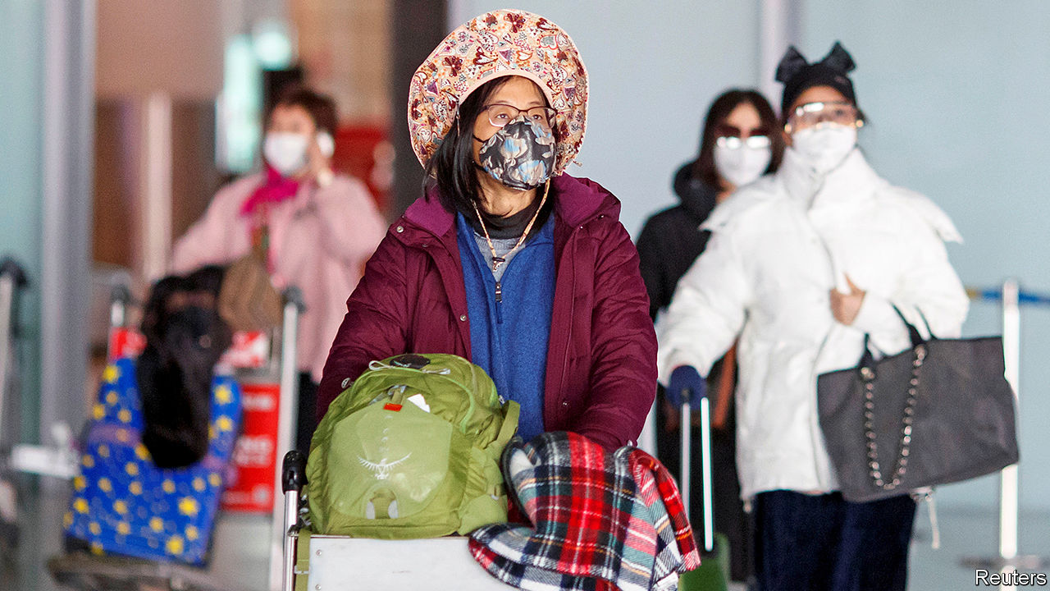

IN EARLY MARCH Alina Wang, a Chinese citizen studying in Sydney, decided it would be best to go back to her native country. She felt that China was doing a good job curtailing the spread of covid-19. In Australia she had worries, including that few people wore masks when out and about. Now Ms Wang is in a hotel near her family’s home in a north-eastern Chinese province. She is serving out the last few days of a two-week quarantine that local officials said new arrivals must undergo. Fortunately her room has good Wi-Fi. She is keeping busy with coursework.

As infections dwindle in China and soar elsewhere, many Chinese citizens living abroad are wondering whether it would be safer to return. The pull is strongest for the 1.5m Chinese studying in foreign universities, many of which have suspended face-to-face classes. They are often urged to return by family members, who fear that foreign countries do not have the gumption or the power to enforce the kind of sweeping restrictions that China has used to fight the new coronavirus. On March 15th Global Times, a Beijing tabloid, said the less-draconian measures adopted by Britain and the Netherlands were “irresponsible and harmful to the world”.

Long ago China was reluctant to allow its citizens to travel the world freely. Now its doors are open and the numbers living abroad have soared. China sees them as a source of soft power and of knowledge that can help the country’s rise. In recent years it has been trying to boost their loyalty to the motherland by standing up for their interests. It says that since the outbreak began it has repatriated 1,000 nationals who had become stranded in hard-hit countries. But now it is starting to worry.

Officials say that making sure people entering China do not bring the virus with them has become a priority. All 34 new cases of covid-19 that were detected in the country on March 18th involved someone who had recently entered from abroad. Most of those people are believed to be Chinese citizens.

Netizens have been expressing anxiety about this on social media. They have raged against a handful of people who have concealed symptoms when entering the country or disregarded requests that they self-quarantine for two weeks after they arrive. This anger relates to a common complaint in China, that those with money and connections are often able to skirt rules. Only a small fraction of Chinese are rich enough to study abroad.

Officials appear keen to stem the return flow, especially to Beijing (protecting the capital is always considered vital). On March 16th it was announced that most people who enter the city from a foreign country would have to do two weeks of quarantine in a designated hotel and pay $30-$80 a night for it. Two days later a city official advised Chinese students not to return unless they had to.

Many Chinese students abroad say there are good reasons to stay put. Going home before graduation could make it harder to find jobs overseas. Some worry that they could catch the virus in transit, or that returning would cause hassle for their parents. On balance, Ms Wang thinks she made the right decision. She says being home is a great relief. ■

This article was downloaded by calibre from <https://www.economist.com/china/2020/03/19/china-worries-about-infections-by-travellers-from-abroad>

|  |  |  |  |
| --- | --- | --- | --- |
| Previous | Articles | Sections | Next |

|  |  |  |  |
| --- | --- | --- | --- |
| Previous | Articles | Sections | Next |

#### Chaguan

# How the virus kills dreams for Chinese teens

By disrupting exams, it could shatter chances of social advancement

Mar 21st 2020 |

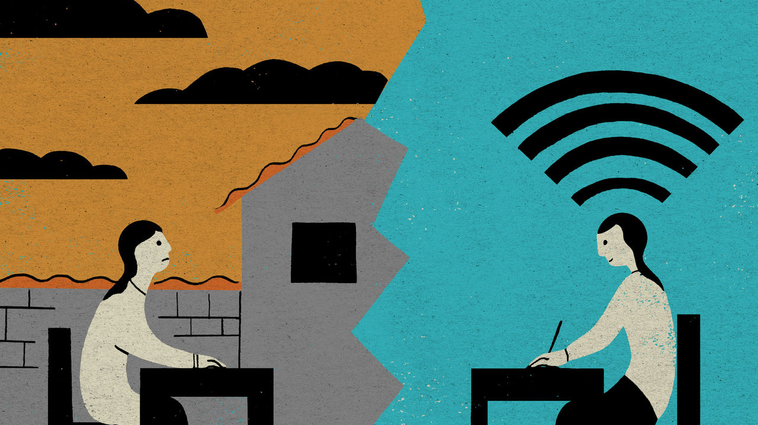

AS A TEENAGE schoolgirl, Tang Sisi has mixed feelings about the snowstorm that hit her village in the poor western province of Gansu on March 16th. On the downside, the snow burned out the village’s electrical transformer, cutting her access to online classes that have replaced normal lessons since covid-19 closed schools across China weeks ago. On the upside, when the internet dropped just after Chinese class, Sisi’s first lesson of the day, she could abandon her usual place of study—a rough wooden chair and desk in an outdoor courtyard, placed to catch the signal from a neighbour’s Wi-Fi—and shelter from the storm.

Sisi, whose father is a village official and whose mother is a migrant worker, cannot afford to miss many classes. Like millions of Chinese teenagers she is preparing for an examination for entrance to senior secondary school. It is known as the zhongkao, and sends students down one of two tracks. A vocational track involves three years studying a trade at a technical school. An academic track starts at senior high school and, for the most studious, ends with a four-year degree course at university.

Put bluntly, those who do well at the zhongkao have a shot at becoming doctors, bank managers, government officials or teachers—Sisi’s own ambition is to teach English. Teenagers who do badly must either enter the labour market or study for vocational diplomas of varying quality. The zhongkao may not be as famous as the gaokao, the terrifying university entrance exam that has inspired books, documentaries and feature films. But the zhongkao shapes more lives. In one sign of the exam’s hold on parental imaginations, Chinese social media erupted in heated debate when Hubei province, seat of the virus outbreak, announced that the children of medical workers would be granted ten bonus points on their zhongkao scores.

The idea that clever, hard-working villagers can make it to the best schools is not just an interesting question of public policy. It is a pillar of China’s social contract, with roots in ancient tales of poor students transformed into powerful scholar-officials by brilliance at exams. In modern-day China, a harshly unequal country, education remains an unrivalled ladder of social mobility. Even in a good year, success in the zhongkao is a hard ladder-rung to grasp. As a matter of stated government policy, the test is designed to send roughly half of all students into vocational training, an outcome widely seen—fairly or not—as failure. In 2018 just under 8m teenagers were admitted to academic senior high schools. They represented 58% of all students who completed nine years of compulsory, free education that year. With schools still closed in most of China by covid-19, this is not a good year.

The coronavirus will leave many scars on China. Some of the longest-lasting, but hardest to see, may involve months of schooling missed by vulnerable students, who risk doing worse in the zhongkao than they could have done if face-to-face classes had not been disrupted. In painful contrast, affluent teenagers with good computers, fast internet and private tutors may overperform.

Sisi turned 15 on March 19th and normally attends boarding school in a town an hour from her home. She described her life in an interview conducted over the internet because Chaguan is spending 14 days inside his flat in Beijing, behind a front door bearing a government notice inviting neighbours to monitor his quarantine after a family member returned from abroad.

She has some reasons for hope. Sisi has diligence on her side. Ranked 20th in her class of 52, she reports that “this morning for our English class, only 30 or so students signed in.” Her father installed an internet connection this week, allowing her to study indoors from now on. Sisi is under less time-pressure than students a year older than her. She is in the first of two school years that end in zhongkao tests. This June, assuming the exam is not delayed, she is taking two subjects, with the rest to follow in a year.

More alarmingly, however, Sisi finds online classes hard to follow. “Sometimes I come across things I don’t know in homework and there’s nobody to ask,” she worries in a quiet voice. Some teachers move through lessons too fast, she adds. When unable to take notes in time, she takes screenshots on her phone then tries to make sense of the material later.

A veteran middle-school teacher from Xiamen, reached by telephone, fears that virus-imposed distance learning will hit certain students hard. She worries about those without parents at home to police them, and those—mostly boys, she says sadly—going “through a rebellious age” who don’t see the point of study.

## Quaranteens

Better-off parents can buy help from such services as Fudaojun, an app which offers one-on-one tuition by experienced teachers, at a typical cost of 150 yuan ($21) for 40 minutes. The app has seen orders from zhongkao students jump by 72% since last year. One of its tutors, a chemistry teacher from the southern province of Guangdong, explains how the zhongkao controls access to elite schools with the teachers and resources that help students to reach good universities, and thus prestigious jobs. That makes a bad zhongkao result a grave blow. “If you’re already losing at the starting line, the gap to catch up is huge,” she says.

Because the epidemic broke out during the spring-festival holidays, easy-going students “still feel they’re on winter break, they haven’t quite shifted their mindset,” worries the chemistry teacher. Nonetheless, one of her tutorial students, a boy with bad school grades, is experiencing a useful culture shock. “Now his mum is home full time, she doesn’t allow him to go out and has set very specific times for study and homework. He’s already doing much better.” That is both a cheering tale and worrying. If good schools promote equal opportunities, closed schools play up accidents of birth. In exam-obsessed China covid-19 is going to break a lot of young dreams. ■

This article was downloaded by calibre from <https://www.economist.com/china/2020/03/21/how-the-virus-kills-dreams-for-chinese-teens>

|  |  |  |  |
| --- | --- | --- | --- |
| Previous | Articles | Sections | Next |

|  |  |  |
| --- | --- | --- |
| China | Sections | Europe |

Middle East and Africa

Separatism in Ethiopia: Abiy’s war

.

HIV and the disabled: Double trouble

.

The Democratic Republic of Congo: A crocodile-hunter’s tears

.

Coping with covid-19: Prayer in a pandemic

.

Israeli politics: Bibi and the virus

.

|  |  |  |
| --- | --- | --- |
| China | Sections | Europe |

|  |  |  |  |
| --- | --- | --- | --- |
|  | Articles | Sections | Next |

#### Onslaught in Oromia

# A hidden war threatens Ethiopia’s transition to democracy

Abiy Ahmed’s crackdown in Oromia is bloody and lawless

Mar 19th 2020 | NEKEMTE

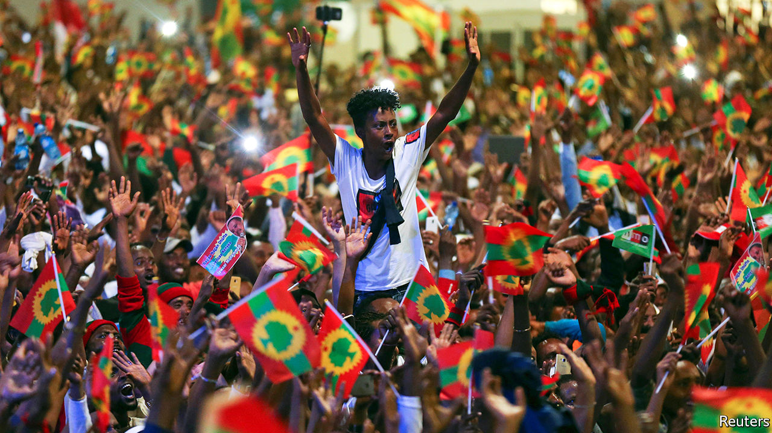

IN THE CORNER of a restaurant in Nekemte, a town in western Ethiopia, Fisaha Aberra unfolds a piece of paper on which he has scrawled the names of 11 men he says were shot by soldiers last year. After this came mass arrests. Fisaha and two siblings fled their home in Guliso to Nekemte, leaving one brother behind who was arrested last month, for the second time in a year, and beaten so hard he cannot walk.

Arrests and summary executions have become commonplace in the far-flung reaches of Oromia, Ethiopia’s largest region. The Ethiopian security forces are waging war on armed Oromo separatists. They are also treating civilians brutally. Accounts by witnesses suggest there is indiscriminate repression of local dissent in a country supposedly on the path from one-party rule towards democracy.

This was not what Ethiopians expected from Abiy Ahmed, who became prime minister in 2018. He was a young reformer from Oromia. He promised democracy for all and redress for what Oromos claim is centuries of political and economic marginalisation. Abiy freed thousands of political prisoners and welcomed rebel groups back from exile to contest elections, now scheduled for August.

Abiy made peace with neighbouring Eritrea, for which he won the Nobel Peace Prize, as well as with rebel groups including the Oromo Liberation Front (OLF), which is now an opposition party. The group’s armed wing, the Oromo Liberation Army (OLA), agreed to put down its guns; in return its soldiers were to join Oromia’s police. Many hoped to see the end of an insurgency that began almost 50 years ago.

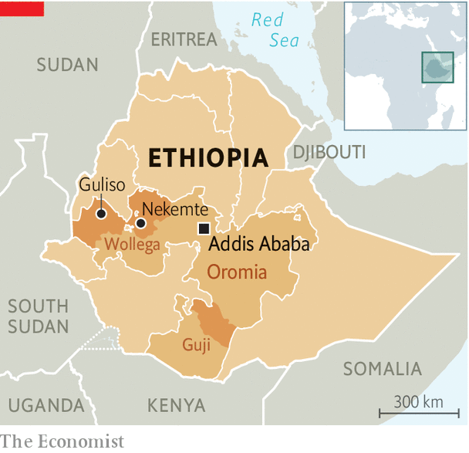

But the social fractures that lifted Abiy to high office continue to divide Ethiopia. Years of unrest in Oromo areas have weakened local government and left a security vacuum. In Wollega (to the west) and Guji (in the south) returning rebels stepped into the breach, sometimes working with the police to enforce order. But they soon began accusing the government of betraying the Oromo cause and reneging on promises to give them jobs in the police. The government, in turn, accused the OLA of keeping its weapons. The details of the peace deal were never disclosed, making it easier for both sides to accuse the other of failing to honour it.

By the end of 2018 the rebels had returned to the forests and were murdering officials and attacking army convoys. In 2019 the air force was reportedly bombing OLA training camps. After a third peace deal flopped in 2019 the OLF formally split from its armed wing (though they are thought to keep covert lines of communication). The government, in effect, declared a state of emergency in Wollega and Guji, with the army in charge of security. By the start of 2020 fighting in Guji had forced some 80,000 people from their homes.

In January, as the security forces intensified their operations, the government switched off the internet across much of western Oromia. Outside big towns in Wollega, which is under curfew, even landlines and mobile networks are disconnected. Reports of killings and arrests travel by word of mouth. “We’re back to the pre-telephone age,” says Asebe Regassa, a local academic. Aid workers can barely enter the very far west, where the war is most intense. In parts of Guji, transport is banned. “Farmers are punished from both sides,” says Mulatu Jergafa, who lives in Nekemte. “If they go to their coffee farms the guerrillas suspect they might be government informants and beat them; but the military also suspects they might be informants for the guerrillas and does the same.”

Geresu Tufa, an Oromo activist, describes it as a war in which “you cannot tell who is friend and who is foe.” Nobody knows, for example, exactly how many fighters the OLA has, though it is thought to number in the low thousands. It is also unclear which armed groups are actually linked to the OLA, since anyone can pick up a gun and claim to be fighting for it. In most places the insurgency may be a potpourri of loosely connected militias rather than a full-fledged rebellion.

Uncertainty also surrounds the counter-insurgency. By December the Oromia Support Group, an NGO, had documented 64 extra-judicial killings and at least 1,400 cases of arbitrary detention over the previous six months. Since then many more abuses have been reported, including the burning of homes. In January activists claimed the army had massacred 59 civilians in Wollega. The OLF alleged another 21 had been killed nearby. The government has denied all allegations. This is unconvincing, but it is possible atrocities reflect a breakdown in the chain of command rather than orders from the top. “Senior federal officials may not know the full extent or nature of the military’s operations in Wollega,” says William Davison of the International Crisis Group, an NGO in Brussels.

What is not in doubt is that there has also been political repression. “The opposition movement in Oromia has totally stopped,” says the OLF’s chief, Dawud Ibsa. In recent months thousands of its supporters have been arrested, including nine of its leaders. In Nekemte, security forces have repeatedly closed offices belonging to the OLF and its more moderate ally, the Oromo Federalist Congress (OFC). Public gatherings have been banned, though the ruling Prosperity Party recently staged a rally. The OFC’s representative in Nekemte spent four months in a cell in the town’s historic palace, which has been turned into a detention facility.

All this comes months before what is supposed to be Ethiopia’s first free and fair election (unless it is derailed by covid-19). In Wollega and Guji the vote will probably be postponed on security grounds. This will help the government, which is unpopular in these places.

The government insists it remains open to negotiation with the rebels. “It is good for people to solve their issues through discussion, meetings and conversations,” Abiy told lawmakers last month. But it seems uninterested in further peace talks and acts as if the conflict can be resolved through force. The rebels, meanwhile, continue to denounce the Ethiopian state as a colonial oppressor which can never be trusted. And so the carnage continues. ■

This article was downloaded by calibre from <https://www.economist.com/middle-east-and-africa/2020/03/19/a-hidden-war-threatens-ethiopias-transition-to-democracy>

|  |  |  |  |
| --- | --- | --- | --- |
|  | Articles | Sections | Next |

|  |  |  |  |
| --- | --- | --- | --- |
| Previous | Articles | Sections | Next |

#### Double trouble

# Africans with disabilities are at higher risk of HIV

And they are less likely to receive treatment

Mar 19th 2020 |

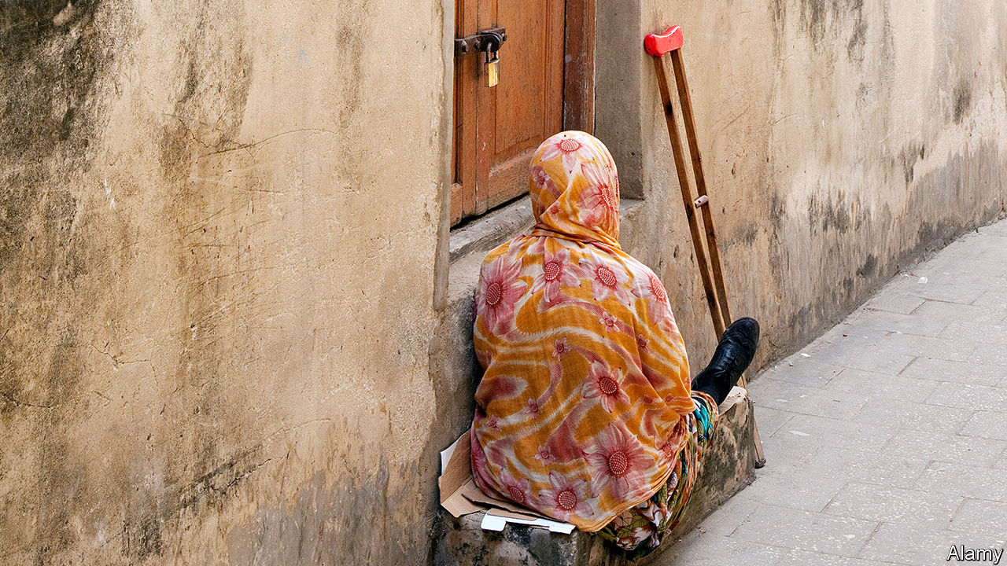

NOMASOMI LIMAKO, who lives in South Africa, was often told that she could not get HIV because she is wheelchair-bound. She had never met a disabled person with the disease, as far as she knew, so she believed the rumour. Then came her own diagnosis. Today the 48-year-old pharmacy assistant knows that her disability actually made her more vulnerable to the disease. Even as covid-19 creates a new public-health crisis, Africa is continuing to grapple with an old one. Studies show that Africans with disabilities are at least twice as likely to get HIV as those without.

One reason is that disability compounds HIV’s other risk factors. Disabled children are often excluded from school, so many receive no sex education. Even for those in school, a widespread assumption that disabled people do not have sex means that teachers think they do not need to learn about it. In Ethiopia more than three-quarters of 10- to 24-year-olds with disabilities had never discussed sex with their parents. Social status matters, too. Even in places where disabled people know more about condoms than everyone else, such as Uganda, they still have higher rates of sexually transmitted diseases. Researchers think this is because the disabled have a tougher time negotiating with their partners about having safe sex.

“When you are disabled and you have HIV, you get double discrimination,” says Miiro Michael, a social worker in southern Uganda. “When you are a woman, you get triple discrimination.” This is because women in much of sub-Saharan Africa, disabled or not, are at higher risk of getting HIV than men. In Burundi women with disabilities are three times more likely to have HIV than those without, and ten times more likely than able-bodied men. In Burkina Faso disabled women have the same HIV prevalence (5.4%) as sex workers.

Trading sex for money is something disabled women are more than three times as likely to do as able-bodied women, according to a study in Cameroon. This is often because they are poor. Across Africa disabled women tend to suffer high levels of sexual abuse, too. In Burundi they are about twice as likely to have endured it as the non-disabled. Some are victims of “virgin rape”—a crime reflecting the belief that an HIV-positive man can be cured if he has sex with a virgin and transfers the disease to her. Since disabled women are often baselessly assumed to be virgins, they are particularly at risk.

Once the disabled get HIV, treatment is difficult. Travel costs are a big reason. Disabled people also report being turned away by clinics because health workers don’t believe the disabled can get HIV. Moreover, many clinics do not have wheelchair ramps and the like to provide access to people who cannot walk. One study in Uganda found that disabled people were less likely to receive their test results than others. This may have been because they found it difficult to return to a clinic.

Some are trying to improve the situation. A project in Kenya led by Humanity & Inclusion, an international NGO, provides HIV information to the blind using Braille and radio shows. Community health workers in South Africa offer in-home HIV treatment to the immobile. In Rwanda they are taught to communicate the basics about the virus in sign language. Senegal conducted a prevalence survey of disability and HIV—a good step in the “disability data revolution” that advocates say is necessary to tailor future policies. All but five African countries have ratified the Convention on the Rights of Persons with Disabilities, which pledges them to ensure broad legal equality for the disabled.

No country stands out as a model. Policymakers often fret that providing for disabled people will be expensive and consume scarce resources. But some solutions that do not cost much can make a big impact. Health centres, for example, could start by installing wider doorways, adjustable beds and ramps. And health and education departments could do a far better job of teaching their own staff about the sex lives of the disabled, even if it may take time to remove social stigmas and correct horrific misapprehensions, such as that rape is a cure for HIV. ■

This article was downloaded by calibre from <https://www.economist.com/middle-east-and-africa/2020/03/19/africans-with-disabilities-are-at-higher-risk-of-hiv>

|  |  |  |  |
| --- | --- | --- | --- |
| Previous | Articles | Sections | Next |

|  |  |  |  |
| --- | --- | --- | --- |
| Previous | Articles | Sections | Next |

#### Croc in the pot

# The toils and spoils of Congo’s crocodile-killers

They threaten wildlife. But other jobs are scarce

Mar 19th 2020 | MBANDAKA

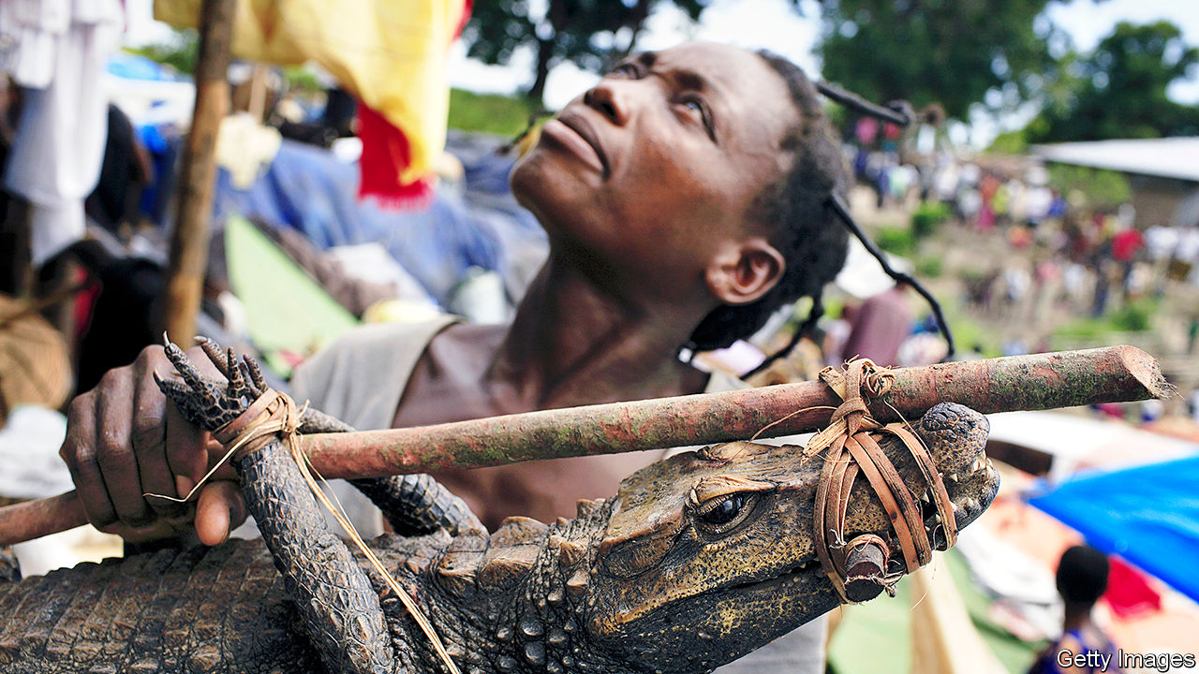

CICERON NYALOWALA’S parents are disappointed. Their son took a boat from their riverside village to the city of Mbandaka, in the heart of the Congo Basin rainforest, where he enrolled in a teacher-training college. They wanted him to become a crocodile hunter, like his father and most of his ancestors. “There is a lot of pressure,” says Mr Nyalowala. Hunting for bush meat is popular—and may pay better than teaching.

However, it harms wildlife in the rainforest, which spans six countries and is second in size only to the Amazon. Around 6m tonnes of bush meat are thought to come out of the Congo Basin each year. The number of animals killed for the pot has been increasing, according to a study from 2016 led by Goethe University Frankfurt. More hunters are selling their prey in markets, instead of eating it themselves. The trade has emptied out parts of the forest; 39% of it is at severe risk of over-hunting, the study says. Everything from bonobos (an endangered species of ape) to cobras, antelopes and, occasionally, elephants, appear at market stalls in Mbandaka.

Over-hunting has made life more dangerous for crocodile hunters. The number of dwarf crocodiles, once common in the Congo river, is dwindling. So hunters have to chase the ferocious Nile crocodile instead. There are plenty of those. Their scaly bodies stretch to six metres and they often kill humans. Stalkers in canoes go after them at night, shining a torch while stirring the water. “The crocodile does not like that,” says Mr Nyalowala. “He begins to writhe and then comes to attack.” As the animal pounces so do its pursuers, spearing it.

A live crocodile fetches more than a dead one in the markets in Mbandaka, so hunters bind their jaws and transport them some 200km downstream in their canoes. They sell for around $150 each. A teacher at a state school, by comparison, earns around $170 a month, though many did not get paid at all last year. No wonder Mr Nyalowala’s parents wanted him to follow in his father’s footsteps.

This article was downloaded by calibre from <https://www.economist.com/middle-east-and-africa/2020/03/19/the-toils-and-spoils-of-congos-crocodile-killers>

|  |  |  |  |
| --- | --- | --- | --- |
| Previous | Articles | Sections | Next |

|  |  |  |  |
| --- | --- | --- | --- |
| Previous | Articles | Sections | Next |

#### Coping with covid-19

# How prayer is changing as a result of covid-19

Mosques are closed, sermons are shortened and communion causes anxiety

Mar 19th 2020 | BEIRUT

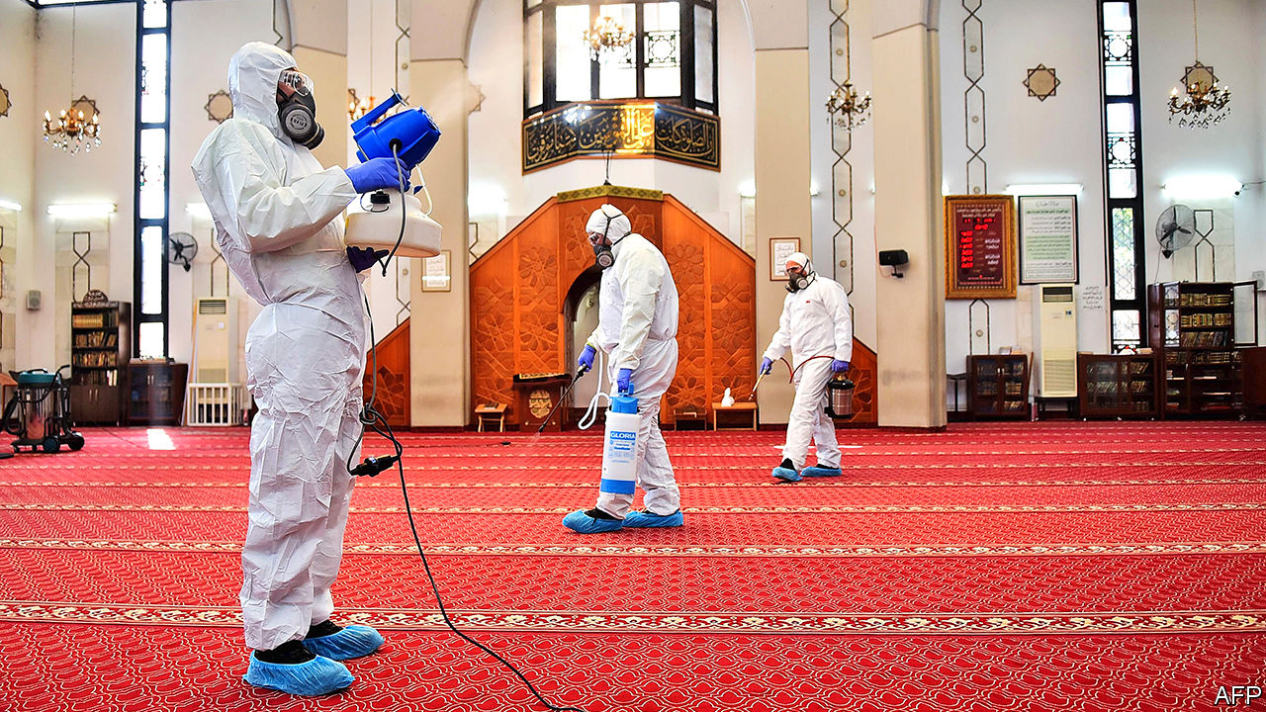

FOR CENTURIES the adhan, the Muslim call to prayer, has been a changeless feature of life in the Arab world. In war or peace, prosperity or famine, the same rhythmic chant echoes across cities and towns five times each day. Midway through comes an exhortation to worship. But on March 13th a muezzin in Kuwait, his voice plainly cracking with emotion, made a small tweak. Instead of “hayya alas-salah” (come to prayer), he told the faithful “as-salatu fi buyutikum” (pray in your homes). Words that seemed immutable were no longer such.

Covid-19 has already disrupted economic and social life. Across the Middle East it is also changing ancient patterns of worship. There is scriptural precedent for stopping Friday prayers: for example, an uncle of the Prophet Muhammad is said to have urged followers to stay at home during foul weather. But Kuwaitis say this is the first time in their modern history that prayers were cancelled.

Other countries are following suit. Egypt, the most populous Arab country, first capped Friday sermons at 15 minutes. Then al-Azhar, the Sunni world’s most prestigious scholarly centre, decreed that they could be halted altogether to stop the virus from spreading. The United Arab Emirates stopped them on March 18th. Jerusalem’s al-Aqsa mosque has been closed indefinitely, though worshippers still gather on the large esplanade outside.

The scene is even more striking in Mecca, the spiritual centre of the Muslim world. In normal times the city’s grand mosque is a teeming mass of humanity, filled day and night with thousands of pilgrims circumambulating the Kaaba, the imposing granite cube that is Islam’s holiest site. On March 4th, though, the authorities in Saudi Arabia suspended the umrah, a pilgrimage that occurs year-round. Astounded Saudis swapped photos of the mosque’s white-marble plaza, glittering in the sun—and deserted, save for a few workers spraying disinfectant.

Younger Saudis could not recall ever seeing it so empty; older ones drew a parallel with 1979, when the mosque was seized by extremists and besieged for two weeks. The government has not made any decision about the annual haj pilgrimage, which should begin in late July. Cancelling it would be a blow both spiritual and financial: it attracts millions of people and contributes more than $10bn to the Saudi economy. Pilgrimages are the kingdom’s largest source of revenue after oil.

Coptic churches in Egypt have suspended most activities. Instead of holding one large mass they plan to conduct several, to limit crowds. The Maronite church in Lebanon ordered priests to hand communion wafers to worshippers, instead of placing them on their tongues. Holy water has been replaced with hand sanitiser. In Jerusalem the Western Wall, the holiest site where Jews are permitted to pray, is largely deserted. Rabbis have urged the faithful not to kiss the stones.

## Qom on Iran

The outlier has been Iran. It has the third-highest number of confirmed cases of the virus, behind only China and Italy. Yet for weeks it refused to close the bustling shrines in Qom, a holy city that is the centre of its outbreak. When the authorities shut them at last on March 16th, small crowds broke through the doors in protest. A few other congregations have been restive: a mass in Ajaltoun, a village in the mountains north-east of Beirut, had to be halted when worshippers complained about the changes to communion.

Most have accepted them with equanimity, though. Some even find small cause for amusement. The new taboo around social contact is alien to many in the region, used to clasping hands or kissing on the cheeks. But it is old hat for conservative Muslims, who avoid physical contact with the opposite sex. Instead of awkward innovations like the elbow bump, they greet as they always have: a hand on the heart, a slight bow of the head. Not everything has changed. ■

This article was downloaded by calibre from <https://www.economist.com/middle-east-and-africa/2020/03/19/how-prayer-is-changing-as-a-result-of-covid-19>

|  |  |  |  |
| --- | --- | --- | --- |
| Previous | Articles | Sections | Next |

|  |  |  |  |
| --- | --- | --- | --- |
| Previous | Articles | Sections | Next |

#### Crisis, opportunity

# Binyamin Netanyahu vows to protect Israel from the virus

But his rival, Benny Gantz, has the first shot at forming a government

Mar 19th 2020 | JERUSALEM

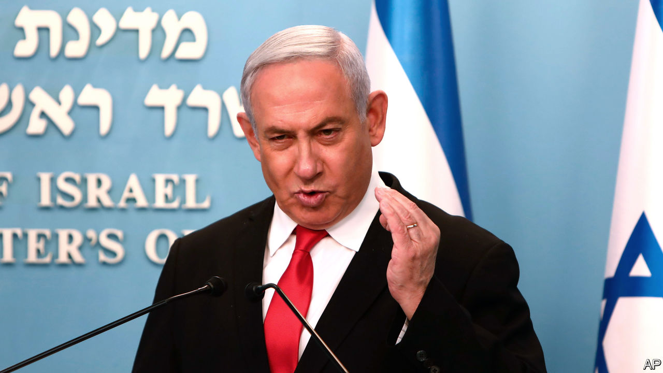

BINYAMIN NETANYAHU, Israel’s prime minister for the past 11 years, is never one to waste a crisis. In recent days he has used his televised briefings on the covid-19 pandemic to exhort the leader of the opposition, Benny Gantz, to join an emergency unity government—under Mr Netanyahu, of course. The prime minister seems undeterred by the failure of his coalition of nationalist and religious parties to win a majority in the parliamentary election on March 2nd (see chart), or by the charges of bribery and fraud that he faces.

On March 16th Mr Gantz was given the first shot at forming a government, having received the endorsement of 61 members of the 120-seat Knesset (Israel’s parliament). He vowed to “form a national unity government, as broad as possible, within days”. But his allies are united only in their desire to replace Mr Netanyahu. They include Yisrael Beiteinu, a Jewish nationalist party led by Avigdor Lieberman, and the Joint List, an alliance of Arab-majority parties that is now the third-biggest bloc in the Knesset. They are unlikely to sit in government together. Even some in Mr Gantz’s own party, Blue and White, oppose a government that is supported by Arab lawmakers.

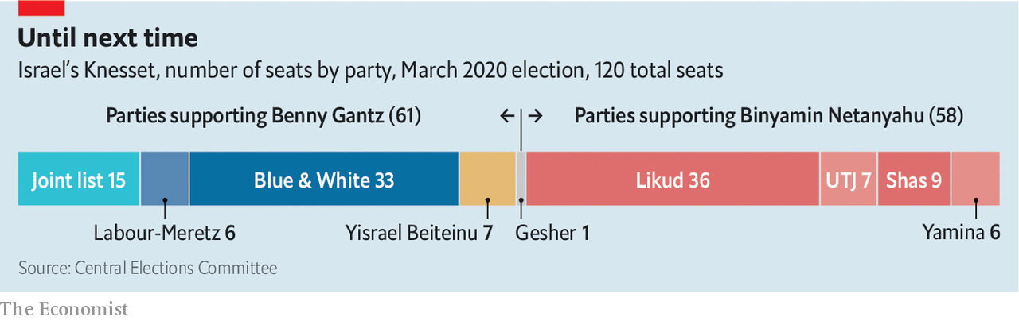

Mr Gantz’s preference would be to form a unity government that includes Mr Netanyahu’s Likud party. “I extend my elbow,” said Mr Gantz, referring to new guidelines barring handshakes. But Mr Netanyahu has always insisted that, if the premiership were to rotate between them, he should go first. Mr Gantz and his colleagues are loth to accept this proposal as they believe Mr Netanyahu would not abide by the deal. Moreover, they think he will use his position to try to shield himself from legal action. Mr Gantz could try to pass legislation preventing a politician facing criminal charges from forming a government. But right-wing politicians might accuse him of sabotaging the effort to fight covid-19.

The outbreak in Israel has given the negotiations a sense of urgency. There have been over 400 confirmed cases but no deaths yet. Israel is refusing entry to all foreigners. Citizens returning from abroad must self-quarantine for 14 days. Schools and restaurants have been ordered to close, and indoor gatherings of over ten people are banned. The government has also taken the controversial step of using mobile-phone surveillance technology, normally reserved for counter-terrorism operations, to track virus-carriers. By designating the move an “emergency measure”, Mr Netanyahu was able to bypass the Knesset.

A more comprehensive response, involving emergency funding, will be difficult to implement without a new government or oversight committees in the Knesset. Yet on March 18th the speaker of the Knesset, Yuli Edelstein, a Likudnik, adjourned the body for five days. Mr Gantz, backed by a majority, had been trying to replace Mr Edelstein and form the committees in a way that reflected the minority status of Likud and its allies.

Mr Netanyahu accuses Mr Gantz of practising “small politics” at a time of national emergency. But the same accusation has been levelled at the prime minister. His critics claim that he delayed the order to quarantine American visitors to Israel because of pressure from the administration of President Donald Trump, and that he delays the publication of public-health orders until his own televised briefings, so that he can strike the pose of a leader. “A small group of officials are really doing the hard work,” says a minister.

Mr Netanyahu’s trial, originally due to begin this week, has been pushed back to May 24th. Some have viewed this as a political decision—made by judges, but under pressure from the justice minister, a Netanyahu appointee. Mr Gantz, upon accepting the mandate to form a government, spoke of “illegitimate efforts by the current prime minister to evade justice”. ■

This article was downloaded by calibre from <https://www.economist.com/middle-east-and-africa/2020/03/19/binyamin-netanyahu-vows-to-protect-israel-from-the-virus>

|  |  |  |  |
| --- | --- | --- | --- |
| Previous | Articles | Sections | Next |

|  |  |  |
| --- | --- | --- |
| Middle East and ... | Sections | Britain |

Europe

Italy and covid-19: The race against time

.

Spain: Sánchez’s big test

.

Europe’s borders: Frontier theatre

.

France: The virus and the vote

.

North Macedonia: Deplinthing Alexander

.

Russia: The new Soviet Union

.

Charlemagne: Europe, more or less

.

|  |  |  |
| --- | --- | --- |
| Middle East and ... | Sections | Britain |

|  |  |  |  |
| --- | --- | --- | --- |
|  | Articles | Sections | Next |

#### A gathering catastrophe

# Italy is overtaking China as the country worst-hit by covid-19

The government is scrambling to meet the challenge

Mar 19th 2020 | ROME

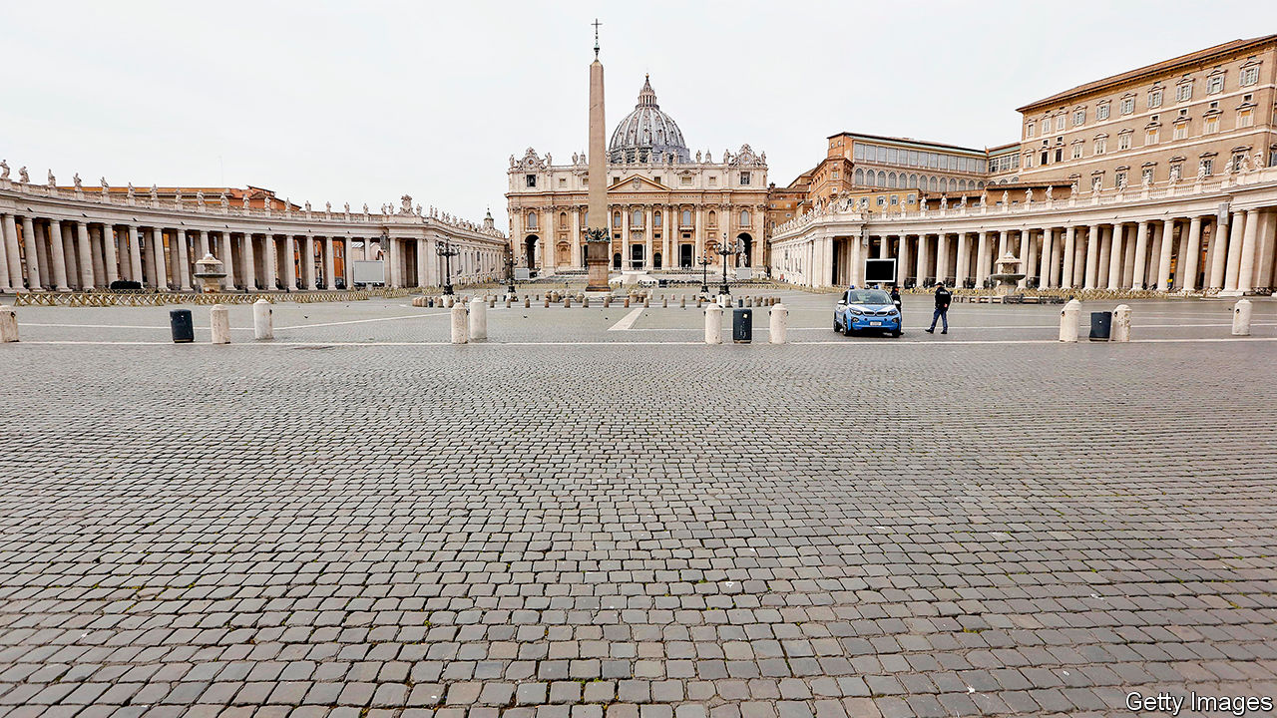

GIULIO GALLERA, a Milanese corporate lawyer from Silvio Berlusconi’s Forza Italia party, is health minister in the regional government of Lombardy. “We are working hour by hour,” he said on March 17th. “Yesterday, we were almost [down] to zero beds in intensive care.” What were lacking were ventilators to go with the other equipment. But then the Red Cross offered 30. “When, at 10pm, the news came through of those 30 ventilators, I almost wept,” said Mr Gallera.

Nowhere is Italy’s race against time more dramatically evident than in Lombardy, the region around Milan and the one worst hit by the spread of covid-19. In the city of Bergamo, the virus has overwhelmed the local health system. Doctors have been taking life-and-death decisions since last month, deciding which patients should be put on the available ventilators. It is hoped that a vast makeshift intensive-care unit being assembled at the Milan exhibition centre will supply the capacity Lombardy needs to cope with relentlessly growing demand. Mr Berlusconi has personally donated €10m ($11m) to the project.

By March 18th the number of people in Lombardy who have tested positive had grown to 17,713, almost half the national total. Of these, 1,959 had died and 924 were in intensive care.

The next few days will be crucial in showing whether draconian containment measures ordered by the central government (see Briefing) will begin to slow the spread of the virus in northern Italy and mitigate its effects on the rest of the country, where it could speedily overwhelm health services far weaker than that of prosperous Lombardy. It is grimly predictable that Italy’s death toll of 2,978 when The Economist went to press will soon pass China’s to become the highest in the world.

In Lombardy, the number of new daily cases is still growing, but as a share of the total existing cases the number is starting to fall. By March 18th it was down to 9.2%. Three days earlier, the governor, Attilio Fontana, noted the change. “Let’s hope it is the start of a trend reversal,” he said. But he added: “I am saying it in a whisper.”

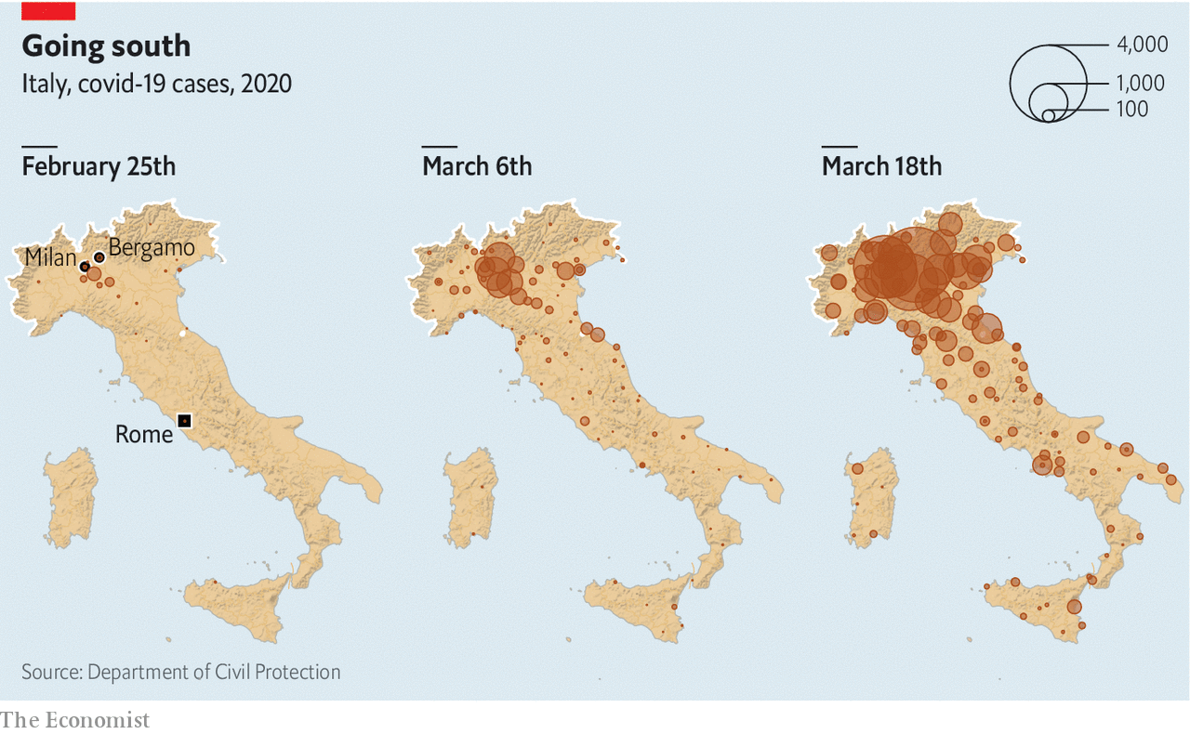

Nationally, the percentage increases have also been dropping. But the latest figures showed an uptick, from 12.6% to 13.4%, as the virus spread out to other regions north and south of Lombardy. The absolute numbers, which are what matter to the country’s regional health services, keep rising alarmingly.

So far the south has had fewer than 5% of cases. But tens of thousands of people have fled from the north as the virus spread. The worry is that some are asymptomatic carriers and that the next few days could see the tally of infections soar in the Mezzogiorno, where people have been less scrupulous in respecting the lockdown.

The extent and duration of the epidemic will also determine its impact on a weak economy. Francesco Daveri, who teaches macroeconomics at Bocconi University in Milan, says much depends on when the country returns to normal. If it is in June, he conjectures that the fall in GDP for 2020 could be 2-3%—substantially less than the 5.5% fall in 2009 after the financial crisis. That is a big “if”, though.

On March 16th Giuseppe Conte’s government, a coalition of the centre-left Democratic Party (PD) and the anti-establishment Five Star Movement (M5S), unveiled an emergency budget worth €25bn ($27bn). It includes €10bn of support for incomes and employment, such as a payment in March of €600 for non-salaried workers and a two-month freeze on lay-offs. Other measures include loan guarantees and a moratorium on loan repayments for small and medium-sized companies. “But, almost certainly, a second raft of measures will be needed, targeted more selectively at the sectors that have suffered most,” says Mr Daveri.

The emergency budget marked the second time Mr Conte had trumped his critics, notably in the hard-right Northern League, by providing more than they had demanded (the first time was when he applied stiffer containment measures across the entire country). As before, he waited to show it was he, not they, who was in control. His canny tactics are paying off: the most recent poll found 62% of voters endorsed his government’s handling of the epidemic.

One exception is the League’s leader, Matteo Salvini. He has kept up a barrage of criticism, despite evidence that Italians want their politicians to mute their differences until the crisis is over. On March 16th he was embarrassed by a photograph showing him and his girlfriend strolling through Rome, ignoring the government’s insistence that people keep a metre apart and possibly its requirement that they have a valid reason for leaving home. Mr Salvini said he was shopping for necessities. “This is surely not his moment,” says Sofia Ventura, a professor of political science at the University of Bologna.

It is less obvious that in the longer term the epidemic will undermine the nationalist populism of which Mr Salvini is Italy’s (and arguably Europe’s) most prominent champion. True, it has swept away the disdain for experts that is a core populist trait. Never have Italians been keener to listen to their virologists and epidemiologists or more respectful of their health workers. But contempt for science is more characteristic of the M5s, and the crisis may yet lend credibility to the League’s causes, including its antipathy to globalisation and its Euroscepticism. Already shocked by their neighbours’ refusal to allow the export of protective equipment, Italians were appalled when on March 12th the European Central Bank governor, Christine Lagarde, appeared to rule out steps to protect Italy from the effects of additional borrowing, though she later changed tack, and the bank introduced a large new bond-buying scheme on March 18th.

“When Europe has been in need, Italy has always given,” Mr Salvini railed in one of his many tweets. “Now that we are asking for help, all the [other] countries are starting to close their frontiers.” It is an oversimplification, but one that will strike a chord with many Italians. ■

This article was downloaded by calibre from <https://www.economist.com/europe/2020/03/19/italy-is-overtaking-china-as-the-country-worst-hit-by-covid-19>

|  |  |  |  |
| --- | --- | --- | --- |
|  | Articles | Sections | Next |

|  |  |  |  |
| --- | --- | --- | --- |
| Previous | Articles | Sections | Next |

#### Sánchez’s big test

# Spaniards are uniting against covid-19

Now is not the time for political bickering

Mar 19th 2020 | MADRID

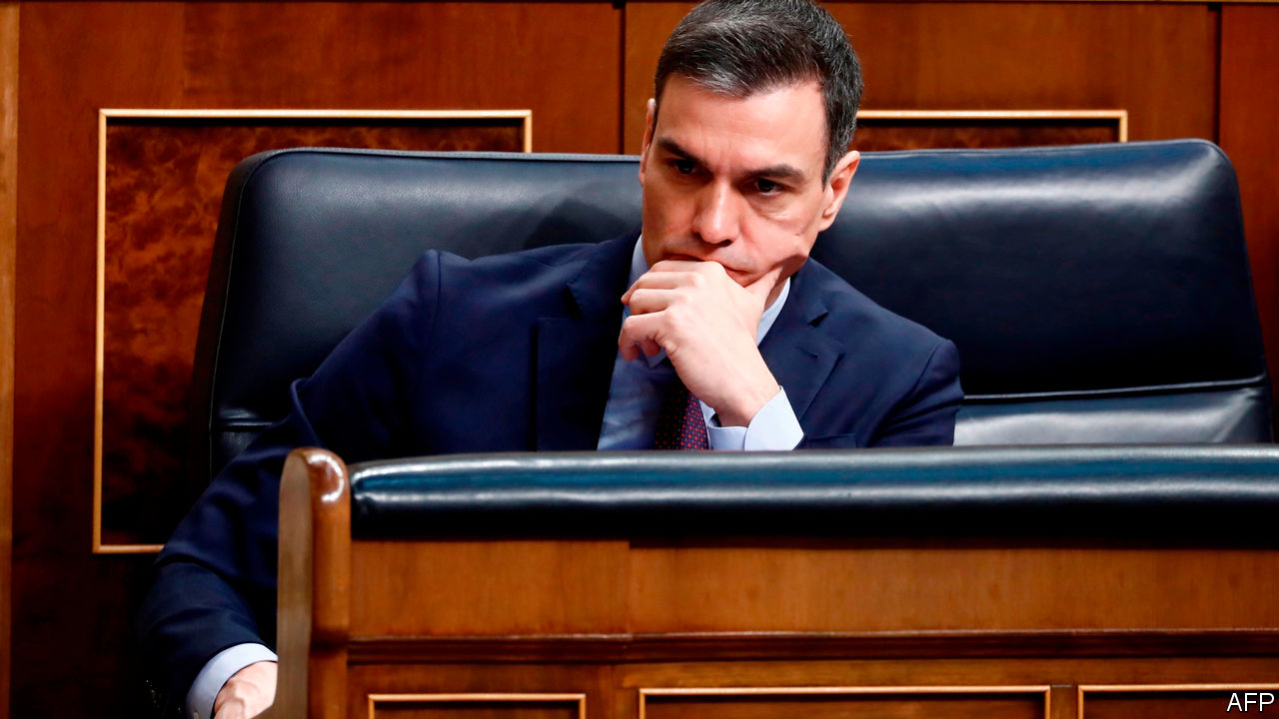

NEXT TO THE Street of the Virgin of Dangers, in the heart of Madrid, builders have been finishing years of work on a big new luxury hotel that was due to open in May. Like almost everything else in Spain’s economy, that plan is now up in the air. Facing Europe’s worst outbreak of covid-19 after Italy’s, Spain’s government on March 14th imposed a state of emergency, locking the country down for 15 days. Down the road from the hotel the Puerta de Sol, a normally busy transport hub, is deserted. With 14,370 cases and 630 deaths by March 18th, rising steeply each day, the shutdown is likely to last at least a month. It is a test not just of the patience of Spaniards but of their inexperienced coalition government. After a halting start, Pedro Sánchez, the Socialist prime minister, at least seems to have the country behind him.

In Spain’s decentralised democracy, health care is run by regional governments, and so in Catalonia and the Basque country is policing. The novel coronavirus has taken its strongest grip in Madrid, governed by the conservative opposition People’s Party (PP). As cases ramped up last week Mr Sánchez was accused of being “behind events” by Pablo Casado, the PP’s leader.

Acting unilaterally, the Madrid regional government closed all educational establishments as well as day centres for old people; the Basque government closed some schools; and Catalonia isolated 70,000 people around the town of Igualada. The opposition criticised Mr Sánchez and Podemos, his far-left coalition ally, for allowing a big feminist march to go ahead on March 8th. Several of those who took part, including the partners of both Mr Sánchez and Pablo Iglesias, Podemos’s leader, later tested positive for the virus (as have other politicians from the right).

The government at last got a grip on March 14th when, after a seven-hour cabinet meeting, it issued its emergency decree. The delays reflected disagreement between the economic team, which favoured caution, and those who favoured lockdown and sweeping compensation.

The decree puts the national government in charge of health care and policing. It prompted grumbling from Quim Torra, the separatist head of the Catalan administration and to a lesser extent from his Basque nationalist counterpart. Mr Sánchez insists that the virus is no respecter of ideology or place. Most of the opposition has swung behind him. That may make it easier for him to get a budget through Congress. He needs it: despite public debt of 96% of GDP, the government announced a big, and welcome, package to help laid-off workers and struggling businesses.

So far Spaniards seem to be rallying round. Each evening at 8pm residents stand on balconies to applaud harried health workers. Patience may flag. But for now, the virus has revived the nation-state after years of centrifugal pressure. ■

This article was downloaded by calibre from <https://www.economist.com/europe/2020/03/19/spaniards-are-uniting-against-covid-19>

|  |  |  |  |
| --- | --- | --- | --- |
| Previous | Articles | Sections | Next |

|  |  |  |  |
| --- | --- | --- | --- |
| Previous | Articles | Sections | Next |

#### Frontier theatre

# Why Europe’s new border controls won’t help much

The real work of beating the virus takes place at home

Mar 19th 2020 | BERLIN

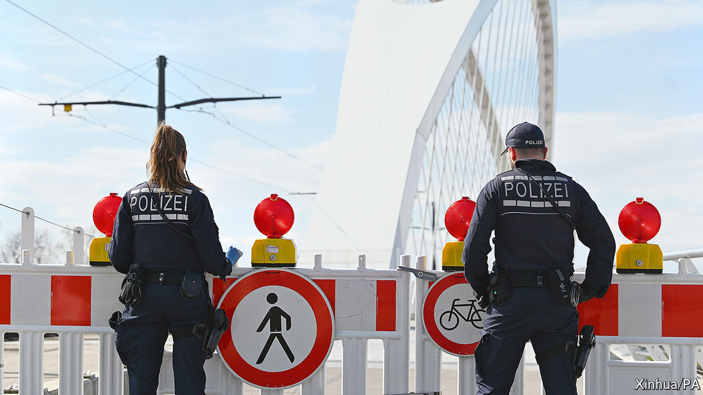

TWO HUNDRED kilometres of glistening slopes, a gorgeous Alpine setting and a boisterous après-ski scene make Ischgl, a resort in the western Austrian state of Tyrol, one of Europe’s livelier winter playgrounds. It has also turned out to be one of its worst coronavirus hotspots. Hundreds of European cases, especially in the Nordic countries and Germany, have been traced to Ischgl, many of them to a bar renowned for its crowded, dancing-on-tables parties. Air, road and rail links from Austria to other countries have been cut, and governments have quarantined visitors returning from the now-shuttered resorts.

The speed with which the virus has raced from country to country has driven several European governments to adopt a familiar remedy: border controls. In the past week, as governments woke up to the scale of the pandemic, several began limiting entry to outsiders, albeit in haphazard and un-coordinated fashion. Central European and some Scandinavian countries moved first, sealing off entry to most foreigners. On March 16th Germany imposed controls at most of its land frontiers, citing the need to stop the spread of the virus but also to limit cross-border panic-shopping. Goods transporters and commuters were exempt, but for the first time in years they needed to show uniformed officials documentary proof of their right to cross the border. Hiccups were inevitable, especially at Poland’s tightly controlled frontiers. There were reports of 18-hour traffic jams at one crossing with Germany. Some 21,000 people were turned away in two days.

Such measures contradict the spirit, if not the letter, of the European Union’s Schengen zone. Schengen is meant to guarantee document-free travel across the borders of its 26 member-countries (four of which are not in the EU). It has provisions for emergencies. But the speed with which governments erected checks revived unhappy memories of the crisis in 2015-16, when migrants poured across Schengen’s external border into Greece and internal controls went up as far away as Sweden. Six Schengen countries have had partial controls in place ever since, making a mockery of what are supposed to be strictly time-limited exemptions. Now the virus is encouraging the barrier-builders.

The European Commission, as the body charged with keeping goods and services flowing across the EU’s single market, frets more than most. On March 17th European heads of government approved a proposal from Ursula von der Leyen, the commission’s president, to block foreigners from entering the EU for 30 days, with exceptions for legal residents, medical and health workers, and citizens of Britain plus the four non-EU Schengen members. Ms von der Leyen hopes that tough action at the external border will soothe leaders’ nerves enough to ease the internal ones, which she fears could hold up the cross-border provision of food, medical supplies or transport workers. But there is little sign of that yet.

Around 80 countries have restricted travel in some way since the outbreak began, including America, which has imposed a travel ban on Europe and closed its land border with Canada. At the start of an outbreak, when a place has few or no infections, such controls can buy time for governments to put in place social-distancing measures. They might also reduce the likelihood that infections will resurge once a country has got its internal situation under control, as China and South Korea appear to have done.

Yet most experts think border controls are largely useless for protecting areas in which infected people are already mingling. “From an epidemiological point of view border controls are a distraction, and potentially a damaging one,” says Christopher Dye of Oxford University. In a study in 2014, five analysts found that internal and international travel restrictions imposed during influenza outbreaks cut the number of new cases by less than 3%. During the Ebola crisis in west Africa, controls may have made things worse by encouraging infected people to sneak across borders, evading health checks.

There may be a case for governments to introduce checks as part of a suite of actions to convince citizens that the threat is serious enough to warrant adjusting their behaviour: border controls as theatre. But that must be set against the costs of such measures, from the risk of blocking goods transport to shoving airlines into bankruptcy. Ultimately, says Dirk Brockmann at Humboldt University in Berlin, the effect of closing borders is marginal next to social-distancing measures designed to limit interpersonal contact. That lesson may be getting through. Five European countries, including Austria, have now introduced draconian rules banning citizens from leaving home under most circumstances. The new coronavirus will be defeated inside borders, not at them. ■

This article was downloaded by calibre from <https://www.economist.com/europe/2020/03/19/why-europes-new-border-controls-wont-help-much>

|  |  |  |  |
| --- | --- | --- | --- |
| Previous | Articles | Sections | Next |

|  |  |  |  |
| --- | --- | --- | --- |
| Previous | Articles | Sections | Next |

#### The virus and the vote

# France suspends local elections because of covid-19

President Emmanuel Macron’s handling of the crisis gets high marks from the public

Mar 19th 2020 | PARIS

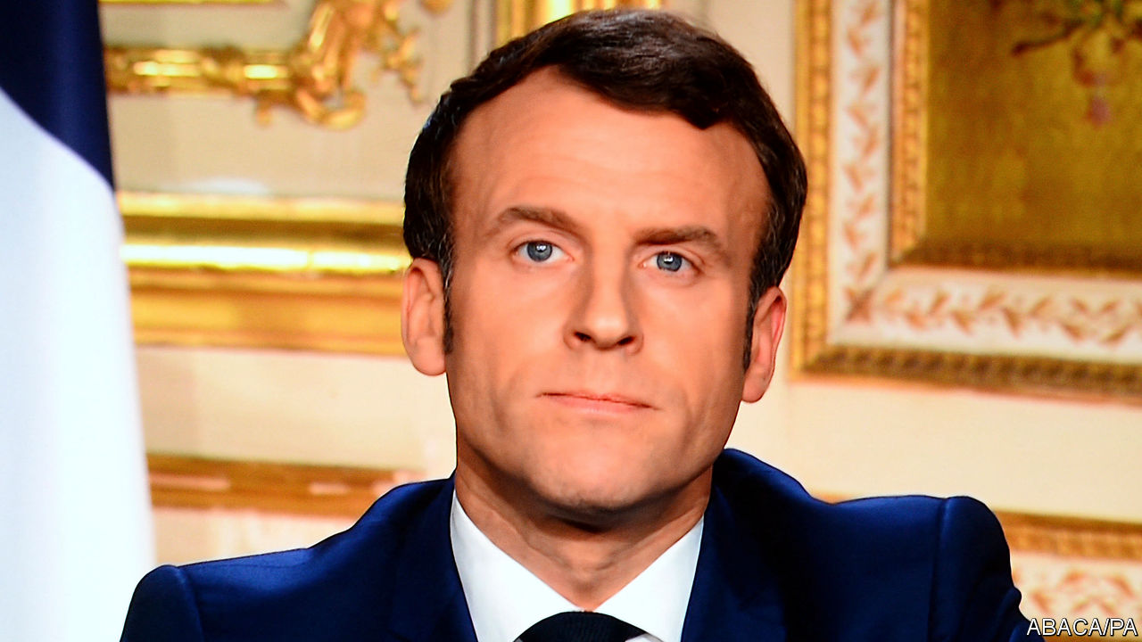

AN EERIE SILENCE descended on the French capital at noon on March 17th. In a city famed for its café culture and street life, policemen with megaphones were on patrol, checking papers and ordering those still out without permission to go back indoors. All residents countrywide were told to stay at home, unless they need to shop for food or medicine, attend medical appointments, or go to an essential job. Yet just two days earlier the same government had urged the French to vote in the first round of the municipal elections in the country’s 35,000 cities, towns and villages.

As the country adjusts to the drastic new regime, questions are inevitably being asked. The week before confinement, mayoral candidates were still holding rallies, though with a cap of 1,000 people. On March 12th President Emmanuel Macron announced that the situation was worrying enough to close all schools and universities from March 16th. His prime minister, Edouard Philippe, introduced stage three on March 14th, shutting all cafés, restaurants, non-food shops, hairdressers, cinemas and sports centres. The elections, they said, would go ahead.

There followed surreal scenes on voting day. Polling stations were organised to ensure that staff and voters remained at least a metre apart. Returning officers counted the vote wearing masks and gloves. Official results were declared, showing, broadly, a strong Green vote, backing for incumbent mayors, poor support for Mr Macron’s party and a record low turnout. Yet, at the same time, Parisians were to be found gathered in parks or shopping in crowded street markets, ignoring advice to stay in. The next day, Mr Macron addressed the nation again, deploring the fact that people were behaving “as if, basically, life had not changed”. He suspended the second-round vote, due on March 22nd, shut France down, and declared, “We are at war.”

Why did Mr Macron not delay the elections earlier? His former health minister now says she knew it was a “masquerade” to go ahead. It turns out that postponement was still on the table as late as March 12th. Delaying a democratic vote, however, was a decision that required cross-party consensus, at least politically. There was already a climate of suspicion at the government’s recent use of a decree to pass its pension reform. Gérard Larcher, president of the Senate, opposed a postponement. Christian Jacob, the Republican leader (who has since contracted covid-19), had said publicly that a delay would constitute a coup d’état. Moreover, the scientific council advising the president suggested that voting would not pose a health hazard if sanitary rules were followed.

As France deals with an acceleration of cases, such questions will become second-order. A military hospital is being mobilised in Alsace, one of the worst-affected regions. Fully 66% of the French told a poll that they found Mr Macron’s first address, which mixed solemnity and science with much-needed warmth, convincing. An astonishing 35m people, more than half the entire population, watched his second. And, despite disapproving of the decision to hold a first-round vote, 57% of the French think he and his government are managing the crisis well—his highest approval rating for a very long time. ■

This article was downloaded by calibre from <https://www.economist.com/europe/2020/03/19/france-suspends-local-elections-because-of-covid-19>

|  |  |  |  |
| --- | --- | --- | --- |
| Previous | Articles | Sections | Next |

|  |  |  |  |
| --- | --- | --- | --- |
| Previous | Articles | Sections | Next |

#### Deplinthing a potentate

# The tricky politics of tearing down statues of Alexander the Great

Nationalists in North Macedonia claim the ancient conqueror as their own. Greece begs to differ

Mar 19th 2020 | SKOPJE

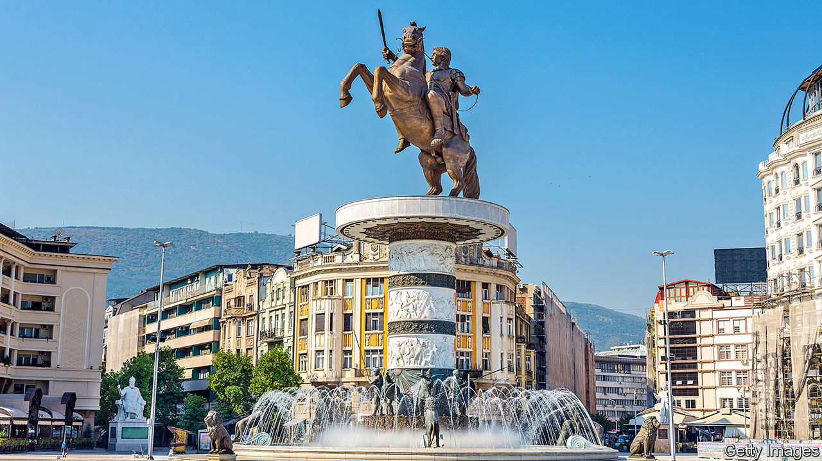

ALEXANDER THE GREAT is off to the dump. If the authorities in Skopje, the capital of North Macedonia, have their way, statues and monuments glorifying him, his father Philip II and other ancient, mythical and more modern Macedonians around the city will soon be yanked off their pedestals and dispatched to a distant park on a reclaimed rubbish tip.

Skopje was refurbished by the previous city authorities, who lost power in 2017. One aim of their €685m ($765m) renovation project was to instil pride in an antique Macedonian past centring on Alexander, the general who created an empire stretching as far east as Pakistan by the age of 30. But Greeks regard Alexander as wholly theirs, and reckon that Skopje’s claim to him is absurd. The territory now occupied by North Macedonia was not, they argue, even part of the ancient kingdom of Macedonia (the Romans added it to their province of that name later on.) By claiming him, North Macedonia poisoned relations with Greece, the regional economic hegemon.

A new coalition government finally managed to end the 27-year-old conflict with Greece in 2018 by agreeing to change the country’s name from Macedonia (which is the name of a Greek region) to North Macedonia.

The Social Democrats who now run Skopje have talked of removing a giant Alexander statue, and others of him and other heroes, though done little. Cost is one reason, says Nikola Naumoski, the mayor’s chief of staff, but politics is a bigger one. Every statue is “like a landmine”, he says. If they are removed, protests will erupt. For that reason, the government pressed the city authorities to hold off on purging the plinths.

However, in October France vetoed the opening of EU accession talks with North Macedonia, infuriating its government. An election was called shortly afterwards, but is now up in the air, thanks to the coronavirus. If the nationalists return to power, they will stop the statues from being removed. But if the incumbent Social Democrats win, says Mr Naumoski, Alexander will be taking a long walk in the park.

This article was downloaded by calibre from <https://www.economist.com/europe/2020/03/19/the-tricky-politics-of-tearing-down-statues-of-alexander-the-great>

|  |  |  |  |
| --- | --- | --- | --- |
| Previous | Articles | Sections | Next |

|  |  |  |  |
| --- | --- | --- | --- |
| Previous | Articles | Sections | Next |

#### Another president for life

# Some Russians are resisting Putin’s power grab

His new constitution recalls the Soviet Union

Mar 19th 2020 |

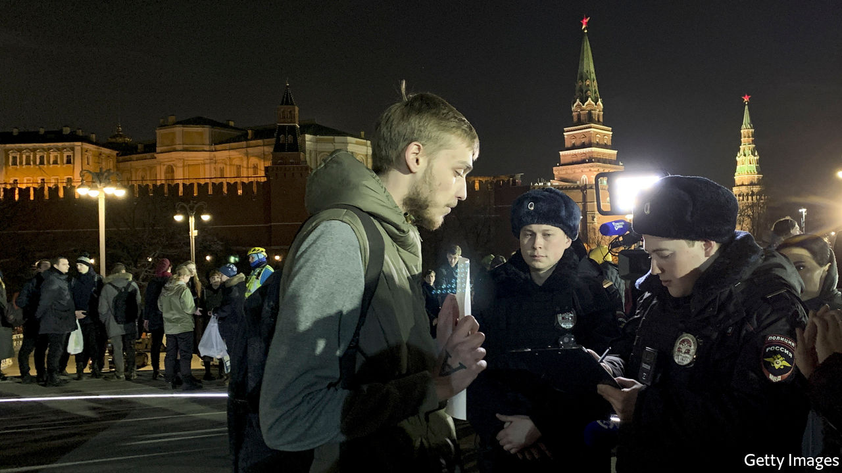

THE WORLD might be heading into its biggest crisis since the second world war, Russians may be sweeping the shelves of supermarkets clean, but Vladimir Putin knows his priorities. On March 17th he decreed that his country must hold an “all-people vote” on a constitutional change designed to keep himself in power indefinitely. “Against the background of the pandemic, Putin’s decision seems criminal,” tweeted Alexei Navalny, Russia’s most prominent opposition figure.

Mr Putin later said the vote could be postponed if need be, but for now it is to be held on April 22nd—the birthday of Vladimir Lenin. It is as meaningless as were elections in the Soviet Union The amendments that give the president vast powers and reset the clock on his term limits have already been signed into law by Mr Putin and approved by a pliant Constitutional Court. Ekaterina Schulmann, a political scientist, said on Facebook about the court that “rarely has the spirit of slavery and intellectual cowardice revealed itself so fully in a written text.”

The spectacle of a “people’s approval” is likely to stretch over several days, requires no minimum turnout or independent verification and will include home and electronic voting. “Putin was too scared to hold a proper referendum so he came up with this fake procedure,” says Mr Navalny. “The Kremlin is desperate to draw us into it, count us up and then declare victory,” he adds. He has refused to participate in it. On March 15th a group of 350 lawyers, intellectuals and journalists signed an open letter warning of a constitutional coup that threatens to plunge the country into a national conflict. Three days later the number of signatures had swelled to 30,000.

Even Mr Putin’s loyalists feel deceived. “Lying to foreigners is one thing. Lying to his own people is quite another,” one former military officer says. The growing fear of a covid-19 outbreak in Russia, where the number of cases has been suspiciously low, and Mr Putin’s insistence on sticking with the vote, despite his government’s decision to close borders and schools, could exacerbate that anger. Many people remember the Kremlin lying about the scale of the Chernobyl nuclear disaster in 1986. Mr Putin’s amended constitution proclaims today’s Russia to be the heir to the Soviet Union, whose falsehood-filled propaganda rag was called, simply: “Truth”. ■

This article was downloaded by calibre from <https://www.economist.com/europe/2020/03/19/some-russians-are-resisting-putins-power-grab>

|  |  |  |  |
| --- | --- | --- | --- |
| Previous | Articles | Sections | Next |

|  |  |  |  |
| --- | --- | --- | --- |
| Previous | Articles | Sections | Next |

#### Charlemagne

# More Europe or less?

The EU must move closer together—or let states save themselves

Mar 19th 2020 |

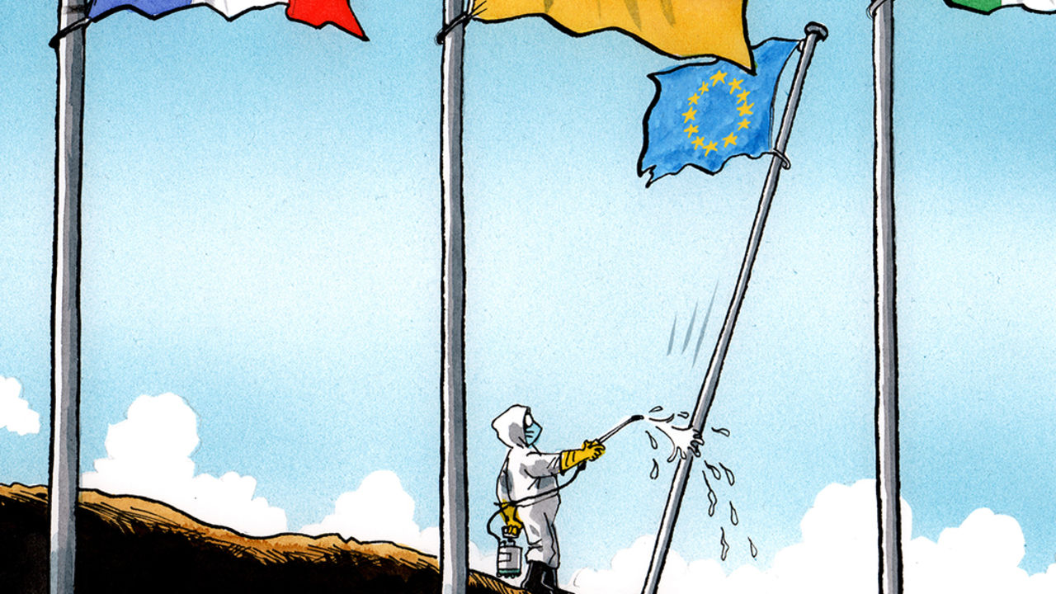

“MORE EUROPE” is the invariable mantra for the European Union’s most devout believers. The president of the European Commission, Ursula von der Leyen, is particularly fond of the phrase, usually as a solution to the pressing geopolitical questions of the day. The answer to a rising China? More Europe. A response to a wayward Washington? More Europe. “The world is calling for more Europe,” declared Mrs von der Leyen after her selection last summer. “The world needs more Europe.”

Faced with the covid-19 pandemic, however, the commission has so far opted for a different tactic: less Europe. It has focused on getting the EU out of the way of national governments. Fiscal rules are being quietly abandoned, allowing national governments to spend heroic amounts to allay the crisis. State-aid rules, which stop governments from flooding pet businesses with cash, are being loosened. Some €37bn ($41bn) of funds earmarked for the structural projects that make up the humdrum daily business of the EU budget can be spent on keeping people alive instead.

From one perspective, covid-19 torpedoes the logic of “more Europe”. At its heart was a belief that a body like the EU is the only means of survival in a globalised world. In comparison, the bog-standard nation-state—developed to fend off the miserable Hobbesian state of nature—seems dated and almost vulgar. A pandemic, however, is a nasty blast from this ugly past. The EU evolved to deal with a post-modern world, where borders blurred and markets ruled. Pandemics are a pre-modern problem, best solved by the tool that brought order to a brutish world: the modern state.

Keeping people safe is, after all, a state’s primary concern. Health is the purview of national governments, according to the EU’s treaties. Previous European crises festered in the cracks between national and EU responsibility. Monetary union without a fiscal union left a wound that turned gangrenous. Introducing a passport-free Schengen zone without a functioning European asylum system was another example of half-baked federalism. Often, Brussels is left with responsibility for a topic but not the power to do anything. In this case, responsibility is clear. The actions of national governments will determine how many live or die. Complaining that the EU is failing to help on health matters is akin to buying a cat and moaning when it will not fetch a stick.

When not pursuing “less Europe”, the EU can be most efficient by maintaining the same amount of Europe. Each country will simultaneously face colossal strains on its health service. A functioning single market can churn out medical equipment more efficiently than states going every man for themselves. Yet already accusations of hoarding are flying, while traffic jams build up on intra-EU frontiers after panicky border closures. If goods disappear and markets collapse in a crisis, then old-fashioned autarky starts to appeal and the allure of the EU’s slick trading system fades. Keeping national governments from actively working against one another would be triumph enough for Brussels.

For the optimists, however, this is a perfect moment for the “more Europe” mantra. So-called coronabonds would allow struggling euro-zone states to fund themselves with debt guaranteed by the bloc as a whole. Such an idea is often floated as a cure for the euro-zone’s ills. Countries such as Italy, whose borrowing costs have shot up, love the idea; those who would probably end up paying, such as the Netherlands and Germany, have historically been far less keen. Attitudes could shift. A pandemic comes without the moral baggage of borrowing and the caricatures of feckless Italians running up debts. It is a natural disaster, endured by all.

The European Central Bank, based in Frankfurt, has now done its bit for “more Europe”. It launched a €750bn bond-buying programme late on 18th March. Unlike with earlier schemes from the central bank, Greece’s debt, previously excluded, will be eligible for purchase. After bungling her initial response to the crisis, ECB chief Christine Lagarde issued a belated guarantee: “There are no limits to our commitment to the euro.” The statement was a homage to the mantra of her predecessor, Mario Draghi, who said he would do “whatever it takes” to save the euro.

Yet not all EU leaders are as happy to seize the “more Europe” moment. Some are chomping at the bit. The French president, Emmanuel Macron, applauded the ECB and called for “greater financial solidarity” in the euro zone. Other leaders were muted. In meetings behind closed doors, EU leaders agreed to stick with the “whatever it takes” formulations beloved by the ECB but have offered few actions to back up the words. At the moment, the phrase is used in the same way children say “open sesame!”. Monetary policy is only one half of the solution. A co-ordinated fiscal response at a European level is still necessary for leaders to dig themselves out. It is not guaranteed to happen.

## Leviathan unleashed

If European leaders spurn “more Europe” on the fiscal level, then at least they should remove the manacles that fetter Leviathan. Shackling the state was not some Lilliputian scheme by small-minded bureaucrats. The EU has reined in the worst impulses of national governments, first in the name of peace, by binding economies so closely together that war was impossible; then, with the aim of prosperity, by stopping them running huge deficits or pouring mad amounts of money into airlines because they have the national flag on the tail-fin. Deficits and bungs are petty concerns in the face of mass death. The state must be unbound.

Covid-19 will offer the most brutal test not of the EU but of Europe’s member-states. Without the EU finally binding itself together fiscally, it will be left to individual states to write the cheques that stop their economies choking. It will be states that deal with the sick. It will be states that take the blame from the bereaved. “More Europe” offers a tantalising solution to the EU’s latest crisis. But “less Europe” must also have its role. ■

This article was downloaded by calibre from <https://www.economist.com/europe/2020/03/19/more-europe-or-less>

|  |  |  |  |
| --- | --- | --- | --- |
| Previous | Articles | Sections | Next |

|  |  |  |
| --- | --- | --- |
| Europe | Sections | International |

Britain

Government: Leviathan rising

.

Theatreland: Curtains

.

Trains: Bailing out the railways

.

Panic buying: Supermarket sweep

.

Old people: Leave granny alone

.

Life under lockdown: Dispatches from the front room

.

Brexit and covid-19: Crises collide

.

Digital infrastructure: Stayin’ online

.

Bagehot: The spirit of the Blitz

.

|  |  |  |
| --- | --- | --- |
| Europe | Sections | International |

|  |  |  |  |
| --- | --- | --- | --- |
|  | Articles | Sections | Next |

#### Government

# The virus means the big state is back

Covid-19 is the main reason, but not the only one

Mar 19th 2020 |

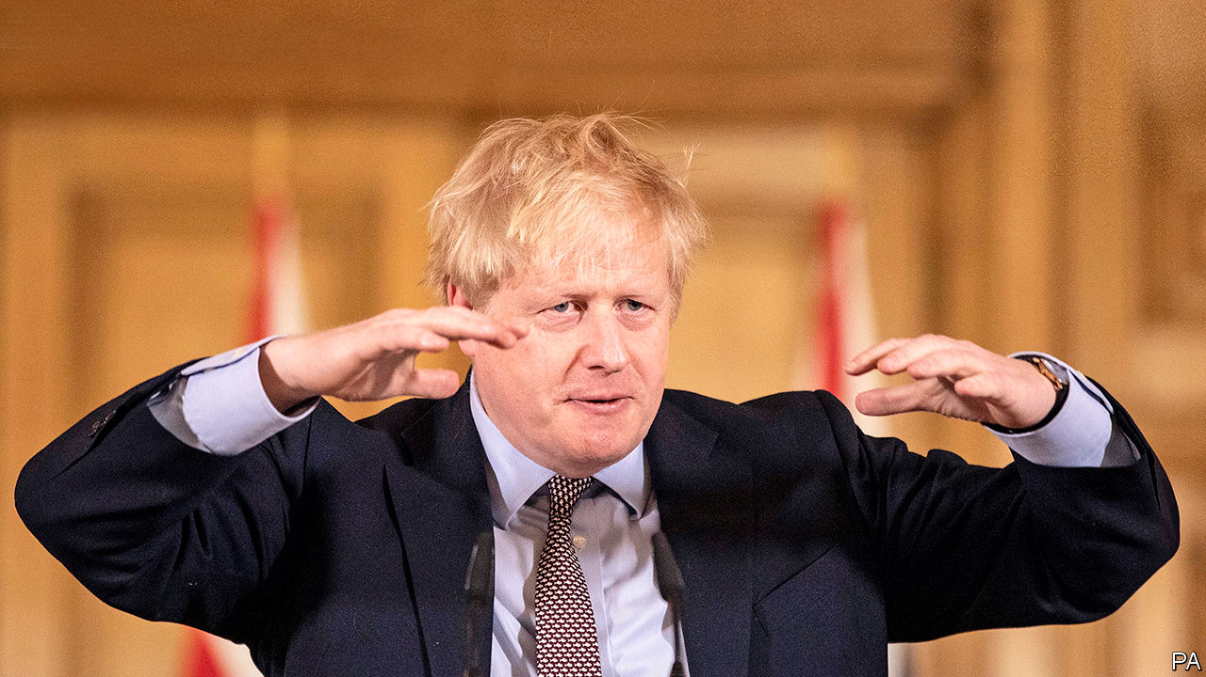

IN 2012, IN the midst of David Cameron’s austerity campaign, a clutch of newly elected Tory MPs published “Britannia Unchained”, a book lamenting Britain’s “bloated state, high taxes and excessive regulation”. The authors included Priti Patel, Dominic Raab and Liz Truss, now home, foreign and trade secretaries respectively. Later, Boris Johnson would advertise Brexit as a liberating mission for a nimble nation. His supporters dreamed of turning Britain’s face away from Brussels and towards Singapore.

They were swimming with the tide, for the horizons of the British state have shrunk over the past 40 years. It intervenes in fewer markets and owns fewer industries. Limits on executive power have been embraced: state aid and competition laws, human rights legislation, and the expansion of judicial review.

But since 2016 this trend has reversed. Brexit is one reason: £6bn ($7bn) in funds and some 20,000 officials have been dedicated to the project, partly reversing cuts to the civil service headcount. The government prepared a bail-out fund for businesses and emergency ferry capacity in case of a messy exit. The free movement of people will be replaced by an occupation-based visa system, representing a shift towards state planning in the labour market.

The second factor is Mr Johnson’s plan to level up poorer parts of the country. In the budget on March 11th, Rishi Sunak, the chancellor, announced £640bn on infrastructure spending over five years, the highest as a share of GDP since the 1970s. Public spending as a share of GDP under Mr Sunak’s plan was due to settle at 40-41%, higher than any recent point outside the financial crisis. Jesse Norman, a treasury minister, says Brexit and big spending are linked. “It’s a Burkean understanding that a nation is a moral idea: a group of people bound together by a moral affinity. It’s that legitimating sense of self that underwrites a nation’s capacity to tax.”

Failing railway franchises have been renationalised with little murmur in recent years. Controls on energy prices, denounced as Marxist by the Tories when proposed by Ed Miliband, then Labour leader, in 2013, were implemented by Theresa May and will be kept by Mr Johnson. He plans new taxes on social-media companies, and new rules over online content.

The third factor is Mr Johnson’s aversion to restraints on ministerial discretion. He hopes to reform judicial review to prevent the courts being used to conduct “politics by other means”, and wants to review human-rights laws to ensure “effective government”. He skips scrutiny hearings in Parliament and plans to loosen European Union rules on state aid and procurement.

But covid-19 is likely to do more than all of these to extend the reach of the state. Already the government has introduced a degree of social control not seen since the second world war. Schools are closing indefinitely. Office workers have been told to stay at home. The elderly have been urged to cocoon themselves from human contact. There is widespread expectation of a lockdown in London. Emergency legislation will allow the speedy hiring of retired and student nurses, the detention of the infectious, the closure of ports and the rapid burial of the dead.

On March 17th Mr Sunak announced a vast economic intervention. He proposes £330bn ($389bn) of state guarantees for bank loans to firms, equivalent to 15% of GDP, plus £20bn of grants and tax reliefs for the leisure industry and small businesses. It followed £12bn of assistance announced in the budget. Airlines and train companies may be nationalised, said Grant Shapps, the transport secretary. Carmakers, drafted 80 years ago to assemble Spitfires, have been asked to make ventilators. Landlords may not evict tenants during the crisis. “This is not a time for ideology and orthodoxy,” said Mr Sunak.

What state will emerge from the virus? The courts should prevent emergency powers granted to handle coronavirus from being misused once normality returns, says Jonathan Sumption, a historian and former Supreme Court judge. But some measures may prove hard to unwind. A better deal for self-employed workers, renters and benefit claimants could be popular. Nationalised transport companies may prove efficient, or hard to sell. The BBC’s doughty schedule of emergency programming is a rebuke to its opponents.

Government itself may be rehabilitated. The drive to downsize the state was born of the belief that the market is a more efficient decision-maker. Pandemics challenge this. “If the government takes huge powers and doesn’t obviously cock it up, people come to accept the higher and more intrusive exercise of state powers as a norm,” says Lord Sumption. Bailed-out industries will need to repay the favour by better training British workers, argues Nick Timothy, a Tory thinker and former Number 10 aide.

The government of Clement Attlee, Mr Churchill’s successor, offers an analogy: Attlee redirected the wartime state to establishing free health care, public housing and state ownership of industry. Covid-19 will combine urgent mobilisation with a collective experience of pain, the breaking of economic taboos and the midwifing of once-radical ideas, argues Peter Hennessy, a constitutional historian. The outcome may be a more interventionist, “filled-in” state. “The tide of ideas and the tide of practicalities have turned. A new consensus is coming out of necessity,” he says.

The challenge for liberals, argues David Gauke, a former treasury minister, is not to fight the growth of the state on principle, but to ensure that government does not revert to the bad habits of producer-capture and pork-barrel spending. The need, he argues, is to reconcile the big state that is likely to be needed with a flourishing market economy, and to ensure it is efficient and effective. ■

This article was downloaded by calibre from <https://www.economist.com/britain/2020/03/19/the-virus-means-the-big-state-is-back>

|  |  |  |  |
| --- | --- | --- | --- |
|  | Articles | Sections | Next |

|  |  |  |  |
| --- | --- | --- | --- |
| Previous | Articles | Sections | Next |

#### Entertainment

# The closure of London’s theatres

In a pandemic, the play’s no longer the thing

Mar 19th 2020 |

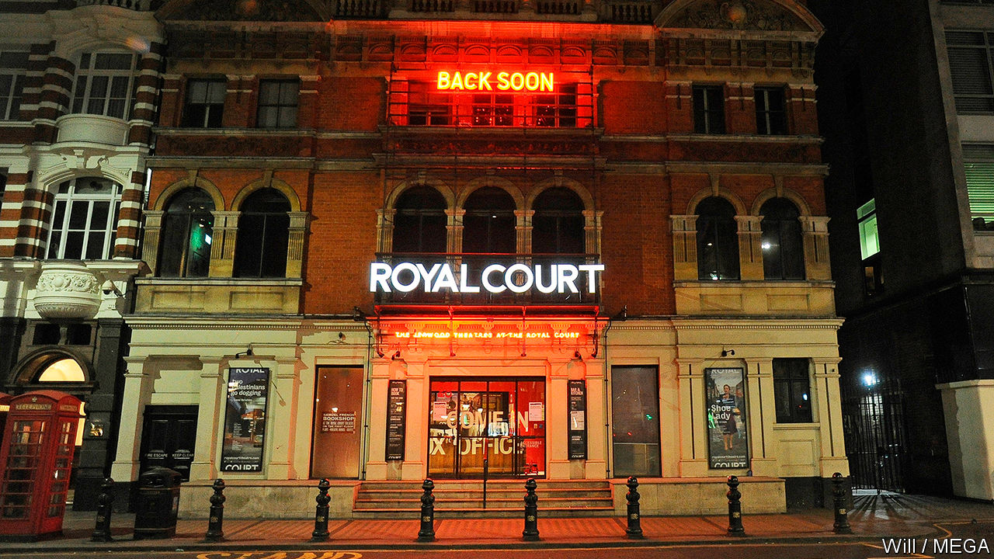

PETER SALMON has been cleaning costumes since he was 13. As a “small and wiry” teenager, he was sent inside the dry-cleaning machines to fix any hiccups. Now 67, he is trusted by London’s West End theatres to make everything from ball gowns to animal outfits gleam. Every morning, his vans come back from theatreland stuffed with pongy garb for his team of nine—including his brother, sister-in-law and two nephews—to wash, press and return before the curtain goes up. He has two boilers, just in case. “If one breaks down, we carry on,” he says. The show must always go on.

Soon, though, Mr Salmon’s three dry-cleaning machines and four presses will fall as silent as the capital’s stages. A handful of London’s 240 or so theatres had already curtailed runs in an attempt to slow the spread of covid-19. The rest followed suit on March 16th, when Boris Johnson recommended that Britons avoid gathering in confined spaces. The National Theatre has closed until April 12th. Others have turned off their spotlights indefinitely.

Arts institutions around the world are shutting their doors. Nowhere, though, has a greater concentration of live theatre than London. According to the Society of London Theatres, a trade body, more than 15m people saw a show in the capital last year, just edging New York. Only last month the society trumpeted its members’ 16th consecutive year of rising revenues, which came to £799m ($929m) in 2019. Now these same venues—many of them elderly relics with crimson carpets and box offices squeezed into cubby holes—are fighting for their survival. As David Babani, artistic director of the Menier Chocolate Factory theatre, notes: “It looks incredibly bleak.”

In New York Andrew Cuomo, the governor, ordered Broadway to close down for a month on March 12th. Even 9/11 only halted performances for two days, but Mr Cuomo said the measures were necessary to slow the spread of the virus.

London’s independent theatres are particularly vulnerable. The Arcola, in Dalston, solicited donations as soon as it announced its temporary closure, warning theatregoers that its future is at risk. Others begged ticket holders not to demand refunds. The government has promised grants and business-rate holidays; Arts Council England, a quango, has pledged emergency support.

Actors are accustomed to finding ways to pay the bills in fallow patches between shows, but businesses are laying off rather than hiring. Work has also dried up for stage hands and costume-makers. “The wardrobe girls have got no work,” says Mr Salmon. “They’re all really sweating.” If the shutdown forces such people to find other work, skills could be lost for good.

The crisis will, at least, spur innovation. Some theatres are planning to experiment with streaming productions online. Papatango, a charity that supports new writers, is soliciting monologues penned in self-isolation. And Fra Fee, an actor who usually performs to sell-out crowds at venues like the National Theatre, says he will post videos of Irish songs online to pep others up. “We’ve got a whole load of people sitting in their bedrooms going nuts,” says Ben Todd, executive director of the Arcola. “We will figure out a way to be useful.” ■

This article was downloaded by calibre from <https://www.economist.com/britain/2020/03/19/the-closure-of-londons-theatres>

|  |  |  |  |
| --- | --- | --- | --- |
| Previous | Articles | Sections | Next |

|  |  |  |  |
| --- | --- | --- | --- |
| Previous | Articles | Sections | Next |

#### Trains

# A bailout for Britain’s railways?

Rail companies will probably end up under state control

Mar 19th 2020 |

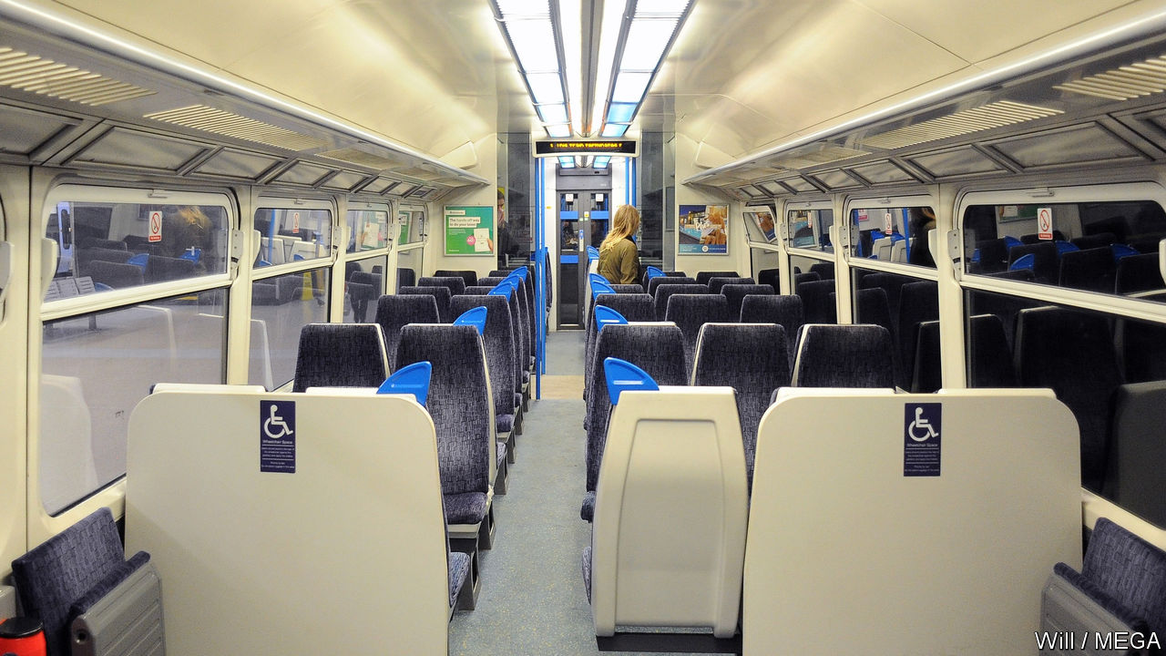

OVERCROWDING ON trains, normally the biggest gripe of the British commuter, is no longer a problem. According to people in the industry, since the government recommended on March 16th that Britons should stay away from the office and avoid social contacts, some commuter lines have since seen their passenger numbers fall by 30%. The train operating companies are asking the government to keep them afloat. “We’re working with them all to see what it is we’d need to do to sustain them,” says Grant Shapps, the transport secretary.

Despite widespread grumbling among consumers about ticket prices, British rail firms operate on relatively thin profit margins. In 2018-19 the sector actually made a loss. With a high fixed-cost base and contractual obligations to the government to meet service requirements, even a few weeks of disruption, let alone months, would be enough to tip the entire sector much deeper into the red. FirstGroup, the only listed British operator of rail franchises, has seen its share price fall by 75% in the past month. Rail commuters tend to be better off than the average British employee, and to do jobs which offer more scope than most for working from home.

Transport for London (TFL), the public-sector body which runs London’s public transport network, said that in the week to March 15th, Tube journeys were down by 19% year on year and bus trips by 10%. If London is locked down, the Tube and the buses will presumably stop.

The industry fears that Whitehall’s bandwith is being consumed by the wider virus response and that the acute problems in the airline industry will delay government action. This week the government announced it was holding sector round tables with a airlines, retailers, manufacturers and a half dozen other industries. Rail was notable for its absence. Yet while the civil service may not have the resources to consider a new package for rail, there may be one almost ready to go. The long-awaited, but much-delayed, Williams Review of the structure of the rail industry was expected to report this month, although that is now likely to be put off further.

Keith Williams, the former airline-industry boss heading the review, had been expected to recommend a move from the current franchise model to a concession system. Under that framework, common in other rich countries, private companies manage the trains, but the model is different from the one operating in Britain. Rather than carrying the costs and reaping the rewards, rail companies get a fee from the state for the service they provide. The government gets the income from fares, and taxpayers bear the risk in case of losses. That’s how London Overground, a well-run network, operates.

Train operators have been somewhat wary of a concession model, preferring the potential financial upside of the current franchise arrangements. But with losses mounting, the sector is now keen for the government to take back control. A once controversial package of reforms has suddenly found unlikely friends.■

This article was downloaded by calibre from <https://www.economist.com/britain/2020/03/19/a-bailout-for-britains-railways>

|  |  |  |  |
| --- | --- | --- | --- |
| Previous | Articles | Sections | Next |

|  |  |  |  |
| --- | --- | --- | --- |
| Previous | Articles | Sections | Next |

#### Retail

# How panic buying is affecting supermarkets

Retailers battle to restock shelves quicker than Britons are emptying them

Mar 19th 2020 |

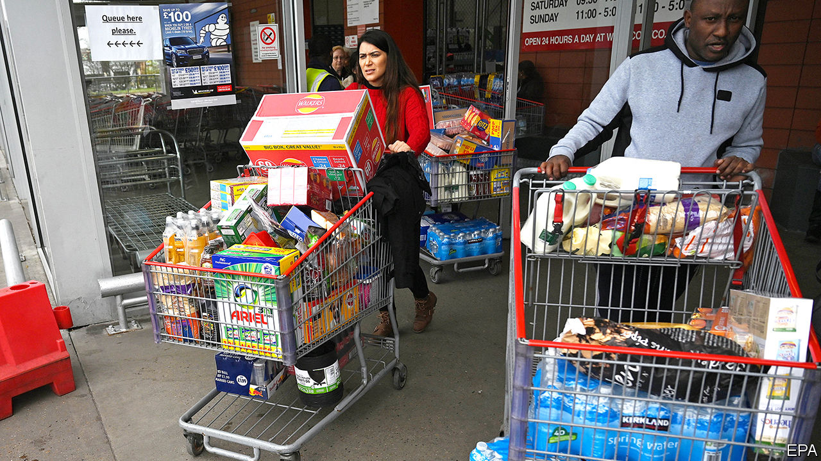

EYEING A NEW wave of hoarders advancing towards already half-empty shelves, a supermarket employee says that in normal times the shop sells only ten of its most expensive sirloin steaks in two weeks. “Now 30 go in a day!” Other parts of the store—a branch of Sainsbury’s in east London—resemble a battleground. Those tasked with replenishing toilet rolls look especially flushed. “They are just grabbing them off the boards,” grumbles one worker. “I’m just handing them out one by one.”

Six in ten Britons reckon stockpiling is an unacceptable response to the spread of covid-19, according to Ipsos MORI, a pollster. Yet my prudence is your stockpiling. As customers strip shelves bare, most British supermarkets have implemented some form of rationing. Some chains are limiting purchases of the most popular items, like loo roll, pasta and rice. Others have banned customers from buying more than a few of each product line. Emergency plans, many of which were drawn up to cope with a no-deal Brexit, are being dusted down and put into action.

“We’re seeing Christmas-type levels of demand at the moment but usually you have months to stock up and staff up beforehand,” says one supermarket’s supply-chain boss. Grocers’ depots typically hold enough food to last a week and only a few days’ worth of perishable goods and bulky items, such as loo roll. At the store in east London, the manager remains calm. “The supply chain is doing fine, the depots haven’t run out of stock,” he says. “All I can do is put out what they send me.”

For now, the problems are caused by surging demand rather than disrupted supplies. That could soon change. Bruno Monteyne, a former supply-chain director who now works for Bernstein, a financial-research firm, says Tesco, Britain’s largest supermarket chain, regularly war-gamed pandemics when he worked there. In a note for clients this month, he noted that supply disruptions are likely to become widespread if unexpected staff absences reach 5-10% of the workforce. At that point “it would only take a few weeks to generate major shortages across the store estate.” Stores will probably narrow the range of goods they sell in order to ease bottlenecks. As Mr Monteyne puts it, “who needs 35 types of ketchup in a pandemic?”

One difficulty is that supermarkets have been engaged in a multi-year price war to maintain market share with two German discounters, Aldi and Lidl, and online services like Ocado and Amazon. Profit margins in the retail sector fell from 6.4% in 2007 to 2.7% in 2018. One of the main responses has been to make their supply chains more efficient—and thus vulnerable to disruption. “We’ve been rationalising supply chains for years and that’s great news for consumers who have ever lower prices, but we don’t have much spare capacity,” says an industry insider.

Italy has managed to maintain food supplies despite a more severe outbreak of covid-19 and a much tighter lockdown. The British supermarket industry is confident it can do the same, but in the weeks ahead disruption is likely and the range of goods offered to consumers will probably narrow still further.

Shelf-stackers in east London are not convinced rationing will put an end to panic buying, however. “First it was toilet roll,” one explains, “then it was pasta, then it was tinned tomatoes, then it was bread, and now it’s fruit and veg.” Her colleague adds that “it will be beer next.”■

This article was downloaded by calibre from <https://www.economist.com/britain/2020/03/19/how-panic-buying-is-affecting-supermarkets>

|  |  |  |  |
| --- | --- | --- | --- |
| Previous | Articles | Sections | Next |

|  |  |  |  |
| --- | --- | --- | --- |
| Previous | Articles | Sections | Next |

#### Demography and COVID-19

# In Britain, old people already practise social distancing

The sociable Italians are in more danger

Mar 19th 2020 |



DOROTHY MOIR, a 77-year-old retired head teacher who lives on the Isle of Wight, kept busy last week. She talked to teenagers in a nearby school, attended a charity-trustees meeting and two intellectual clubs, and dropped in on friends. “I had a lovely time,” she says. “There won’t be another week like that for some time.”

Muddled and changeable though the government’s response to covid-19 has been, it is clear about one thing. The over-70s must isolate themselves from society more drastically than younger people. That will change Ms Moir’s life. But for a large proportion of old people—bigger in Britain than in the rest of Europe—it represents a sadly small adjustment.

Joël Mossong, head of epidemiology at the national health laboratory in Luxembourg, has studied social interactions in eight European countries, as recorded in special diaries. He found the same basic pattern everywhere: the young are much more sociable than the old. But the study also turned up differences between countries. On average, old Britons see many fewer young and middle-aged people than old Italians do (see chart).

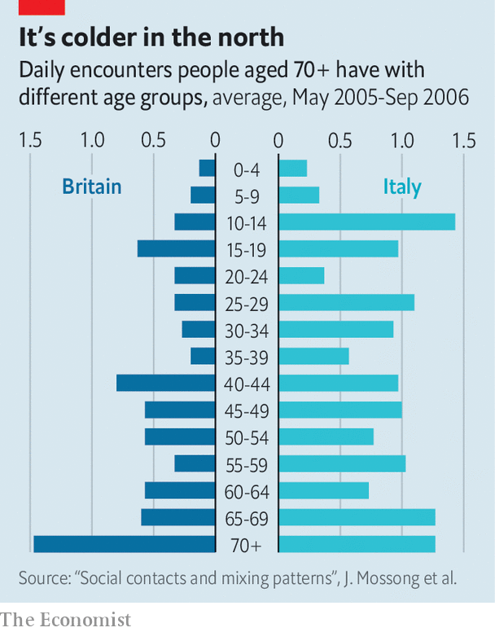

That is probably because family life is so different. Despite complaints about a “boomerang” generation that goes to university and then lands back at home, young Britons are comparatively keen to get away. In 2018 just 16% of 25- to 34-year-olds lived with their parents, compared with 44% of Spaniards and 49% of Italians. Three-generation households are much rarer than in southern or eastern Europe. Britain has 28m households, of which 4m consist of a single person over 65, living alone. British social butterflies like Ms Moir go out to socialise; her Mediterranean equivalent would hold court over a busy home.

When British children leave the parental home, they tend not to come back. Researchers have developed a “filial responsibility” index to measure how obliged people feel to care for their parents. Britain comes 20th out of 24 European countries (Austria, the Netherlands, Sweden and Finland are lower). Nor do the old feel much obligation to their children or grandchildren. In the Netherlands, where many mothers work part-time, many grandparents baby-sit. That is rarer in Britain, though not as rare as in Scandinavia, where almost all children go to nurseries.

All this is a shame in many ways—but it does protect old Britons from dangerous germs. Melinda Mills, a sociologist at Oxford University, says that northern Italy was particularly susceptible to the new coronavirus. Not only does it have a lot of old people; those people see a good deal of the young and middle-aged. Many workers commute to highly connected, germy cities like Milan, then go back to their village to have dinner with mum.

Despite their isolation, old Britons do not feel particularly lonely. According to the national Community Life Survey, conducted in 2016 and 2017, just 3% of over-75s report feeling lonely all the time, compared with 10% of 16- to 24-year-olds. That could reflect a generally benign outlook on life—the old are more cheerful in many ways. Or it could be that the few social interactions they have are especially enjoyable. We are about to find out.■

This article was downloaded by calibre from <https://www.economist.com/britain/2020/03/19/in-britain-old-people-already-practise-social-distancing>

|  |  |  |  |
| --- | --- | --- | --- |
| Previous | Articles | Sections | Next |

|  |  |  |  |
| --- | --- | --- | --- |
| Previous | Articles | Sections | Next |

#### Life under lockdown

# Slices of British life under coronavirus

Behaviour in the time of covid-19

Mar 19th 2020 |

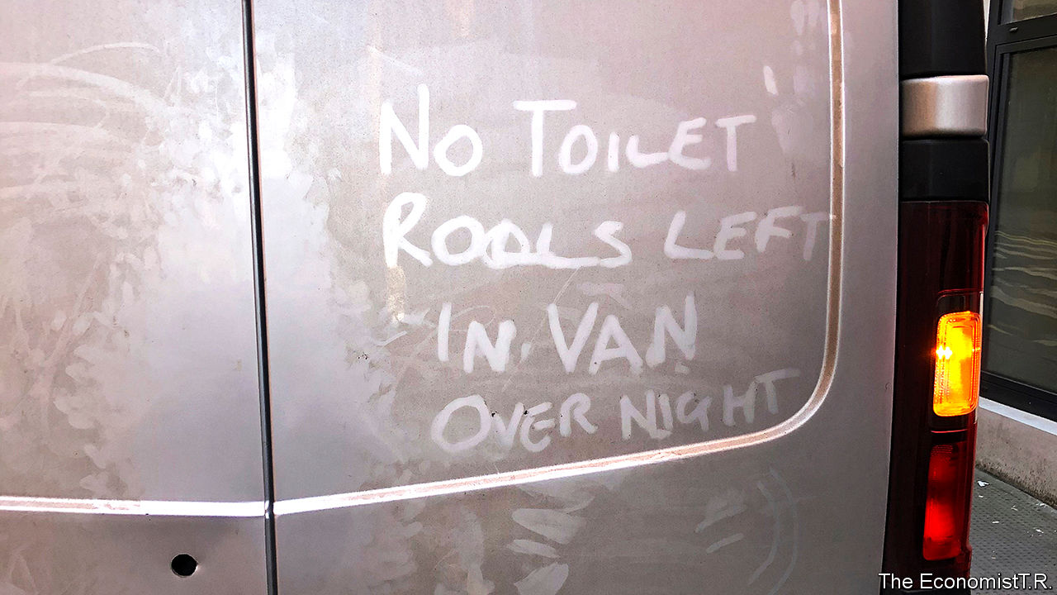

Half measures

“Of course I’ll go to a pub if I need to go to a pub.”

Stanley Johnson, the prime minister’s father, intends to ignore his son’s advice to stay at home. He is not alone; staff in one London pub said it was busier than usual.

Faith and science

“We respectfully ask that you refrain from the physical sign of peace—especially anyone with cold or flu symptoms—and for all to receive Holy Communion on the hand only. The distribution of the Precious Blood of Christ has been suspended.”

Immaculate Conception, a Catholic church in the Oxfordshire town of Bicester, tends to its flock’s physical as well as spiritual health. The Church of England has suspended services. The Archbishop of Canterbury will lead believers in a digital service.

Especially honourable members

“He’s making a series of very powerful points.”

Boris Johnson responds to Jeremy Corbyn, the opposition leader, in an unusually even-tempered Prime Minister’s Questions.

Soap shortage

“It’s a shame ‘EastEnders’ has been postponed for now. It could have served as a timely reminder that there’s always people worse off than you.”

Paul Sinha, a television quiz-show personality, responds to the BBC’s decision to suspend filming of the soap opera.

Viral video

“We’ve all got the virus, na na na na.”

British holidaymakers in Benidorm failed to impress locals with their football-style chant, which was quickly shared online.

Old-age protesters

“The proposed self-isolation for the over-70s is a euphemism for house arrest...We have done nothing wrong except grow old and are set to be sentenced, without trial…What punishments will be meted out to those who sneak out, maybe to their allotment, or just for a walk in a green space by the sea?”

Eve Woodward in a letter to The Times, March 17th.

This article was downloaded by calibre from <https://www.economist.com/britain/2020/03/19/slices-of-british-life-under-coronavirus>

|  |  |  |  |
| --- | --- | --- | --- |
| Previous | Articles | Sections | Next |

|  |  |  |  |
| --- | --- | --- | --- |
| Previous | Articles | Sections | Next |

#### Crises collide

# Covid-19 is delaying Brexit negotiations

It may yet delay Britain’s exit from the EU’s orbit

Mar 19th 2020 |

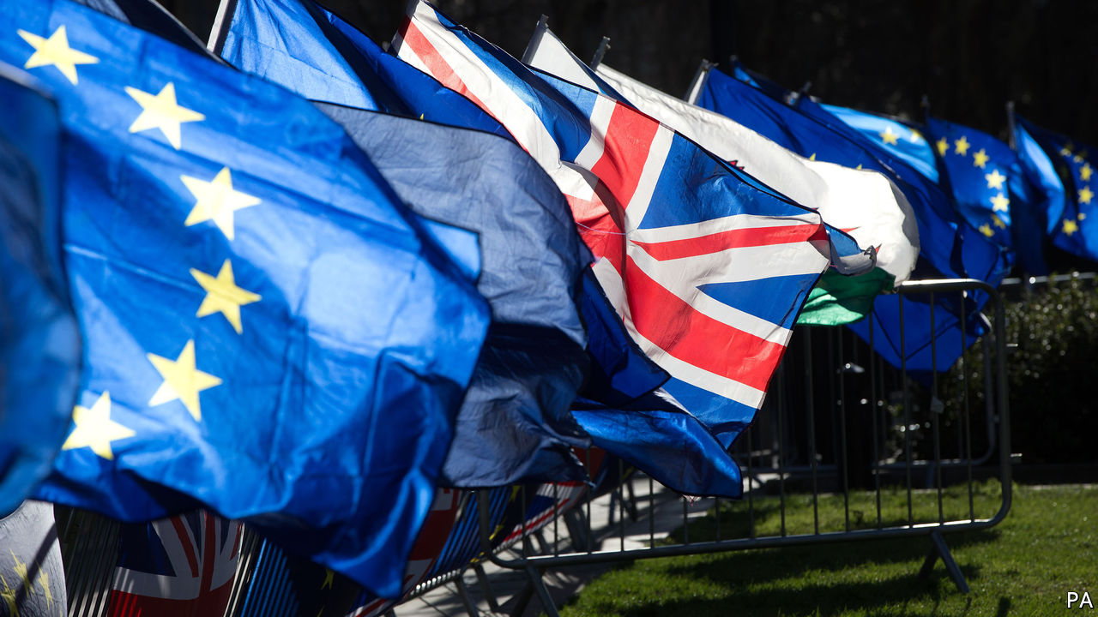

BREXIT NEGOTIATORS spent months mulling the prospect of empty supermarket shelves and grounded flights. Their nightmare scenario duly arrived, but from an unexpected source. And an early victim of the pandemic has been trade talks between Britain and the EU.

Negotiations were due to restart on March 18th, with Britain determined to rattle through them in order to leave the EU’s orbit by December 31st. They were put on hold even before Michel Barnier, the EU’s chief negotiator, confirmed on March 19th that he had contracted covid-19. The delay has raised expectations that Boris Johnson will be forced to break his promise by requesting an extension to negotiations.

There are plenty of reasons to delay. For a start, the two sides are already far apart. Britain opposes EU proposals for strict conditions on unfair competition, and to allow European boats to fish in its waters. With covid-19 consuming the British government’s attention, it is hardly an ideal time to thrash out compromises. Charles Grant of the Centre for European Reform, a think-tank, notes that EU minds are also elsewhere, as they confront the serious risks to the bloc’s economy and the potential for destabilisation. “The chances of getting a deal fixed in time are diminishing,” he notes. “An extension is more likely.”

Agreeing a treaty is the easy bit. Afterwards, Britain would have to implement new regulatory systems, immigration policies and customs controls. These changes will be similar whether or not a deal is struck and, despite the best efforts of 25,000 civil servants, the timetable looked tight even without a pandemic. On top of this, Parliament would have to pass a number of major pieces of legislation covering trade, agriculture and fisheries.

If the virus is still causing havoc come winter, the government may conclude it is a bad time to introduce new checks at the border, which risk creating delays to the supplies of food and medical equipment. Planners for Operation Yellowhammer, last year’s no-deal preparations, warned that “concurrent risks” such as a typical winter flu or an outbreak of flooding would stretch government agencies.

But while the logic of a delay is straightforward, the politics are not. A delay would prompt a backlash from Tory Eurosceptics. “It would turn Boris into Theresa May,” says one. And any extension beyond December 31st must be requested by the end of June. That date acts like the mouth of a lobster pot—easy for the government to swim through in the belief that plenty of time remains, but impossible to escape from later.

The hope is that Eurosceptic concerns are outweighed by more pragmatic ones. Businesses will plead with the government not to compound the economic hit from the virus with the pain of a hard exit. Given that any settlement with the EU will probably require compromises on sensitive questions such as fisheries and the European Court of Justice, Mr Johnson may conclude they are best rushed through while attention is elsewhere.■

This article was downloaded by calibre from <https://www.economist.com/britain/2020/03/19/covid-19-is-delaying-brexit-negotiations>

|  |  |  |  |
| --- | --- | --- | --- |
| Previous | Articles | Sections | Next |

|  |  |  |  |
| --- | --- | --- | --- |
| Previous | Articles | Sections | Next |

#### Digital infrastructure

# The internet’s resilience to mass homeworking

Britain’s internet is well-prepared for a nation of home-workers

Mar 19th 2020 |



THE INTERNET is a lot like the London Underground: both are made up of a series of tubes, both carry stuff—either people or packets of data—and both have multiple nodes, so that if one goes down, journeys can continue along another route. This week, as people who could work from home did, the Underground emptied out and the internet filled up. By March 15th, a day before the prime minister asked people to telecommute, British internet traffic was already up 12% compared with the beginning of February, according to data from Cloudflare, a big network-infrastructure provider. Ridership on the Tube, meanwhile, slumped.

The two are alike in another important way: the Tube is designed for its maximum, rush-hour capacity. Ride it in the middle of the day and there is plenty of room. Similarly, Britain’s internet service providers also plan for peaks. Data use is typically heaviest in the evenings, as people settle in to watch a show after dinner. Sometimes that coincides with a live-streaming sports event or a new video-game release, or both, causing spikes in demand. Yet such events rarely cause disruptions to service because, as John Graham-Cumming, Cloudflare’s technology chief, puts it, “the internet was built for this.”

The Centre for Cities, a think-tank, reckons that about two-fifths of workers in cities such as London, Edinburgh, Cardiff and Leeds have jobs that they can do easily from home. Since many of them are now doing just that, traffic from corporate networks has dropped to almost nothing. Home broadband use is up. But most peoples’ needs are straightforward: video-conferencing and chat apps, neither of which use enormous quantities of data. Even a big rise in streaming and streaming, likely now that schools are to close, should not strain British broadband’s resilience, say people in the industry.

There will still be hiccups. Mobile networks are “generally adapted to a considerably lower level of data traffic passing over their networks than fixed-line broadband,” notes Mark Jackson of ISPreview.co.uk, an industry site. People who rely on mobile broadband may find occasional lags if lots of people use their phones for heavy-duty tasks. For others, slow internet at home could be the result of several members of the household streaming and video-calling at once, rather than of broader network issues. Corporate systems unprepared for all their workers logging in through virtual private networks (VPNs) could fall over. The same applies to apps, which may initially struggle with the extra load. Microsoft Teams, a workplace chat app, briefly collapsed in Europe on March 16th.

The bigger worry during a period of widespread home-working is cybercrime. The National Cyber Security Centre, an arm of GCHQ, warned that criminals are taking advantage of fear over coronavirus to target internet users with “phishing” attacks. Unusual emails have become normal in many workplaces over the past weeks, and people have their guard down. There have also been other types of cyber-attacks, including malware and extortion. “Whenever there is some type of crisis, almost inevitably you see a spike in attacks,” says Patrick Sullivan, who runs security strategy for Akamai, another internet-infrastructure provider. Workers who use corporate machines and must log into the VPNs are less vulnerable than those using personal machines and sharing home networks. But they are not immune, any more than they are from the virus itself.■

This article was downloaded by calibre from <https://www.economist.com/britain/2020/03/19/the-internets-resilience-to-mass-homeworking>

|  |  |  |  |
| --- | --- | --- | --- |
| Previous | Articles | Sections | Next |

|  |  |  |  |
| --- | --- | --- | --- |
| Previous | Articles | Sections | Next |

#### Bagehot

# Spirit of the Blitz

History is a valuable resource in dark times

Mar 19th 2020 |

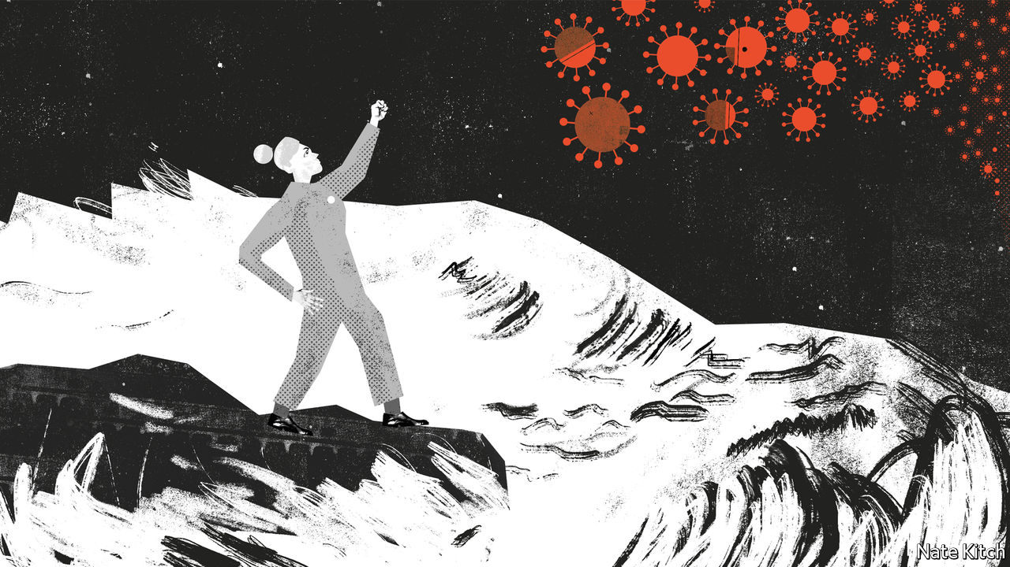

WHEN THE British are confronted with a national crisis they default to talking about the second world war—and especially 1940, when Britain stood alone against Hitler’s Germany. Boris Johnson, who fancies himself as Churchill, has declared that “we must act as in wartime and do everything it takes to support the economy”. Matt Hancock, the health secretary, has called on Britons to emulate their grandparents’ behaviour during the Blitz. “Despite the pounding every night, the rationing, the loss of life, they pulled together in one gigantic national effort. Today our generation is facing its own test, fighting a very real and new disease.”

Some smart people think that this is all juvenile jingoism. What is the point of comparing a virus with a political movement? Why bring up Germany’s dark past when today it is fighting the same enemy as Britain? In 1940 the English Channel helped to keep the foe at bay. Today it is among us and spreading rapidly. When T.S. Eliot proclaimed in “Little Gidding”, written while he was fire-watching during the Blitz, that “history is now and England” he captured Britain’s unique role in holding the line against Nazism. The appropriate line today would be “history is now and everywhere”.

Helen Lewis, of the Atlantic magazine, argues that the Blitz spirit may actually be harmful because it encourages older people—people incidentally who are most at risk from the virus—to ignore namby-pamby advice about the need for washing your hands and staying at home. “This appeal to Blitz spirit, to the unbowed might of Albion, to the idea that Britain withstood the Luftwaffe”, she writes, “all of it is deeply unhelpful when dealing with an infectious disease.”

Dunderheads can always draw daft conclusions from the historical record—and concluding that there’s something Churchillian about not washing your hands is daft indeed. But the comparison to wartime is nevertheless compelling. Covid-19 marks a sharp break in history just as Hitler’s Blitzkrieg did. Dealing with the virus will call for dramatic action of a kind that has seldom been seen in peacetime.

Britain already has a wartime feel. People listen to prime-ministerial announcements and BBC news bulletins with the same anxious seriousness that they did back in 1940. Great commuter terminals are empty. Freedom of movement is being curtailed. People are hunkering down in their homes. Urged on by the government, manufacturers, including Vauxhall and Airbus, are repurposing their factories to make ventilators.

Even in normal times the British are unusually fond of celebrating their history. Turn on the television on a Sunday night and there is a historical drama on offer. The most successful highbrow novel of the past few years is Hilary Mantel’s three-volume roman á Cromwell. Whereas some countries are defined by their creeds (liberté, egalité, fraternité in France, the American dream in America) Britain is defined by its long history. Whereas most countries have felt the need to exorcise parts of their past out of shame or rage, Britain has never been subjected to the rule of Nazis, Communists or other madmen. In abnormal times the British instinctively turn to history for both inspiration and a roadmap.

And what year in history could be more inspiring and instructive than 1940? The world’s future hung by a thread. If the RAF had lost control of the air, Britain would have fallen to the Germans and America would have stayed out of the war. The British summoned up extraordinary heroism to keep that thread from snapping. It also contains important lessons for today: that you can change the course of history through force of will; that Britain’s greatest resource is the character of ordinary people rather than the genius of elites; and that character is reflected in the way you go about your daily business—keeping calm and carrying on; resisting the temptation to hoard or shirk—as well as in war heroics. Churchill might have provided the roar, as he put it, but it was the people who had the lion’s heart.

During the civil war over Brexit—remember that?—the Brexiteers made a concerted attempt to expropriate the memory of the Blitz and yoke it to a partisan cause. The white cliffs of Dover, films such as “The Dam Busters”, David Low’s celebrated cartoon, captioned “very well, alone”, depicting a Tommy, fist in the air, defying the storm-tossed seas and German bombers. All were part of the Brexiteer lexicon. Boris Johnson even warned that dreams of European unification had always ended in disaster: “Napoleon, Hitler, various people tried this out, and it ends tragically.” Today some curmudgeons argue that younger people are too enfeebled by the cult of victimhood to play their part.

Covid-19 provides Britain with an opportunity to recapture the memory of the Blitz for the whole nation rather than for a political sect. It also provides the young with a chance to prove the curmudgeons wrong. Though hoarding is all too common, it is more than offset by acts of public-spiritedness. Post Office workers have offered to turn themselves into an additional emergency service delivering food parcels and pharmaceuticals and checking on the vulnerable. Neighbourhood groups are spontaneously organising online; much more help is being offered than there is need for it, as yet. Many people report getting in touch with, and hearing from, friends and relations they haven’t spoken to for years.

Back in 1940 the British showed an acute sense of the power of history to inspire a beleaguered people. The Picture Post said in 1940 “some nations are separated by a sad gulf from a heroic past but we are not”. The Times likened the struggle for control of the Channel ports to epics of English history such as Agincourt, the Armada and Waterloo. On June 18th Churchill urged the British to “so bear ourselves that if the British empire and its commonwealth last for a thousand years men will say, ‘This was their finest hour’.” Winning the war against covid-19 will require the world to mobilise all its resources. One of the most powerful resources that Britain has is its memory.■

This article was downloaded by calibre from <https://www.economist.com/britain/2020/03/19/spirit-of-the-blitz>

|  |  |  |  |
| --- | --- | --- | --- |
| Previous | Articles | Sections | Next |

|  |  |  |
| --- | --- | --- |
| Britain | Sections | Business |

International

School closures: Mid-term break

.

|  |  |  |
| --- | --- | --- |
| Britain | Sections | Business |

|  |  |  |  |
| --- | --- | --- | --- |
|  | Articles | Sections | Next |

#### Mid-term break

# How covid-19 is interrupting children’s education

Almost a billion children have seen their schools close

Mar 19th 2020 | TREVISO

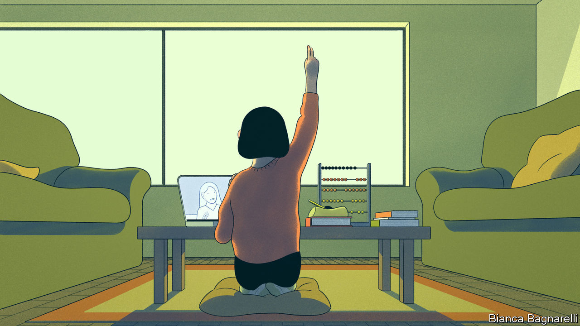

CHILDREN USUALLY rejoice in a break from school, assuming it will be a chance to slack off. Not Ryu, a nine-year-old in Tokyo. As the new coronavirus spread across Japan, schools throughout the country closed on March 2nd. His parents have enforced a strict schedule every day. It includes Japanese, science and physical education. He does mathematics on his abacus every morning. On weekdays he is allowed to play in a park for 90 minutes. “I wish I could take him to the park more, but we have limited time as we work from home,” frets his mother, Fujimaki Natsuko.

Ryu is one of almost 1bn students around the world whose schooling has been interrupted as a result of covid-19 (see map). As The Economist went to press, just over 100 countries including China, Italy and South Korea had closed their schools, as had 43 states in America, as part of efforts to contain covid-19. Britain will close all schools on March 20th. Schools, where sticky-fingered children gather every day, sharing toys and sucking on pencils, are an obvious place for diseases to flourish. In 2013 Britain’s Health Protection Agency looked at flu outbreaks that coincided with school closures. It found that shutting them slowed the transmission of the virus, even if it also slowed the transmission of knowledge.

The data on whether school closures will curb covid-19 are limited. Children may not be the “main routes of transmission”, says Michael Head, who studies global health at the University of Southampton. And the economic, social and educational costs are heavy. On March 12th Bill de Blasio, the mayor of New York, said there were “many, many reasons” not to close the city’s 1,800 schools (though on March 16th it did just that, shuttering America’s largest school system for at least four weeks). For all governments, deciding whether or not to close schools is a choice between two bad options.

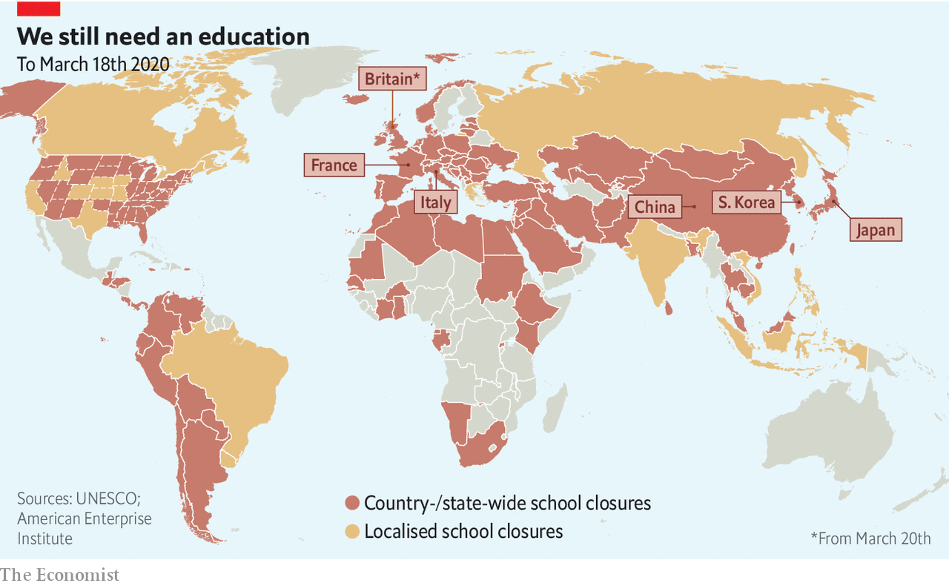

A study in 2009 modelling the effects of closing all schools and formal day-care centres in America for a month put the cost at 0.1-0.3% of GDP. Some countries seem better prepared to deal with the economic impact. In China the nationwide closures came with government-mandated work-from-home policies and subsidies for companies to enable their employees to do so. But in Japan not all parents are entitled to work from home or to take paid sick leave. In Italy one-fifth of workers are self-employed and so do not qualify for sick pay. People in precarious work may lose their jobs altogether if they have to stay at home to look after children.

For poor children, schools may provide the most nutritious meal of the day. Around 26m children in American schools—roughly half of all students—qualify for free or reduced-price lunches. In New York City 22,000 children sleep in municipal shelters. Some school districts in New York are setting up pickup points so that the hard-up can still get free meals. Britain has said it will continue to provide those children who ordinarily get free school meals with food.

Officials must always take such costs into account. But in the middle of a pandemic there is an extra consideration. The study in 2009 estimated that, if schools are closed for a month, between 6% and 19% of key health-care workers would have to stay at home to take care of their offspring. Britain will keep schools running for vulnerable children and those whose parents are key workers.

For most parents, however, the immediate worry is how prolonged school closures will affect their children’s education. Those preparing to take crucial exams are particularly jittery. The gaokao, China’s single university-entrance exam, is usually held in June. This year it will probably be delayed, says Xu Liangdi of China Policy, a think-tank, although the government has so far made no announcement.

Around 245,000 students in Britain were expecting in May and June to sit their A-levels, the exams that determine which university—if any—will grant them a place. On March 18th the government announced that those exams would be cancelled. Boris Johnson, the prime minister, said that the government would make sure that children still got “the qualifications they need and deserve for their academic career.” That may go some way to assuaging fears that children whose parents lack the cash or knowledge to compensate for schools closing would be worst affected.

For American students the stakes are lower, in part because their transcript—based on their academic performance throughout the year—is the most important part of their university application, but also because they can take SATs, the exams used in college admissions, all year round. Most sit them in the spring. For those hoping to start university in 2021, the March and May tests have been cancelled. They will be rescheduled, however, and students may be able to take them at home.

Nonetheless universities may have to be more accommodating. Covid-19 will “absolutely” affect the admissions procedure for Miami University in Ohio, says Bethany Perkins, the director of admissions—particularly the deadlines. Students with offers from American universities have to choose which to accept by May 1st. But students worry that they will have to make an important decision without being able to visit any campuses. Along with their parents, some are calling for the date to be pushed back to June 1st. Colleges have yet to react. Harvard says it is not changing its application process.

The disruption has lent ammunition to those who disapprove of high-stakes exams, which some education theorists want to scrap. Some institutions have already made SATs optional. Others, including Miami University, were considering doing so. The upheaval caused by covid-19 might accelerate that process, says Ms Perkins. But the flaws of other kinds of assessment may become clear in the coming months, bolstering those who believe that SATs and other high-stakes exams, which offer a relatively objective and transparent measure of ability, are the least unfair way to decide who gets into university.

The pandemic won’t change this. But it will highlight the strengths and weaknesses of teaching online. Online resources are increasingly popular but few countries boast a developed digital infrastructure for all students. A survey by Teacher Tapp, an app, of over 6,000 teachers in Britain found that only 40% of those in state schools would be able to broadcast a video lesson, compared with 69% of teachers at independent schools. Elena Silva of New America, a think-tank, says that few American states have adequate kit for teaching online. “Most states are not that prepared. This is a moment of forced opportunity.”

Teachers have little choice but to seize it. Since Italy closed its schools and universities on March 5th, teachers’ forums have filled with discussions on the relative merits of Zoom, Moodle and virtual classrooms. Some teachers had been trained to use such technology, but many have faced a steep learning curve. Carla Crosato, a teacher in Treviso, in northern Italy, has been uploading videos in which she explains the novels of Italo Svevo and Luigi Pirandello to her students. “I never thought I’d become a YouTuber at 56,” she says.

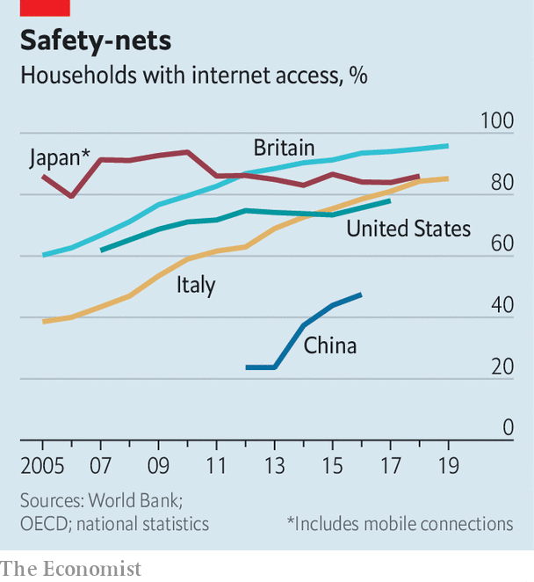

Even if teachers manage to broadcast their lessons, students may struggle to join them. Not everyone can get online (see chart). In America 7m school-age children cannot access the internet at home. Lin Kengying of 21st Century Education Research Institute, a think-tank in China, says that the closure of schools since the Lunar new year holiday, which began at the end of January, has led his organisation to reconsider the potential of e-learning. “It hasn’t been smooth,” he says, citing problems such as internet access, scheduling classes, teachers unfamiliar with online tuition, and subjects such as physical education being “awkward” to teach remotely. In China teachers have to submit lesson plans for review by censors, which has led to delays. Students have been spamming the main online teaching app with one-star reviews in an effort to get it removed from the app store. And Xue Hua, a mother of two in Jiangxi province, has been printing out all the learning materials for her 16-year-old son, Guo Guo, because she worries about too much screen-time.

Even done properly, online learning is a poor substitute for the kind that happens in a classroom. On average, students fare worse working online, especially those with less strong academic backgrounds, says Susanna Loeb of Brown University. Online courses can be an asset when students cannot be in school, but she reckons that they are “suboptimal for most” and argues that long periods of time spent away from actual schools will probably lead to children’s education suffering.

Online learning has clear potential. Educational technology powered by artificial intelligence can help children in poor countries with iffy schools—supposing they have internet access. In 2018 researchers found that after four and a half months of using an Indian app called Mindspark, which tests basic language and maths skills, children made more progress in these areas than those in the control group. But the success of such initiatives relies on preparation and organisation, not sudden scrambles to teach existing curriculums to entire populations of students in the midst of a pandemic. ■

This article was downloaded by calibre from <https://www.economist.com/international/2020/03/19/how-covid-19-is-interrupting-childrens-education>

|  |  |  |  |
| --- | --- | --- | --- |
|  | Articles | Sections | Next |

|  |  |  |
| --- | --- | --- |
| International | Sections | Finance and ... |

Business

Business and the pandemic: Covid carnage

.

Air transport: Flight risk

.

Manufacturing: My iron lung

.

Very golden oldies: Berkshire Hathaway has America Inc’s oldest board

.

Bartleby: Embracing the suck

.

Schumpeter: Processing power

.

|  |  |  |
| --- | --- | --- |
| International | Sections | Finance and ... |

|  |  |  |  |
| --- | --- | --- | --- |
|  | Articles | Sections | Next |

#### Covid carnage

# Much of global commerce has ground to a halt

Some companies will never restart

Mar 19th 2020 | NEW YORK

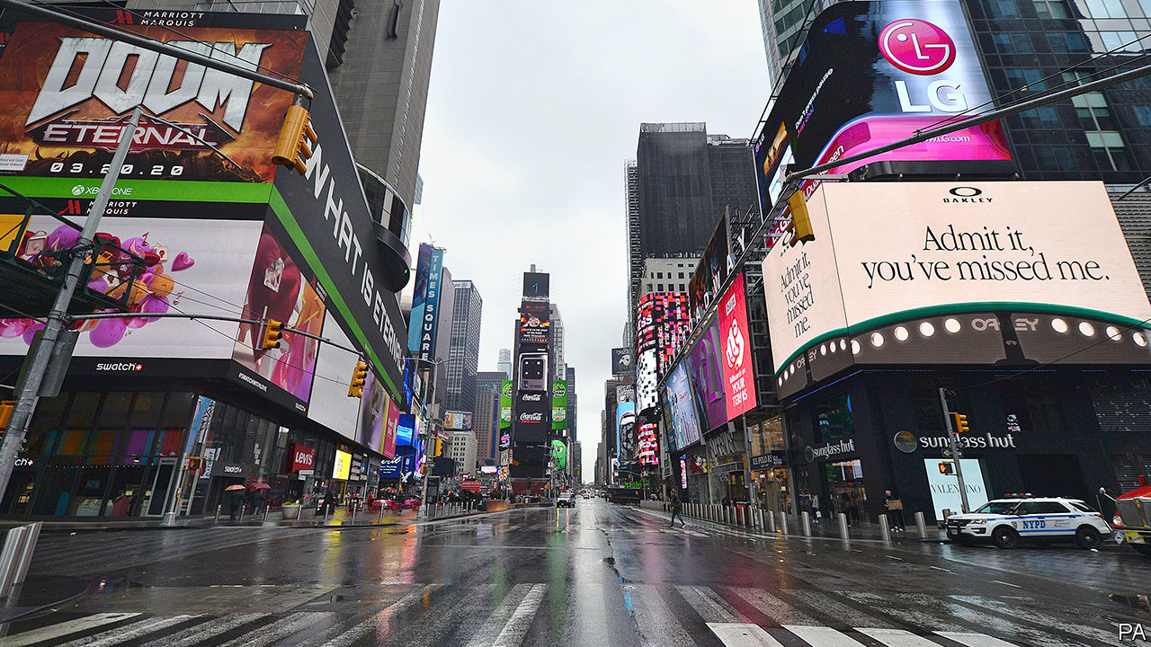

“THE COVID-19 pandemic is having a significant impact around the world,” warned Fred Smith, boss of FedEx, at his firm’s earnings conference on March 17th. That is putting it mildly. The express-delivery giant announced that it was slashing its delivery capacity and, for the first time ever, refused to give earnings guidance. While economists debate whether this recession will be short-lived or sustained (see Briefing), bosses the world over already see mayhem. The virus has destroyed $23trn in global market value since mid-February.

As governments curb citizens’ activities—including much of commerce—in an effort to save lives, the ranks of corporate casualties are swelling. Fewer people are taking planes (see [article](https://www.economist.com/business/2020/03/21/airlines-are-running-out-of-cash)), hailing rides, eating out, staying in hotels, going to cinemas or gathering just about anywhere. Most American and European sports leagues have been suspended. Formula 1 motor-racing has ground to a standstill. Apple and Nike have closed most of their stores outside of China. Carmakers including Ford, Toyota and Volkswagen are shutting factories in Europe and America.

The bloodletting will continue. Scott Stringer, New York’s finance chief, predicts that the city’s hotels will be two-thirds empty until the end of June. Its restaurants and bars, ordered shut, could see sales drop by 80%. The American Hotel and Lodging Association fears a blow exceeding the impact of September 11th 2001 and the “Great Recession” of 2008 combined. Morgan Stanley, a bank, reckons retail foot traffic may plunge by 60% in coming weeks, as more American cities follow many European ones into lockdown.

Many companies will pull through. Governments are rushing in to ensure as many as possible do. Britain this week unveiled a £330bn ($382bn) package of loan guarantees and other support for businesses. America’s Federal Reserve earlier said it would create a new funding facility to provide liquidity to American issuers of commercial paper. President Donald Trump has called for $1trn in economic stimulus.

Even so, some firms will not make it. It is too early to say for sure who the corporate fatalities will be. To get a sense of which are most at risk, liquidity and business model are a good place to start.

Take liquidity first. American firms account for 55% of global non-financial debt maturing until the end of 2024, and 62% of debt rated junk, according to S&P Global, a rating agency. Non-financial firms in America will see $394bn in investment-grade debt and $87bn in junk debt fall due this year; the figures for next year are $461bn and $195bn. Potential trouble spots include construction (with nearly $30bn in junk debt due by the end of 2021), media and entertainment ($35bn), and energy and utilities ($56bn).

Oil companies in particular have been clobbered by the steep fall in the price of crude, which sank to $25 a barrel on March 18th, the lowest level in nearly two decades. Morgan Stanley calculates that the median exploration and production firm needs an oil price of $51 a barrel to break even. Saudi Aramco, the world’s mightiest oil colossus, said it might cut capital spending by up to a quarter this year. America’s ExxonMobil echoed that it will make “significant” cuts.

Oilmen are not the only ones trying to preserve cash. Many companies are sending workers on leave or worse. Norwegian Air Shuttle, an airline, is temporarily laying off 90% of its 10,000 employees. Marriott International, the world’s largest hotel chain, said on March 17th that it will have to let go of tens of thousands of workers.

Companies are rushing to tap credit lines secured with their bankers. AB InBev, the world’s biggest brewer, is drawing down its $9bn revolving credit. Boeing, a troubled aerospace giant, has accessed $13.8bn. Carnival Cruise Line hopes to stay afloat thanks to a $3bn lifeline. Bloomberg, a financial-data firm, reckons that if firms in five big sectors (health care, energy, transport, leisure and mining) drew down 70% of their credit lines, and the rest tapped 30% of theirs, America’s biggest banks would be on the hook for $700bn.

Companies’ second vulnerability besides a liquidity crunch arises from their business models. Some tried and tested ones suddenly look rather fragile in the age of pandemic. If Apple does not sell a new iPhone it may still convince consumers to buy one later. Revenues from a restaurant meal not eaten or a forgone trip to the cinema are lost for ever.

That is bad news for industries like the arts, which depend on a few big, one-off events—at least in countries like Britain, where state-funding of the arts is less lavish that in France, Germany or Gulf sheikhdoms. Art Basel Hong Kong was cancelled last month. The main Art Basel fair in Switzerland, which is due to open on June 18th, may also not go ahead. Galleries that depend on such fairs, as many do, could see as much as 80% of their sales evaporate.

No surprise, then, that the coronavirus is provoking some soul-searching, especially in conservative industries. On March 20th Art Basel Hong Kong will launch online “viewing rooms” with more than 231 galleries—over 90% of the original exhibitor line-up. They will offer over 2,000 artworks worth a total of $270m. The crisis is also breaking down Hollywood bosses’ stubborn attachment to the old-fashioned model of distributing films in theatres. Universal Pictures is making some movies available at home on the same day as their theatrical release. “The Invisible Man” and “Emma” can now be streamed online. Disney has released its popular “Frozen 2” on its newish Disney+ streaming service well ahead of schedule.

Some companies may not only survive the pandemic but thrive, either now or once it recedes. Supermarkets are struggling to keep up with demand from panic buying. Kimberly Clark and other peddlers of toilet paper, which many people are frantically stockpiling, are riding high, too. So are purveyors of cleaning products such as Clorox and Purell.

This boomlet will probably not last. Early panic will inevitably die down. Other industries may prosper for longer. By forcing many people to work, shop and amuse themselves at home, the crisis may give a permanent boost to online companies. Zoom, Microsoft Teams, Slack, WeChat Work and other corporate-messaging services are experiencing a surge in demand. Data from Sensor Tower, an analytics firm, suggests that weekly new users of such apps leapt from 1.4m in early January to 6.7m in early March. A survey in Britain for Barclaycard, a payments firm, points to year-on-year growth of 12% in subscription entertainment services like Netflix in the four weeks to February 21st, and of nearly 9% growth in food takeaway and delivery spending. Amazon is hiring 100,000 new distribution workers in America to meet demand for internet shopping.

Bricks-and-mortar firms that have invested in online offerings are also cashing in. A survey of American shoppers conducted on March 13th by Gordon Haskett, a research firm, found that one in three bought food online in the previous week. Among the 41% doing so for the first time, over half chose Walmart, with its convenient grocery pickup and delivery service. In Britain Tesco and Sainsbury may be outpacing Aldi and Lidl, European discount chains that have invested less online.

And, of course, any firm that comes up with a vaccine or treatment for covid-19 can expect a bonanza. Amid the market meltdown the share price of Gilead, a biotechnology firm working on a coronavirus drug, is up by 20% this year.

One lasting consequence of the pandemic will almost certainly be further concentration of corporate power in the hands of a few superstar firms. The current airline carnage may leave skies everywhere resembling the uncompetitive ones above North America. JPMorgan Chase, a bank, observes that American carriers generate two-thirds of global airline profits with barely a fifth of worldwide capacity (not to mention shabby service). Similar consolidation now looks all too probable in Europe and Asia.

Companies with the most resilient businesses, deepest pockets and longest investment horizons may grow more super still through cut-price acquisitions. Rumours swirl that Apple, with a gross cash pile of over $200bn and Tinseltown ambitions, may swoop in to buy Disney, whose share price has nearly halved since January. Warren Buffett of Berkshire Hathaway, who is sitting on $128bn and has long grumbled about overpriced equities, may at last find a bargain or two. Having raised a record $888bn last year, private-equity firms are on the prowl. Steve Schwartzman declared earlier this month that the dislocation and fear caused by the coronavirus has created “a substantial opportunity” for Blackstone, the buy-out powerhouse he leads.

The Depression wreaked economic havoc but also produced radical new business models from carmaking and entertainment to beauty products. In time, today’s crisis, too, may lead to some corporate resurrections—and plenty of new births. Comparisons to that agonising time in world history must not be made lightly. That they look apt is a sign of just how bad things are looking right now. ■

This article was downloaded by calibre from <https://www.economist.com/business/2020/03/19/much-of-global-commerce-has-ground-to-a-halt>

|  |  |  |  |
| --- | --- | --- | --- |
|  | Articles | Sections | Next |

|  |  |  |  |
| --- | --- | --- | --- |
| Previous | Articles | Sections | Next |

#### Flight risk

# Airlines are running out of cash

Many will fail unless governments bail them out

Mar 19th 2020 |

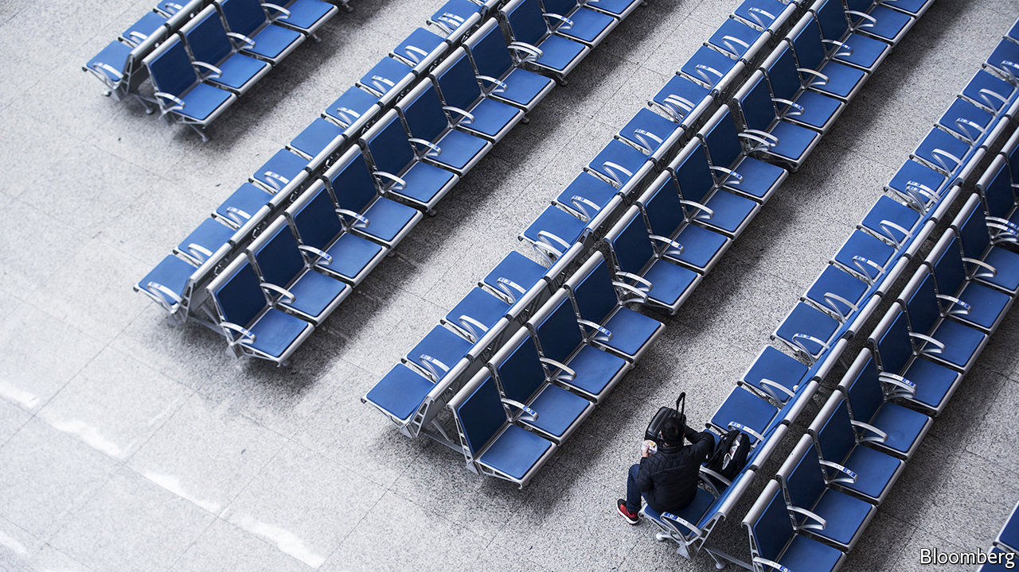

NO INDUSTRY HAS been more battered by covid-19 than air transport. With people wary of confined spaces—and country after country imposing travel bans—passenger numbers have nosedived, and with them airline revenues. The estimate of $113bn in lost sales, which the International Air Transport Association (IATA) made on March 5th, already looks rosy. The trade body says that the world’s carriers may need $200bn in state aid to stay aloft.

Plenty were stalling before the pandemic. Of the 120 airline companies ranked by IATA only around 30 made money in 2017 and 2018. Last year the biggest half-dozen in Europe earned the bulk of the $7bn in profits there, calculates Citigroup, a bank. Many firms had borrowed heavily to buy planes which the virus has grounded. The 90-odd that are in the red have on average six times as much net debt (adjusted for aircraft leases) as EBITDAR (a measure of airline profits). In January the typical carrier had enough cash to cover between 50% and 80% of short-term liabilities and about two months of revenues, IATA says (see chart). Three-quarters could not cover costs beyond three months—if that.

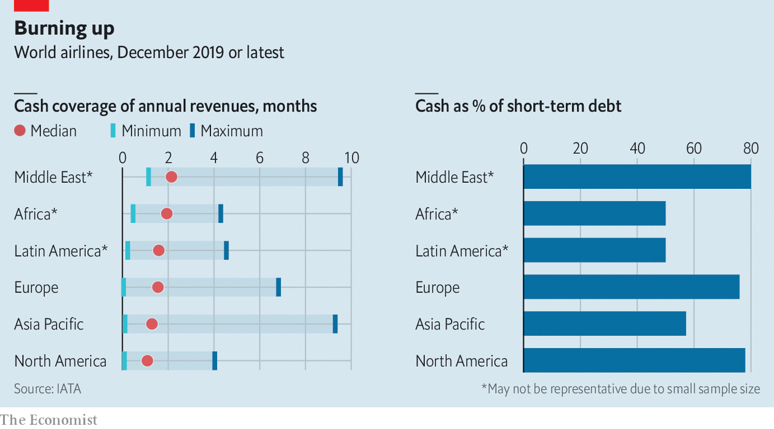

Big companies have secured generous credit lines from banks. IAG, which owns British Airways, can tap €1.9bn ($2.1bn) in revolving credit. EasyJet, a British low-cost carrier, has $500m available. Most firms, especially in Europe and Asia, nevertheless have no choice but to cut flights and sack staff. Cancellations in America are a bit less savage while planes are still permitted to crisscross its air space; Southwest has cut just one in five flights. If revenues fall by 35% in 2020, Delta, Southwest and United should end the year with “adequate” liquidity, says JPMorgan Chase, another bank—as long as demand begins to bounce back.

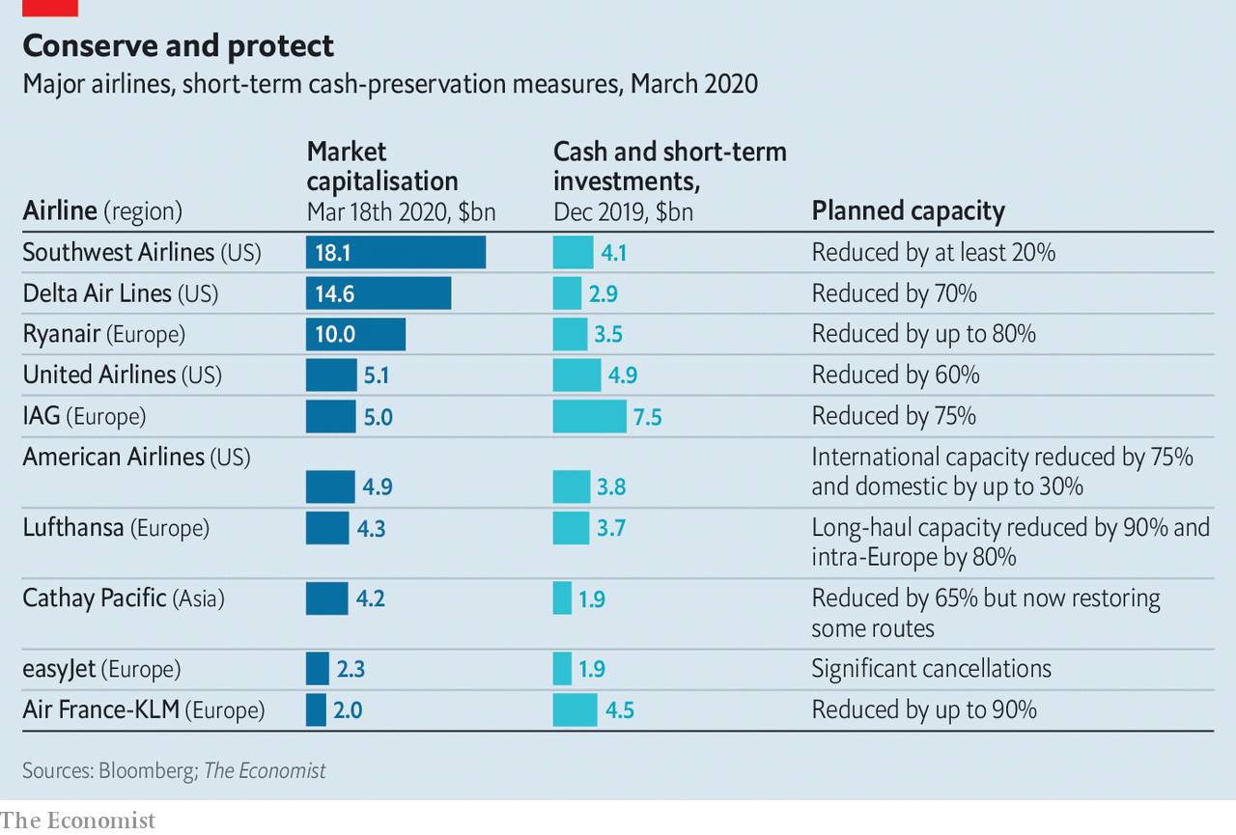

China offers hope that it might. The first to be infected, its airlines are lifting off again. In mid-February capacity was down by 71% compared with a year ago, says OAG, a data firm. In the first week of March it was 43% lower, as people returned to the skies lured by cheap fares (see [article](https://www.economist.com/graphic-detail/2020/03/21/as-western-flights-shut-down-chinese-routes-are-opening-again)). Combined with government handouts to carriers, which are mostly state-owned, this may tide them over. Airline bosses elsewhere are banking on similar luck—and largesse.

This article was downloaded by calibre from <https://www.economist.com/business/2020/03/19/airlines-are-running-out-of-cash>

|  |  |  |  |
| --- | --- | --- | --- |
| Previous | Articles | Sections | Next |

|  |  |  |  |
| --- | --- | --- | --- |
| Previous | Articles | Sections | Next |

#### My iron lung

# Companies are scrambling to build more ventilators

Demand for breathing apparatus greatly outstrips supply

Mar 19th 2020 |

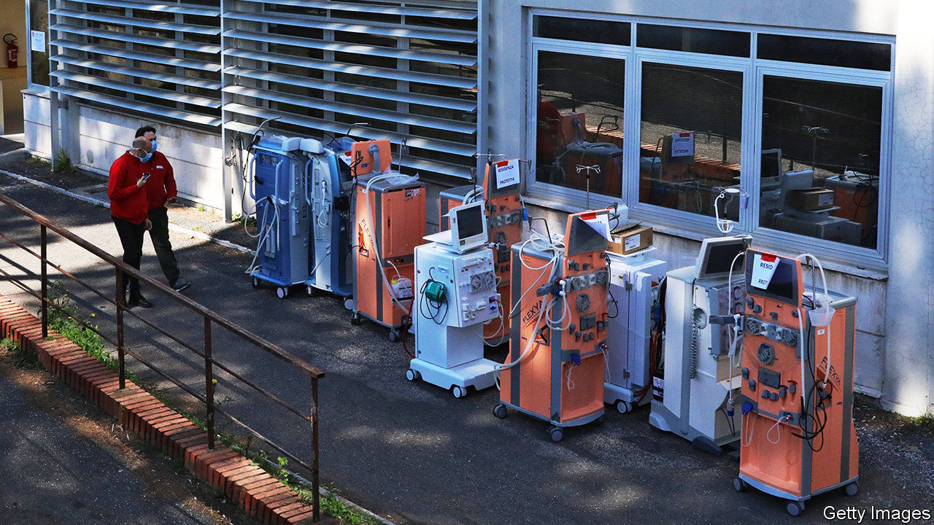

MUCH OF THE panic-buying provoked by the covid-19 pandemic seems overblown. Grocers insist they are not about to run out of food. But in one category of product, scarcity is all too real. Overwhelmed health services are desperately short of mechanical ventilators to help the roughly 10% of sufferers with severe symptoms to breathe. Political leaders are urging existing specialist producers to ramp up production. Germany’s government ordered 16,000 new machines from two domestic producers. Others, like Britain’s prime minister, Boris Johnson, want manufacturers of all stripes to retool and help out. That is easier said than done.

It is hard to pin down how many ventilators health-care systems have on hand. The last survey of ventilator capacity in America was ten years ago. It tallied 62,000 sophisticated machines and 100,000 basic ones. American health authorities are now hastily counting anew. They are likely to find fewer than 200,000, 80-90% of which are typically used by non-covid patients. A rough calculation by The Economist suggests that, if the virus keeps spreading at the current rate, America would run out of spare devices in four weeks. The situation is worse in other countries (see chart).

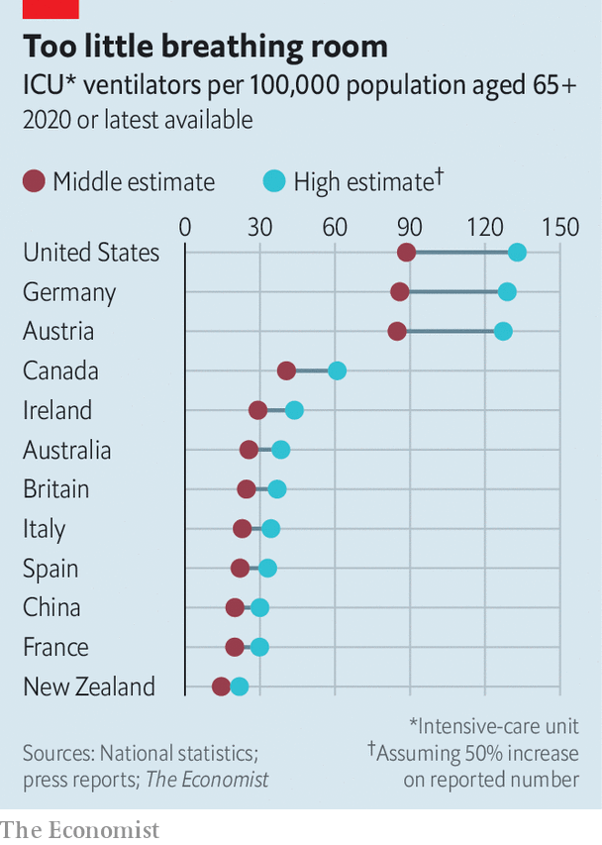

In 2019 ventilator-makers had the capacity to churn out just 40,000 units suitable for intensive care, according to Getinge, a Swedish firm which makes one in four such machines sold worldwide. Most companies build kit, which costs anywhere between $10,000 and $60,000 apiece, to order rather than keep inventories. Premier, a firm that bought 2,000 last year on behalf of 40% of America’s hospitals, says that buyers must now wait 8-12 weeks for new ones to arrive, not a fortnight as in normal times. Getinge’s order book is completely filled until June.

All manufacturers are ramping up production. Getinge plans to make 16,000 units this year, 60% more than in 2019. Most of its rivals hope to increase output by a similar amount. Italy’s army has sent 25 technical staff to Siare, its only domestic producer, to try to quadruple production, to 500 units a month. Mr Johnson’s government sent 60 large manufacturers a blueprint of a ventilator along with links to a YouTube video and an academic paper describing a device that could be deployed rapidly. OneBreath, a startup in California, is hoping regulators will fast-track approval of its $4,000 design that could be ready to produce in less than a year.

Getinge’s boss, Mattias Perjos, doubts that the British prime minister’s plan will work, at least in the short term. Ventilators are not the most complicated pieces of machinery. But they are fiddly. It takes Getinge two years on average to develop a new model. Even if regulators relaxed their approval process—which can take another two years—a carmaker will not learn to build safe and effective medical gear overnight.

Even if specialist firms add production lines to their factories, and non-specialists reconfigure theirs, one other constraint remains. Most components come from China, where virus-related stoppages reduced production of industrial equipment by 28% in January and February, year on year. China is beginning to rev up its industrial engine as new infections slow. But it will be a while before its factories are fully back in business. By the time they are, drastic measures that governments around the world are taking to slow the virus’s spread may leave ventilator-makers themselves with less breathing room to function.■

This article was downloaded by calibre from <https://www.economist.com/business/2020/03/19/companies-are-scrambling-to-build-more-ventilators>

|  |  |  |  |
| --- | --- | --- | --- |
| Previous | Articles | Sections | Next |

|  |  |  |  |
| --- | --- | --- | --- |
| Previous | Articles | Sections | Next |

#### Very golden oldiest

# Berkshire Hathaway has America Inc’s oldest board

Its new 68-year-old member looks positively ephebic

Mar 21st 2020 |

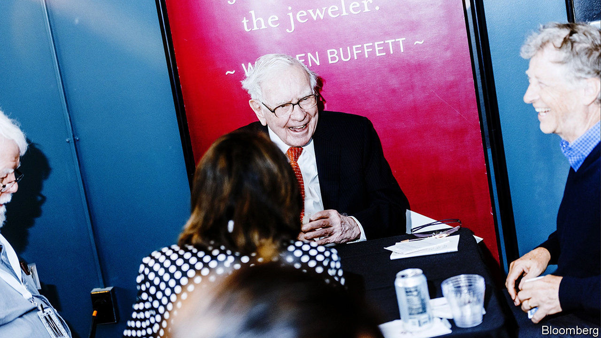

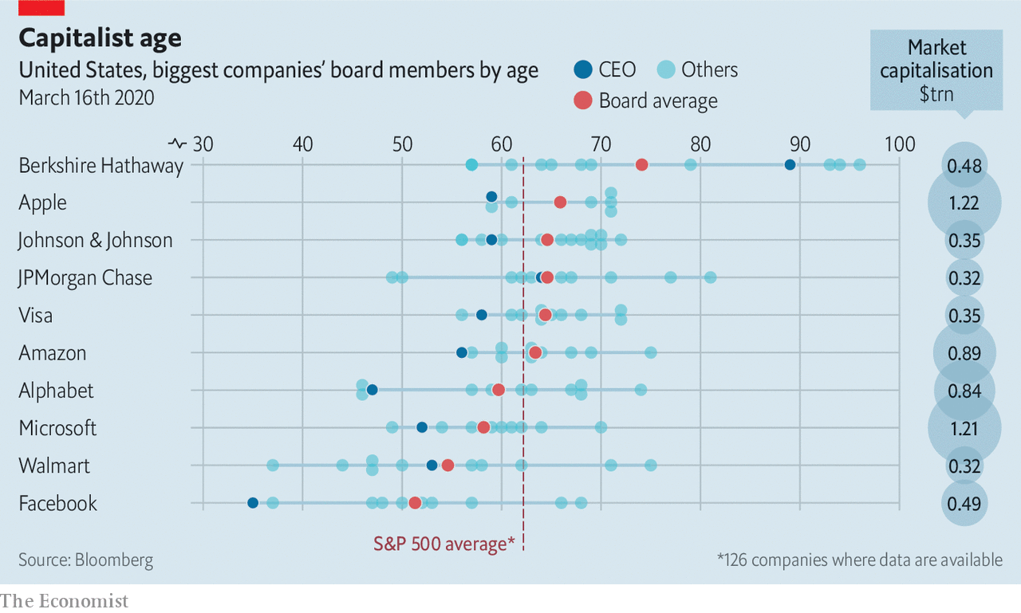

ON MARCH 13TH Bill Gates stepped down from the boards of Microsoft, the software giant he founded, and Berkshire Hathaway, a company run by his plutocrat pal, Warren Buffett. The 64-year-old Mr Gates’s replacement at Microsoft has not been named. At Berkshire, he will be succeeded by Ken Chenault, a respected former boss of American Express. Mr Chenault, who is four years older than Mr Gates, may not look like the fresh blood the underperforming conglomerate needs, exactly. But relative to its ancient boardroom, which includes three nonagenarians, he looks positively ephebic.■

This article was downloaded by calibre from <https://www.economist.com/business/2020/03/21/berkshire-hathaway-has-america-incs-oldest-board>

|  |  |  |  |
| --- | --- | --- | --- |
| Previous | Articles | Sections | Next |

|  |  |  |  |
| --- | --- | --- | --- |
| Previous | Articles | Sections | Next |

#### Bartleby

# How corporate leaders should act in a crisis

Managers earn their money when the going gets tough

Mar 19th 2020 |

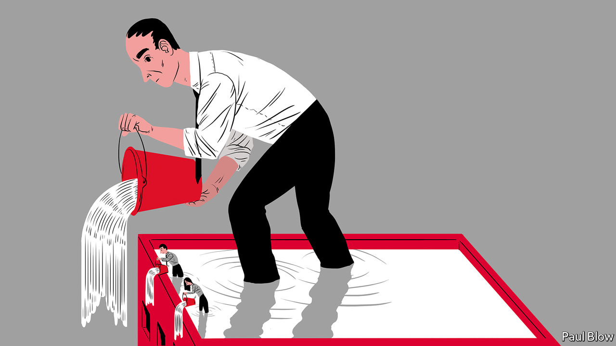

WHEN THINGS are going well, it is pretty easy being a business leader. The economy is booming, orders are rolling in and there are no tricky decisions to make about staff or budgets. It is still possible to screw things up, but a rising tide tends to lift all yachts.

It is in a crisis that corporate helmsmen show their mettle. Employees will be uncertain and will look to the leader for direction. Sometimes, as with the covid-19 pandemic, the problem will be something few bosses can reasonably have anticipated. Now they are expected to chart a steady course in days.

In the political arena the obvious examples of successful crisis leadership are Franklin Roosevelt and Winston Churchill. Both were somewhat erratic decision-makers. But they made up for it by being excellent communicators. Their styles diverged, but the public had little difficulty in understanding their core message. Roosevelt made clear that he was willing to try any combination of new ideas in an attempt to end the depression; Churchill was unambiguous about the need for Britain to resist Nazi Germany, whatever the cost.

Corporate leaders should resist the temptation to give Churchillian speeches. But they have something to learn from the calm authority of Roosevelt’s “fireside chats”. As chief executive you have to communicate a message to two different audiences: your workforce and your customers. That message should demonstrate that the company has a plan to deal with the virus. This may involve staff working from home (to prevent the spread of infection) or changes in the supply chain (to maintain production). Both staff and customers will also need reassuring that the company has sufficient financial resources to survive the economic downturn.

Jefferies, an investment bank, has just provided a fine example. In a joint letter, the chief executive, Rich Handler, and the president, Brian Friedman, stressed that “topmost on our minds is the safety of our employees and our clients” before adding that the firm “is flush with capital at both the operating business level and our parent company”. Other firms may not be so lucky. But silence on such matters would be dangerous.

For the broader strategy, tips can be gleaned from the National Defence University (NDU), an American military college. In 2006 it produced a useful—and prescient—report called “Weathering the Storm: Leading Your Organisation Through a Pandemic”. It advised leaders to analyse the tasks required for an organisation to continue operating and prioritise them. To ensure essential functions can be performed, employees should be trained in different disciplines. That way they can cover for colleagues who become sick.

It helps to have done this in advance, of course. But even firms that dithered can—besides making amends now—adopt the right the tone. How you handle crisis communication is, the NDU says, “critical”. It can matter as much as having the right message.

This point is amplified by Shawn Engbrecht, a former US Army ranger who now runs a personal-protection company. He has written a highly entertaining, if idiosyncratic, book entitled “Invisible Leadership”. “As a leader,” he cautions, “you can promise everything to the many until you are unable to deliver even a little to the few.” In the end, “Failure to tell the truth rapidly erodes trust and confidence in higher command.”

In a crisis, Mr Engbrecht advocates “embracing the suck”. This means accepting where you are at a given moment: “Wishing, hoping and praying the problem away does not work so don’t waste your time with coulda, shoulda or woulda.” In short, no sugarcoating. If everyone on staff realises there is a problem, they will not be reassured by an executive blithely promising that it may go away.

A good manager must take time to listen to staff concerns and answer their questions. That may require a bit of patience. In Mr Engbrecht’s words, “the quieter you become, the more you can hear”. Mass meetings may not be appropriate at a time of a highly infectious disease. But an online town-hall gathering would be salutary.

Have a clear message, keep calm and be transparent: all obvious stuff, crisis or no crisis. Another kind of leadership may be more painful. Executives at airlines like Qantas and United have agreed to take pay cuts (or forgo their salaries entirely) until the pandemic passes. Good leaders show they face at least some of the same dangers as their troops.

This article was downloaded by calibre from <https://www.economist.com/business/2020/03/19/how-corporate-leaders-should-act-in-a-crisis>

|  |  |  |  |
| --- | --- | --- | --- |
| Previous | Articles | Sections | Next |

|  |  |  |  |
| --- | --- | --- | --- |
| Previous | Articles | Sections | Next |

#### Schumpeter

# How Visa became the top dog in global finance

It has overtaken JPMorgan Chase to become the world’s most valuable financial-services firm

Mar 19th 2020 |



TOP DOGS in finance used to be big banks with trillion-dollar balance-sheets. No longer. Earlier this month Visa, a humble payments processor, became the world’s most valuable financial-services company. The ongoing stockmarket rout has dragged Visa’s share price down, with analysts cutting forecast revenues from transaction fees, as the coronavirus forces self-isolating consumers around the world into a shopping hiatus. But it has suffered less than erstwhile title-holders like JPMorgan Chase. That investors view Visa as more resilient than Wall Street is perhaps more revealing even than its still eye-popping $291bn market capitalisation. How did a mere cog in the system end up here?

Ask Visa’s bosses and they crow about their firm’s tech and marketing nous. That is a part of it. But the deeper reason for Visa’s success is more prosaic. Being the biggest player in a deeply entrenched payments oligopoly turns out to be fabulously lucrative.

Many casual observers often confuse Visa for a lender that extends credit to people who spend using credit cards adorned with its logo. What it actually does is co-ordinate a complex web of intermediaries that stand between buyers and sellers. The American firm now connects more than 61m merchants to 3.4bn Visa-branded cards, nearly one for every two people on Earth, issued mostly by banks. It takes a small cut for making those connections. Given their volume—nearly $9trn last year, equivalent to over a tenth of global GDP—the commissions add up. Before covid-19 Visa’s revenues grew by around 10% a year, reaching $23bn in 2019.

Banks used to keep all the fees for themselves. Over 10,000 of them collectively owned Visa until it was spun out in 2008. Since then they have watched with envy as Visa’s profits have swelled 15-fold. Some of this is the result of global expansion and so higher revenues. Visa may not be literally “everywhere you want to be”, but it is close. It claims to be present in more than 200 countries and territories. Better yet, operating margins have swollen over the past 12 years—from a rich 43% to a heart-stopping 65%. Of the world’s 100 biggest listed firms by market value, last year only a state-run Chinese booze giant and Saudi Aramco, an oil colossus, had higher margins. Even the juicy 20-25% levels of technology darlings like Apple and Alphabet are meagre by comparison.

Because adding more capacity to Visa’s payments network is cheap, its costs have grown far more slowly than revenues in the past decade. Visa can thus get away with charging more for its services—sometimes considerably more—than its marginal cost of providing them. The windfall profits are funnelled to Visa’s shareholders, whose returns (including dividends) have averaged 24% a year since 2008. Investors, who value the firm at nearly 30 times its most recent annual earnings, against less than ten times for fellow finance firms in the S&P 500 index, clearly believe no competitor will challenge its dominance any time soon.

Visa is not entirely competition-free. Americans still write cheques and the Japanese love their cash. Local schemes nibble at its heels in individual markets—and Mastercard, its only global rival of note, does so just about everywhere. But cheques and banknotes are in decline. Rival incumbents are geographically limited, smaller, or both. And consumers will not sign up to an upstart system before merchants adopt it—which merchants won’t do until it has been embraced by a critical mass of customers. This chicken-and-egg problem is particularly hard to overcome.

Hard, but not impossible. In the longer term Visa faces three threats. First, authorities fed up with it and Mastercard are setting up national lookalikes. China already has UnionPay. Places like Russia, Australia and the EU want payment rails they can control. They could use regulations, including on consumer data, to weaken the duopoly. Competition watchdogs worldwide have gone after both firms, forcing large settlements. Europe and America have capped the fees that payment processors can levy.

Some countries are exploring alternative tracks. Bank-to-bank transfers, which used to take days, are now instant in many places (though not, inexplicably, in America). Thanks to smartphones, interbank pipes could be used to funnel money from consumers’ accounts directly to those of sellers, bypassing Visa’s systems and fees. Such plumbing has caught on in places like Sweden and India. But it is limited to one country, whereas Visa and Mastercard work globally. And uptake has been slow; Britain has had instant transfers for a decade but few shoppers or shopkeepers have noticed. All eyes are on America, with its vast home market. The Federal Reserve wants such a system to be up and running by 2024.

The last threat looms in cyberspace. So far, “fintech” payments startups like Square or Stripe shunt transactions onto Visa’s rails rather than offer a new set of tracks. Apple Pay and Google Pay are little more than a plastic-less way to store your Visa and Mastercard. Facebook’s more ambitious attempt to mint a digital currency, called Libra, has stalled. But Silicon Valley’s vast user base could in principle get around the chicken-and-egg problem, as China shows. Tencent and Alibaba used a huge social-media platform and an online emporium, respectively, to bootstrap payments systems. Amazon could do the same, especially now that Visa has said it would start charging the e-commerce giant higher card fees in its American online stores.

## No Visa-free travel

Visa still has plenty of transactions to chase. At a time of social distancing, contactless payments and online shopping look more appealing than filthy banknotes or crowded supermarkets. Banks continue to tolerate it, not least because they receive the bulk of the fees merchants are charged for every Visa transaction. Its revenues of about $7 per card a year are not enough to spark consumer outrage. And it works; its systems are down just 0.001% of the time. Until a rival emerges that is literally everywhere consumers want to be, Visa will be hard to dislodge from its cosy perch.■

This article was downloaded by calibre from <https://www.economist.com/business/2020/03/19/how-visa-became-the-top-dog-in-global-finance>

|  |  |  |  |
| --- | --- | --- | --- |
| Previous | Articles | Sections | Next |

|  |  |  |
| --- | --- | --- |
| Business | Sections | Science and ... |

Finance and economics

The cash crisis: Down the drain

.

Buttonwood: Capitulation

.

The surging dollar: Multi-coloured swap shop

.

Two versions of reality: Exchange-traded fundamentals

.

Closing stock exchanges: The pits

.

Free exchange: From V to victory

.

|  |  |  |
| --- | --- | --- |
| Business | Sections | Science and ... |

|  |  |  |  |
| --- | --- | --- | --- |
|  | Articles | Sections | Next |

#### The cash crisis

# Why America’s financial plumbing has seized up

Central-bank action is failing to stem the rout

Mar 19th 2020 | NEW YORK

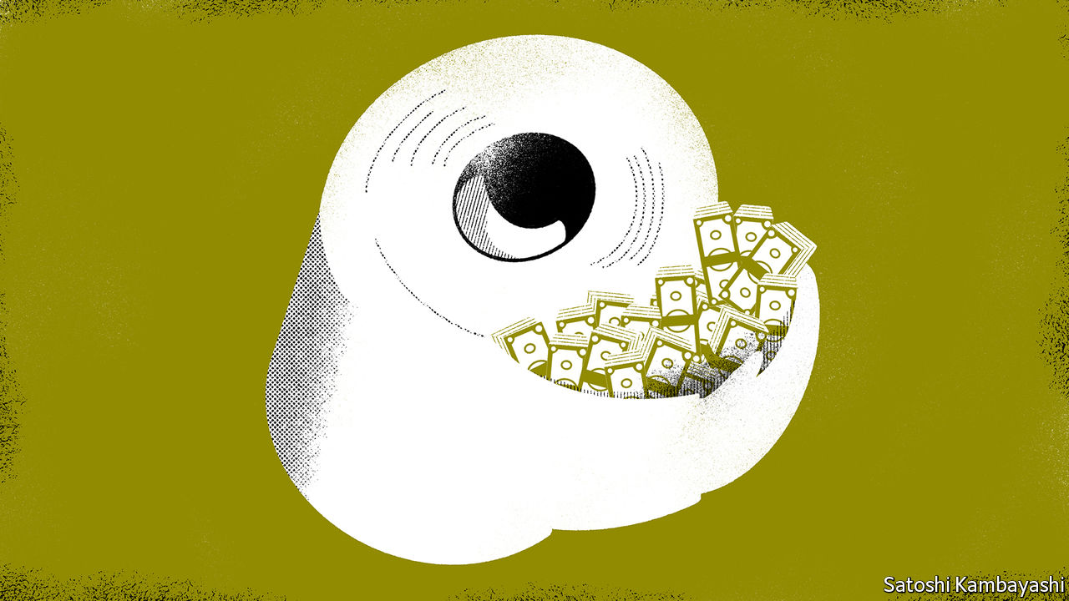

HOUSEHOLDS ARE frantically stocking up on essentials such as loo roll. But in financial markets, the staple that no one can do without in times of stress is cash—the flushing mechanism of the world economy. In theory, it should never dry up; money can be printed. But when firms are desperate for cash it puts a potentially devastating strain on the plumbing of the global financial system. That is why in the past week America’s Federal Reserve has unleashed a huge amount of liquidity. Foreign central banks have joined in. Many face the additional challenge of a strengthening dollar (see [article](https://www.economist.com/finance-and-economics/2020/03/21/the-agonies-of-stock-picking-in-a-falling-market)).

Unlike the 2007-09 financial crisis, when problems in the financial system caused an economic meltdown, the spread of the covid-19 disease has caused a health and economic crisis that has caught banks, financial markets and business in its wake. Big and small firms realise that they are facing— at the least—months of scant revenues, yet still have bills and debts to pay.

Some are better equipped than others (see left-hand chart). The operating expenses (opex), like wages and rent, of all nonbank S&P 500 companies in 2019 amounted to $2.6trn. The same firms held $1.7trn in cash and liquid securities at the end of that year. On average, that was about seven months of opex. But this cash is unevenly distributed. Apple could pay for six years of opex with its $200bn war chest. Many big utilities, such as Edison International, carry only enough cash to cover a week’s worth.

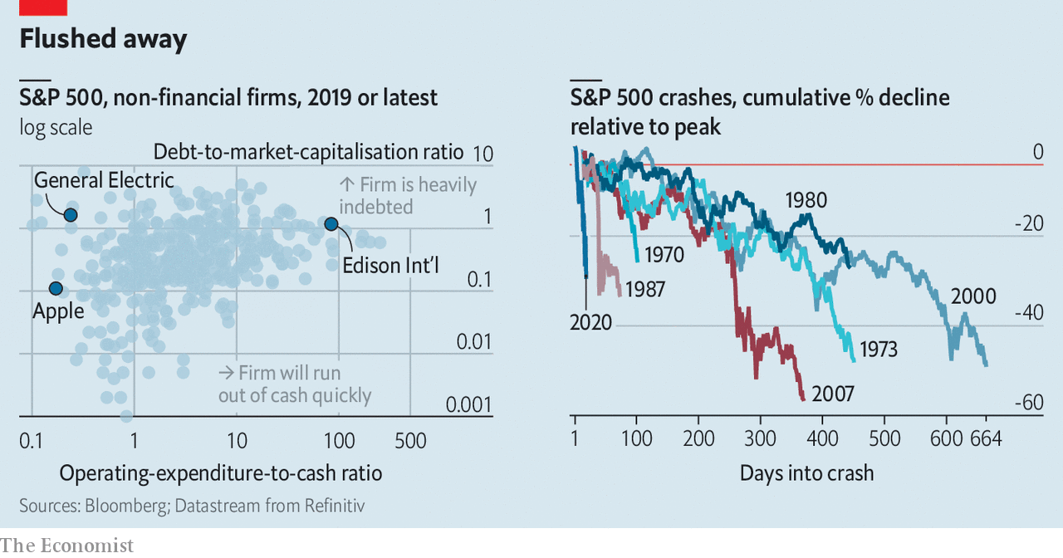

The quickest way for investors, firms and banks to raise cash is to sell liquid assets. Investors moved first. Their priority was to liquidate holdings of risky assets, like stocks and high-yield bonds, and buy safe assets like Treasuries. Markets moved accordingly: the S&P 500 has sold off hard and fast (see right-hand chart) and bond yields rallied. But companies and banks tend to hold their liquid assets in Treasuries. When their need for cash became dire, they dumped even these.

Asset sales help reallocate the stock of existing cash. For every investor selling stocks or bonds to raise cash, there are those willing to take the other side—like Warren Buffett, the fabled “be greedy only when others are fearful” investor, who held $125bn in “dry-powder” at Berkshire Hathaway, his investment firm, at the end of 2019. He has already snapped up shares in Delta, an American airline. But reallocation can only do so much. When all firms face the same economic shock, they need a vast increase in the supply of credit.

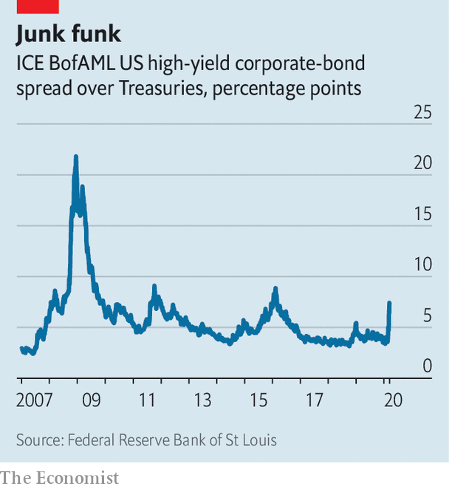

Unfortunately, credit is not readily available. Funding strains have emerged across markets globally. In January American firms that issued risky high-yield debt paid around 3.5 percentage points more to issue a bond than the government did. This spread is now above 8 percentage points (see chart 3). But even if firms did want to issue bonds at such rates, they cannot. Corporate debt markets are virtually shut in America and Europe.

If bonds are unavailable, firms turn to banks. Many have credit lines enabling them to borrow whenever they need, up to a certain limit (akin to a credit card). Last week Boeing, an aircraft manufacturer, drew down its entire $13.8bn line in order to stockpile cash. In America, there have been reports of firms of all stripes—from chipmakers to casino and cruise operators—doing the same. In Europe Aercap Holdings, an aircraft-leasing firm, said it was drawing down its $4bn credit line.

But banks have problems of their own. The first is that the thicket of global bank regulations imposed on them since the financial crisis may be exacerbating the funding crunch. Take regulations concerning “risk-weighted assets”. Banks must hold a certain amount of capital relative to the size and riskiness of the assets, such as loans, they have on their books. But as volatility in the value of the assets rises, they become more risky, forcing banks to shrink their balance-sheets. Another example is the new Current Expected Credit Losses rule, which came into effect for public companies in January. It forces banks to provision for bad loans as the probability of default rises, rather than waiting until counterparties start missing payments before booking losses.

The second problem banks have is their own scramble for cash. As lenders make loans, their balance-sheets grow. But balance-sheet is a scarce resource, especially in the current climate. In order to issue more loans banks must either shrink other assets, or find extra capital and funding. They are doing both. Banks have pulled back from market-making activity, as evidenced by the stubbornly high interest rates in the “repo” market, where firms and banks can swap cash overnight in exchange for posting Treasuries as collateral. Ordinarily banks might jump at the opportunity to arbitrage the difference away by hoovering up Treasuries. Yet intermediating in the repo market is something they can ill afford at present. Banks are also retaining more of their profits in order to build up capital. On March 15th America’s six largest banks announced they were halting share buybacks for three months.

Their backstop is the Federal Reserve, America’s lender of last resort. It has gone out of its way to ease the blockages in the financial system by encouraging banks to lend. It started on March 12th when the New York Fed, a branch of the central bank, made $1.5trn (an ocean of cash) available for repo operations. In addition to cutting interest rates on March 15th the Fed announced it would buy up $500bn-worth of Treasuries and $200bn-worth of mortgage-backed securities. By taking assets off the banks’ hands, it enables them to expand lending. It cut the rate on the “discount window”, a tool for banks to borrow from the Fed, and encouraged them to use it freely. It suggested that banks could dip into their capital buffers, worth $1.9trn, and their liquidity buffers, another $2.7trn, to lend to firms and households, which helped ease their regulatory constraints. Then, on March 18th, the Fed announced it would start buying short-dated commercial paper, to provide direct support for big companies. It also relaunched a facility to lend directly to “primary dealers”, a group of financial firms that do not have direct access to typical Fed lending channels.

These steps are the right ones. Other central banks are taking similar steps. For banks that promise to lend cash the European Central Bank has cut the rate at which banks can borrow from the central bank below the rate at which they are compensated for deposits. It says it will also expand its bond-buying programme by a whopping €750bn ($818bn). The Bank of Japan, meanwhile, is buying up company shares directly, too.

The scramble for cash will continue. If enough liquidity is created quickly, the long-term damage to the real economy will be minimised, though. And if firms know that they can get cash whenever they need it, they might not need quite so much in the first place. Rather like loo paper. ■

This article was downloaded by calibre from <https://www.economist.com/finance-and-economics/2020/03/19/why-americas-financial-plumbing-has-seized-up>

|  |  |  |  |
| --- | --- | --- | --- |
|  | Articles | Sections | Next |

|  |  |  |  |
| --- | --- | --- | --- |
| Previous | Articles | Sections | Next |

#### Buttonwood

# The agonies of stock-picking in a falling market

A fictional fund manager in his pyjamas ponders capitulation

Mar 19th 2020 |

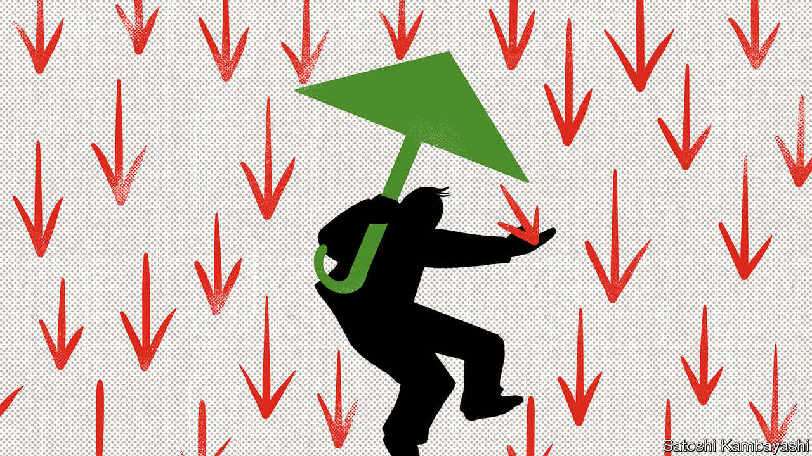

I SUSPECT THAT this not a common feeling, but part of me is excited about the crash in stock prices. It is the part of me with a personal-account portfolio. I have long-term financial goals. I want to hold equity risk, even as others run from it. If I can buy streams of cash flows at lower prices, I am happy. But another part of me, the professional who invests on behalf of others, is anxious. I try to fuse these two selves. It is not easy.

In my lifetime there have been three bear markets in which the value of shares in aggregate has fallen by half. Perhaps this episode will be as bad—or worse. I don’t know. I can say this, though. For a long-term investor who doesn’t have to worry about perfect timing, there should be opportunities to buy good stocks at attractive prices. As a private investor, I can wait for risky bets eventually to pay off. My clients may not be so patient.

Nobody knows how this pandemic will play out. Lots of people claim to know, of course. A few of them will be right, by luck or judgment. That’s a matter for the scientists and for economists, too. The biggest insight I have gleaned from economics is that asset prices are set at the margin. The stock price on the screen is the one at which the most desperate seller and the bravest buyer are willing to do business. When the ranks of the first group overwhelm the second, the result is a rout—or capitulation, in market-speak.

Every recession is unique. This one has the impact of a natural disaster or a nuclear accident. But every recession is also the same. You can never be sure how deep it will be, how long it will last and what scars it will leave. China has just experienced its sharpest downturn in a century. That is scary. But 2008 was scary. The dotcom bust was scary. I was a baby in 1974, but my old boss tells me that was scary. True, this is a different kind of scary. I call my parents every day to check how they are. I didn’t do that in 2008. (I wasn’t trading stocks in pyjamas on a weekday either.) This could be a savage recession. But it will be like other recessions in that there will be a recovery.

In the meantime, stock prices can keep falling. I understand why people are selling. A lot are forced to. They may have borrowed to buy stocks and had their loans called by nervy lenders. Fund managers that promised low volatility must cut their equity risk. But capitulation is more than this. It is the dumping of stocks that have already fallen a long way. Retail investors are prone to it. But why would any professional do it? Well, sometimes you sell your duds so you don’t have to talk about them anymore—to the firm’s risk manager or to your clients. Owning a stock that goes to zero is too horrible to contemplate. So you sell. And sometimes you sell things that as a private investor you would hold onto or double-down on. Clients want you to take risk. But they don’t like what risk-taking looks like when it doesn’t work. Try explaining, after the fact, why you bought a stock two weeks before the firm went bankrupt, because you judged that, should it survive or be rescued, you stood to make ten times your money.

I am lucky. I have been in the top-quartile of stockpickers. So I have earned the trust to make risky bets in a falling market. A good portfolio in a recession is not necessarily a good portfolio for when the economy recovers. I know that at some point I am going to have to change tack. I would have to be a genius to time this shift perfectly. And I am not a genius. The best I can hope for is not to get it too badly wrong.

My instinct is to be contrarian, to buy what others now hate. Some industries, such as oil, are outside my comfort zone. The politics of OPEC are too messy for me to fathom. But I have an eye on mining companies with attractive dividend yields and low debt. If China’s economy rebounds, they will benefit. And, yes, I am absolutely looking at airlines. A national champion or two is bound to be saved. In the right situation, I might make a lot of money for clients. Dislocation on this scale will take out the weaker players in every industry. The best companies will emerge even stronger. I hope I pick the right ones.

There will come a time when the market surveys the whole panorama—bad businesses cleared out; interest rates even lower; fiscal policy in the pipeline; cheaper stocks—and changes direction. I have to be ready for that. The S&P 500 is America’s capital stock. It will survive (or most of it will). People will want to fly, stay in hotels and go to restaurants and coffee bars again. I have to keep that in mind always. I feel queasy. But this is the game I have chosen to be in.

This article was downloaded by calibre from <https://www.economist.com/finance-and-economics/2020/03/19/the-agonies-of-stock-picking-in-a-falling-market>

|  |  |  |  |
| --- | --- | --- | --- |
| Previous | Articles | Sections | Next |

|  |  |  |  |
| --- | --- | --- | --- |
| Previous | Articles | Sections | Next |

#### Multi-coloured swap shop

# The dollar is in high demand, prone to dangerous appreciation

The Fed does not want to be the world’s central bank

Mar 21st 2020 | HONG KONG

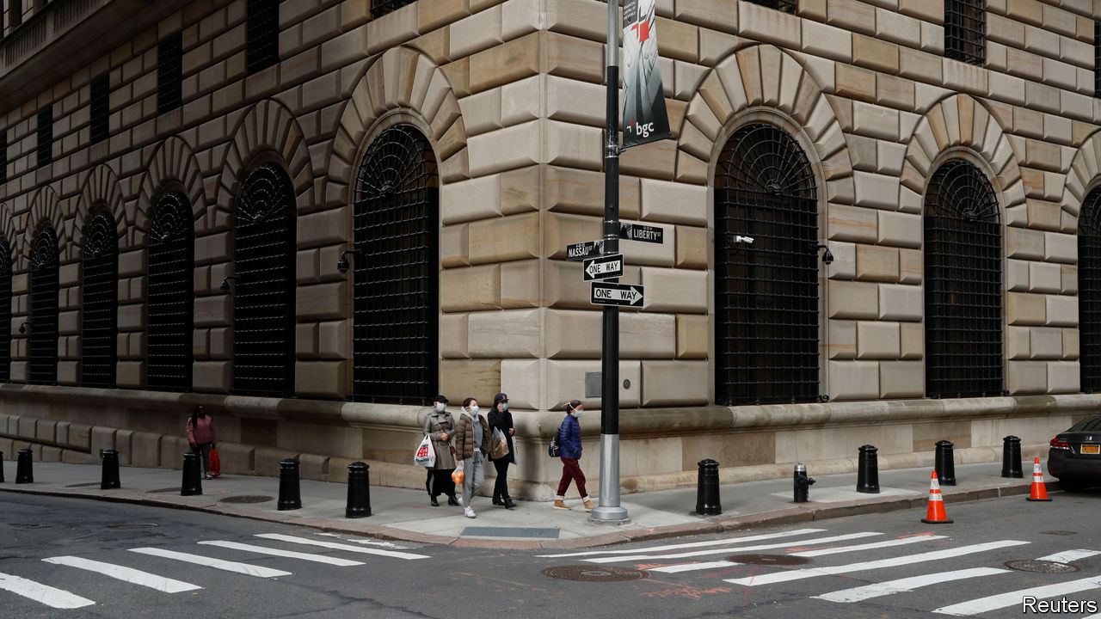

AMERICA’S CURRENCY was not always as coveted as it is in today’s troubled times. In the 1960s European central banks had more dollars than they felt comfortable holding. To discourage them from converting their greenbacks into gold, the Federal Reserve introduced its first “swap line” in 1962, allowing foreign central banks to obtain dollars in exchange for their own currency, then swap them back at a later date. Combined with the Fed’s purchases of dollars, the swaps helped protect nervous foreign central banks from the dangers of a dollar devaluation.

The world now faces the opposite problem: a dollar in high demand, prone to dangerous appreciation. It has, unsurprisingly, strengthened against the currencies of emerging markets, which have suffered brutal capital outflows since late January (see chart). But the dollar has, more surprisingly, also strengthened against safe-haven currencies such as the yen and the Swiss franc, and pushed currencies like the pound and the Norwegian krone to their weakest level in decades. On March 18th Bloomberg’s dollar spot index, which measures the greenback against a basket of currencies, hit an all-time high, its seventh consecutive rise. Anyone seeking to swap their yen, francs or euros for dollars (and then swap them back again after a few months) must pay a premium, known as the cross-currency basis, which is deducted from any interest they earn. That premium has risen sharply on several occasions in the past two weeks.

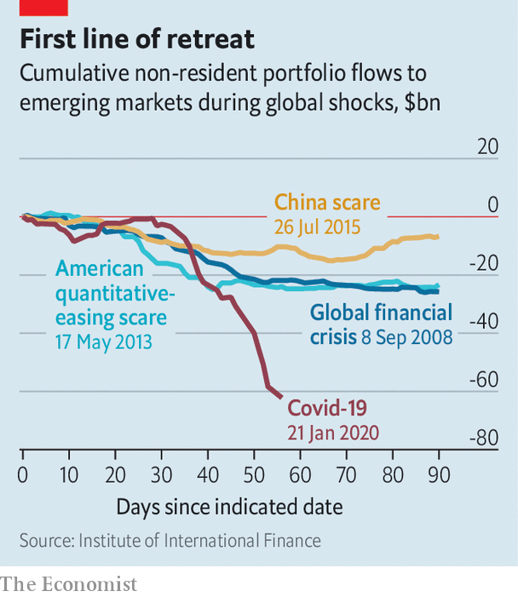

One reason for this scarcity may be the dollar’s global role. Zoltan Pozsar and James Sweeney of Credit Suisse, a bank, have pointed out that supply chains are payment chains in reverse. When the flow of parts, components and assembly is interrupted, so is the flow of payments in the other direction. In East Asia, where the pandemic began, these payments are often made in dollars.

Some hospitals overwhelmed by covid-19 cases have reported a lull before the storm, a period when emergency rooms fall quiet, because people with other ailments are staying away, but the people who cannot breathe have yet to arrive en masse. Something similar befell the dollar funding markets in February. China’s shutdown reduced the need for trade finance, point out Mr Pozsar and Mr Sweeney, removing one source of demand for dollar lending. But as companies’ dollar earnings have dried up, more of them have turned to their banks for help. Companies with pre-arranged credit lines have drawn them down. Large firms that are accustomed to obtaining money directly from the capital markets, through bonds or commercial paper, have also turned to the banks instead.

The banks themselves can turn to the Fed, which can lend them dollars they cannot obtain on their own. But the Fed is less able to help banks that lack a presence in America. Last year non-American banks had $13trn-worth of dollar liabilities, according to calculations by Iñaki Aldasoro and Torsten Ehlers of the Bank for International Settlements. Only 22% of this total was booked with branches or subsidiaries in America. The rest was out of the Fed’s immediate reach.

The Fed can, however, reach out to its fellow central banks. And they, in turn, can help commercial banks within their own bailiwicks. On March 15th the Fed eased the terms of its swap lines with central banks in the euro area, Japan, Britain, Switzerland and Canada. Two days later, the Bank of Japan offered over $30bn in 12-week loans, the largest amount since the 2007-09 global financial crisis. The European Central Bank followed up with $112bn. That narrowed the “basis” that must be paid to obtain dollars through foreign-exchange swaps.

Fed-watchers immediately began wondering if it would expand its swap lines to include prominent emerging markets. There is precedent. The Fed’s first swap line to Mexico dates back to 1967. And in October 2008 it also offered lines to Singapore (which even then was overqualified for the role of emerging market), South Korea and Brazil (the “dodgiest of the lot”, according to Richard Fisher, then president of the Dallas Fed). But Fed officials back then were, and still are today, reluctant to serve as central bank to the world. Transcripts of the October 2008 meeting indicate that several other emerging markets (their identities remain redacted) had already inquired about joining the Fed’s magic circle. “We have done everything we possibly can to discourage” such approaches, said one Fed economist. “We’re not advertising.” ■

This article was downloaded by calibre from <https://www.economist.com/finance-and-economics/2020/03/21/the-dollar-is-in-high-demand-prone-to-dangerous-appreciation>

|  |  |  |  |
| --- | --- | --- | --- |
| Previous | Articles | Sections | Next |

|  |  |  |  |
| --- | --- | --- | --- |
| Previous | Articles | Sections | Next |

#### Two versions of reality

# Exchange-traded fundamentals

The funds show signs of strain but not panic

Mar 21st 2020 |

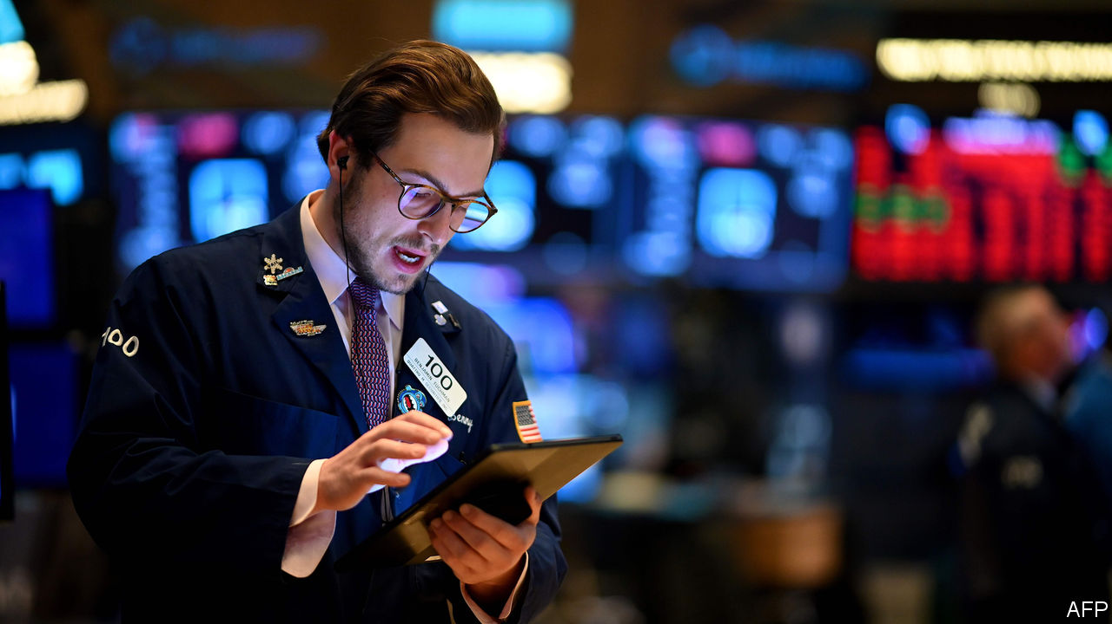

JEREMIADS HAVE long argued that if some of the $6trn-odd of assets underpinning exchange-traded funds (etfs) are illiquid, then the funds must be too, posing a big risk to their investors. But so far there are signs of strain but not panic. During the current turmoil, some etfs are trading at a discount to their net asset value, often those that have invested in debt. But that may be because they are easy to trade, making them a better gauge of reality than the last recorded price of the underlying securities. ■

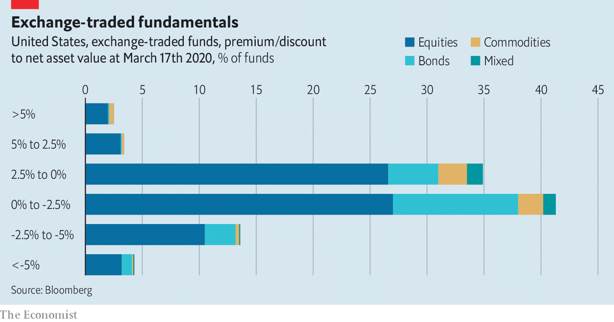

This article was downloaded by calibre from <https://www.economist.com/finance-and-economics/2020/03/21/exchange-traded-fundamentals>

|  |  |  |  |
| --- | --- | --- | --- |
| Previous | Articles | Sections | Next |

|  |  |  |  |
| --- | --- | --- | --- |
| Previous | Articles | Sections | Next |

#### Closing stock exchanges

# Venues may close. Trading should remain open

Amid a scramble for cash, the world needs capital markets

Mar 19th 2020 |

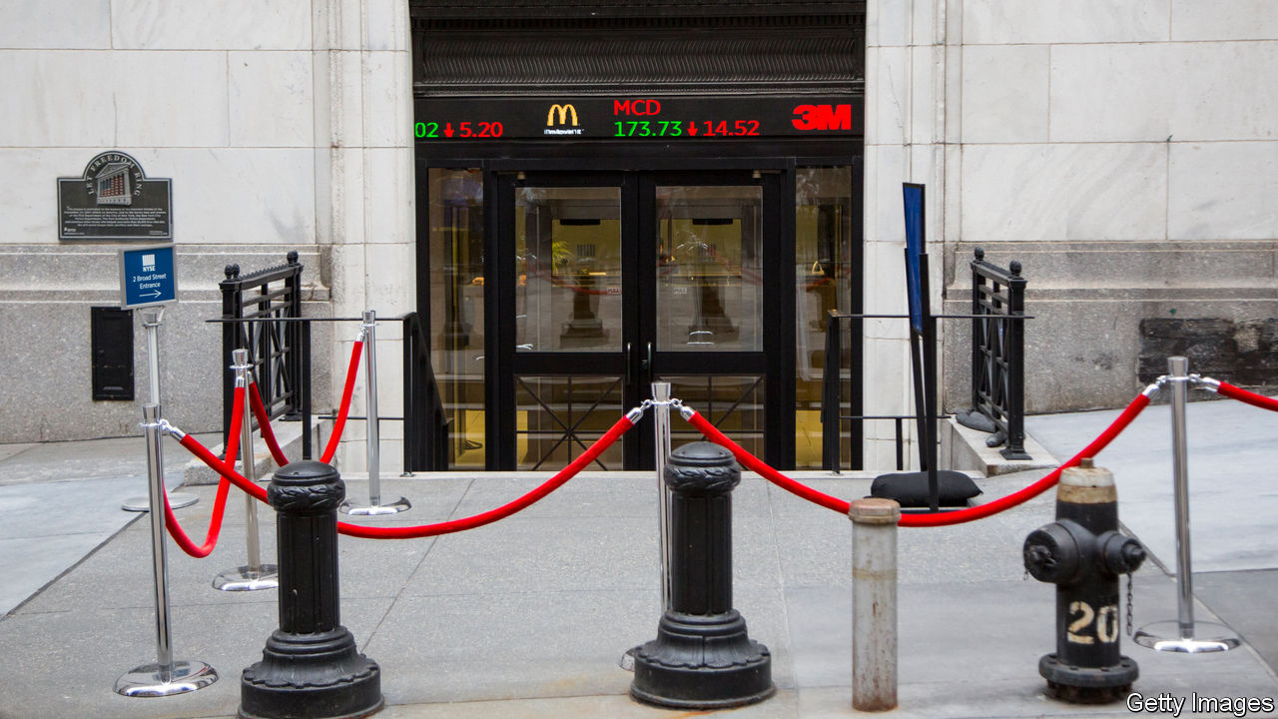

INSOFAR AS STOCK exchanges used to worry about viruses, it was of the type that infect the computers through which virtually all trading is done. But on March 18th the New York Stock Exchange (NYSE) became the latest venue to announce that its trading floors would close in response to the covid-19 disease, and that trading would become fully electronic from March 23rd. Such closures, amid extreme market volatility, may add to calls that all securities dealings should be suspended in response to the pandemic. But Stacey Cunningham, president of the NYSE, was not alone when she insisted that markets should stay open. With the world scrambling for cash, it would be the height of foolishness to shut off access to the capital markets.

Some markets have come perilously close to a prolonged shut down. On March 17th the Manila stock exchange was suspended as part of a lockdown on the main Luzon island. But amid fears of a backlash from investors, stock trading has resumed.

In America Steven Mnuchin, the treasury secretary, has mulled over the possibility of shortening trading hours, though he insists markets should stay open so savers can access their stockmarket holdings. Terry Duffy, the boss of CME group, a derivatives exchange, said cutting back trading time “makes no sense ... especially during this unprecedented crisis when news, information and events are changing at such a rapid pace.”

When markets have closed in the past, it has usually been because of some physical limitation on their ability to operate—for example after terrorist attacks in September 2001, or in the wake of storms. Big exchanges stayed open during the financial crisis of 2007-09. When Greece closed its stock exchange in 2015 for five weeks during capital controls, bank shares fell by 30% on the first day that trading resumed and the overall market dropped 16%.

Closing venues for health reasons is less serious than it used to be because so much trading is done electronically. Banks have been rushing out business continuity plans to ensure markets can continue despite potential lockdowns. Traders are in theory able to work from home. Yet having lots of them operating remotely will pose challenges of its own, says one banker. The biggest is the plethora of rules to prevent market abuse by people on bank trading floors. Regulators are being informally asked to relax some restrictions temporarily, such as the need for all conversations by traders to be recorded.

The most tangible trading restrictions so far are on “short-selling”, which allows investors to profit if prices drop. Several European countries including France, Italy and Spain have limited the practice. Hedge funds worry that credit-default swaps, a sort of insurance policy which pays out if a company goes bust, may become difficult to collect because of political pressure. But the end result of such meddling is that investors who might have hedged their existing positions—so protecting themselves against further losses—are likelier to simply sell what they own and stay away.■

This article was downloaded by calibre from <https://www.economist.com/finance-and-economics/2020/03/19/venues-may-close-trading-should-remain-open>

|  |  |  |  |
| --- | --- | --- | --- |
| Previous | Articles | Sections | Next |

|  |  |  |  |
| --- | --- | --- | --- |
| Previous | Articles | Sections | Next |

#### Free exchange

# Economies can rebound quickly from massive GDP slumps—but not always

History suggests full recovery takes, on average, about five years

Mar 19th 2020 |

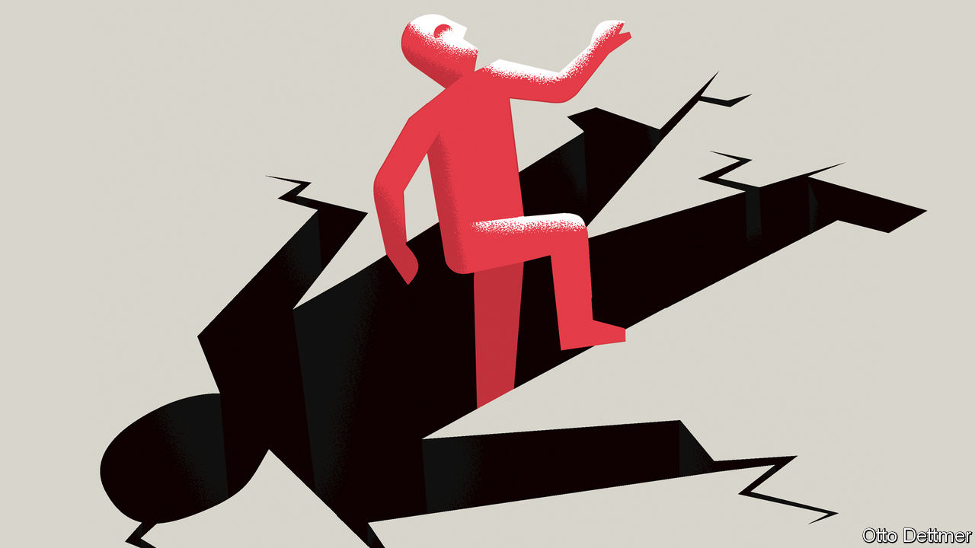

IT WILL BE some time—years most likely—before the full extent of the economic blow from covid-19 can be estimated with any confidence. As ever more of the global economy enters a prolonged shutdown, it seems increasingly clear that the world is facing a drop in output unprecedented in its breadth and intensity. Some analysts see in the growing economic disruptions and market panic the first stirrings of an economic collapse more serious than the global financial crisis of 2007-09. Joachim Fels, an economist at PIMCO, an investment fund, recently warned that in the absence of sufficiently aggressive action from governments the world could face a market meltdown and ensuing depression. All downturns create discomfort, but the pain of a slump—even a very steep one—depends greatly on how long it lasts. History suggests that rapid rebounds from enormous output losses are possible, but not by any means guaranteed.

Some economies, perhaps those of Singapore or even South Korea, could find a footing by the second half of the year, sufficient to offset some of the production lost during the first half. But the probability that others could experience extreme declines in GDP in 2020—perhaps as large as 10%—grows by the day. Falls of that magnitude are not especially unusual in developing economies, where growth is highly volatile. (To take just one example, there have been ten years since 1980 in which real GDP in Libya has fallen by at least 10%, between which plunges the economy has experienced annual growth spurts of as much as 125%.) In industrialised countries swings of that scale are exceedingly rare. An analysis of data gathered by the World Bank reveals that since 1960, across rich countries, there have been only 13 instances in which an economy experienced an annual decline in GDP of at least 5%, only three cases in which output fell by at least 7% in one year (Finland in 2009, and Greece in 2011 and 2012), and none in which output dropped by more than 10%. In the rich world, clusters of large decreases in GDP appear on the heels of the 1973 oil crisis, during the Asian financial crisis of 1997-98, and as part of the global financial crisis and its aftermath.

A longer perspective reinforces the rarity of such events. Economic historians at the University of Groningen, in the Netherlands, maintain a cross-country set of GDP data stretching far into the past. Since 1870, across 18 industrialised economies, there have been only 47 instances in which a country experienced an annual decline in output of more than 10%. Most are associated with world wars and the Depression; of the 47 large output declines, 42 occurred between 1914 and 1945 (see left-hand chart).

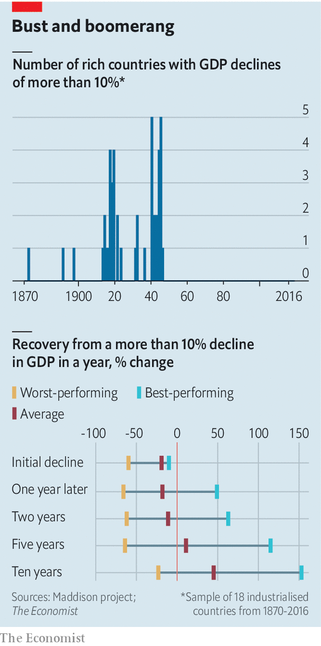

How do countries fare after suffering such economic blows? Recoveries are occasionally quite rapid. At the end of the world wars, a few economies experienced near-immediate bursts of growth—partly, but not always, because of rebuilding. The beleaguered Italian economy grew by about 35% in 1946. By 1949 it had already recovered all the ground it lost during the war and then some. The German economy shrank by a staggering 66% from 1944 to 1946, then grew at an annual average rate of 12% over the subsequent decade. In other cases rebounds are less robust. In 1924 real output in both Germany and Austria remained below the levels before 1914. Across the period from 1870, it took an average of five years for output in countries that experienced declines in GDP of more than 10% to regain their peak (see right-hand chart).

Importantly, this reflects the fact that the main causes of economic contraction—world wars—persisted and disrupted activity for several years. French output fell by more than 10% per year in 1940, 1941, 1942 and 1944, for example. Yet focusing on more recent experience, and on smaller initial output declines of just 5%, does not dramatically change the picture. Among the rich economies which experienced annual drops in GDP of more than 5% since 1960, output took an average of four years to return to its previous level. Again, there are examples of immediate, robust recovery. By 1999, for instance, real GDP in South Korea had already risen well above the peak reached in early 1997, before the Asian financial crisis struck. Recoveries from the global financial crisis, in contrast, have been more sluggish. The Italian economy entered the covid-19 crisis having failed to regain the level of real output it achieved in 2008.

## Catch the trade winds

Any lessons from these experiences should be applied to the world’s current situation with care. A dangerous pandemic working its way across a highly integrated global economy is an unprecedented event. Still, a few historical patterns are worth noting. First, and most obviously, the duration of the economic pain depends on how much goes wrong as a result of the initial shock. Germany and Austria fared worse than other first-world-war combatants because they lost the war and their empires, and suffered state collapse and hyperinflation. If countries today can survive massive output declines without sustaining much institutional damage, that bodes well for the pace of recovery.

Second, large drops in output often accompany a fracturing of global trade networks. The success with which those trade ties are restored matters for the robustness of the economic rebound. Western Europe enjoyed explosive growth in the years after the second world war, thanks in part to efforts to knit trade back together—a very different outcome from that following the first. Similarly, the world must hope that trade recovers quickly when the pandemic ebbs.

And third, it is important to get macroeconomic policy right. The global financial crisis, and the euro-area debt woes which followed, did not kill millions of people or destroy valuable infrastructure, but the sluggish recovery that followed left Europe both economically and politically vulnerable to new shocks.

Even the mildest brush with the coronavirus could prove economically destructive if governments are reluctant to provide enough stimulus. The world should be able to bounce back to growth once covid-19 is brought under control. It has only to avoid the errors of history.■

This article was downloaded by calibre from <https://www.economist.com/finance-and-economics/2020/03/19/economies-can-rebound-quickly-from-massive-gdp-slumps-but-not-always>

|  |  |  |  |
| --- | --- | --- | --- |
| Previous | Articles | Sections | Next |

|  |  |  |
| --- | --- | --- |
| Finance and ... | Sections | Books and arts |

Science and technology

The coronavirus pandemic: Test acts

.

Scientific methods: Sentimental journey

.

Palaeontology: Fowl play

.

|  |  |  |
| --- | --- | --- |
| Finance and ... | Sections | Books and arts |

|  |  |  |  |
| --- | --- | --- | --- |
|  | Articles | Sections | Next |

#### The coronavirus pandemic

# Developing and deploying tests for SARS-CoV-2 is crucial

Without them, no one knows what is going on

Mar 19th 2020 |

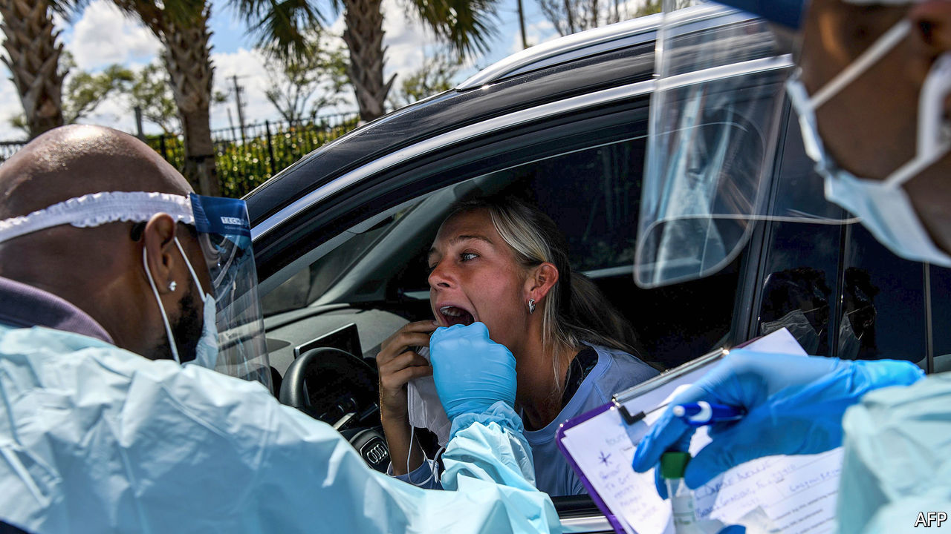

“WE HAVE A simple message to all countries.” So said Tedros Adhanom Ghebreyesus, the head of the World Health Organisation (WHO) at a news conference held in Geneva on March 16th. “Test, test, test. All countries should be able to test all suspected cases, they cannot fight this pandemic blindfolded.” Without adequate testing for SARS-CoV-2, the novel coronavirus that is now sweeping rapidly around the world, he said, there can be no isolation of cases and the chain of infection will not be broken. As if to prove the point, a vigorous policy of testing seems to have slowed the virus’s spread in South Korea quite dramatically. And in Vo, a town in Italy, thorough and repeated testing of all 3,300 inhabitants has stopped new infections entirely.

Two main types of test are used to identify viral infections: genetic and serological. The first genetic test for SARS-CoV-2 was created just a few days after the virus’s genomic sequence was published, on January 12th, by a group of Chinese researchers. Others, developed subsequently by public health bodies around the world (and also a few companies) have their own tweaks, but their broad principle is the same.

## Amplification is his only employ

Each starts with a swab taken from the back of the nose or the throat of an individual suspected of being infected, in a search for RNA—for SARS-CoV-2 stores its genes as RNA, rather than the similar molecule, DNA, which animals such as human beings employ for the purpose. Because of this quirk, the first step of genetic testing is to copy any RNA collected into DNA, using an enzyme called reverse transcriptase. That done, the DNA is then amplified in quantity by a process called the polymerase chain reaction (PCR). The now-amplified DNA is sequenced and matched (or not) against the sequence that would be expected if the starting point was RNA from the virus.

Executed properly, genetic tests of this sort are extremely accurate. But they have limitations. One is that if the virus is present only at low levels—at the start or end of an infection, for example—their sensitivity drops. Also, taking a throat swab is neither simple nor foolproof. If the sampling probe goes insufficiently deeply into the orifice concerned, or fails to gather enough cells, the test might not work. Virologists say that the best sort of throat swabbing almost inevitably makes a patient gag or cough. This means that whoever is doing the swabbing needs to be protected from infection.

All this assumes that the tests themselves are designed properly. The WHO published protocols for a SARS-CoV-2 test in January, and most places which have created their own tests have based them on these instructions. In America, however, the Centres for Disease Control and Protection (CDC) designed its own protocols. Tests created using these American CDC protocols, which were distributed across the country to state-level public-health laboratories, turned out to be flawed. This no doubt contributed to America’s slower response to the unfolding crisis.

The actual apparatus used to carry out PCR tests of this sort—regardless of the exact bug being tested for—is commonplace in hospitals in rich countries, for it is used routinely to identify viruses from influenza to hepatitis to HIV. But the process is thereby centralised, and can be slow. It may take as long as 48 hours after a sample is collected for the result to be returned to a patient. What is needed is a test which can be conducted immediately after sampling, a process known as “near-patient testing”. This involves packing everything required for a test—both the instruments and the chemicals—into a reasonably portable machine, designed specifically to look for SARS-CoV-2, that can be deployed away from a big hospital laboratory.

Several firms are working on such things. BioMérieux, a French biotechnology company, says it will have a test on offer by the end of March, and that it has an emergency-use authorisation for it from the Food and Drug Administration, which approves such devices for America. Cepheid, a Californian firm, will try to use a similar approval process to get its own coronavirus-specific test to market. This is a box, the size of a small laser printer, that ingests a sample, carries out an analysis and returns a result within a couple of hours.

## Think global. Act local

Machines like these could be particularly valuable in places where public-health laboratories are few and far between. John Nkengasong, head of Africa CDC (an arm of the African Union unrelated to the American organisation of the same name), wrote in the Lancet in February of his concern about the spread of coronavirus across his continent, given the strong links between many African countries and China, the place where the pandemic began. One of his worries was the continent’s lack of testing capacity. At the start of 2020, only the Pasteur Institute in Senegal and the National Institute for Communicable Diseases in South Africa were able to carry out full-scale genetic detection of SARS-CoV-2.

Subsequent training, led by the WHO, has now enabled scientists in around 40 African countries to diagnose infection with the virus—but this can still be done only in each country’s central public-health laboratory. Near-patient testing would help a lot. And many health-care workers in Africa are already familiar with similar self-contained diagnostic machines, because they have been used extensively to track the efficacy of antiretroviral therapy for HIV.

Genetic tests identify active infections. But to understand properly how SARS-CoV-2 is spreading through a population it is also important to know who has been infected in the past and recovered. That is where serological tests come in. They look not for RNA in swab samples, but for antibodies in blood samples. Antibodies usually hang around in a person’s bloodstream well after an infection has cleared. They thus form a historical record of the pathogens people have been exposed to over the course of their lives.

Each antibody is tailored to latch onto a specific protein on the surface of a pathogen, thus disabling it. A serological test for SARS-CoV-2 therefore works by using such a protein—referred to as an antigen—to capture antibodies from a blood sample. Most tests under development focus on spike, a protein which protrudes prominently, and in many places, from the surface of the otherwise-spherical SARS-CoV-2 virus particle. In a typical test, a blood sample would be placed into a test tube coated inside with the antigen. If relevant antibodies are present, they will stick to the antigen. Depending on the design of the test, a positive result could produce a colour change or emit light to indicate success. The whole thing is reasonably cheap and could give results in minutes.

BioMedomics, a firm in North Carolina, for example, has designed a serological test for SARS-CoV-2 that needs only a few drops of blood from a finger prick, and which gives results in 15 minutes. It includes a hand-held plastic stick which looks similar to that from a pregnancy-testing kit. And, similarly to those tests, it uses coloured lines to indicate the presence of particular antibodies. The company says the test has already been widely used by China’s public-health authorities, but has not yet been reviewed for use by America’s FDA.

Designing a serological test, then, is straightforward. Checking that it gives accurate results takes time, though. A common problem with such tests is that antibodies may cross-react, meaning that a test for SARS-CoV-2 might also show a positive result when it comes across a different coronavirus—the original SARS, perhaps, or one of the coronaviruses that cause colds. Testing the accuracy of these tests requires trials involving hundreds of people who are known to have had SARS-CoV-2 infections, and hundreds of others who are known not to have been infected.

Once validated, serological tests are fast and cheap to run at scale. They have already been deployed in China, Singapore and South Korea. Data on their efficacy, however, have not yet been publicly released or independently verified. America’s CDC is evaluating two serological tests and Public Health England, the relevant government body in that country, is also working on a test. Chris Whitty, England’s chief medical officer, said that the introduction of such a test would be a “game changer” in the quest to track and control the spread of SARS-CoV-2 across the population. It cannot come fast enough.■

This article was downloaded by calibre from <https://www.economist.com/science-and-technology/2020/03/19/developing-and-deploying-tests-for-sars-cov-2-is-crucial>

|  |  |  |  |
| --- | --- | --- | --- |
|  | Articles | Sections | Next |

|  |  |  |  |
| --- | --- | --- | --- |
| Previous | Articles | Sections | Next |

#### Sentimental journey

# A new way to review scientific literature is being tested

It analyses the sentiments of papers’ authors

Mar 19th 2020 |

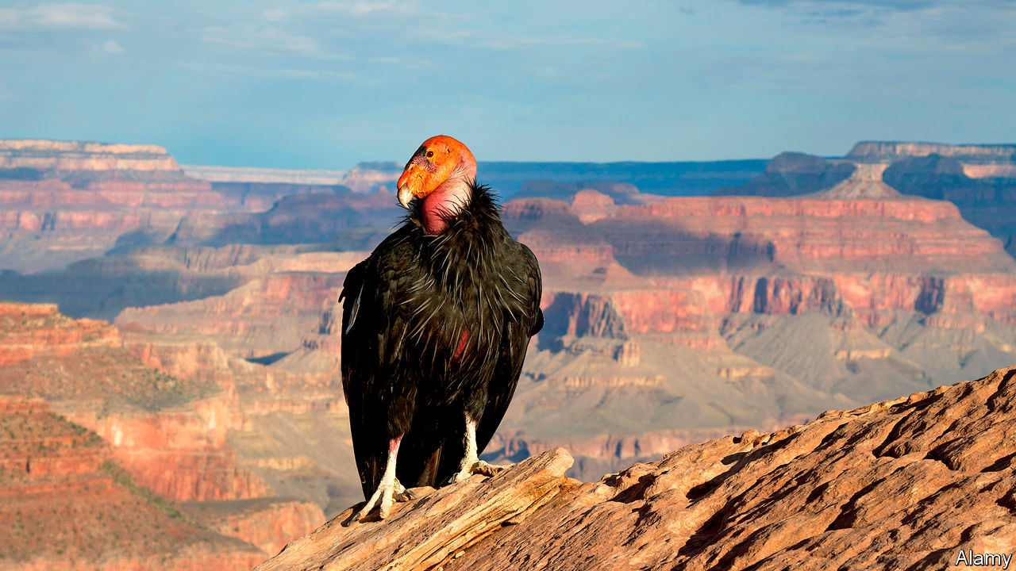

HOW DO YOU measure progress? That is the question Kyle Van Houtan, an ecologist at the Monterey Bay Aquarium, in California, found himself asking when he faced the task of working out whether methods of boosting the populations of endangered species in the wild have improved over the years.

In normal circumstances, those keen on studying the effectiveness of research write reviews of the scientific literature. In a flourishing field, though, this may involve reading and extracting information from hundreds, possibly thousands, of papers. That requires a large team, and brings problems of co-ordination. Dr Van Houtan therefore wondered whether getting computers to do the heavy lifting might help.

The answer is that it does. His study on the matter, published this week in Patterns, tapped into a branch of machine learning called natural-language processing. This is a way of analysing large volumes of text with minimal human supervision. He and his colleagues identified five existing natural-language-processing systems and borrowed them. They used them to search the abstracts of 4,313 papers on species-conservation projects published over the course of the past four decades. The software’s task was to look for words associated with success, such as “protect”, “support”, “help”, “benefit” and “growth”, and also words associated with failure, like “threaten”, “loss”, “kill”, “problem” and “risk”. Different words had different values attached to them, depending on how positive or negative they were felt to be by the original model-makers. The result was that each abstract could be assigned a sentiment score, averaged from the five different inputs.

In total, the team analysed 1,030,558 words. They found that in papers published in the 1980s, when conservation science was in its infancy, terms from the negative list were much more common than those from the positive one. During the past decade, by contrast, terms associated with success became more frequent. Average sentiment scores increased during the study period by 140%.

That is clearly encouraging news for conservationists. It suggests that their methods are working in general, and are improving with experience. But more detailed analysis was also possible. Giant pandas, which numbered 1,864 when censused in 2014 and had their status upgraded from “endangered” to merely “vulnerable” in September, have seen the sentiment of the literature about them swing from negative to positive in a matching way. Papers on the California condor (pictured), by contrast, remain littered with negative sentiments even though its numbers have risen, according to a census in 2016, from an extinction-threatening 22 to 446. But only 276 of those birds were wild, and so the condor is still listed as “critically endangered”.

Given the numbers involved, it might be argued that both of these results were predictable. They seem, nevertheless, to be evidence that the method works. And that may be relevant in the context of the team’s analysis of rat-clearance projects intended to help species which have evolved in the absence of those subsequently introduced rodents, and also projects on small islands intended to protect populations of such autochthonous species (often these projects are the same thing). Sentiment analysis sees no clear signal of success here.

Whether Dr Van Houtan’s method might be generalised to other fields of science is debatable. Conservation is, at bottom, an emotion-driven activity. People care about the results in a way that goes beyond professional amour propre. That researchers’ sentiments show up in their choice of words is therefore little surprise, and might well not be true elsewhere. But the fact that Dr Van Houtan has been able to use natural-language processing to expand the pool of papers which can be taken into a review from the hundreds to the thousands suggests that others might benefit from having a look at his achievement.■

This article was downloaded by calibre from <https://www.economist.com/science-and-technology/2020/03/19/a-new-way-to-review-scientific-literature-is-being-tested>

|  |  |  |  |
| --- | --- | --- | --- |
| Previous | Articles | Sections | Next |

|  |  |  |  |
| --- | --- | --- | --- |
| Previous | Articles | Sections | Next |

#### Palaeontology

# Another ancient bird skull is another bit of avian history

It helps to date the origin of modern birds

Mar 19th 2020 |

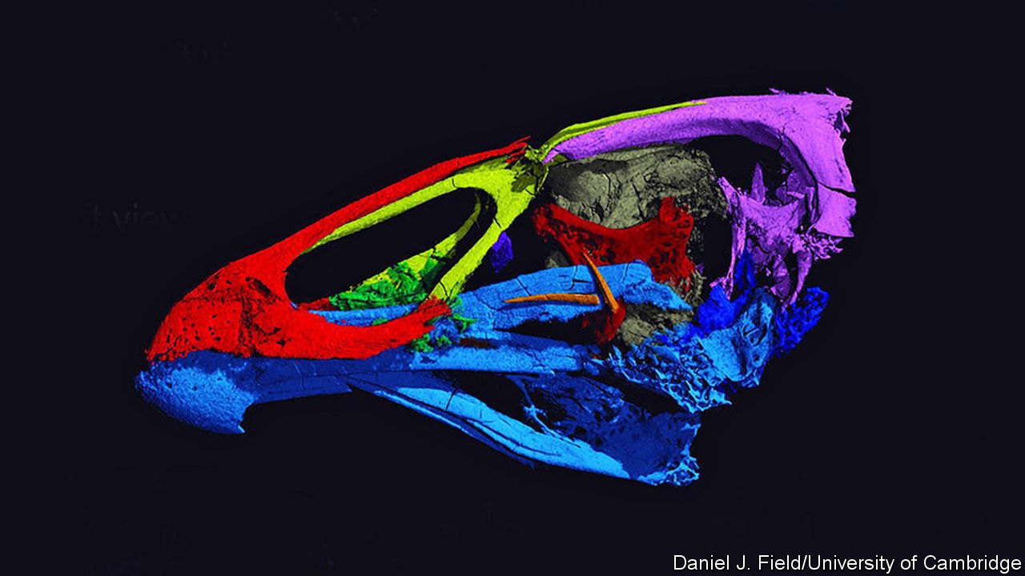

FOSSIL BY FOSSIL, the story of the birds becomes clearer. It is now well established that modern birds, the Neornithes, are actually a relict group of dinosaurs which survived a cosmic collision, 66m years ago, between Earth and an asteroid or comet. This impact wiped out the rest of the Dinosauria, along with a lot of other creatures. A paper published last week about a tiny dinosaur belonging to a related group, the Enantiornithes, which was found preserved in amber in what is now Myanmar, showed just how diverse flying dinosaurs had become more than 30m years before this collision. This week sees the release, in a paper in Nature, of details of another fossil, which those studying it believe is close to the point of origin of the Neornithes themselves.

The fossil in question is called Asteriornis maastrichtensis. As its name suggests, the rock containing it was dug from deposits found near Maastricht—though actually over the border from that Dutch city, in Belgium. These deposits, which are between 66.8m and 66.7m years old, date from the end of the Cretaceous period. Indeed, and not coincidentally, the name of the last stage of this period is the Maastrichtian, for these are strata that originally defined it.

This particular rock interested palaeontologists because it included visible leg bones that looked as though they belonged to a bird. Late Cretaceous bird fossils are rare, so instead of chancing their arms by using physical or chemical methods to explore the rock for more remains, Daniel Field of Cambridge University and his colleagues employed computerised tomography, a process more familiar to most people as a medical-scanning technique. The result, an image of the animal’s skull with false colours added to clarify which bits are which, can be seen in the picture.

A. maastrichtensis does indeed turn out to be a member of the Neornithes. Specifically, it is part of the Galloanserae. This taxon includes both modern dry-land fowl and their kin (chickens, quails and so on) and modern waterfowl (ducks, geese and the like). The skull of A. maastrichtensis exhibits features of both groups, so presumably predates the split between them. Since the Galloanserae are themselves reckoned to have evolved shortly after the Neornithes came into being, this puts A. maastrichtensis as having lived near to the origin of the Neornithes.

As to what it looked like when alive, the animal’s left femur, its best-preserved bone besides those of its skull, suggest A. maastrichtensis was a long-legged creature that strutted around. This, and evidence that the rocks it was preserved in were originally part of a fossil shoreline, has led to reconstructions that somewhat resemble a modern wading bird.

As the example of A. maastrichtensis shows, a single fossil can help to nail down previously uncertain dates. Estimates of the date of origin of the Neornithes, based on so-called molecular clocks, which attempt to use mutation rates to determine when the most-recent common ancestors of organisms now alive were themselves alive, had suggested dates ranging from 139m to 89m years ago. Dates from fossils are more accurate. Based on the discovery of A. maastrichtensis, the smart money is now on the Neornithes as a group being only a little older than the dinosaur-killing impact itself.■

This article was downloaded by calibre from <https://www.economist.com/science-and-technology/2020/03/19/another-ancient-bird-skull-is-another-bit-of-avian-history>

|  |  |  |  |
| --- | --- | --- | --- |
| Previous | Articles | Sections | Next |

|  |  |  |
| --- | --- | --- |
| Science and ... | Sections | Economic and ... |

Books and arts

Music and politics: Ghetto blasters

.

Muhammad bin Salman: The prince

.

The play’s the thing: Brave new world

.

Arresting new fiction: He said, she says

.

Johnson: Talking to the world

.

|  |  |  |
| --- | --- | --- |
| Science and ... | Sections | Economic and ... |

|  |  |  |  |
| --- | --- | --- | --- |
|  | Articles | Sections | Next |

#### Ghetto blasters

# Uganda’s pop stars are enlivening political campaigns—and launching them

Bobi Wine, a singer, is the opposition’s most popular candidate for president

Mar 19th 2020 | KAMPALA

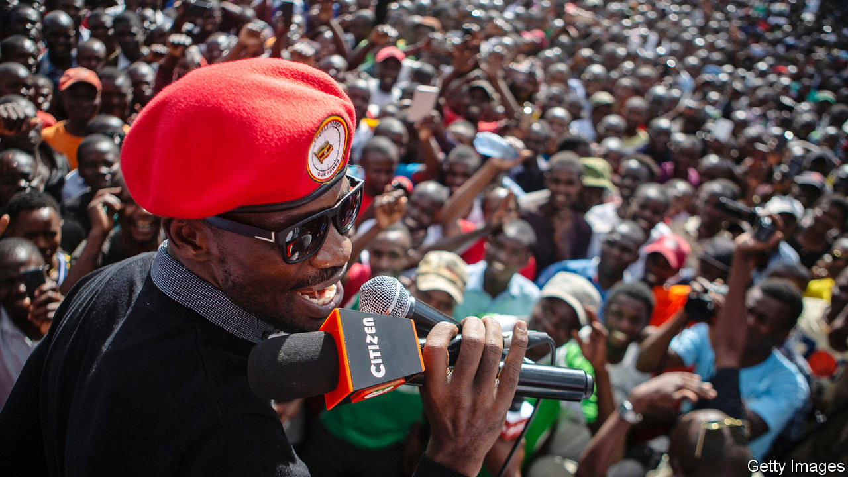

NIGHT IS FALLING when Full Figure gets back to her office in a poor quarter of Kampala, the Ugandan capital. The singer, wearing a baseball cap and psychedelic “My Little Pony” T-shirt, is returning from State House, the country’s seat of power. As an unofficial adviser on “ghetto issues”, she explains, she uses her “big voice” to connect the president, Yoweri Museveni, to the people. Mostly that seems to mean organising state handouts for local youngsters, such as the welders raising sparks on the streets below.

Ugandan musicians have played politics since the days when court troupes serenaded kings. Now the young, fast-growing cities are dancing to a new beat. A pop star-turned-MP called Bobi Wine is probably the opposition’s most popular candidate in next year’s presidential election (like other artistes in this story, he is best known by his stage name). Stars who support him are angling for parliamentary seats; others act as praise singers for Mr Museveni, whose strongman rule has so far lasted 34 years. The race for the ghetto’s votes runs through the recording studio.

The “big three” in Uganda’s home-grown music industry are Mr Wine (pictured) and his two rivals, Jose Chameleone and Bebe Cool. When they first appeared on the scene in the early 2000s the airwaves were filled by Congolese bands, local balladeers and Western pop. The trio brought a “fresh sound”, says Douglas Lwanga, a television presenter, mixing Jamaican influences with a home-grown vibe. They battled in lyrics and brawled in nightclubs. “It was about proving to each other who was bigger and better,” recalls Mr Chameleone, swigging whisky backstage in Kampala.

Mr Wine once sang that “there’s more politics in the music industry than in the parliament”. Not that, for him and his peers, conventional politics was ever far away. Mr Cool is a former cabinet minister’s son. He performed at rallies of the National Resistance Movement (NRM), the ruling party; politics, he says, was “my fate”. One of Mr Wine’s brothers, himself a musician and producer, twice ran for parliament. Another was a council chairman in the slum where he was brought up.

His own political awakening came in 2007, when Kampala hosted a meeting of Commonwealth leaders. In preparation, the authorities demolished makeshift dwellings and shut down roadside stalls, including some owned by Mr Wine. “On the day the queen comes the poor man is displaced,” he sang. Soon he was styling himself as president of the “Ghetto Republic of Uganja”, with a cabinet of dreadlocked ministers. Mr Cool sang for “the uptown boys”, says Mr Wine, but his own songs were “a representation of a ragtag society”.

## Beatbox and ballot box

This was a society that Mr Museveni knew little about. The son of a cattle-herder, he came to power through a rural insurgency; his personal taste was for hymns, army tunes and the Nashville crooner Jim Reeves. But he had an ear for the demotic. He once got down with the bazukulu (grandchildren) by rapping a folk song. At the elections in 2016, Mr Museveni backed a ragga singer as the NRM’s candidate for mayor of Kampala; he enlisted musicians—including Mr Chameleone and Mr Cool—to record a sycophantic anthem for his own campaign.

Mr Wine says he refused that gig; he later stood in a parliamentary by-election, and won. Other singers started pulling on the signature red beret of his People Power movement. Among them was Mr Chameleone, aptly changing colours, who announced plans to stand for Kampala mayor himself. Meanwhile, Mr Cool made himself rather uncool by sticking with the ruling party. Bottles were thrown at him on stage. He says the country needs the leadership of army men, not “failed” artistes; he would feel “so disrespected”, he bristles, were Mr Wine to become his president.

For others, politics offers a different sort of opportunity. Musicians earn little from selling songs, which are widely pirated, so rely instead on concerts and product endorsements for their income. Election season is a “time for them to make money”, says Balaam Barugahara, the country’s biggest promoter, who recruits singers to perform at NRM rallies. Murals of Mr Museveni and his son grin from behind his desk.

This time, a chorus of singers say they will stand for parliament. Many have genuine frustrations with the country’s sclerotic politics, but for some an element of financial calculation is involved, too. Running for office usually plunges candidates into debt; rather than doing so in earnest, some musicians may be hoping to make themselves enough of a nuisance that a mainstream candidate will decide to buy them off. “So many artistes have postured to be speaking truth to power but in a real sense they were trying to elevate their premium,” Mr Wine lamented to a posse of performers at his home.

Mr Museveni is a generous patron. In recent months he has signed up an unlikely roster of talent, from Buchaman, formerly the “vice-president” of Mr Wine’s crew, to Bosmic Otim, the biggest star in the country’s Luo-speaking north. The latter once wrote lyrics that associated Mr Wine with Nelson Mandela, and speculated about the responsibility of Mr Museveni’s forces for massacres. But after encounters with state security and a presidential handshake, his latest track is called “I support the government”.

Radio DJs avoid political tunes, fearing a phonecall from above. The choice is between “playing the song” and “staying in business,” says Isaac Mandev, a programmer at a Luganda-language station. Mr Wine is now blocked from performing in public; he and his supporters are arrested and beaten when they congregate. On a steeply tilted playing-field, his chances of winning the election are slim. All the same, a good rhythm is irresistible. At the parliamentary Christmas party of 2018, when the ghetto president grabbed the mike to sing “Kyarenga”—a smash hit about a poor man wooing a woman away from a richer suitor—even NRM stalwarts got up to dance. ■

This article was downloaded by calibre from <https://www.economist.com/books-and-arts/2020/03/19/ugandas-pop-stars-are-enlivening-political-campaigns-and-launching-them>

|  |  |  |  |
| --- | --- | --- | --- |
|  | Articles | Sections | Next |

|  |  |  |  |
| --- | --- | --- | --- |
| Previous | Articles | Sections | Next |

#### The prince

# A biography of Saudi Arabia’s Machiavellian ruler

Though not yet king, Muhammad bin Salman has a firm grip on the kingdom

Mar 19th 2020 |

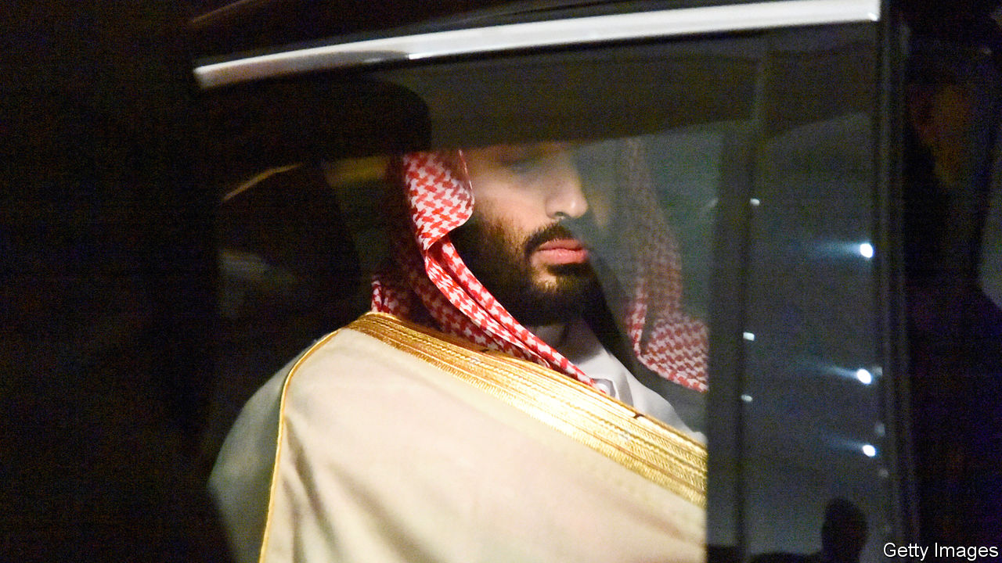

MBS: The Rise to Power of Mohammed Bin Salman. By Ben Hubbard.Tim Duggan Books; 384 pages; $28. William Collins; £20.

TO MARK THE end of its decades-old ban on cinemas, the government of Saudi Arabia held a fancy opening for the first commercial one in Riyadh. Ministers, influencers and at least one royal were invited to watch the Marvel superhero film “Black Panther”. In it a young prince called T’Challa finds himself suddenly in charge of Wakanda, an isolated kingdom rich in a precious natural resource. But he must fight off a challenge to the throne from a ruthless relative called Erik Killmonger. In the end T’Challa prevails and opens up Wakanda to the world.

Sound a little familiar? The man who ended the cinema ban, Muhammad bin Salman, the de facto ruler of Saudi Arabia, has a bit of T’Challa in him. The young crown prince, often known as MBS, is trying to open up his isolated, oil-rich kingdom. Tourists and foreign investors are now welcomed as part of a drive to diversify the economy. Conservative clerics have been muzzled and the vice police curbed, as the Saudis tone down their austere brand of Islam. Archaic restrictions, such as the ban on cinemas and another on women drivers, have been lifted. But, as Ben Hubbard intimates in his book “MBS”, Prince Muhammad arguably has a lot of Erik Killmonger in him, too.

The prince is the sixth son of the 25th son of the founding king of Saudi Arabia—so he was not exactly predestined to rule. Moreover, he was not an especially impressive young man; he never studied abroad, ran a company or served in the army. Abdullah, the previous king, saw him as “an upstart whose experience fell far short of his ambitions”, the author writes. The critique still feels apt. Yet Prince Muhammad was the apple of his father Salman’s eye—and a series of deaths in the family pushed Salman all the way up the royal ladder.

When Salman became king in 2015 he put his son in charge of the economy and defence, but there were still other royals between Prince Muhammad and the throne. That didn’t last long. King Salman, who is now fading, made him deputy crown prince that April. Two years later Prince Muhammad pushed aside his older cousin, Muhammad bin Nayef, to become crown prince. The royal court claimed the move was consensual. Reportedly, however, Muhammad bin Nayef was lured to a palace and denied medicine until he abdicated. He was under house arrest until earlier this month—when, according to Mr Hubbard, who reports for the New York Times, he was taken into custody by security officers. (Senior Saudi officials had denied Muhammad bin Nayef was under house arrest; one described the claim as “not true at all”.)

For a while Saudi-watchers in the West were entranced by the bold and ambitious prince. But recently his rash and ruthless side has been getting more attention. Saudi Arabia’s intervention in neighbouring Yemen, a brainchild of Prince Muhammad’s, has created a humanitarian disaster. His decision to lock up hundreds of Saudi tycoons in a luxury hotel until they handed over chunks of their fortunes alienated outside investors. He in effect kidnapped the prime minister of Lebanon in 2017, then started a pointless feud with Canada. The world’s richest man, Jeff Bezos, thinks the prince hacked his phone (though MBS denies it). World leaders are confounded by all this. “Are his dangerous acts the youthful faults of an inexperienced ruler? Or do they spring from deep in his character and serve as harbingers of things to come?” asks Mr Hubbard.

The book ends with the grisly tale of Jamal Khashoggi, a columnist who was killed and dismembered inside the kingdom’s consulate in Istanbul two years ago. Prince Muhammad denies ordering the murder. Few observers believe him; after all, Saudi dissidents are routinely jailed and tortured. To prevent such incidents from happening again the prince set up a committee to reform the intelligence service. Naturally, he put himself in charge of it. ■

This article was downloaded by calibre from <https://www.economist.com/books-and-arts/2020/03/19/a-biography-of-saudi-arabias-machiavellian-ruler>

|  |  |  |  |
| --- | --- | --- | --- |
| Previous | Articles | Sections | Next |

|  |  |  |  |
| --- | --- | --- | --- |
| Previous | Articles | Sections | Next |

#### Brave new world

# How Shakespeare’s plays reflect America’s preoccupations

But whether they salve political differences, as well as exposing them, is debatable

Mar 19th 2020 |



Shakespeare in a Divided America. By James Shapiro.Penguin Press; 320 pages; $27. Faber & Faber; £20.

ABRAHAM LINCOLN spent no more than six months in school, but he knew Shakespeare’s plays intimately and often recited favourite passages by heart. Befitting a president who waged a devastating war, Lincoln was drawn to the speeches of leaders under strain—particularly Macbeth—for the way they expressed nuanced feelings of guilt and grief. Yet the poet who was such a comfort to Lincoln may have also inspired his killer. John Wilkes Booth was an actor, and partial to Shakespeare’s dark men of action, particularly those less inclined to introspection. In a letter defending his assassination of the president, Booth compared himself to Shakespeare’s Brutus, who stabs the tyrannical Caesar out of “his love of Rome”.

For James Shapiro, a leading Shakespeare scholar and author of “Shakespeare in a Divided America”, this story captures the profound role the Bard has long played in helping Americans grapple with their evolving republic. The Founding Fathers looked to him for insight into treachery, sedition and political rebellion. Alexis de Tocqueville noticed in the early 19th century that there was “hardly a pioneer’s hut” without a few volumes of the plays. It may seem odd that a country founded by theatre-averse Puritans and anti-British revolutionaries would embrace an English playwright. Yet many of the issues that preoccupied Shakespeare in the late 16th century—“the dangers of autocratic rule; the imagined threat posed by those of different races, religions or nationalities; the slippery boundaries of gender”—haunted Americans centuries later, and do still.

And because these complex plays inspire conflicting interpretations, they have offered Americans rare cultural common ground for airing disparate views. In his often fascinating book, Mr Shapiro explores specific plays and productions that have reflected national concerns at fraught moments in the country’s past.

For example, both slave-owners and abolitionists saw in “Othello” a cautionary tale of racial equality. John Quincy Adams, a former president and outspoken abolitionist, wrote in a fiery essay that Desdemona got what she deserved for her “unnatural” interracial desire. During the mid-19th-century crusade to conquer the western frontier, macho ideals made the somewhat effeminate role of Romeo “unplayable” for male actors. In the early 20th century anti-immigrant lawmakers cited the shunning of Caliban in “The Tempest” in their push for race-based quotas.

These cases, Mr Shapiro argues, show how Shakespeare alerts Americans to the “toxic prejudices poisoning our cultural climate”. Whether they salve such antagonisms as well as exposing them is another matter. Sometimes the plays function like Rorschach tests that reveal and confirm whatever viewers want to see.

Consider a controversial production of “Julius Caesar” in New York in 2017 (pictured), which left no confusion over the intended modern parallels. Caesar was a tall, blustering blond in dark suits and overlong ties whose comely wife had a Slavic accent. Anyone familiar with the play knows that the brutal assassination, notionally in defence of the republic, is more ugly than heroic, and that the conspiracy ends badly. In this case, Oskar Eustis, the director, aimed to subvert the contemporary appeal of political violence. But after Fox News played a 12-second clip of this murderous scene, devoid of context, public pressure on social media forced corporate sponsors to withdraw their support. Mr Eustis and others received death threats.

Like Mr Shapiro’s other examples, the production handily highlighted the nation’s rifts. But rather than contend with the play’s ideas, critics simply pushed to shut it down. There is a grim and timely irony in the fact that a show hoping to inspire debate about threats to democracy instead revealed “how easily democratic norms could crumble”. ■

This article was downloaded by calibre from <https://www.economist.com/books-and-arts/2020/03/19/how-shakespeares-plays-reflect-americas-preoccupations>

|  |  |  |  |
| --- | --- | --- | --- |
| Previous | Articles | Sections | Next |

|  |  |  |  |
| --- | --- | --- | --- |
| Previous | Articles | Sections | Next |

#### He said, she says

# Kate Elizabeth Russell’s debut novel is an unsettling tale of abuse

“My Dark Vanessa” will strike a chord with women. But it ought to be read by men

Mar 19th 2020 |

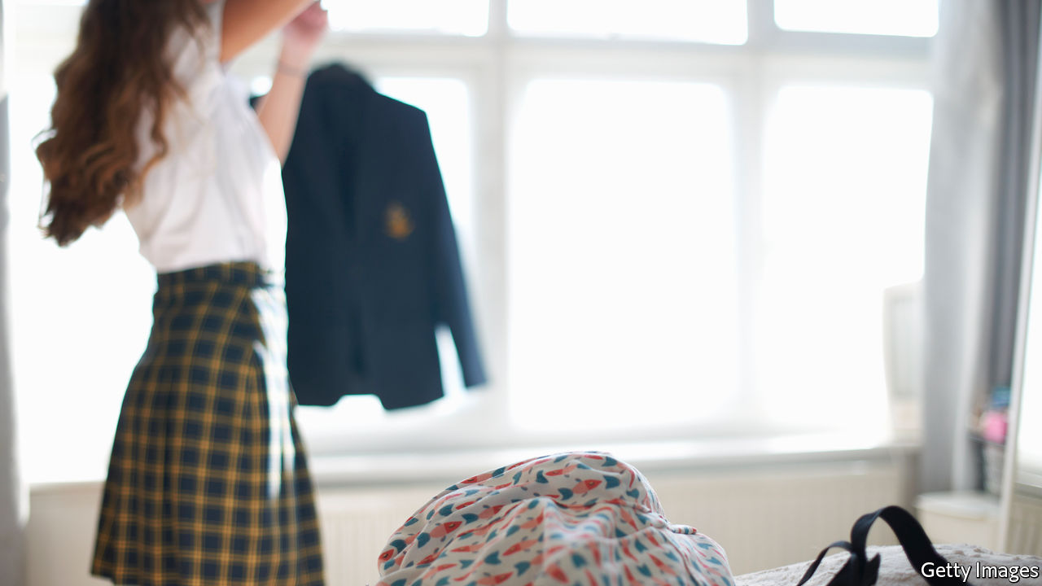

My Dark Vanessa. By Kate Elizabeth Russell.William Morrow; 384 pages; $27.99. Fourth Estate; £12.99.

“HE WAS CAREFUL with me,” the Vanessa Wye of 2017 tells the reader, and herself. Another victim has denounced Jacob Strane, the high-school teacher who “tried so hard to be good”, but Vanessa is sure that her case is different. Or almost sure: her memories are “shadowy, incomplete”, and she needs Strane “to fill in the gaps”, as he always has. Yet it is clear from the drugs and the booze, her pained family relations and stalled career as a hotel concierge, that her life has been derailed.

The scene of Kate Elizabeth Russell’s gripping and unsettling debut novel switches to 2000, when Vanessa, again narrating, is at a boarding school in Maine, a vulnerable outsider on a scholarship. She is 15; Strane is 42. His practised grooming techniques are deniable but unmistakable, albeit not to Vanessa herself. He pays her creepy compliments. “I’m special,” she rhapsodises. “I’m special. I’m special.” He critiques her poems; he puts his hand on her knee; he makes her pity him for the risks he claims to be running. Then he smuggles her into his home and tells her she is in charge, though “after a while he starts asking permission after he’s already done the thing he’s asking about.”

Strane’s crimes, and their consequences, unspool in alternating chapters. He and Vanessa continue to see each other, even though—as the reader understands, though she does not—she is soon too old for his tastes. As the split-screen manipulation proceeds, the real question is not whether Strane will be caught, but whether Vanessa will be: caught, that is, by the reality of her past, which would wreck the love story that she has spun around her trauma. Even as a teenager she knows that there are “things [Strane] needs to believe in order to live with himself, and it would be cruel for me to label these as lies.” The same goes for Vanessa as an adult. Her slow capitulation to the truth is a macabre echo of Strane’s original grooming. “We’ll have to be careful,” says her therapist, “and not do too much too soon.”

On one level, Ms Russell’s tale is a reimagining of “Lolita”, a copy of which Strane gives Vanessa; her title comes from “Pale Fire”, another book by Vladimir Nabokov. But beyond its main villain, this novel’s stealthy power comes from the ambient sexism and harassment that Vanessa and the other female characters suffer from lousy—but ordinary—men: a creep who tries to pick her up at a bowling alley, guests at the hotel, handsy guys in bars, cruel adolescent boys. On a date an older man “clamped a hand over my mouth and said, You want it like this, you want it, you know you do.” Where, Vanessa wonders, is the line that separates “criminal from socially acceptable”? Is Strane different in kind, or merely in degree?

In its evocation of the mix of knowingness and naivety that characterises (and jeopardises) teenagers, plus its frankness about female sexuality and the psychology of victimhood, this is a bracingly uncompromising book. It will doubtless be devoured with an ache of recognition by large numbers of women. But it really ought to be read by men. ■

This article was downloaded by calibre from <https://www.economist.com/books-and-arts/2020/03/19/kate-elizabeth-russells-debut-novel-is-an-unsettling-tale-of-abuse>

|  |  |  |  |
| --- | --- | --- | --- |
| Previous | Articles | Sections | Next |

|  |  |  |  |
| --- | --- | --- | --- |
| Previous | Articles | Sections | Next |

#### Johnson

# A tribute to the original Johnson columnist

Stephen Hugh-Jones loved language and believed in the power of talking

Mar 19th 2020 |

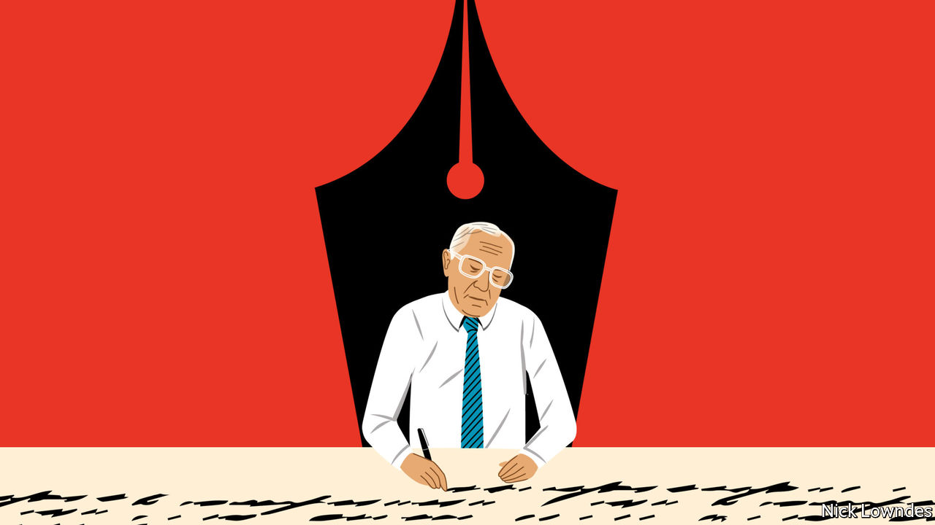

THE FOUNDER of this column, Stephen Hugh-Jones, died on February 28th. He was an extraordinary character at The Economist—long, lean, waspish, and a self-appointed menace to facile consensus. His theatrical interventions tended to come at Monday editorial meetings where, sitting on the floor with his back to the editor’s desk, he would uncurl his lanky frame to shout “Phooey!” Such exclamations (“Ho hum”, “Baloney”, “Piffle”) often found their way into copy, both his own and other people’s. His edits, during which he chanted and sometimes almost sang the lines aloud, were razor-sharp.

He was hired in the 1960s before leaving to run a magazine in Paris. He was lured back to oversee the business pages in 1974, and his first act was to buy calculators for his writers, which along with his force of personality made an immediate difference in quality. He huffed out in 1980 after an organisational dispute, but so admired was he that he was hired a third time—and given a language column from 1992 to 1999.

The column grew from Stephen’s love of the great dictionary-maker’s humanity, and of the original Johnson’s hatred of cant. “The Goths have already seized the airwaves. Do not expect young Johnson to encourage them,” he wrote in high dudgeon in his opening manifesto. His exactitude showed up in columns on “may” v “might”. “Hitler might have won the war” is a counterfactual that wonders what would have happened had Stalingrad gone differently, he explained. “Hitler may have won the war” means the outcome remains unknown.

But he also knew (like the original Johnson) that though changes in language could be slowed, they could not be stopped: “Lovers of English do well to resist until majority opinion overrules them.” In the “endless debate between...the pedantic view of language and the anyfink-goes one...the wise man expects no resolution.” He could be shockingly old-fashioned. “Parental love is seldom honoured in poetry,” he opined; “most mothers, perhaps, are too busy caring for their young to write poems about them, and men prefer their mistresses.” Yet he knew this about himself, and welcomed change too: “political correctness, at its silliest, has never done one-fiftieth as much harm as its reverse.”

His column was global in its reach. Portuguese pronunciation, Indian languages and Chinese characters found a home alongside the more obvious German and French, Greek and Latin. Despite the odd potshot at the yoof and yobs, he wrote admiringly of Caribbean patois, black American vernacular and rural English dialects. Johnny Grimond, who wrote most of The Economist’s style guide, calls him a keen contributor—but mostly to suggest rules for deletion, not addition. His column (twice) quoted Churchill as saying the rule forbidding a preposition at the end of a sentence was the kind of nonsense “up with which I will not put”.

Alas, Churchill never said it—the kind of misstep Stephen would not have made in the age of Google. Indeed, he did not mention the internet until a Christmas piece in 1999. He drank in the world’s languages the old-fashioned way. He was born in Egypt, brought up in Scotland, and was variously an encyclopedia salesman in America, a soldier in Germany and a junior journalist in India. And he was a lifelong reader.

A stubborn legend pursued Stephen—that he threw a typewriter out of his office window in a rage. Or perhaps intended to, but failed to break through the glass. Or perhaps it was a phone, through a window in an internal door. No two versions of the story are the same; he himself denied it, in a history of The Economist published in 1993. But, he told the book’s author, he could understand why people might believe it.

Yet his frantic bursts of irascibility would be followed by graceful and kind conversation, as though nothing was untoward. Friends and colleagues remember surprising tendernesses. He collected glass artefacts. He lavished affection on children visiting the office. Perhaps his most lyrical piece for the paper was a tour of the English churchyards he cherished, finding poignant gravestones of both great and humble. And yes, he was in love with language.

He knew words could be weapons, but they were the best kind. His son David recalls a cover of The Economist that showed a Palestinian and Israeli shouting in each other’s faces, and his father saying “What a hopeful picture that is.” To his puzzled child’s inevitable “why?” he replied: “they’re talking to each other.”

This article was downloaded by calibre from <https://www.economist.com/books-and-arts/2020/03/19/a-tribute-to-the-original-johnson-columnist>

|  |  |  |  |
| --- | --- | --- | --- |
| Previous | Articles | Sections | Next |

|  |  |  |
| --- | --- | --- |
| Books and arts | Sections | Graphic detail |

Economic and financial indicators

Economic and financial indicators

.

|  |  |  |
| --- | --- | --- |
| Books and arts | Sections | Graphic detail |

|  |  |  |  |
| --- | --- | --- | --- |
|  | Articles | Sections | Next |

# Economic and financial indicators

Mar 19th 2020 |

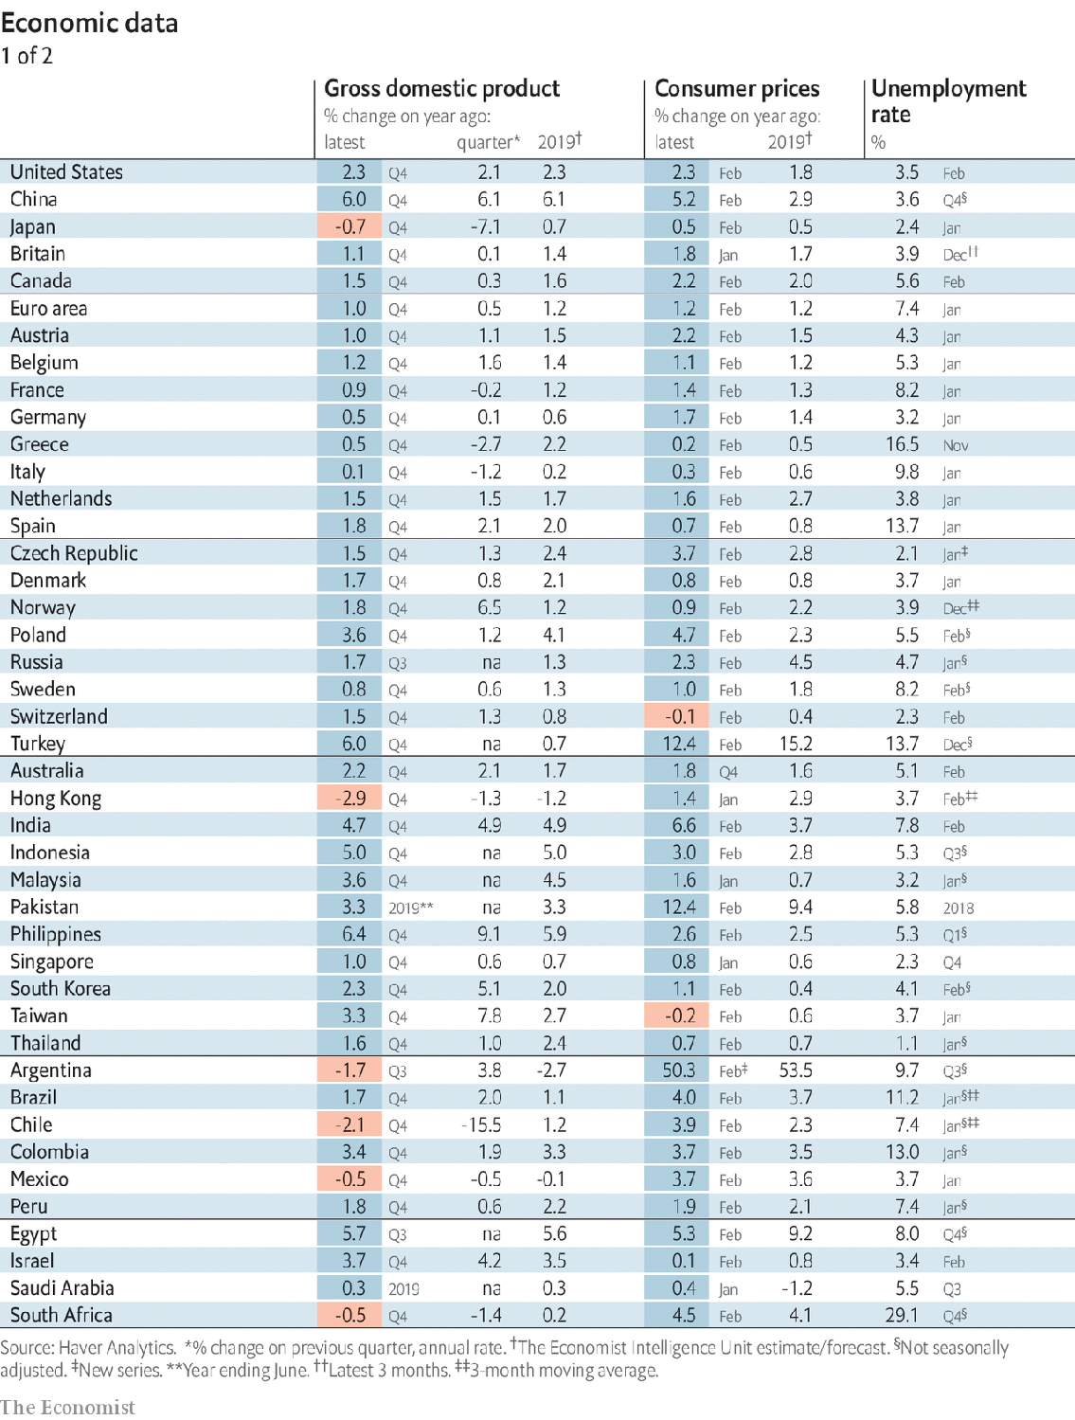

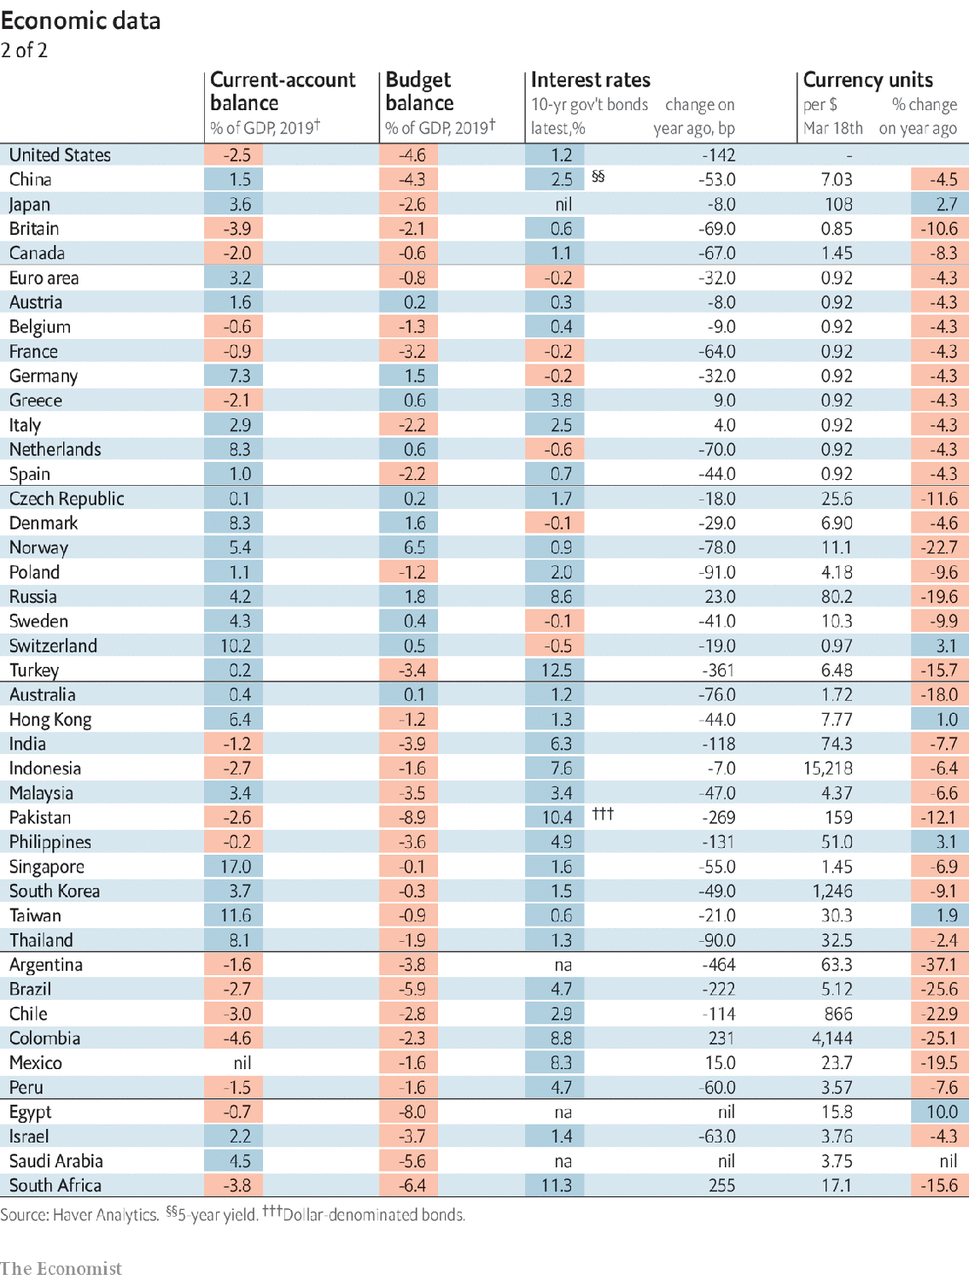

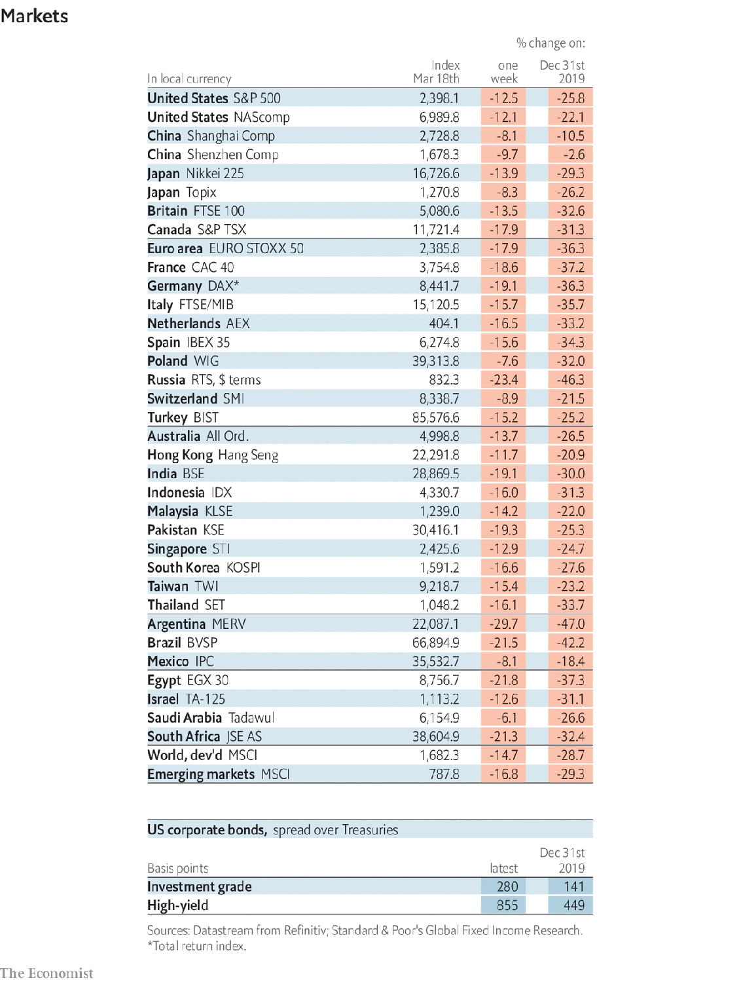

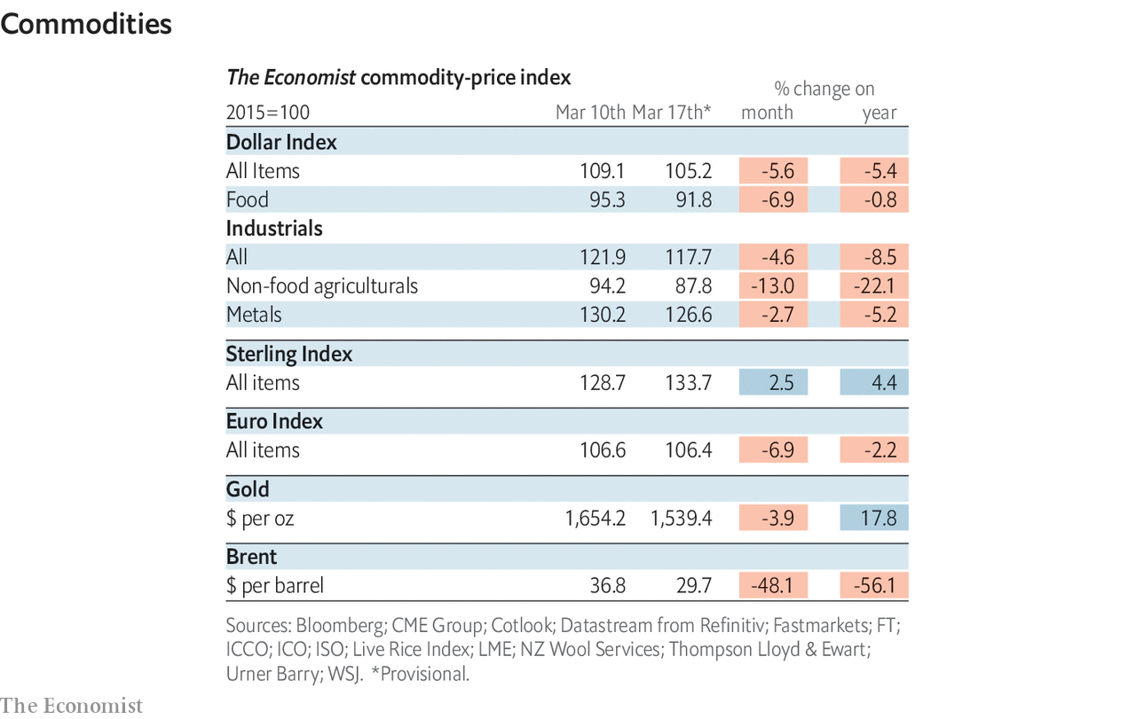

This article was downloaded by calibre from <https://www.economist.com/economic-and-financial-indicators/2020/03/19/economic-and-financial-indicators>

|  |  |  |  |
| --- | --- | --- | --- |
|  | Articles | Sections | Next |

|  |  |  |
| --- | --- | --- |
| Economic and ... | Sections | Obituary |

Graphic detail

|  |  |  |
| --- | --- | --- |
| Economic and ... | Sections | Obituary |

|  |  |  |
| --- | --- | --- |
| Graphic detail | Sections |  |

Obituary

Falafel: The throw of the dice

.

|  |  |  |
| --- | --- | --- |
| Graphic detail | Sections |  |

|  |  |  |  |
| --- | --- | --- | --- |
|  | Articles | Sections | Next |

#### The throw of the dice

# Falafel died on February 14th

The homeless man who became a world backgammon champion was 51

Mar 19th 2020 |

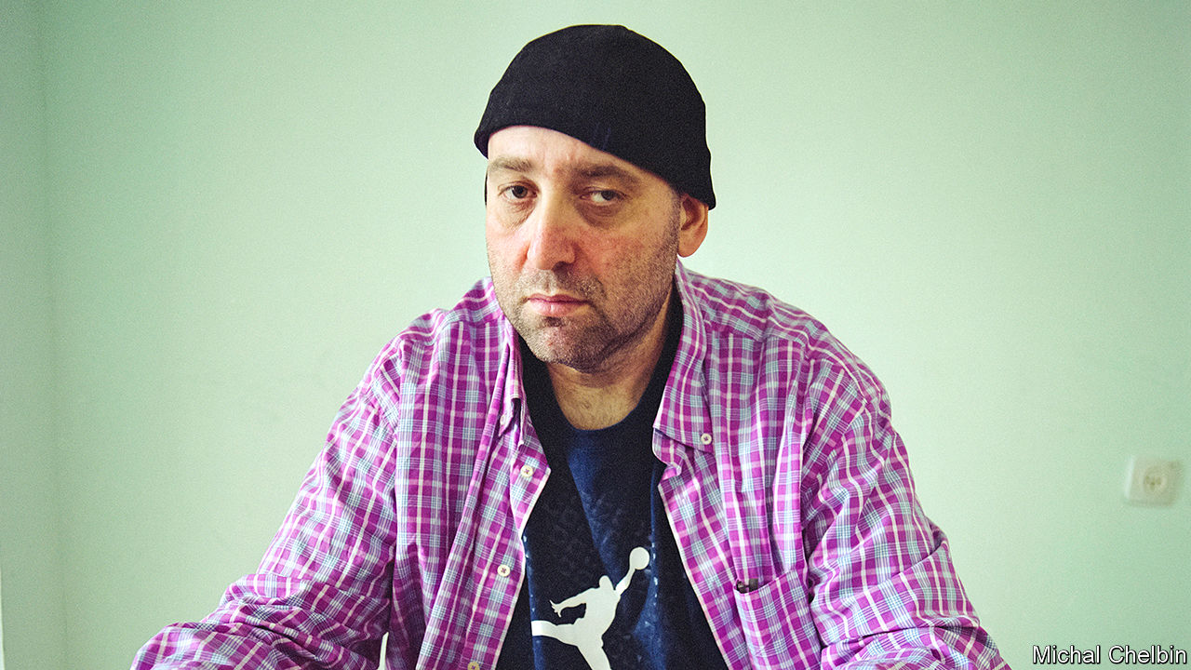

IT WAS THE best of times; it was the worst of times. That was the beginning of a book he had heard about somewhere. He didn’t remember which one. Or perhaps it was “It was the worst of times, it was the best of times.” Either way, it described exactly the months he had spent when he first arrived in 1994 to make his luck in New York. His mother, despairing that he would ever take a job, had kicked him out of the house. He carried nothing with him on the freezing journey from Buffalo except an extra hoodie or two, a chessboard and a chess clock. Being pretty good at chess, that was all he thought he needed to make an impression.

He had no contacts in the Big Apple, no friends, nothing. And nowhere to sleep. Since he liked his sleep, being naturally lazy and lumpish, this was a nightmare. He tried park benches, the subway, anywhere he could. One night the best he could find was one of the stone chess tables in Washington Square Park, where he lay on his back snoring loudly with chunks of falafel, his favourite and almost his only food, stuck to his unshaven face. He was shaken awake by the brawny tattooed arms of Russian Paul, whose particular special table this was; in exchange for guarding it for him, Russian Paul agreed to give him $2 a day to buy more falafel, at least. So Falafel he became. Since no one, not even his mother, called him Matvey, this was fine. And so began a sequence of twists and turns, losses and wins, that culminated in 2007 with his crowning by his peers, the Giants of Backgammon, as a genius, and the best backgammon player in the world.

He hadn’t given the game much thought before. Growing up—moving from Russia, where he was born, to Israel as a child, to Buffalo from the age of 14—he had mostly played chess, which seemed to him a better way to spend the time than going to college. But he noticed in the park that hustling backgammon, playing tourists and other “fish”, or “pigeons”, or “marks”, who wandered by and wanted a game, was much more lucrative. Besides, the more he looked at it, the more fascinated he became. This was both a game of strategy, working out how to get home and bear off all your checkers before your opponent did, and also one of sheer chance, driven by the throw of the dice. It needed not only skill, but luck. You could do all the planning you liked, but the gods had to be on your side. Backgammon mirrored life: sometimes safe, sometimes on the street. He wanted to understand the full truth of it.

Once Russian Paul, in his impatient way, had taught him the moves, and once he had stopped losing, he was hooked. He was no genius in his own mind, and his openings were ragged, but he could survey the vital mid-section of a game and know exactly what to do, with mathematical precision. Backgammon students were already turning to computer programs that could analyse and predict moves, factoring in the near-infinite variations of the dice, and he did that too; one neural-net program, called Snowie, helped him more than anything. But there was still a place for old-fashioned intuition and brainwork, awareness of the tiniest advantage, and this was where he outshone all the rest. When Snowie analysed his games, they often came out perfect.

For up to 15 hours a day he played. Sometimes this was in the park, under the trees. Sometimes it was in casinos, reminders of backgammon’s glamorous days in the 1960s, under gilding and chandeliers, or in tournaments in lookalike hotel ballrooms all over the place. There he would wander in, looking like a dumb-ass in his saggy nylon shorts and yellow woollen hat, so that players clamoured to take him on and he would sit there chattering and rocking, sometimes laughing aloud, as he took them to the cleaners. But at other times he would just sit in his room—if he could find a room, afford one or keep one—playing online with the shades drawn, hour after hour, with his laundry and rubbish piling up around him. In this one sphere of backgammon, he was not lazy. He was always learning, looking for the truth.

He hoped for a fortune, too. Backgammon was a gambling game, and he loved to bet. If he said he could do something—dance, get married within a year, lose weight—he bet on it, usually a “ruble”, or $1,000. Such bets sometimes came good, often didn’t, but winning at backgammon became a near-certainty. He could earn his living that way, with a board game, even though his parents had said he never could. The fact that he looked like an idiot, as he cheerfully admitted, irresistibly drew weaker players towards him. Tournaments did not earn him much, but private side-games were a different matter. If he used the red cube to double the stakes, then double again, and double again, he could win tens of thousands of dollars in a game that might not even take an hour.

Fairly often, he won that big. But then, just as fast, he would lose it again. He bet the money on colleagues who lost their games, or on sports teams that let him down. He took $1,500 to a flophouse on the Bowery, where a thief made off with it as he slept. In the end, he cared much less about the money than the mere fact of having won it, and being able to gamble it away. Any backgammon game could produce heart-stopping reversals of fortune, so he was used to it. Every man played out his luck. And he had nothing much to spend the cash on: plane tickets, hotel rooms, eventually a flat in Tel Aviv, where he became part-owner of a poker club. Even as a global celebrity who was profiled in Esquire and the New Yorker, he continued to wear the baggy shorts, sweatshirt and backwards baseball cap that were his summer wardrobe. He socialised happily over the boards, but still spent his spare time alone with Snowie or with online players from whom, too, he won plenty of money.

It seemed to be true that he could not function properly in normal society. At tournaments he was gregarious and fun in his lumbering bearish way, but with girls he was shy, and the famous marriage bet (with the family he wanted) never came off. He also found America hard to settle in. For years before he managed to return he longed for the love, warmth and closeness of Israel, the childhood paradise he remembered—and where the falafel was much better, too. Backgammon, he knew, was all about getting home. ■

This article was downloaded by calibre from <https://www.economist.com/obituary/2020/03/19/falafel-died-on-february-14th>

|  |  |  |  |
| --- | --- | --- | --- |
|  | Articles | Sections | Next |